
LCLS ‘0.91Q17.72’ LTU Quadrupole Magnet
FIDUCIALIZATION REPORT

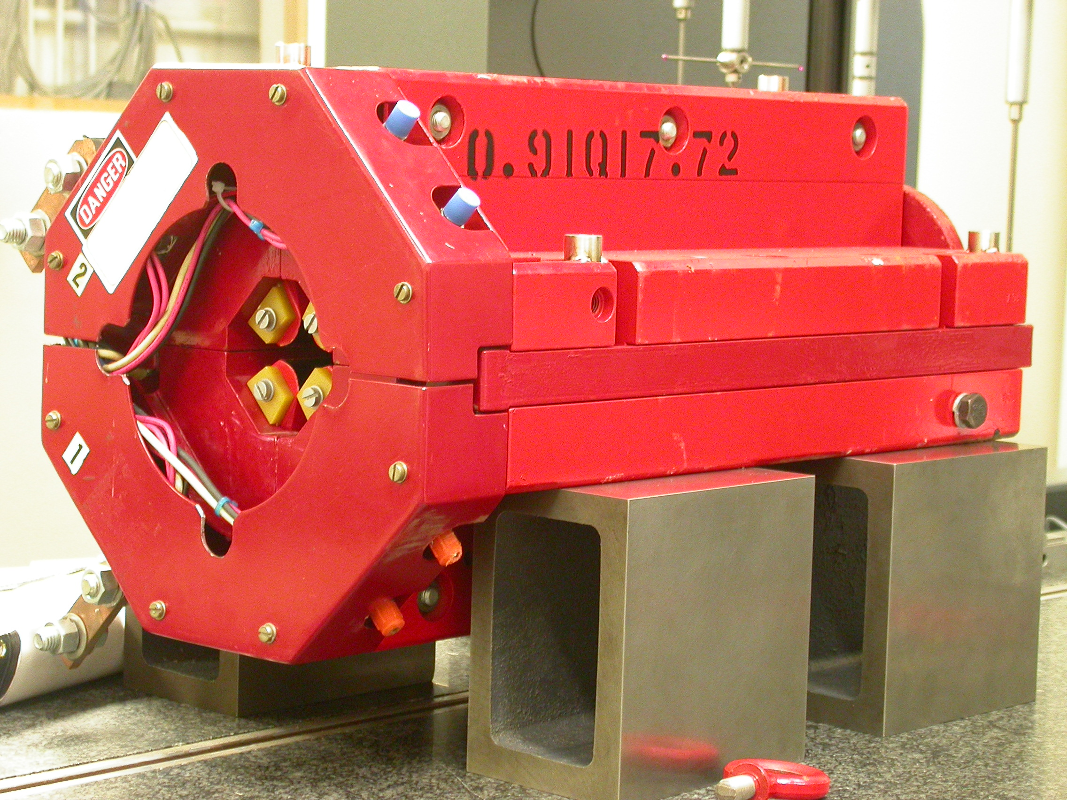

Inspector: | Keith Caban
Responsible Engineer: | Carl Rago
Date: | Monday, March 26, 2007
Work Order/Charge No.: | 21699-1
Serial Number: | 000305
URL of Fiducial Report: | \\Web002\www-group\met\Quality\FIDUCIAL REPORTS\LCLS LTU QUAD\000305.pdf

Part Set-up – Coordinate System Set-up

Spatial Alignment

- Geometric axis of the poles of the magnet.

Planar Alignment

- Clocking plane where TB A,C, D, & E reside.

“Z” Zero

- Mid-plane of the magnet (pole planes on each end).

“X” & “Y” Zero

- Geometric axis of the poles of the magnet.

  +X  +Y  Front View | 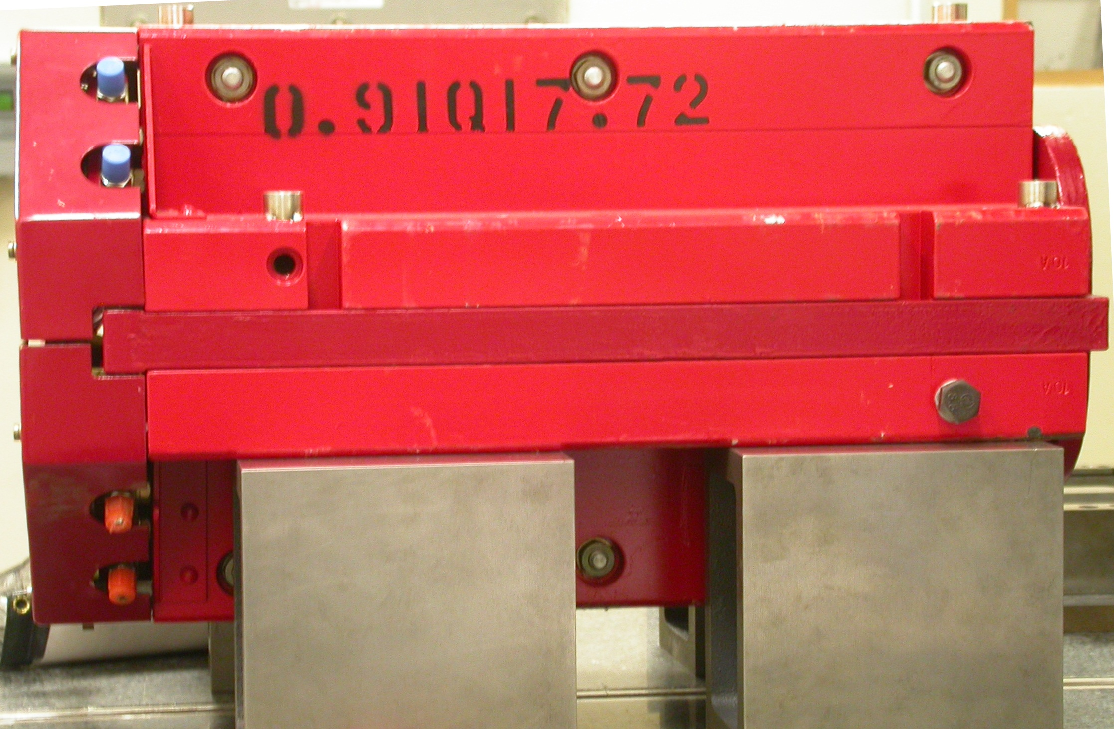  +Z  +Y  Side View

Tooling Ball Measurements/Locations

Top of magnet; view from “+Y”
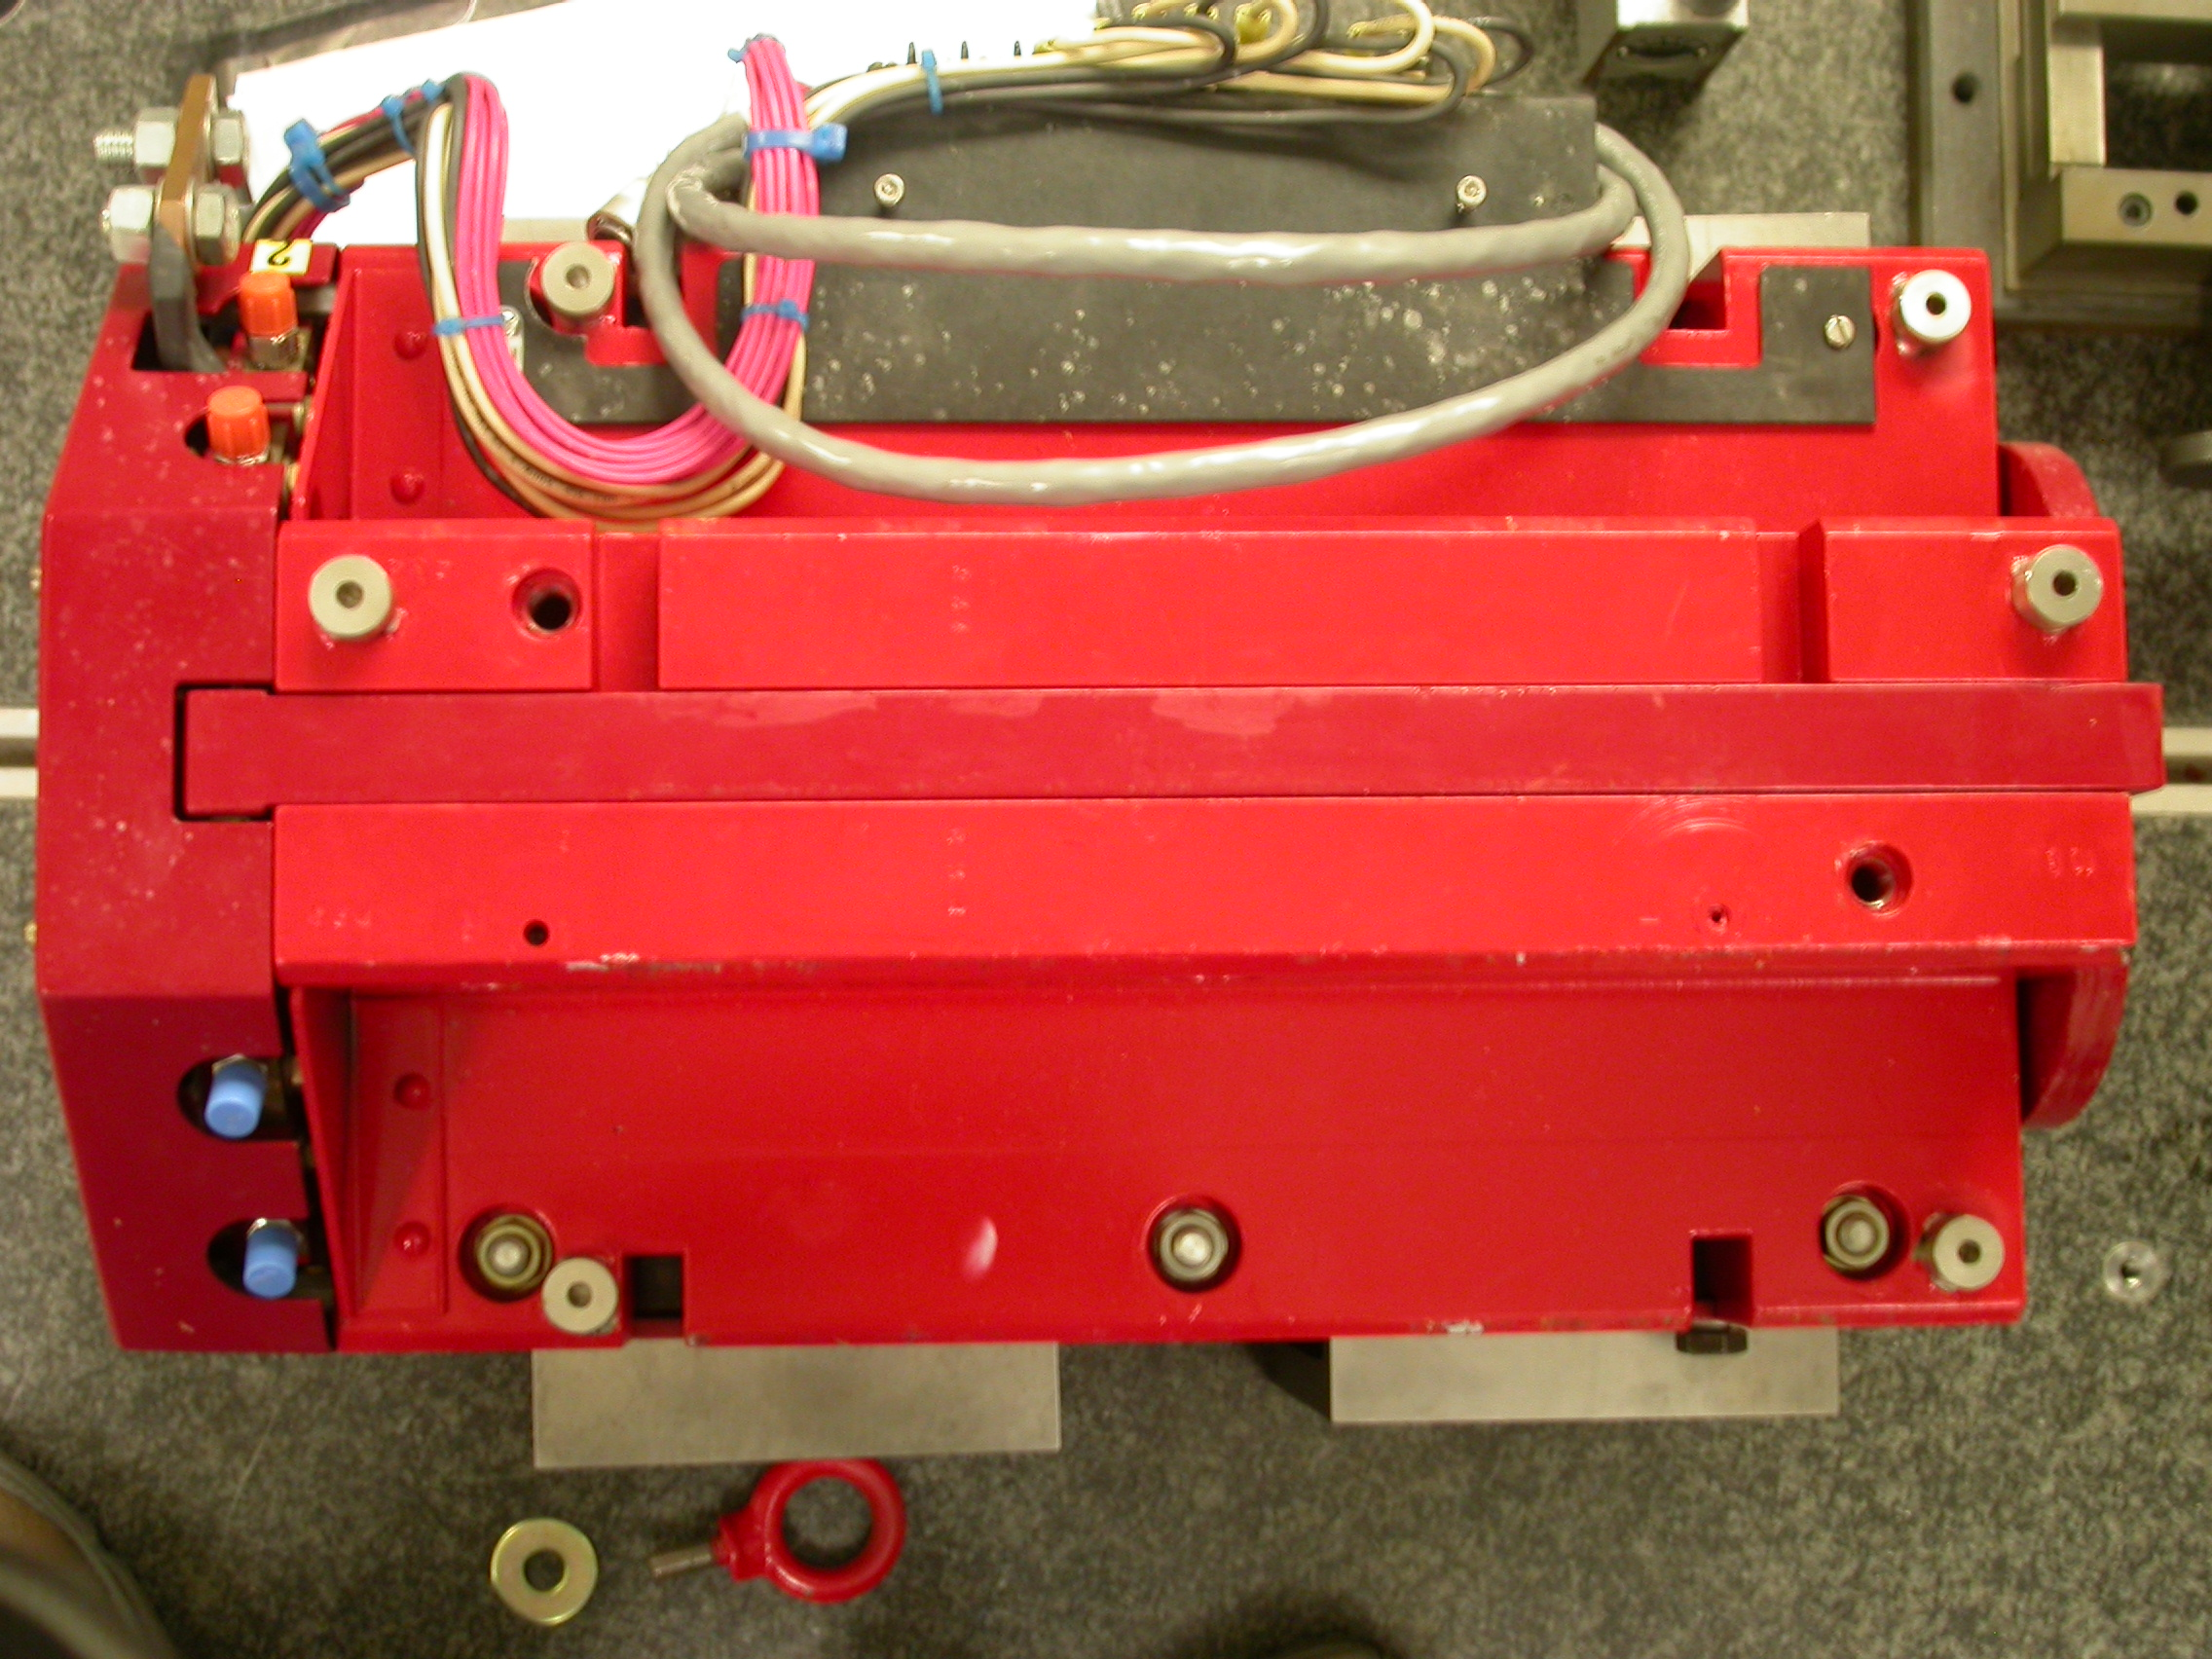

+Z

+X

Tooling Ball | FORM | DIAMETER | X | Y | Z
TB A | 0.00048 | 0.49660 | 5.04721 | 3.70047 | -8.03672
TB B | 0.00020 | 0.49770 | -1.38658 | 7.31919 | -8.02645
TB C | 0.00057 | 0.49739 | -5.01452 | 3.70411 | -8.02948
TB D | 0.00007 | 0.49669 | -5.23398 | 3.70486 | 6.28162
TB E | 0.00042 | 0.49688 | -1.40919 | 7.32016 | 8.07233
TB F | 0.00047 | 0.49614 | 5.26652 | 3.70107 | 6.29811
.

Pole Distances
C
D
Pole | -Z side | +Z side | Δ
A-C | 0.90660 | 0.90419 | 0.00241
B-D | 0.90643 | 0.90653 | 0.00010
A
B

