
LCLS ‘0.91Q17.72’ LTU Quadrupole Magnet
FIDUCIALIZATION REPORT

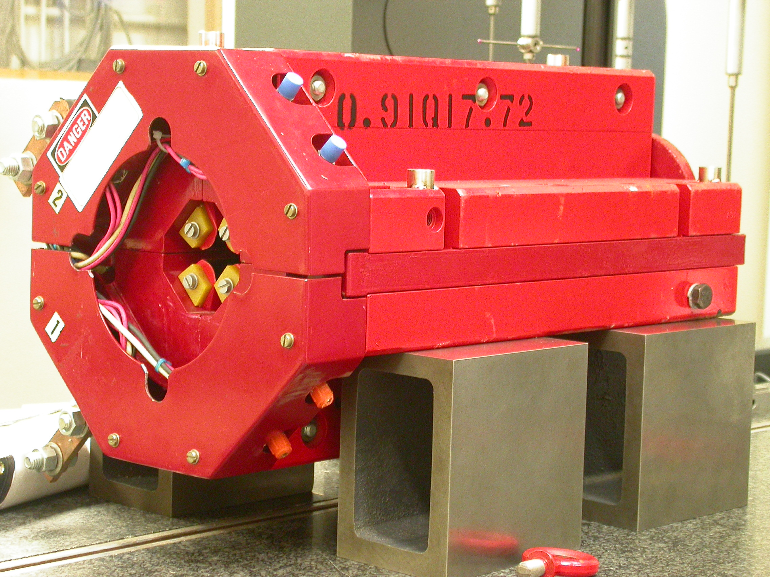

Inspector: | Keith Caban
Responsible Engineer: | Carl Rago
Date: | Wednesday, February 21, 2007
Work Order/Charge No.: | 21699-1
Serial Number: | 000269
URL of Fiducial Report: | \\Web002\www-group\met\Quality\FIDUCIAL REPORTS\LCLS LTU QUAD\000269.pdf

Part Set-up – Coordinate System Set-up

Spatial Alignment

- Geometric axis of the poles of the magnet.

Planar Alignment

- Clocking plane where TB A,C, D, & E reside.

“Z” Zero

- Mid-plane of the magnet (pole planes on each end).

“X” & “Y” Zero

- Geometric axis of the poles of the magnet.

  +X  +Y  Front View | 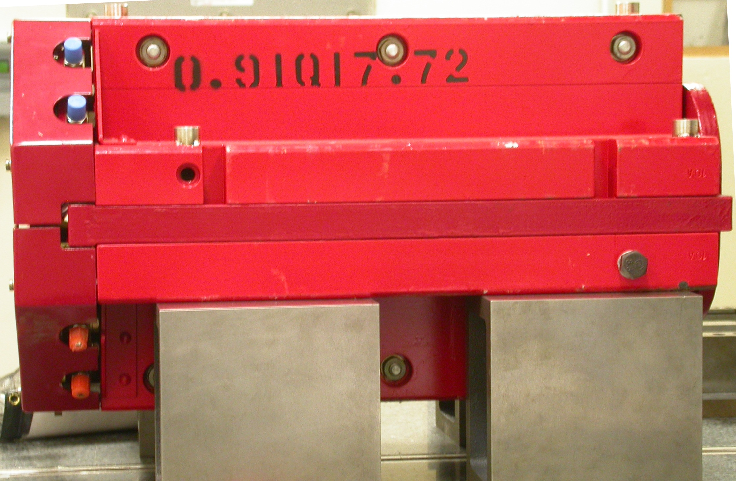  +Z  +Y  Side View

Tooling Ball Measurements/Locations

Top of magnet; view from “+Y”
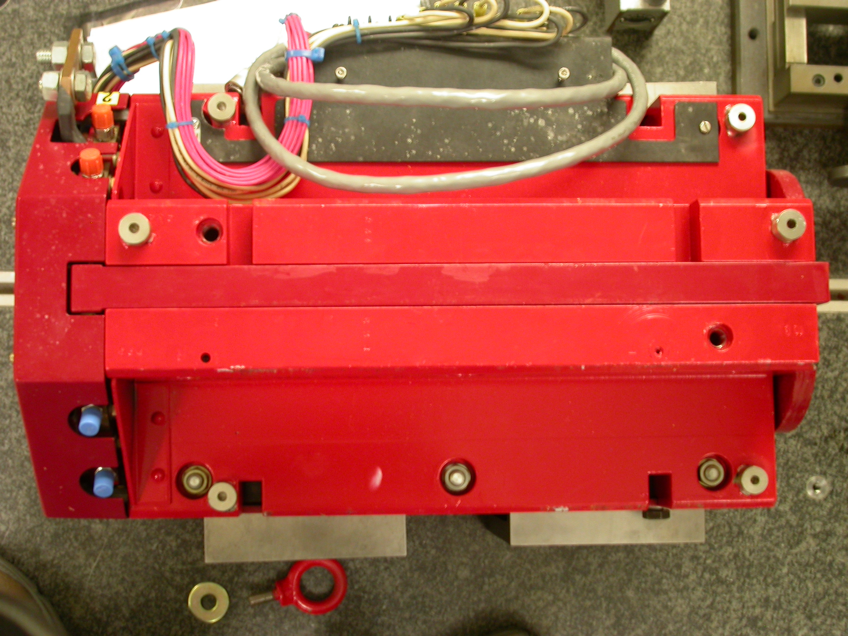

+Z

+X

Tooling Ball | FORM | DIAMETER | X | Y | Z
TB A | 0.00039 | 0.49690 | 5.04055 | 3.69963 | -8.04079
TB B | 0.00008 | 0.49794 | -1.40055 | 7.31459 | -8.04370
TB C | 0.00008 | 0.49935 | -5.02864 | 3.70890 | -8.04076
TB D | 0.00046 | 0.49692 | -5.28813 | 3.70528 | 6.29310
TB E | 0.00024 | 0.49831 | -1.40888 | 7.30934 | 8.05351
TB F | 0.00021 | 0.49806 | 5.28575 | 3.69809 | 6.29598
.

Pole Distances
C
D
Pole | -Z side | +Z side | Δ
A-C | 0.90917 | 0.90490 | 0.00427
B-D | 0.90980 | 0.90557 | 0.00423
A
B

