
LCLS ‘0.91Q17.72’ LTU Quadrupole Magnet
FIDUCIALIZATION REPORT

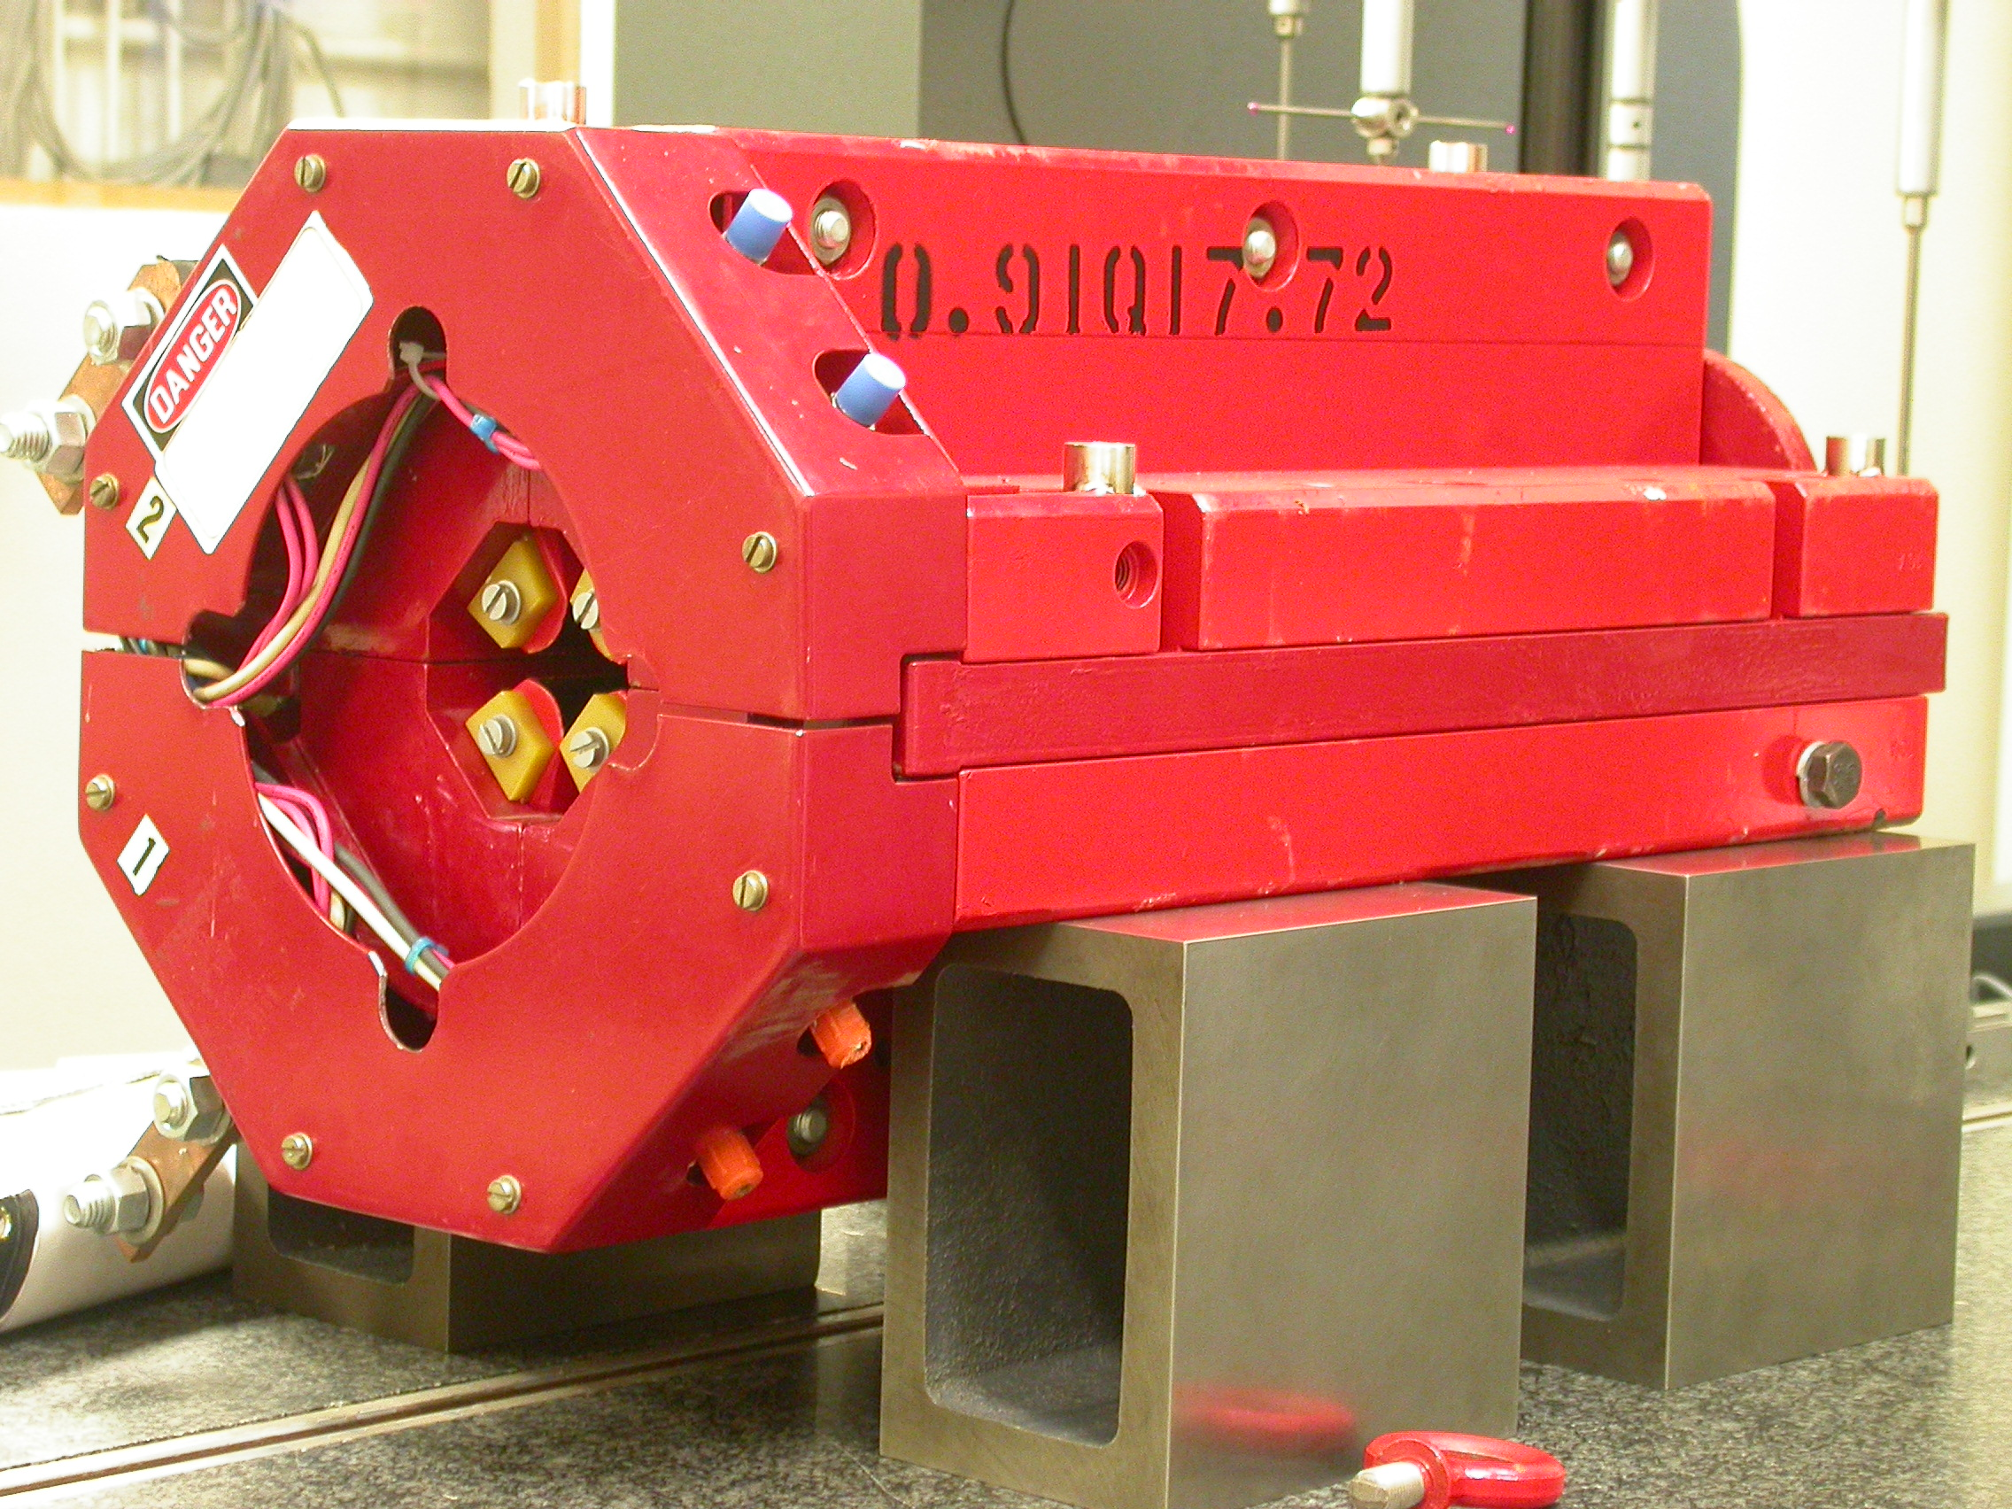

Inspector: | Keith Caban
Responsible Engineer: | Carl Rago
Date: | Friday, March 23, 2007
Work Order/Charge No.: | 21699-1
Serial Number: | 000238
URL of Fiducial Report: | \\Web002\www-group\met\Quality\FIDUCIAL REPORTS\LCLS LTU QUAD\000238.pdf

Part Set-up – Coordinate System Set-up

Spatial Alignment

- Geometric axis of the poles of the magnet.

Planar Alignment

- Clocking plane where TB A,C, D, & E reside.

“Z” Zero

- Mid-plane of the magnet (pole planes on each end).

“X” & “Y” Zero

- Geometric axis of the poles of the magnet.

  +X  +Y  Front View | 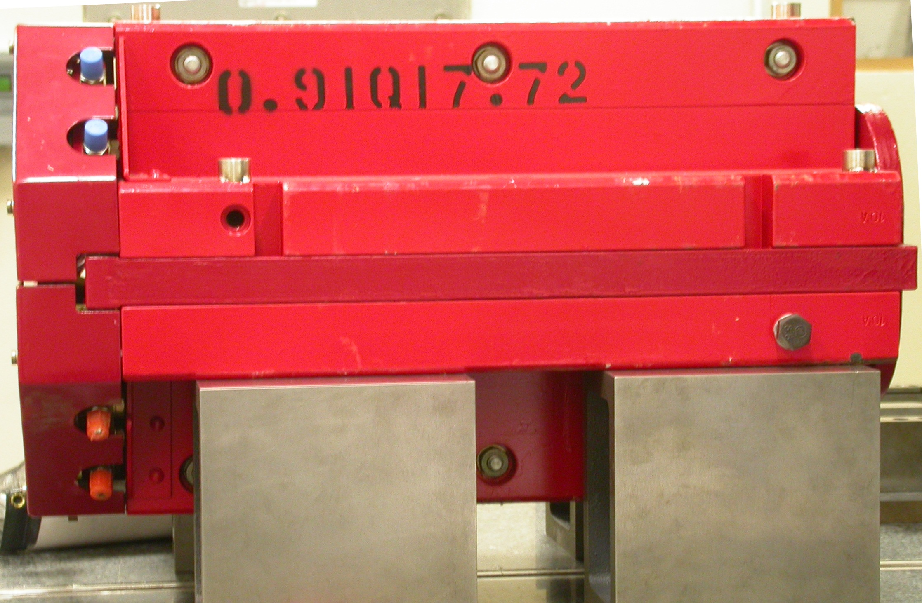  +Z  +Y  Side View

Tooling Ball Measurements/Locations

Top of magnet; view from “+Y”
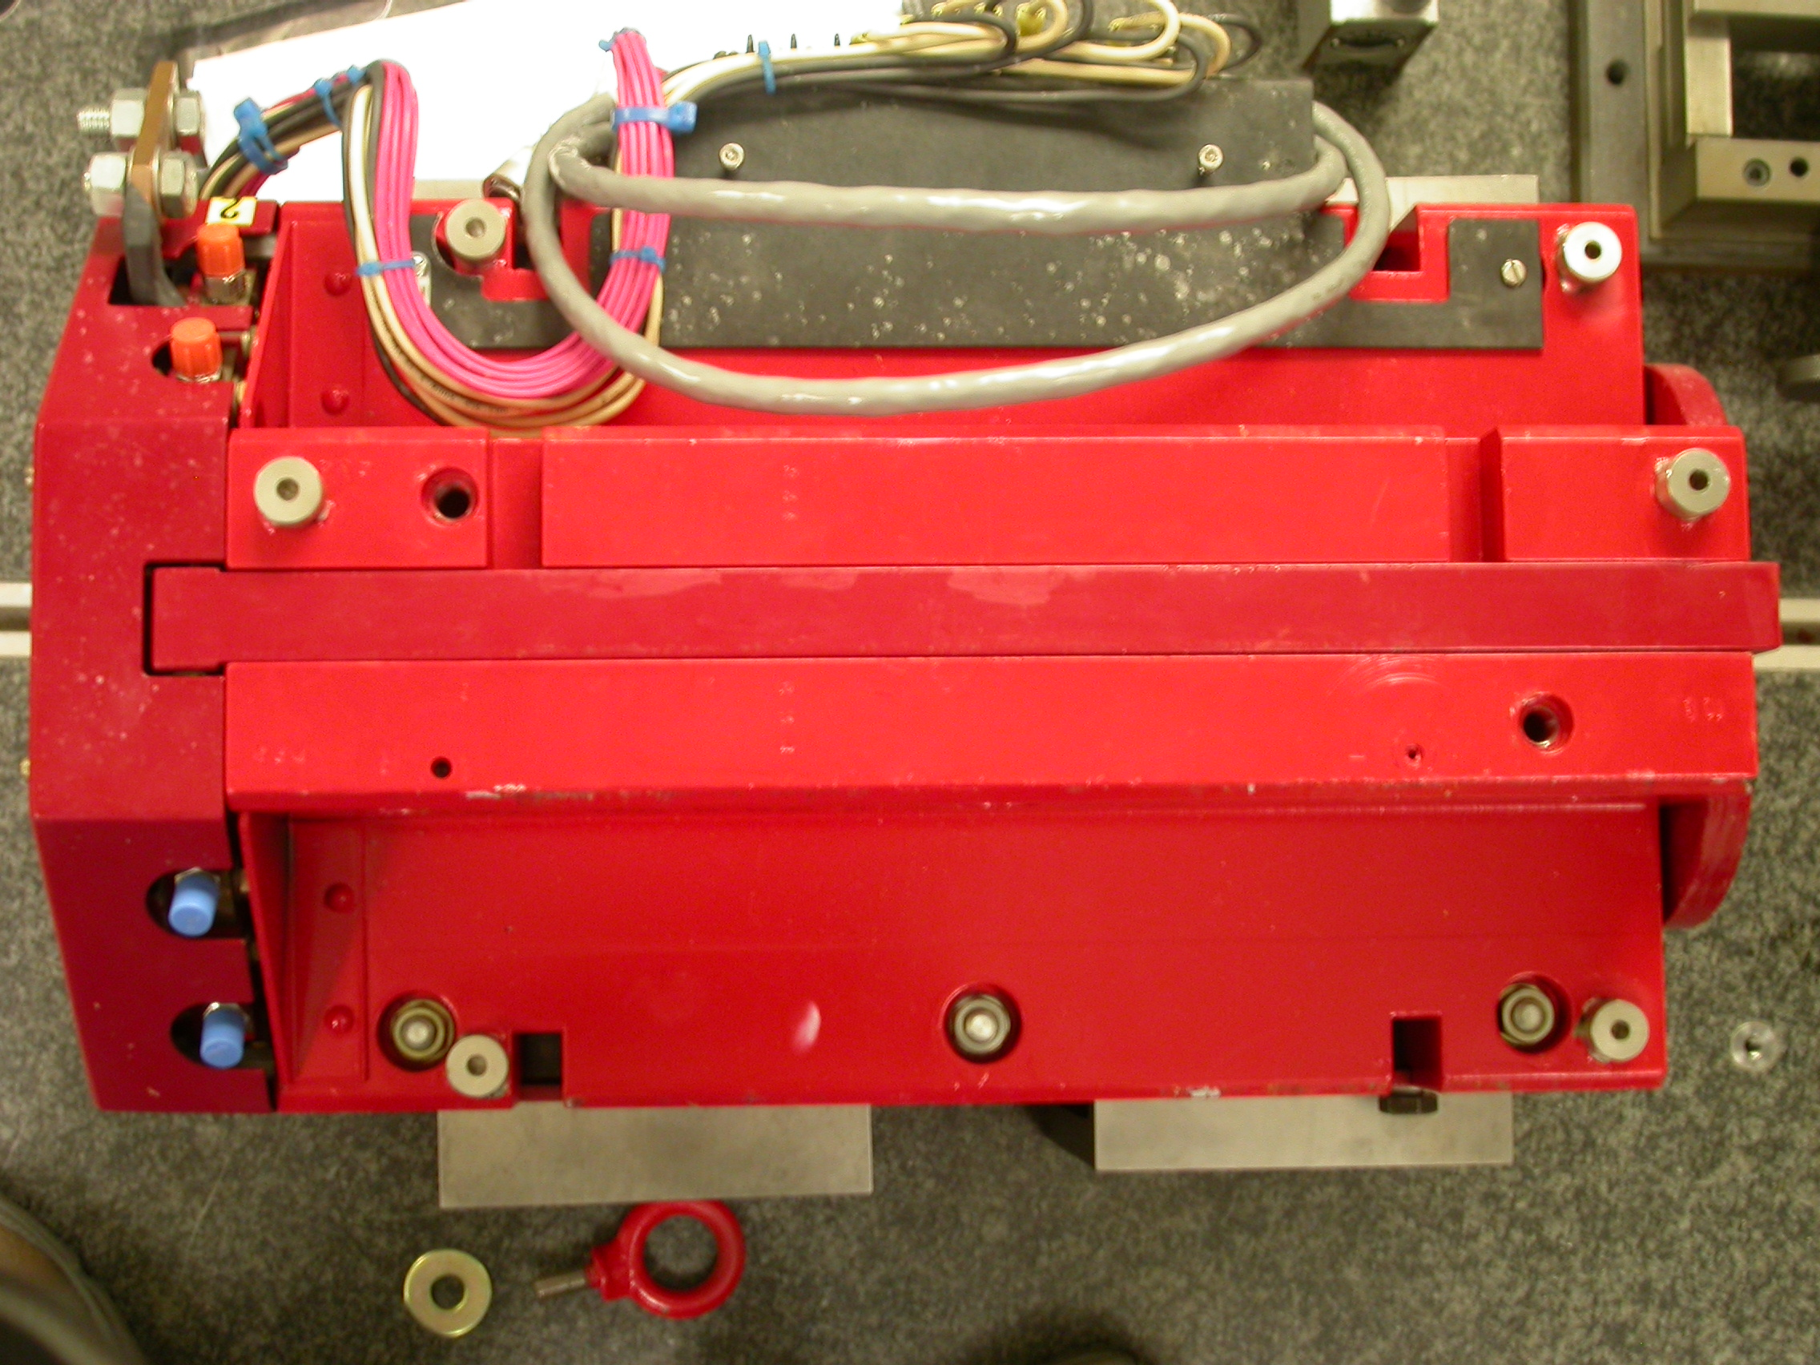

+Z

+X

Tooling Ball | FORM | DIAMETER | X | Y | Z
TB A | 0.00049 | 0.49742 | 5.02439 | 3.68602 | -8.02600
TB B | 0.00027 | 0.49917 | -1.37446 | 7.31248 | -8.04031
TB C | 0.00029 | 0.49654 | -5.00869 | 3.70381 | -8.04784
TB D | 0.00034 | 0.49719 | -5.19244 | 3.70506 | 6.28542
TB E | 0.00048 | 0.49641 | -1.37494 | 7.31544 | 8.05437
TB F | 0.00047 | 0.49737 | 5.28481 | 3.68511 | 6.31020
.

Pole Distances
C
D
Pole | -Z side | +Z side | Δ
A-C | 0.90744 | 0.90775 | 0.00031
B-D | 0.90545 | 0.90622 | 0.00077
A
B

