
LCLS ‘0.91Q17.72’ LTU Quadrupole Magnet
FIDUCIALIZATION REPORT

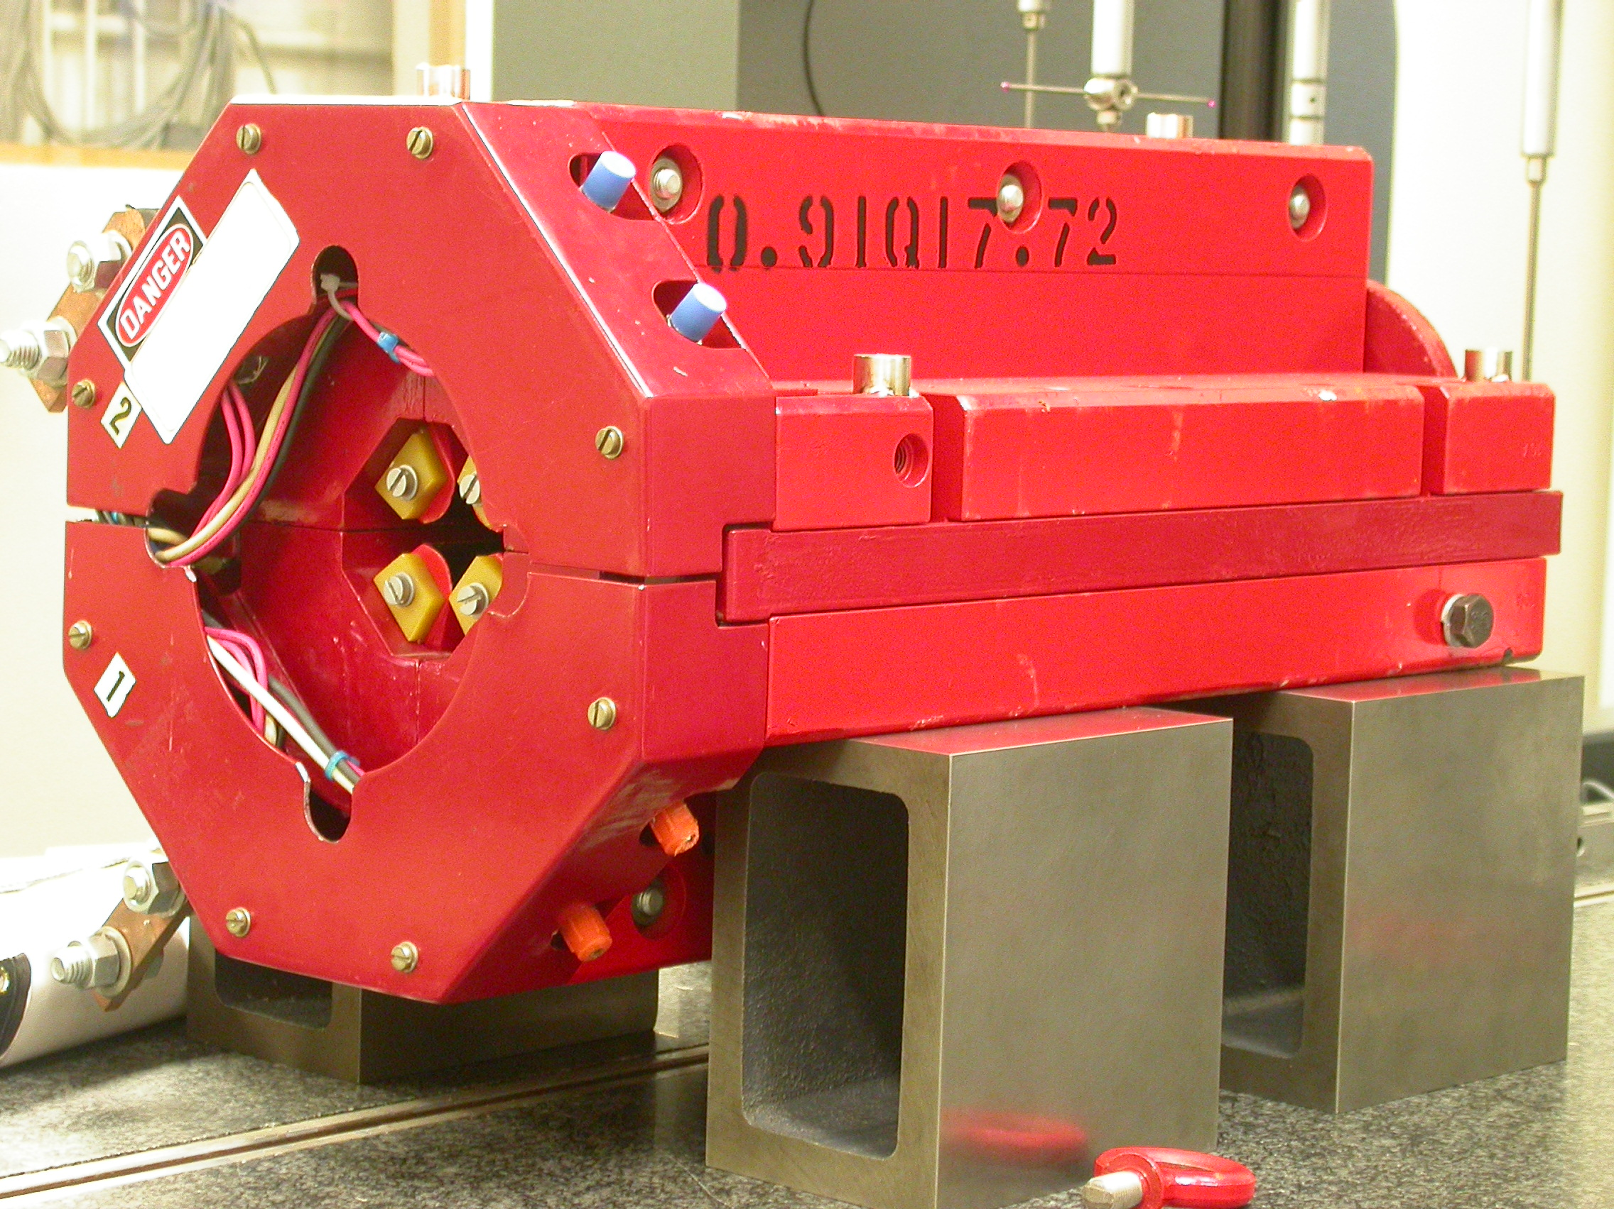

Inspector: | Keith Caban
Responsible Engineer: | Carl Rago
Date: | Friday, February 23, 2007
Work Order/Charge No.: | 21699-1
Serial Number: | 000224
URL of Fiducial Report: | \\Web002\www-group\met\Quality\FIDUCIAL REPORTS\LCLS LTU QUAD\000224.pdf

Part Set-up – Coordinate System Set-up

Spatial Alignment

- Geometric axis of the poles of the magnet.

Planar Alignment

- Clocking plane where TB A,C, D, & E reside.

“Z” Zero

- Mid-plane of the magnet (pole planes on each end).

“X” & “Y” Zero

- Geometric axis of the poles of the magnet.

  +X  +Y  Front View | 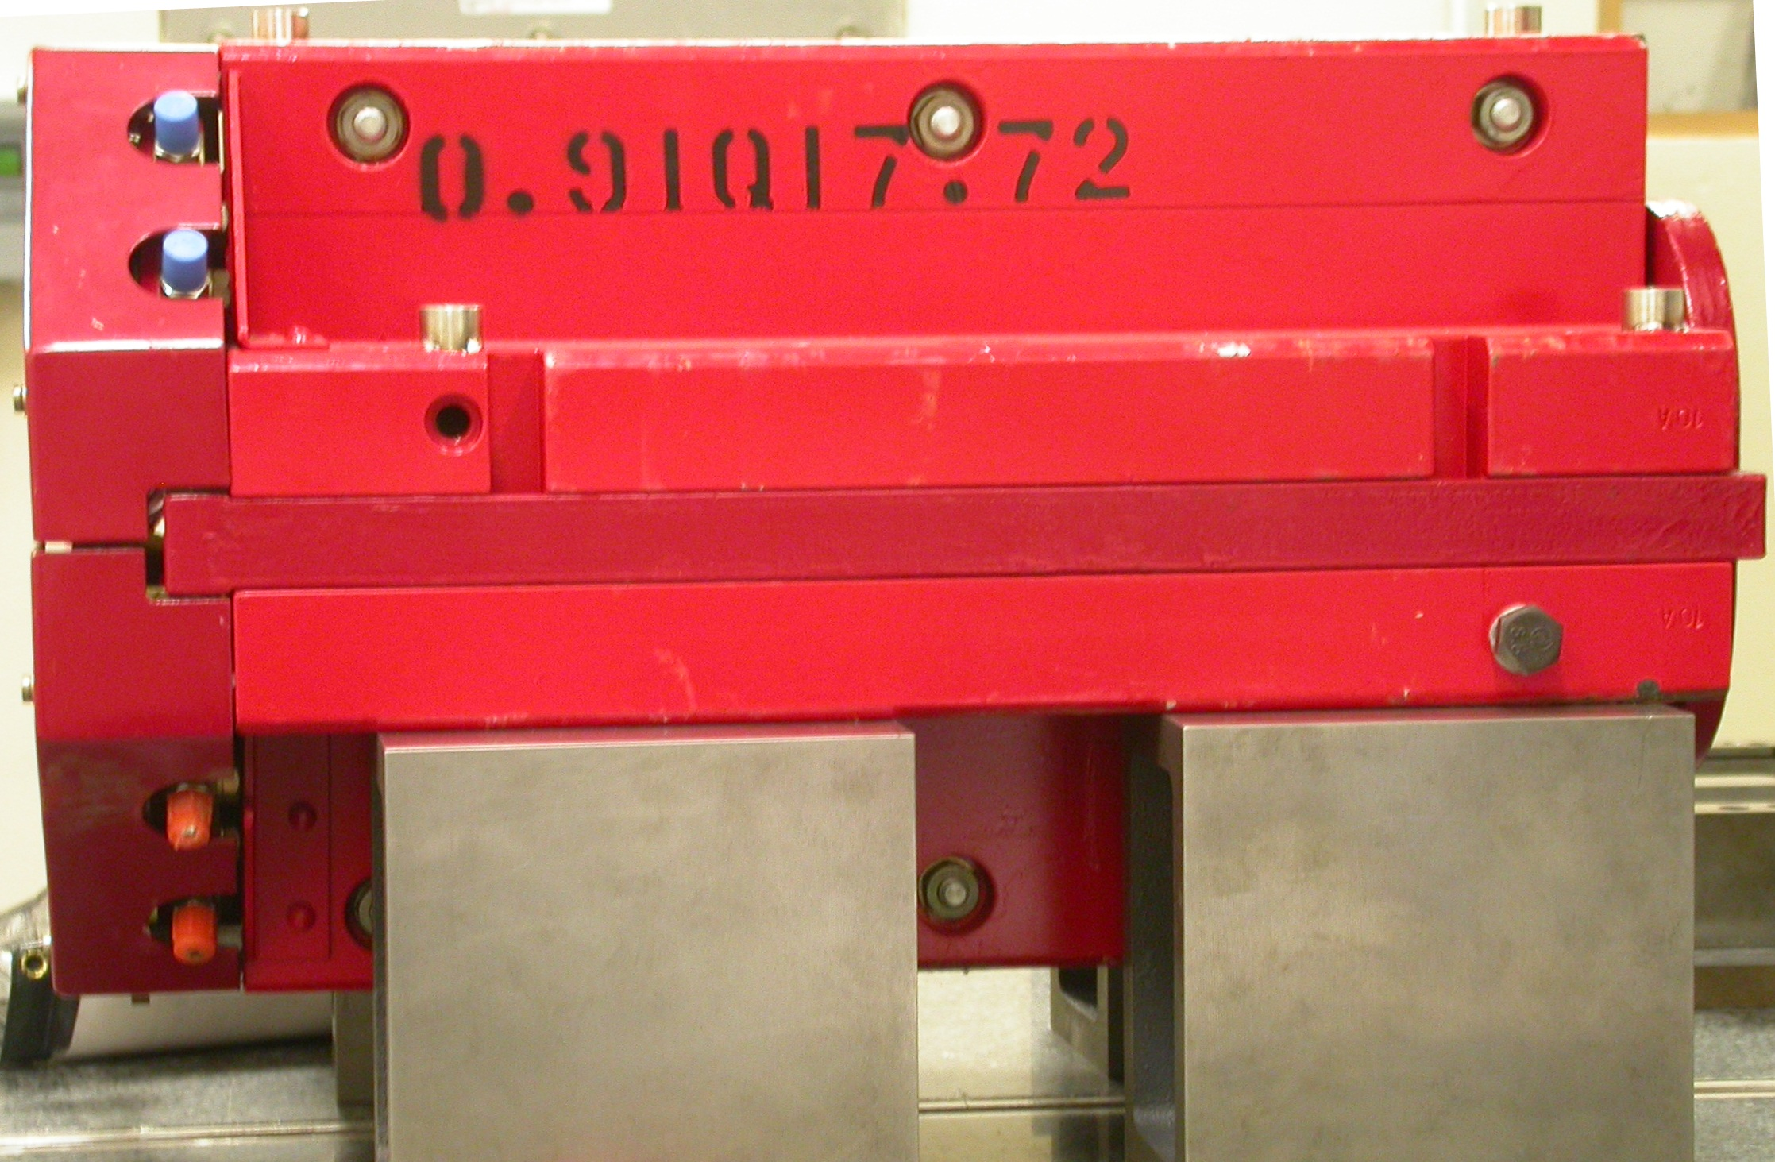  +Z  +Y  Side View

Tooling Ball Measurements/Locations

Top of magnet; view from “+Y”
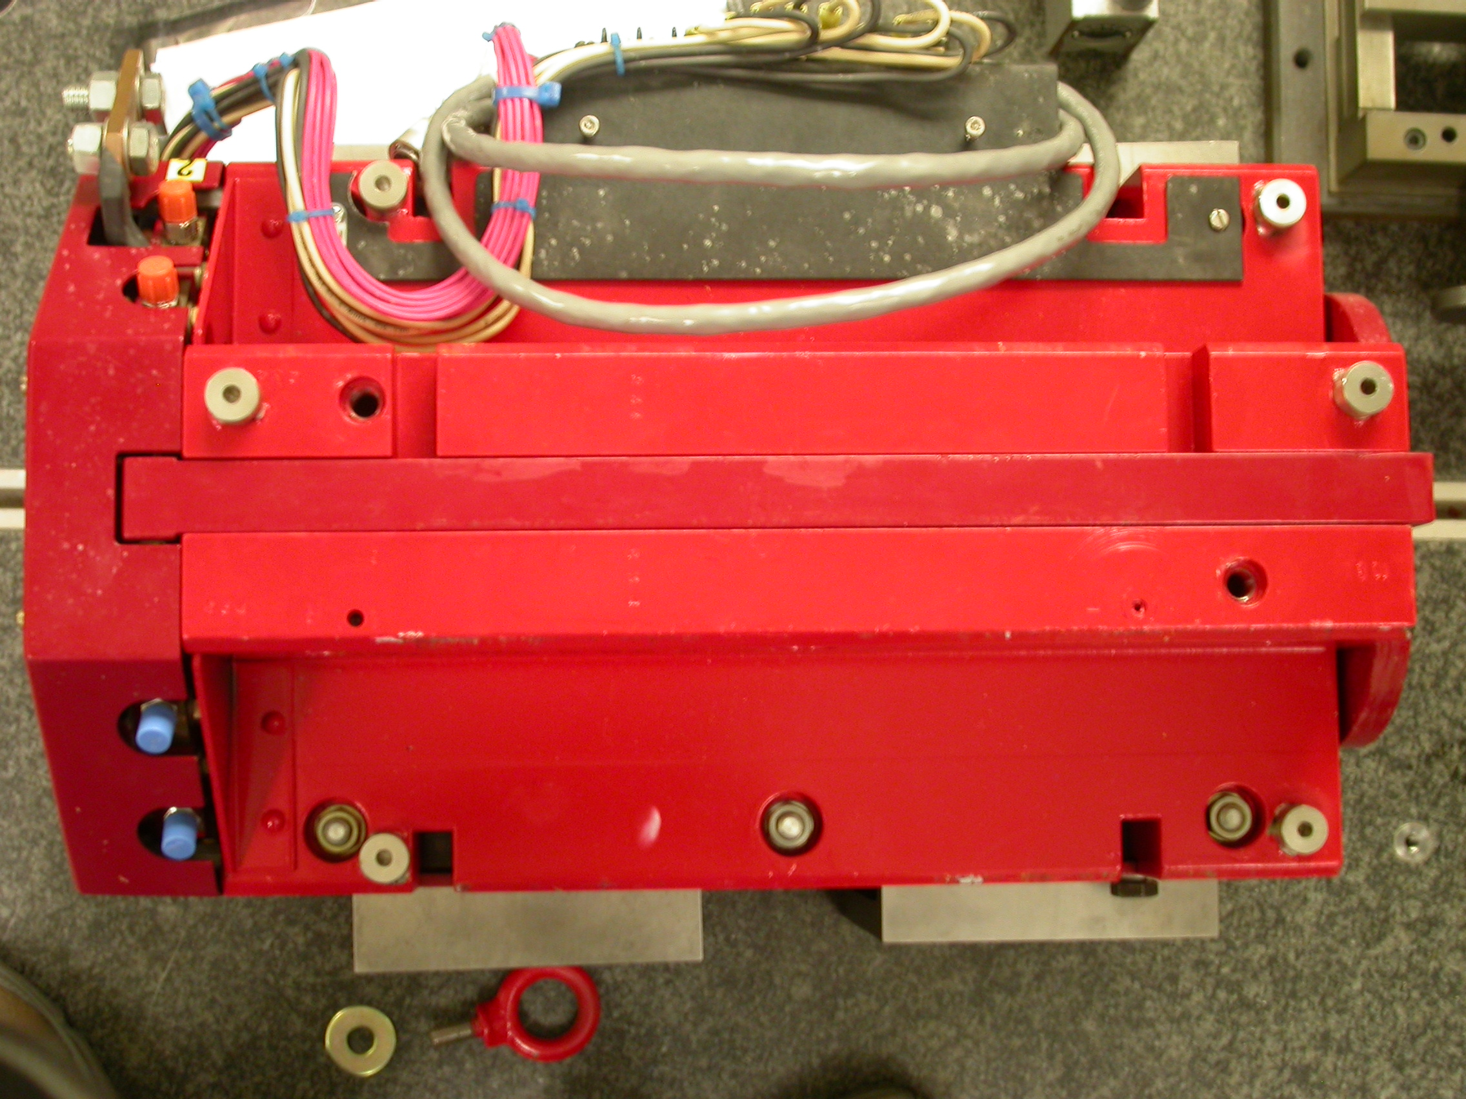

+Z

+X

Tooling Ball | FORM | DIAMETER | X | Y | Z
TB A | 0.00075 | 0.49795 | 5.01858 | 3.69907 | -8.05430
TB B | 0.00038 | 0.49899 | -1.43032 | 7.31203 | -8.03075
TB C | 0.00014 | 0.49787 | -5.00935 | 3.70064 | -8.02983
TB D | 0.00031 | 0.49900 | -5.20288 | 3.69879 | 6.27695
TB E | 0.00023 | 0.49928 | -1.41740 | 7.31151 | 8.06072
TB F | 0.00012 | 0.49722 | 5.25594 | 3.69857 | 6.26839
.

Pole Distances
C
D
Pole | -Z side | +Z side | Δ
A-C | 0.90626 | 0.90598 | 0.00028
B-D | 0.90738 | 0.90776 | 0.00042
A
B

