
LCLS ‘Q150kG’ LTU QUADRUPOLE MAGNET
FIDUCIALIZATION REPORT

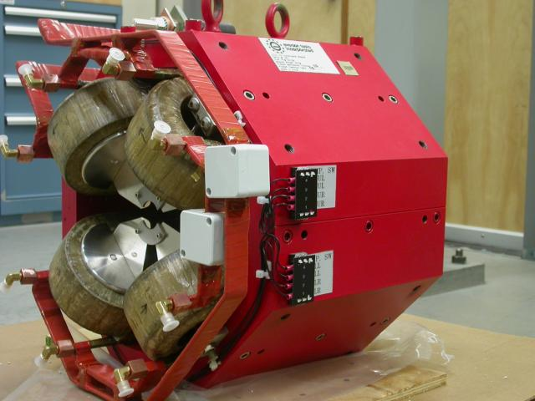

Inspector: | Keith Caban
Responsible Engineer: | Carl Rago
Date: | Monday, January 14, 2008
Work Order/Charge No.: | 9242609
Serial Number: | SLAC – 002884 / SN 013
URL of Fiducial Report: | \\Web002\www-group\met\Quality\FIDUCIAL REPORTS\LCLS LTU Q150kG QUADS\002884.pdf

Part Set-up – Coordinate System Set-up

Spatial Alignment

- Geometric axis of the poles of the magnet.

Planar Alignment

- Plane on top of magnet where tooling ball sockets are welded to.

“Z” Zero

- Mid-plane of the magnet (middle of upstream and downstream ends).

“X” & “Y” Zero

- Geometric axis of the poles of the magnet.

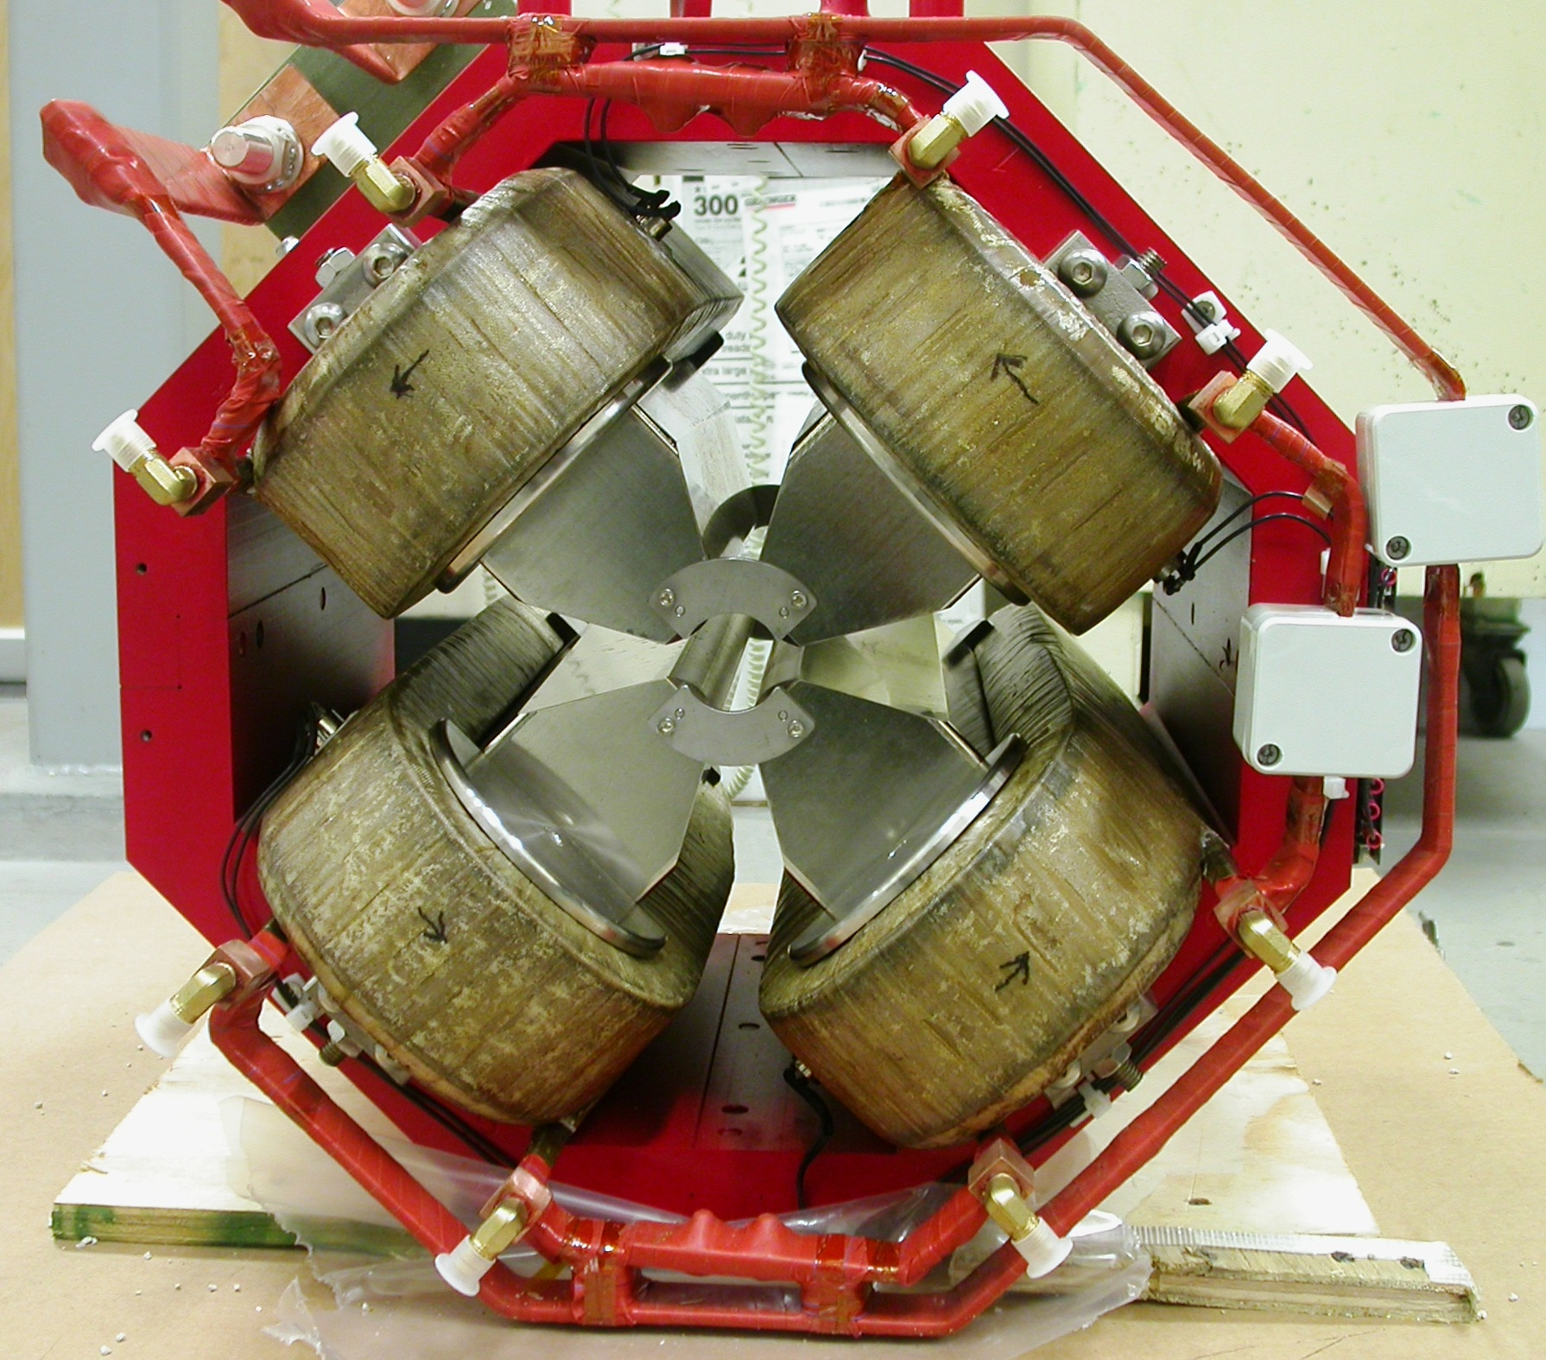  +X  +Y  Front View | 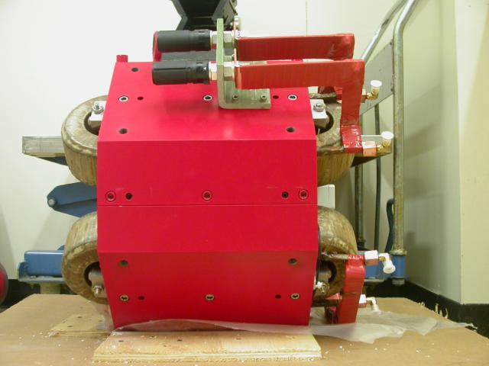  +Z  +Y  Side View

Tooling Ball Measurements/Locations

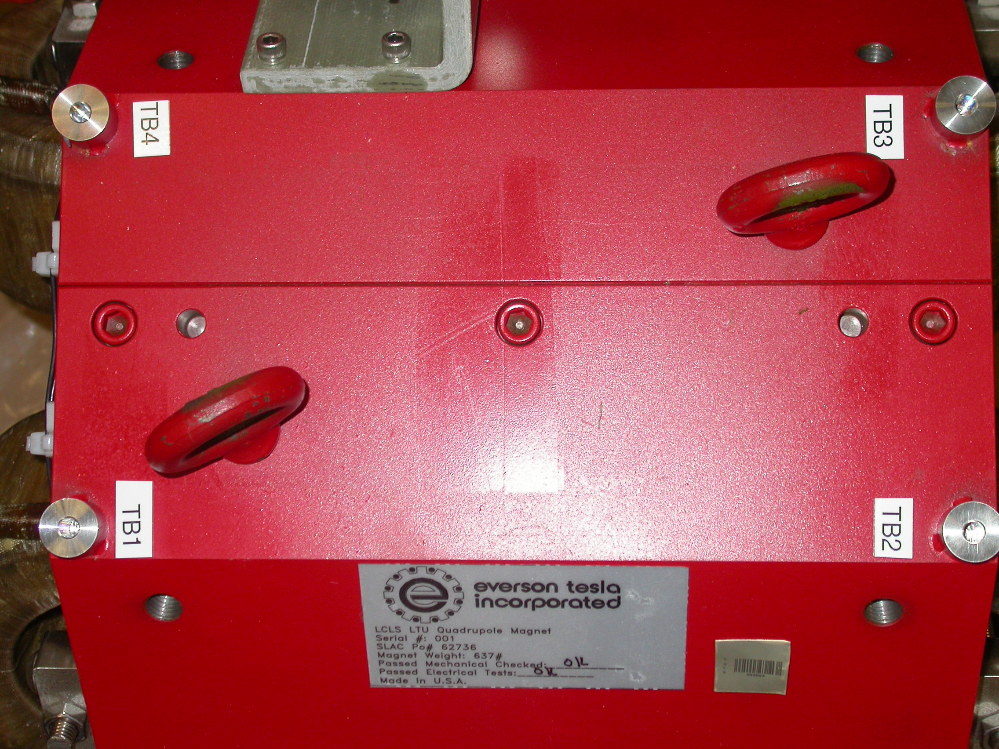
+X
+Z

Tooling Ball Adapter Cylinder Projected 1” Offset to the Tooling Ball Adapter Plane

Tooling Ball | Form | Cyl. Dia. | X | Y | Z | b
Proj. TB 1 | 0.00015 | 0.24993 | 2.65333 | 10.21230 | 5.60647 | 0.00005
Proj. TB 2 | 0.00010 | 0.24999 | 2.65627 | 10.20818 | -5.60955 | 0.00013
Proj. TB 3 | 0.00007 | 0.25002 | -2.65266 | 10.20664 | -5.61167 | 0.00092
Proj. TB 4 | 0.00014 | 0.25013 | -2.66078 | 10.20919 | 5.60349 | 0.00011

.
Pole Data
*Data looking from Downstream End



Side | Pole Dist A-C | Pole Dist B-D | Gap 1 | Gap 2 | Gap 3 | Gap 4
Downstream End (+Z) | 1.26146 | 1.25932 | 0.43064 | 0.44007 | 0.43106 | 0.43409
Upstream End (-Z) | 1.26165 | 1.25914 | 0.42998 | 0.44206 | 0.43366 | 0.43733

