
LCLS ‘Q150kG’ LTU QUADRUPOLE MAGNET
FIDUCIALIZATION REPORT

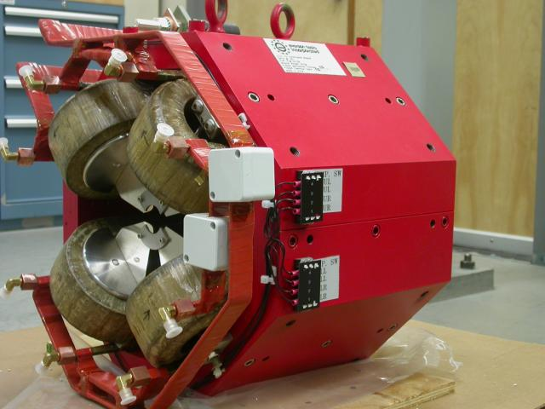

Inspector: | Keith Caban
Responsible Engineer: | Carl Rago
Date: | Friday, August 31, 2007
Work Order/Charge No.: | 9242609
Serial Number: | SLAC – 002883 / SN 001
URL of Fiducial Report: | \\Web002\www-group\met\Quality\FIDUCIAL REPORTS\LCLS LTU Q150kG QUADS\002883.pdf

Part Set-up – Coordinate System Set-up

Spatial Alignment

- Geometric axis of the poles of the magnet.

Planar Alignment

- Plane on top of magnet where tooling ball sockets are welded to.

“Z” Zero

- Mid-plane of the magnet (middle of upstream and downstream ends).

“X” & “Y” Zero

- Geometric axis of the poles of the magnet.

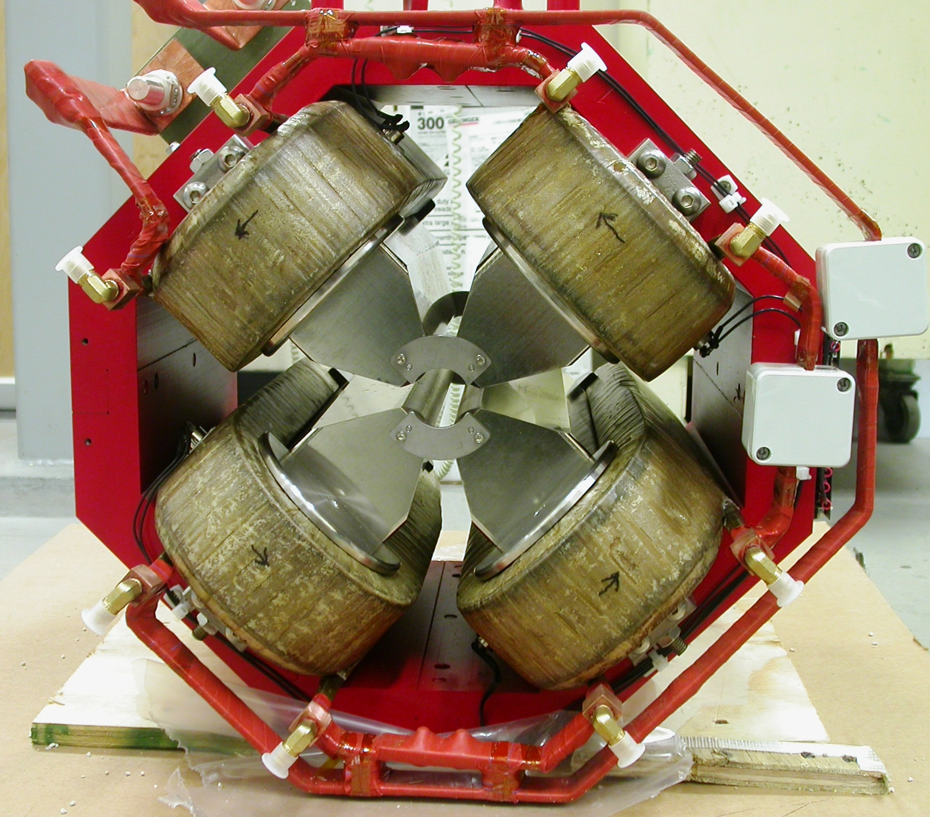  +X  +Y  Front View | 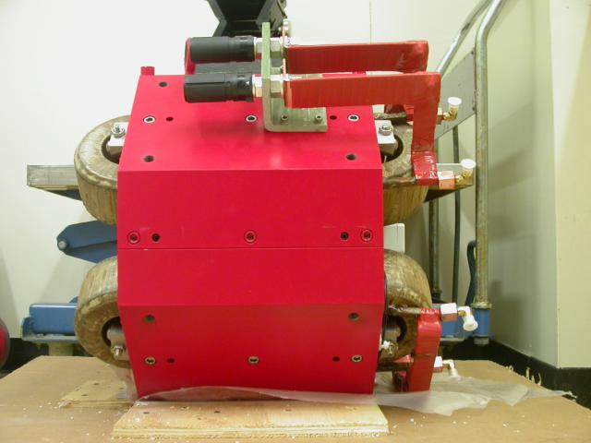  +Z  +Y  Side View

Tooling Ball Measurements/Locations

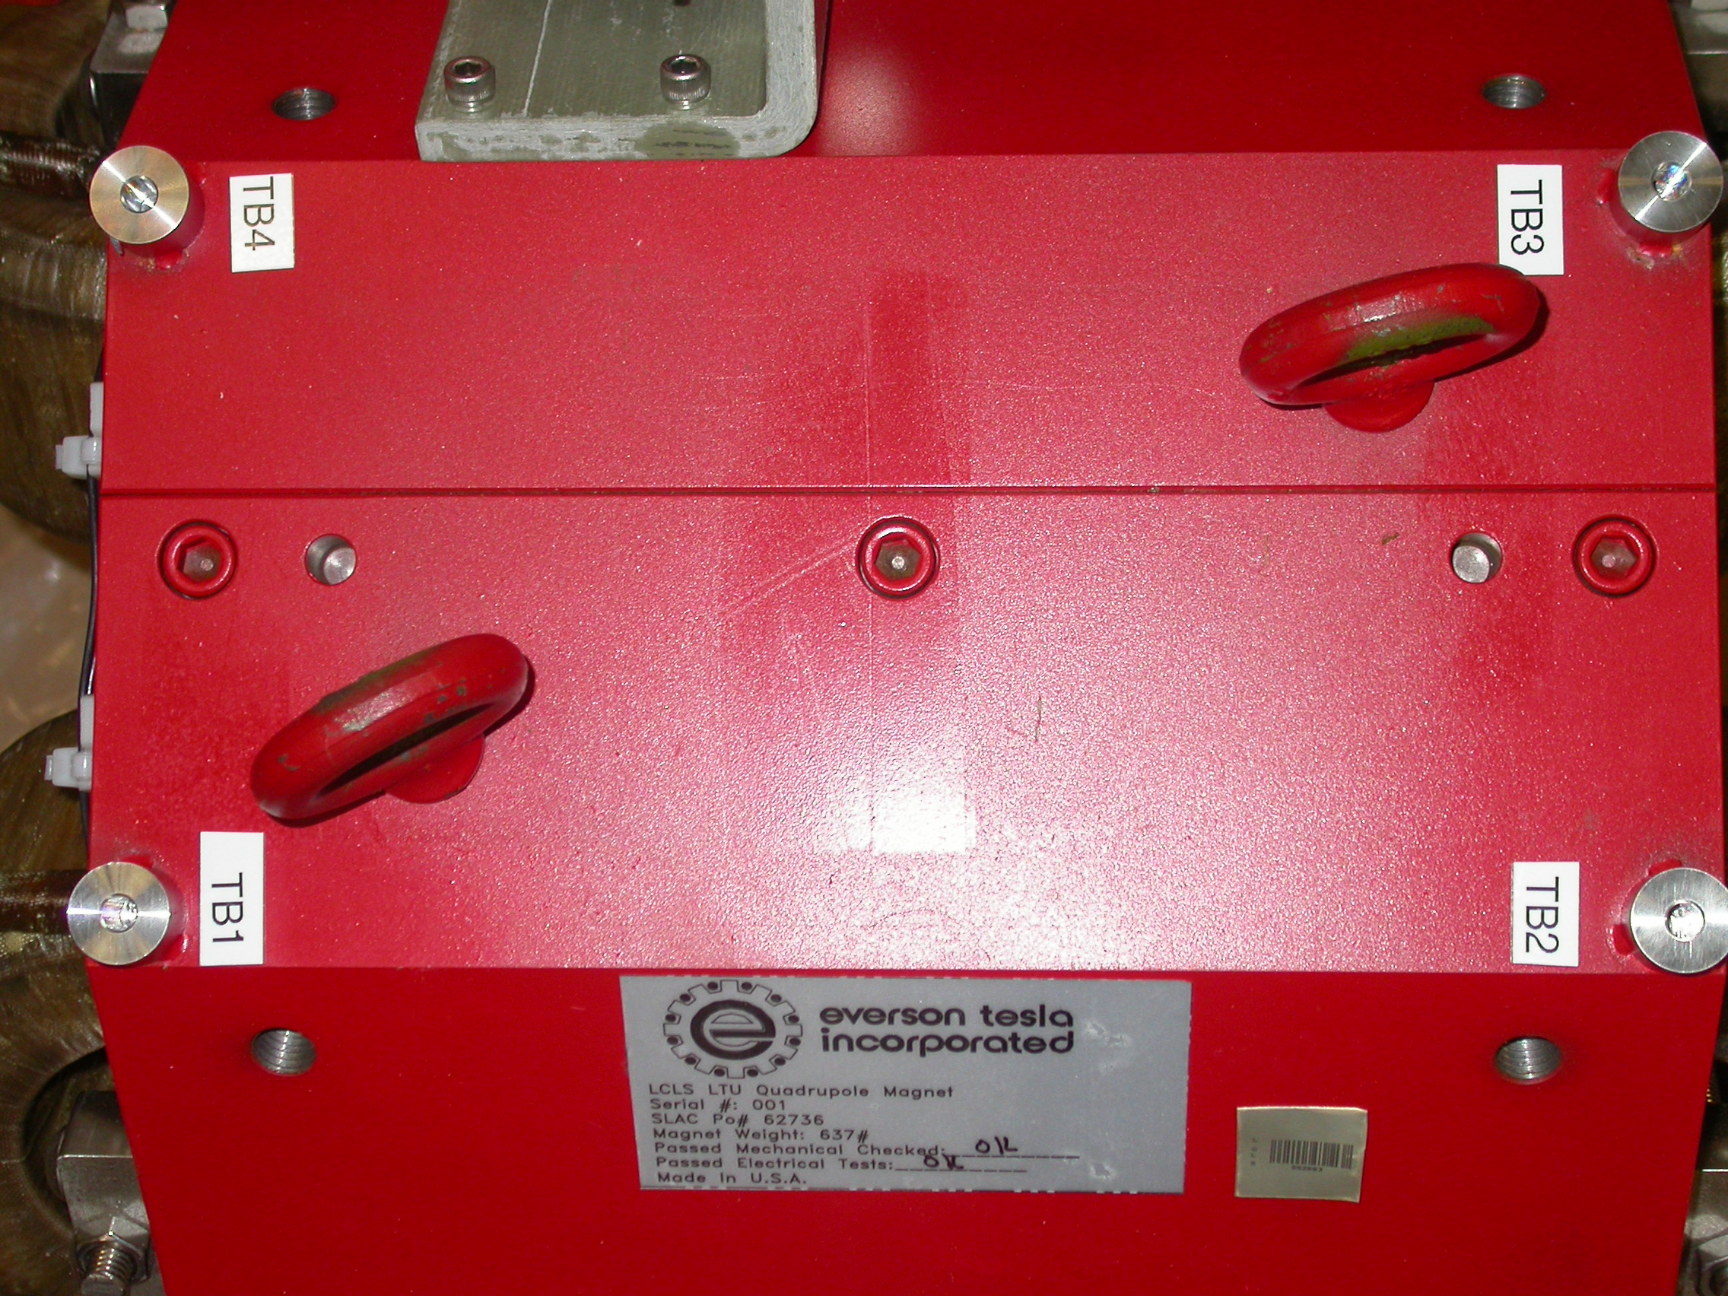
+X
+Z

Tooling Balls Measured with ½” Tooling Ball Socket

Tooling Ball | FORM | Sph. Dia. | X | Y | Z
TB 1 | 0.00039 | 0.49815 | 2.64678 | 10.20691 | 5.61076
TB 2 | 0.00017 | 0.49925 | 2.64939 | 10.20316 | -5.60822
TB 3 | 0.00042 | 0.49866 | -2.67355 | 10.20241 | -5.61104
TB 4 | 0.00032 | 0.49742 | -2.67314 | 10.20636 | 5.60569

Tooling Ball Adapter Cylinder Projected 1” Offset to the Tooling Ball Adapter Plane

Tooling Ball | Cyl. Dia. | X | Y | Z
Proj. TB 1 | 0.25004 | 2.64571 | 10.20597 | 5.61020
Proj. TB 2 | 0.24995 | 2.65028 | 10.20249 | -5.60908
Proj. TB 3 | 0.25006 | -2.67258 | 10.20174 | -5.61180
Proj. TB 4 | 0.25011 | -2.67289 | 10.20496 | 5.60672

.
Pole Data
*Data looking from Downstream End



Side | Pole Diameter | Pole Dist A-C | Pole Dist B-D | Gap 1 | Gap 2 | Gap 3 | Gap 4
Downstream End (+Z) | 1.25905 | 1.25900 | 1.25936 | 0.43818 | 0.43105 | 0.43693 | 0.43453
Upstream End (-Z) | 1.25826 | 1.25820 | 1.25830 | 0.43858 | 0.42942 | 0.43517 | 0.43238

