
LCLS ‘Q150kG’ LTU QUADRUPOLE MAGNET
FIDUCIALIZATION REPORT

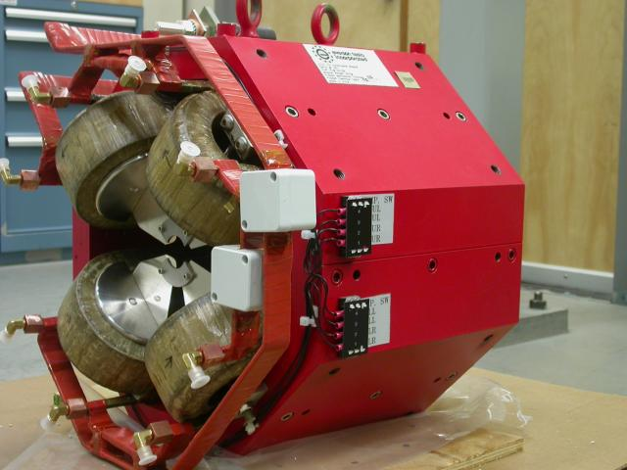

Inspector: | Keith Caban
Responsible Engineer: | Carl Rago
Date: | Tuesday, January 15, 2008
Work Order/Charge No.: | 9242609
Serial Number: | SLAC – 002614 / SN 007
URL of Fiducial Report: | \\Web002\www-group\met\Quality\FIDUCIAL REPORTS\LCLS LTU Q150kG QUADS\002614.pdf

Part Set-up – Coordinate System Set-up

Spatial Alignment

- Geometric axis of the poles of the magnet.

Planar Alignment

- Plane on top of magnet where tooling ball sockets are welded to.

“Z” Zero

- Mid-plane of the magnet (middle of upstream and downstream ends).

“X” & “Y” Zero

- Geometric axis of the poles of the magnet.

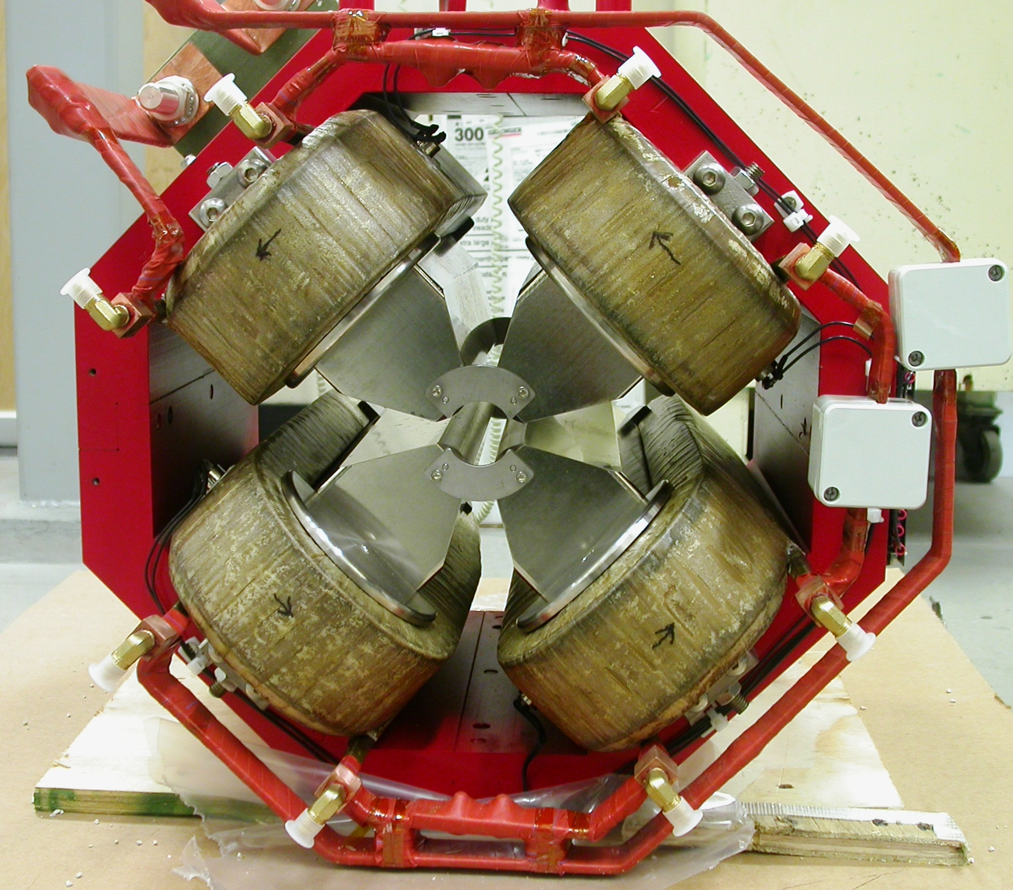  +X  +Y  Front View | 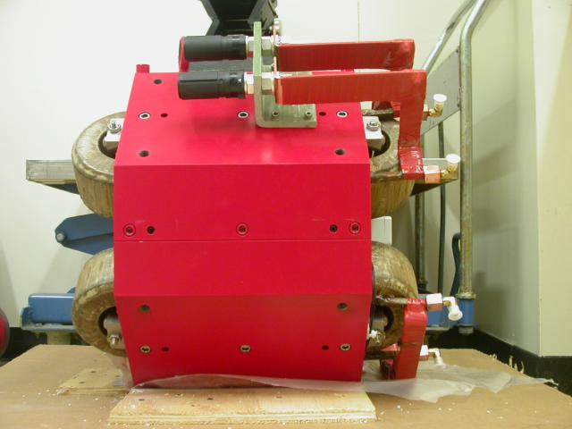  +Z  +Y  Side View

Tooling Ball Measurements/Locations

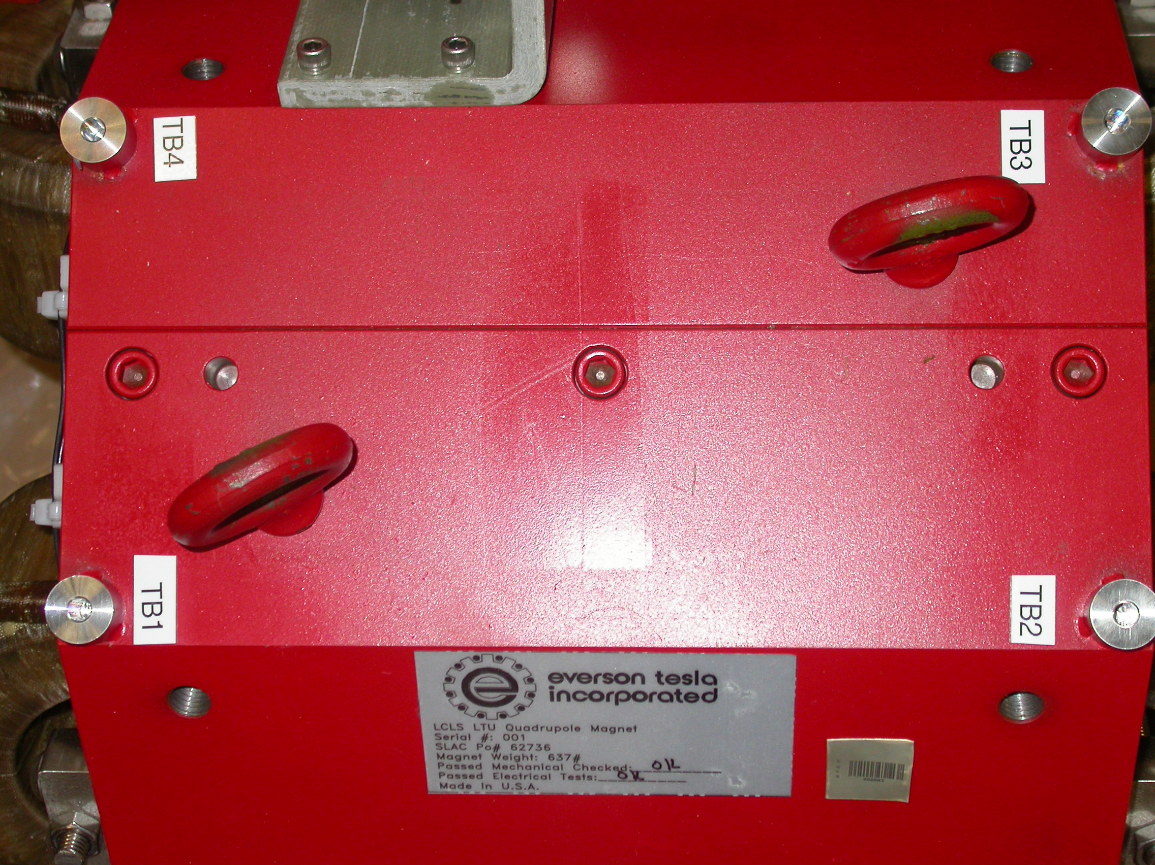
+X
+Z

Tooling Ball Adapter Cylinder Projected 1” Offset to the Tooling Ball Adapter Plane

Tooling Ball | Form | Cyl. Dia. | X | Y | Z | b
Proj. TB 1 | 0.00012 | 0.24988 | 2.66059 | 10.21379 | 5.60697 | 0.00053
Proj. TB 2 | 0.00011 | 0.24999 | 2.65060 | 10.20905 | -5.60846 | 0.00008
Proj. TB 3 | 0.00010 | 0.25005 | -2.64416 | 10.21021 | -5.61097 | 0.00013
Proj. TB 4 | 0.00011 | 0.25001 | -2.63661 | 10.21548 | 5.60174 | 0.00009

.
Pole Data
*Data looking from Downstream End



Side | Pole Dist A-C | Pole Dist B-D | Gap 1 | Gap 2 | Gap 3 | Gap 4
Downstream End (+Z) | 1.25952 | 1.25982 | 0.43480 | 0.43041 | 0.43458 | 0.43502
Upstream End (-Z) | 1.26001 | 1.25963 | 0.43461 | 0.43069 | 0.43569 | 0.43418

