
LCLS ‘Q150kG’ LTU QUADRUPOLE MAGNET
FIDUCIALIZATION REPORT

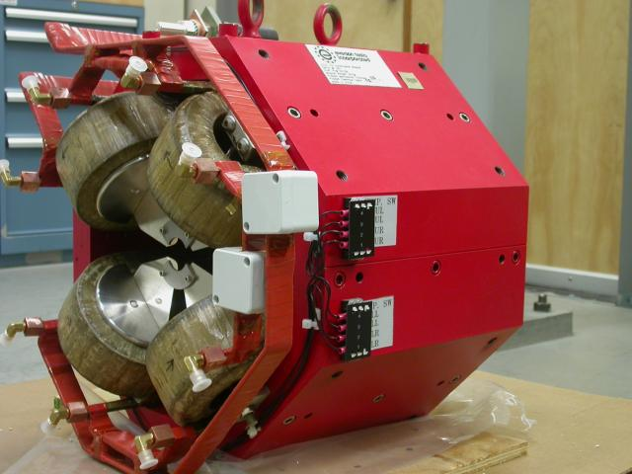

Inspector: | Keith Caban
Responsible Engineer: | Carl Rago
Date: | Tuesday, October 16, 2007
Work Order/Charge No.: | 9242609
Serial Number: | SLAC – 002004 / SN 005
URL of Fiducial Report: | \\Web002\www-group\met\Quality\FIDUCIAL REPORTS\LCLS LTU Q150kG QUADS\002004.pdf

Part Set-up – Coordinate System Set-up

Spatial Alignment

- Geometric axis of the poles of the magnet.

Planar Alignment

- Plane on top of magnet where tooling ball sockets are welded to.

“Z” Zero

- Mid-plane of the magnet (middle of upstream and downstream ends).

“X” & “Y” Zero

- Geometric axis of the poles of the magnet.

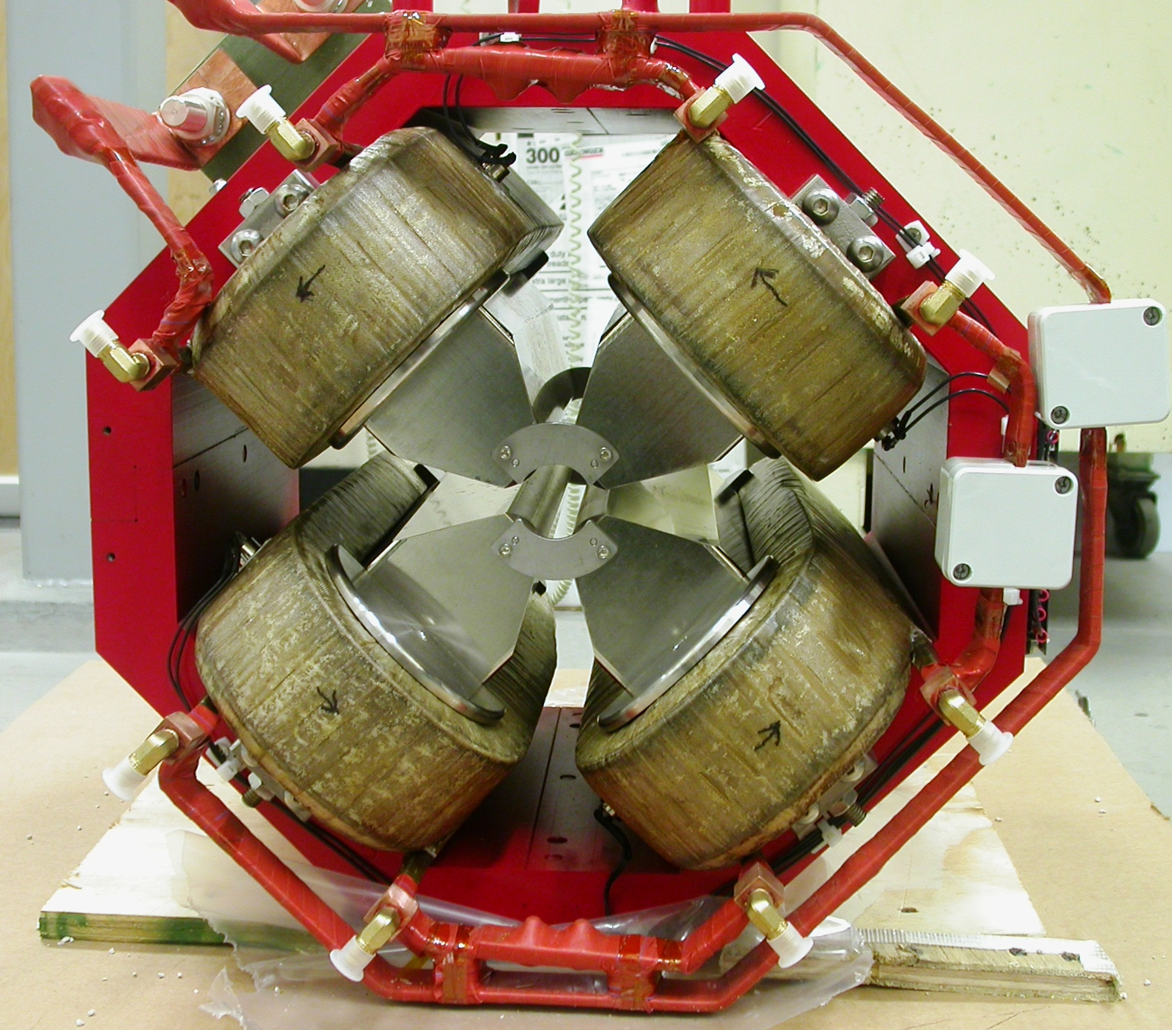  +X  +Y  Front View | 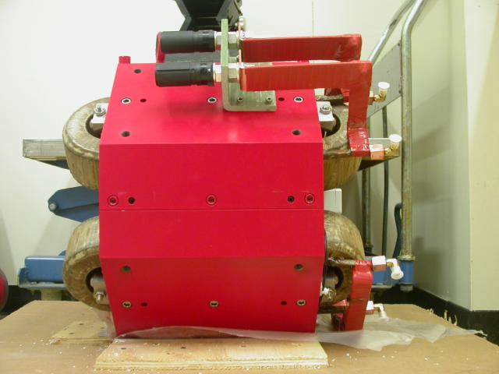  +Z  +Y  Side View

Tooling Ball Measurements/Locations

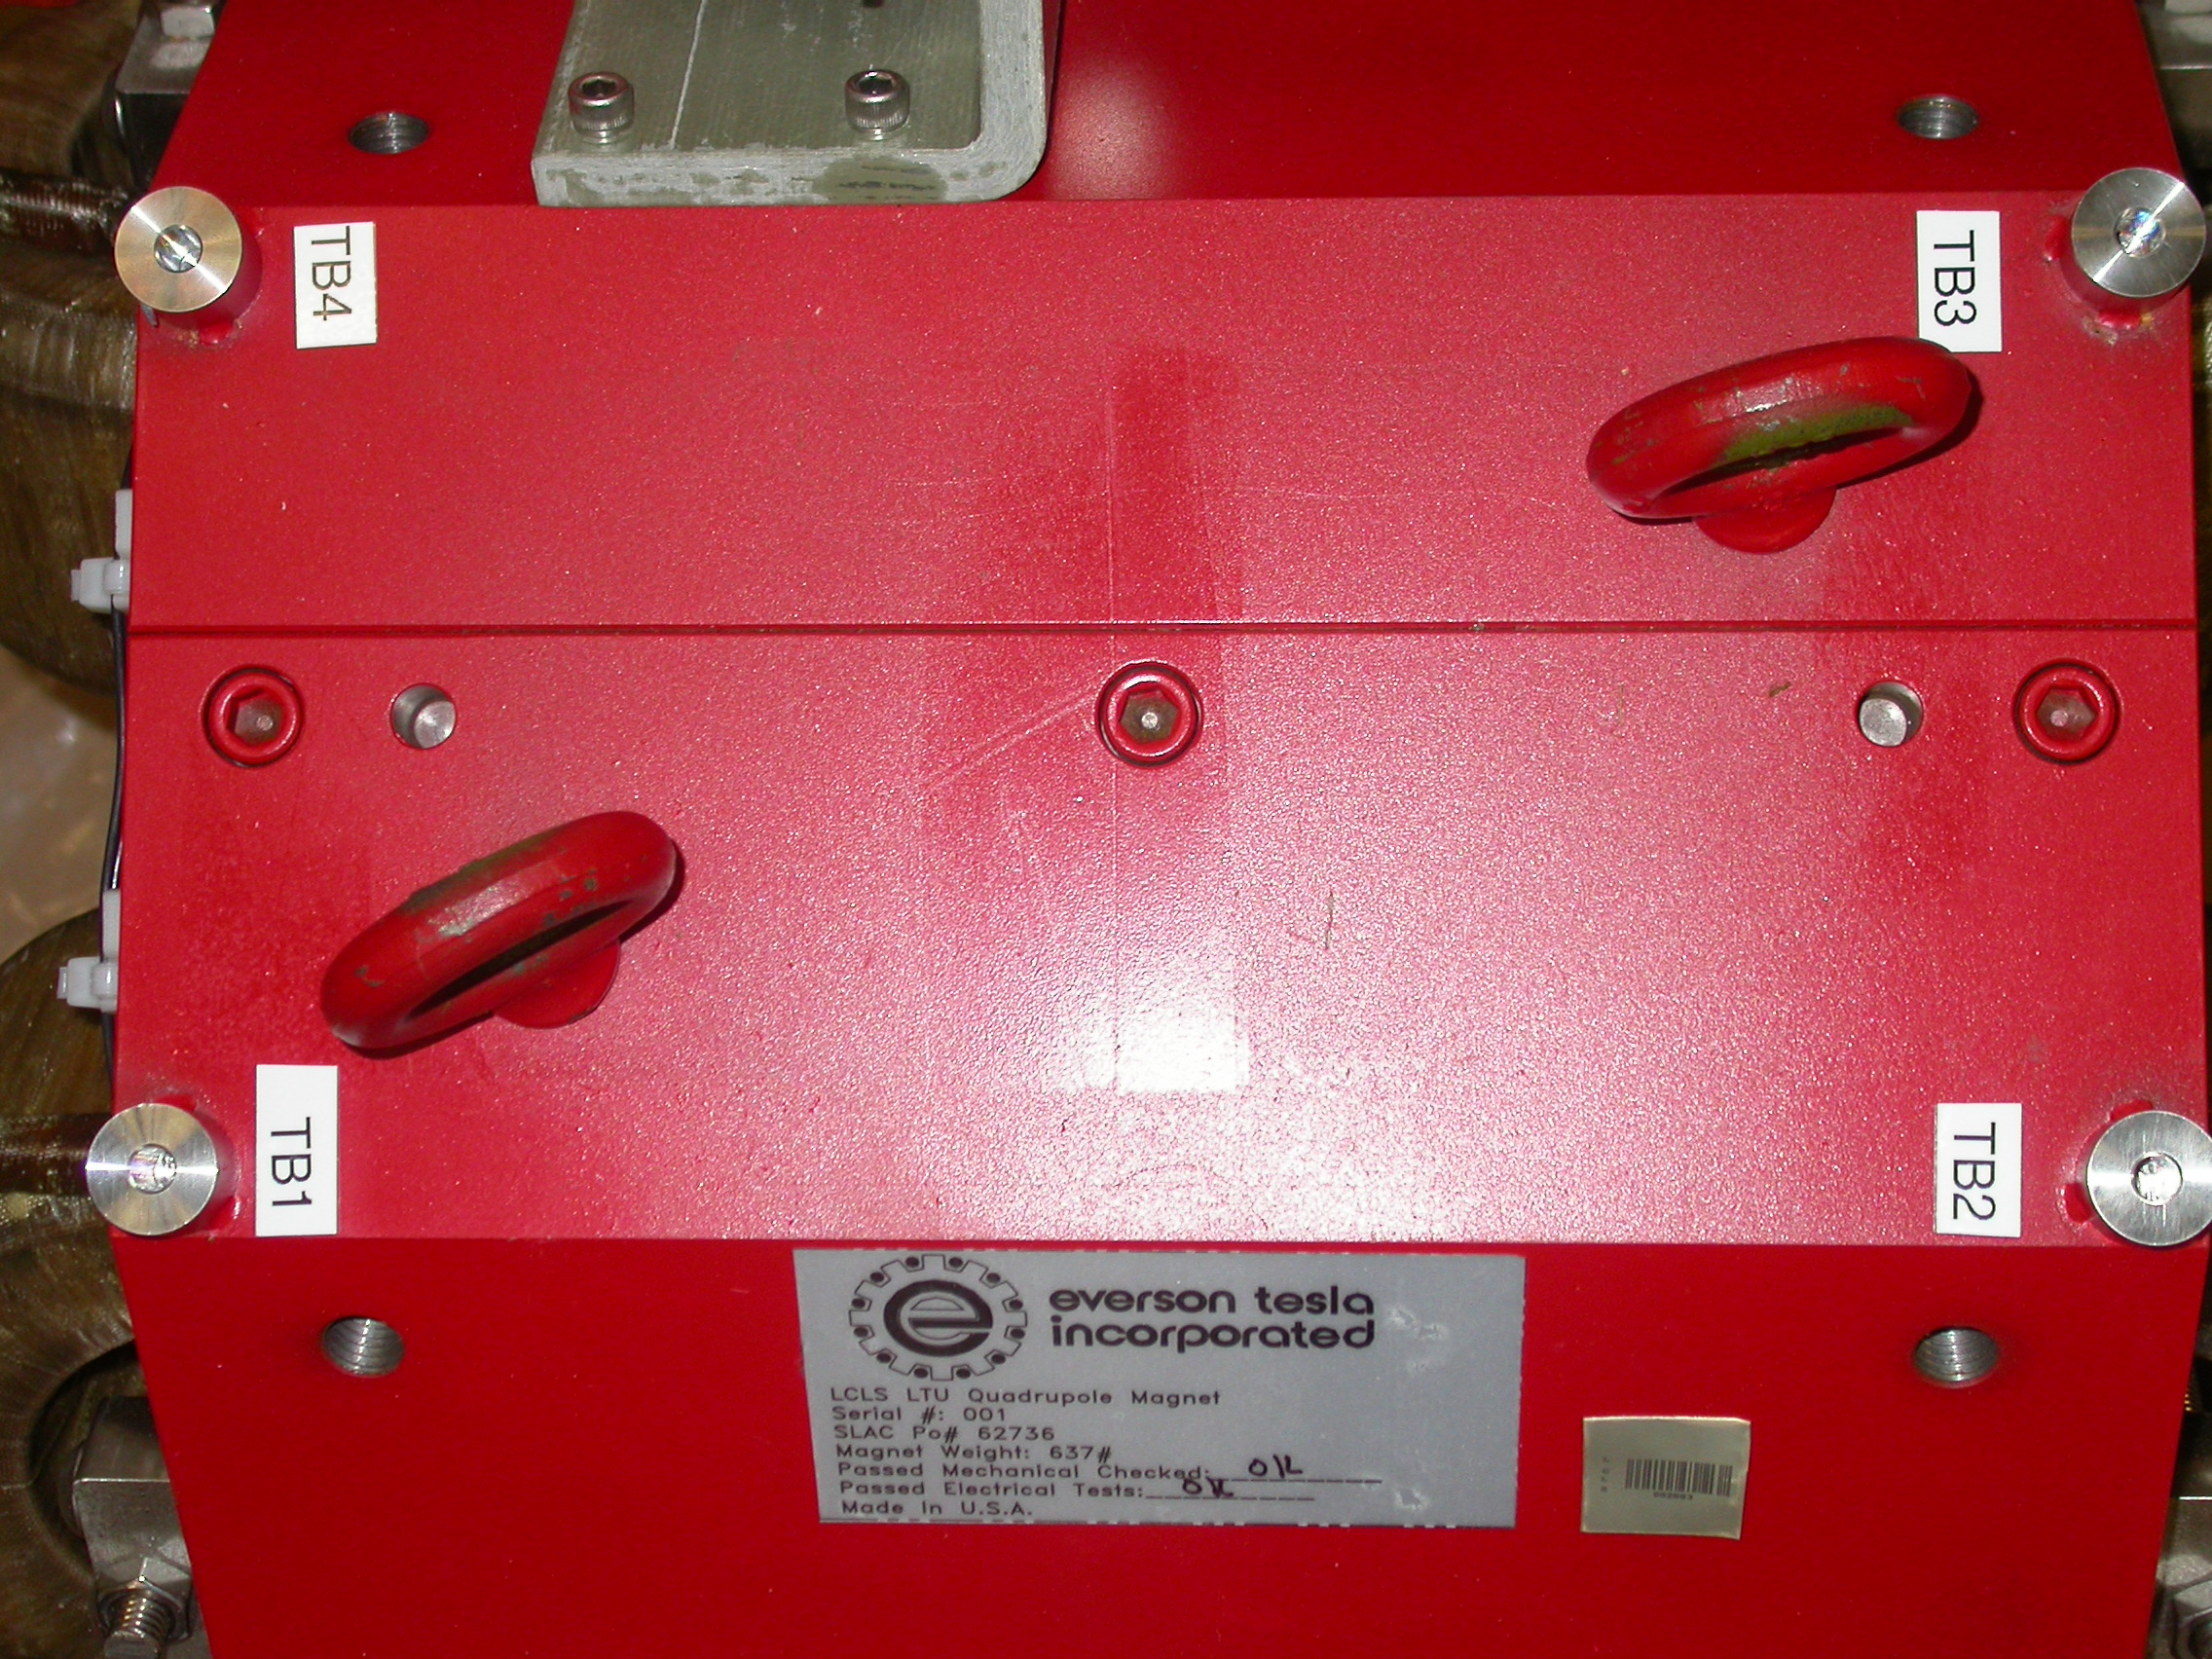
+X
+Z

Tooling Balls Measured with ½” Tooling Ball Socket

Tooling Ball | FORM | Sph. Dia. | X | Y | Z
TB 1 | 0.00015 | 0.49801 | 2.66559 | 10.21700 | 5.60574
TB 2 | 0.00012 | 0.49861 | 2.66495 | 10.21098 | -5.60685
TB 3 | 0.00039 | 0.49785 | -2.64941 | 10.21236 | -5.61032
TB 4 | 0.00021 | 0.49834 | -2.64799 | 10.21721 | 5.60386

Tooling Ball Adapter Cylinder Projected 1” Offset to the Tooling Ball Adapter Plane

Tooling Ball | Cyl. Dia. | X | Y | Z
Proj. TB 1 | 0.25017 | 2.66676 | 10.21576 | 5.60585
Proj. TB 2 | 0.25012 | 2.66584 | 10.20993 | -5.60752
Proj. TB 3 | 0.25029 | -2.64878 | 10.21115 | -5.61140
Proj. TB 4 | 0.25023 | -2.64711 | 10.21619 | 5.60440

.
Pole Data
*Data looking from Downstream End



Side | Pole Diameter | Pole Dist A-C | Pole Dist B-D | Gap 1 | Gap 2 | Gap 3 | Gap 4
Downstream End (+Z) | 1.25806 | 1.25858 | 1.25827 | 0.43538 | 0.43669 | 0.43459 | 0.43128
Upstream End (-Z) | 1.25867 | 1.25749 | 1.25779 | 0.43550 | 0.43551 | 0.43185 | 0.43074

