
LCLS ‘Q150kG’ LTU QUADRUPOLE MAGNET
FIDUCIALIZATION REPORT

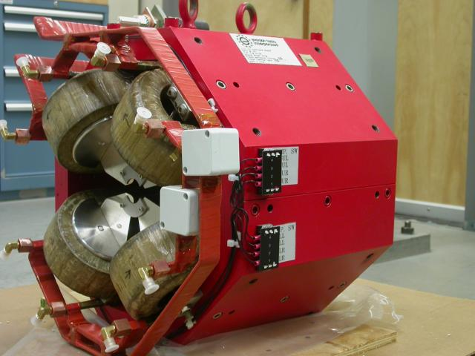

Inspector: | Keith Caban
Responsible Engineer: | Carl Rago
Date: | Wednesday, October 17, 2007
Work Order/Charge No.: | 9242609
Serial Number: | SLAC – 002003 / SN 004
URL of Fiducial Report: | \\Web002\www-group\met\Quality\FIDUCIAL REPORTS\LCLS LTU Q150kG QUADS\002003.pdf

Part Set-up – Coordinate System Set-up

Spatial Alignment

- Geometric axis of the poles of the magnet.

Planar Alignment

- Plane on top of magnet where tooling ball sockets are welded to.

“Z” Zero

- Mid-plane of the magnet (middle of upstream and downstream ends).

“X” & “Y” Zero

- Geometric axis of the poles of the magnet.

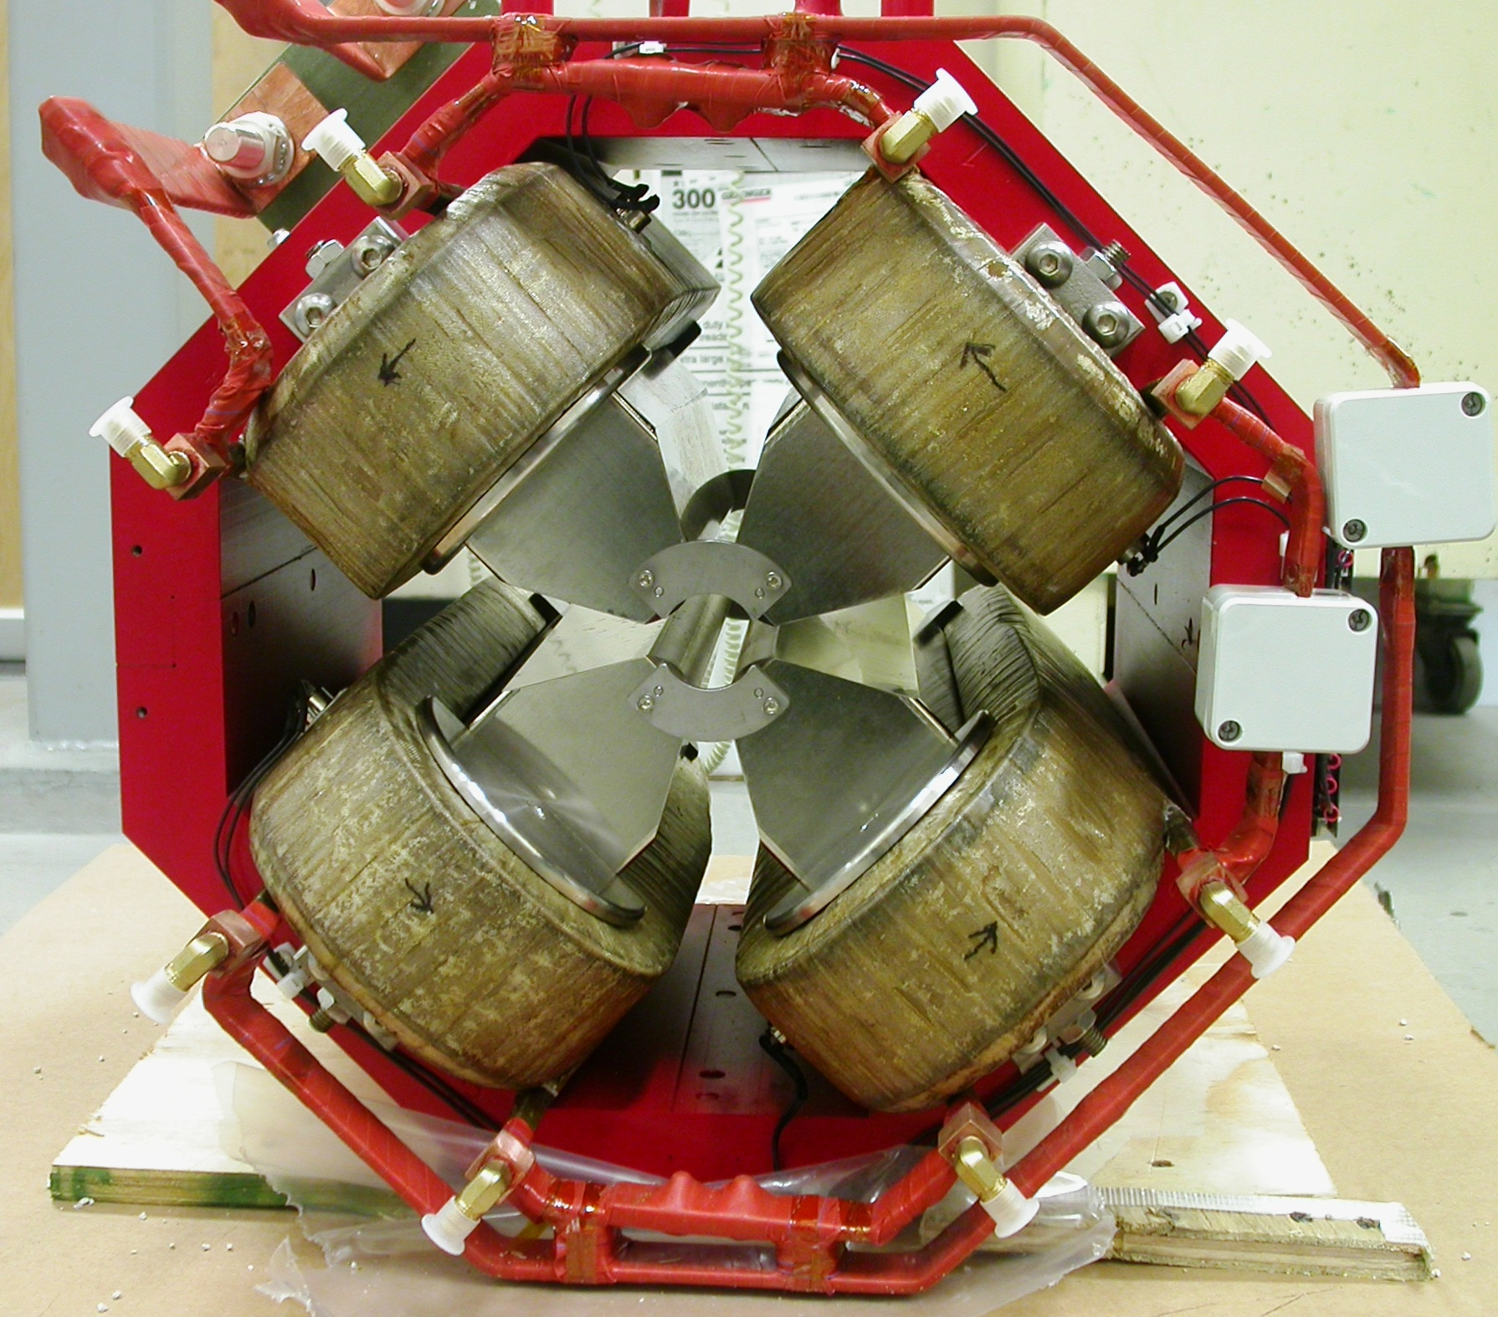  +X  +Y  Front View | 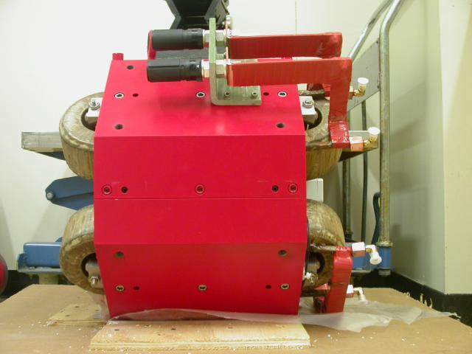  +Z  +Y  Side View

Tooling Ball Measurements/Locations

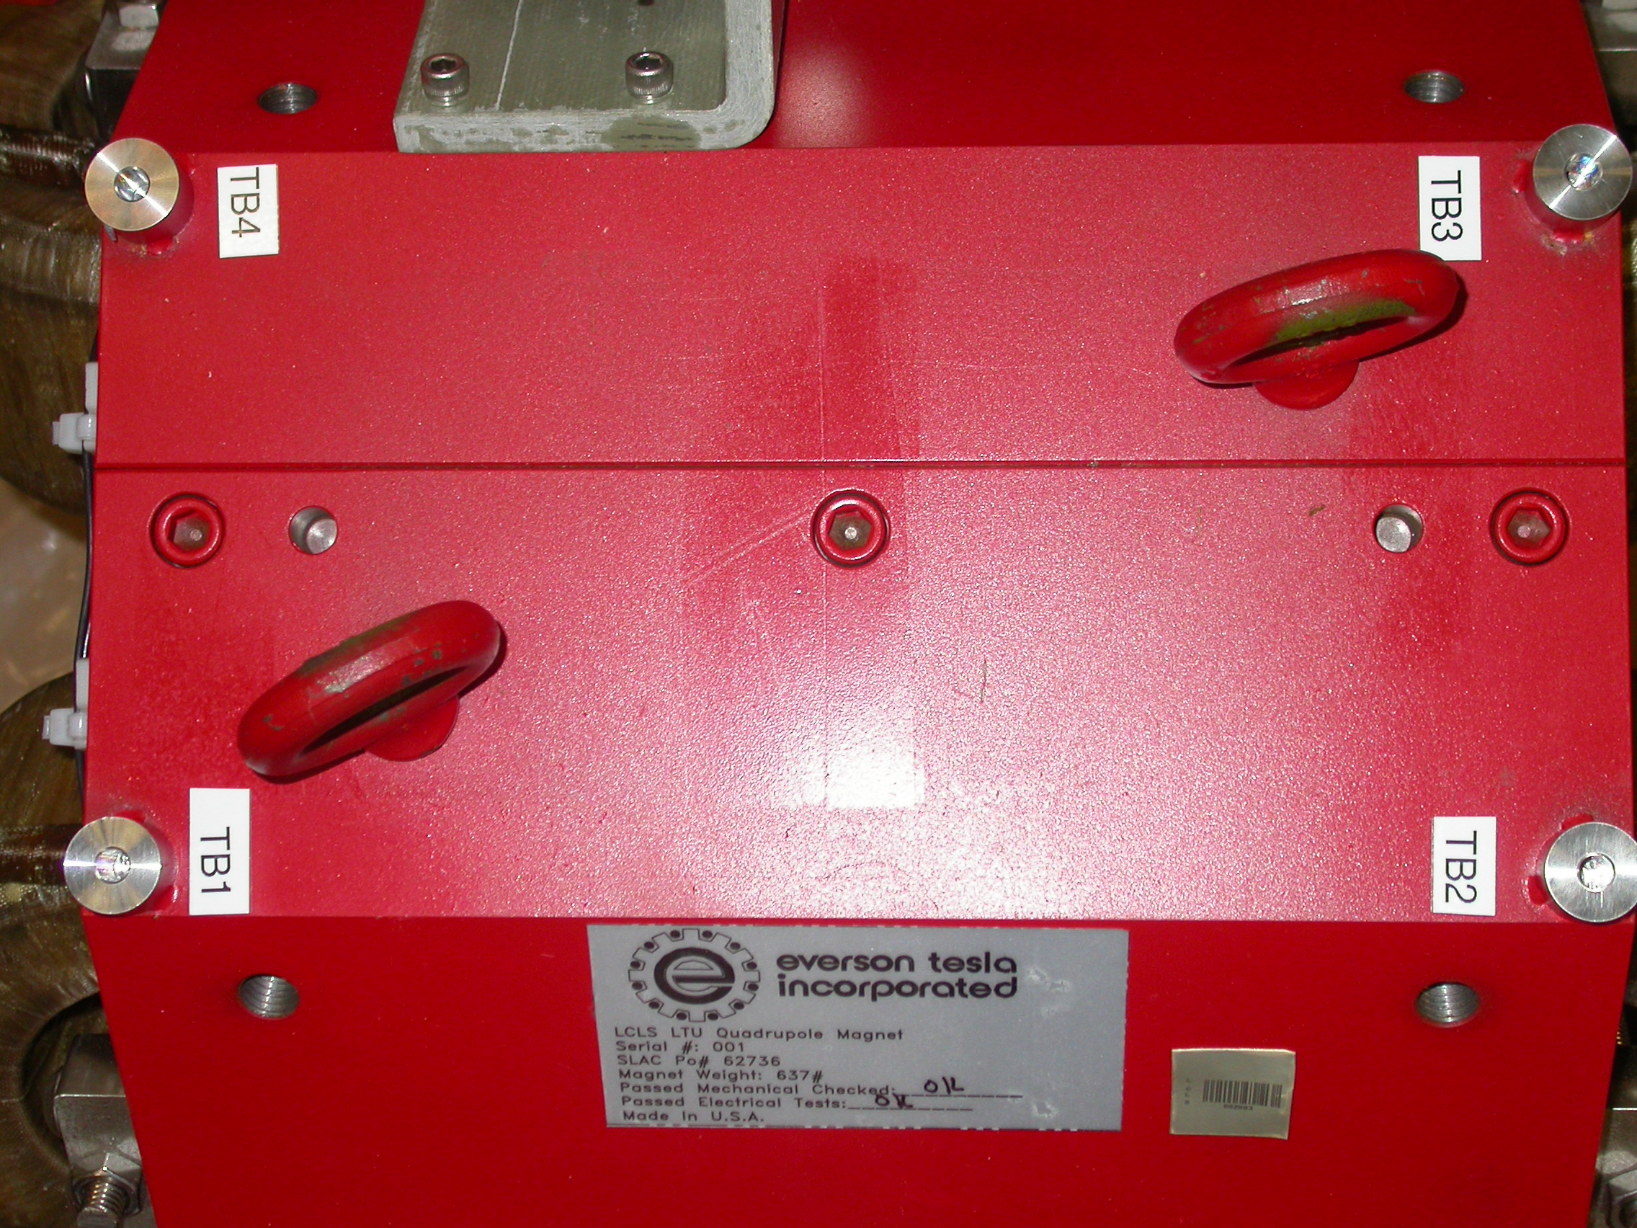
+X
+Z

Tooling Balls Measured with ½” Tooling Ball Socket

Tooling Ball | FORM | Sph. Dia. | X | Y | Z
TB 1 | 0.00019 | 0.49867 | 2.66325 | 10.20947 | 5.60550
TB 2 | 0.00013 | 0.49978 | 2.66286 | 10.20776 | -5.61237
TB 3 | 0.00007 | 0.49952 | -2.65653 | 10.20786 | -5.61233
TB 4 | 0.00009 | 0.49949 | -2.65827 | 10.20943 | 5.60757

Tooling Ball Adapter Cylinder Projected 1” Offset to the Tooling Ball Adapter Plane

Tooling Ball | Cyl. Dia. | X | Y | Z
Proj. TB 1 | 0.25016 | 2.66289 | 10.20839 | 5.60697
Proj. TB 2 | 0.25007 | 2.66200 | 10.20720 | -5.61150
Proj. TB 3 | 0.25002 | -2.65577 | 10.20714 | -5.61114
Proj. TB 4 | 0.24997 | -2.65683 | 10.20859 | 5.60770

.
Pole Data
*Data looking from Downstream End



Side | Pole Diameter | Pole Dist A-C | Pole Dist B-D | Gap 1 | Gap 2 | Gap 3 | Gap 4
Downstream End (+Z) | 1.25806 | 1.25858 | 1.25827 | 0.43538 | 0.43669 | 0.43459 | 0.43128
Upstream End (-Z) | 1.25867 | 1.25749 | 1.25779 | 0.43550 | 0.43551 | 0.43185 | 0.43074

