
LCLS ‘Q150kG’ LTU QUADRUPOLE MAGNET
FIDUCIALIZATION REPORT

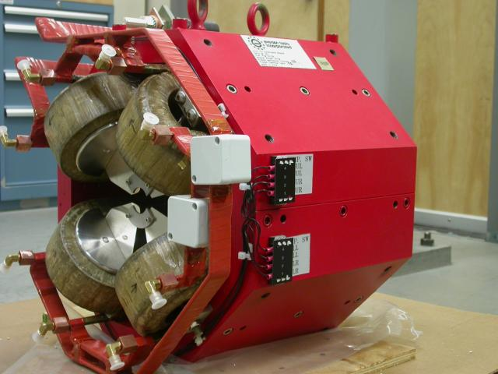

Inspector: | Keith Caban
Responsible Engineer: | Carl Rago
Date: | Thursday, January 17, 2008
Work Order/Charge No.: | 9242609
Serial Number: | SLAC – 000367-010
URL of Fiducial Report: | \\Web002\www-group\met\Quality\FIDUCIAL REPORTS\LCLS LTU Q150kG QUADS\000367.pdf

Part Set-up – Coordinate System Set-up

Spatial Alignment

- Geometric axis of the poles of the magnet.

Planar Alignment

- Plane on top of magnet where tooling ball sockets are welded to.

“Z” Zero

- Mid-plane of the magnet (middle of upstream and downstream ends).

“X” & “Y” Zero

- Geometric axis of the poles of the magnet.

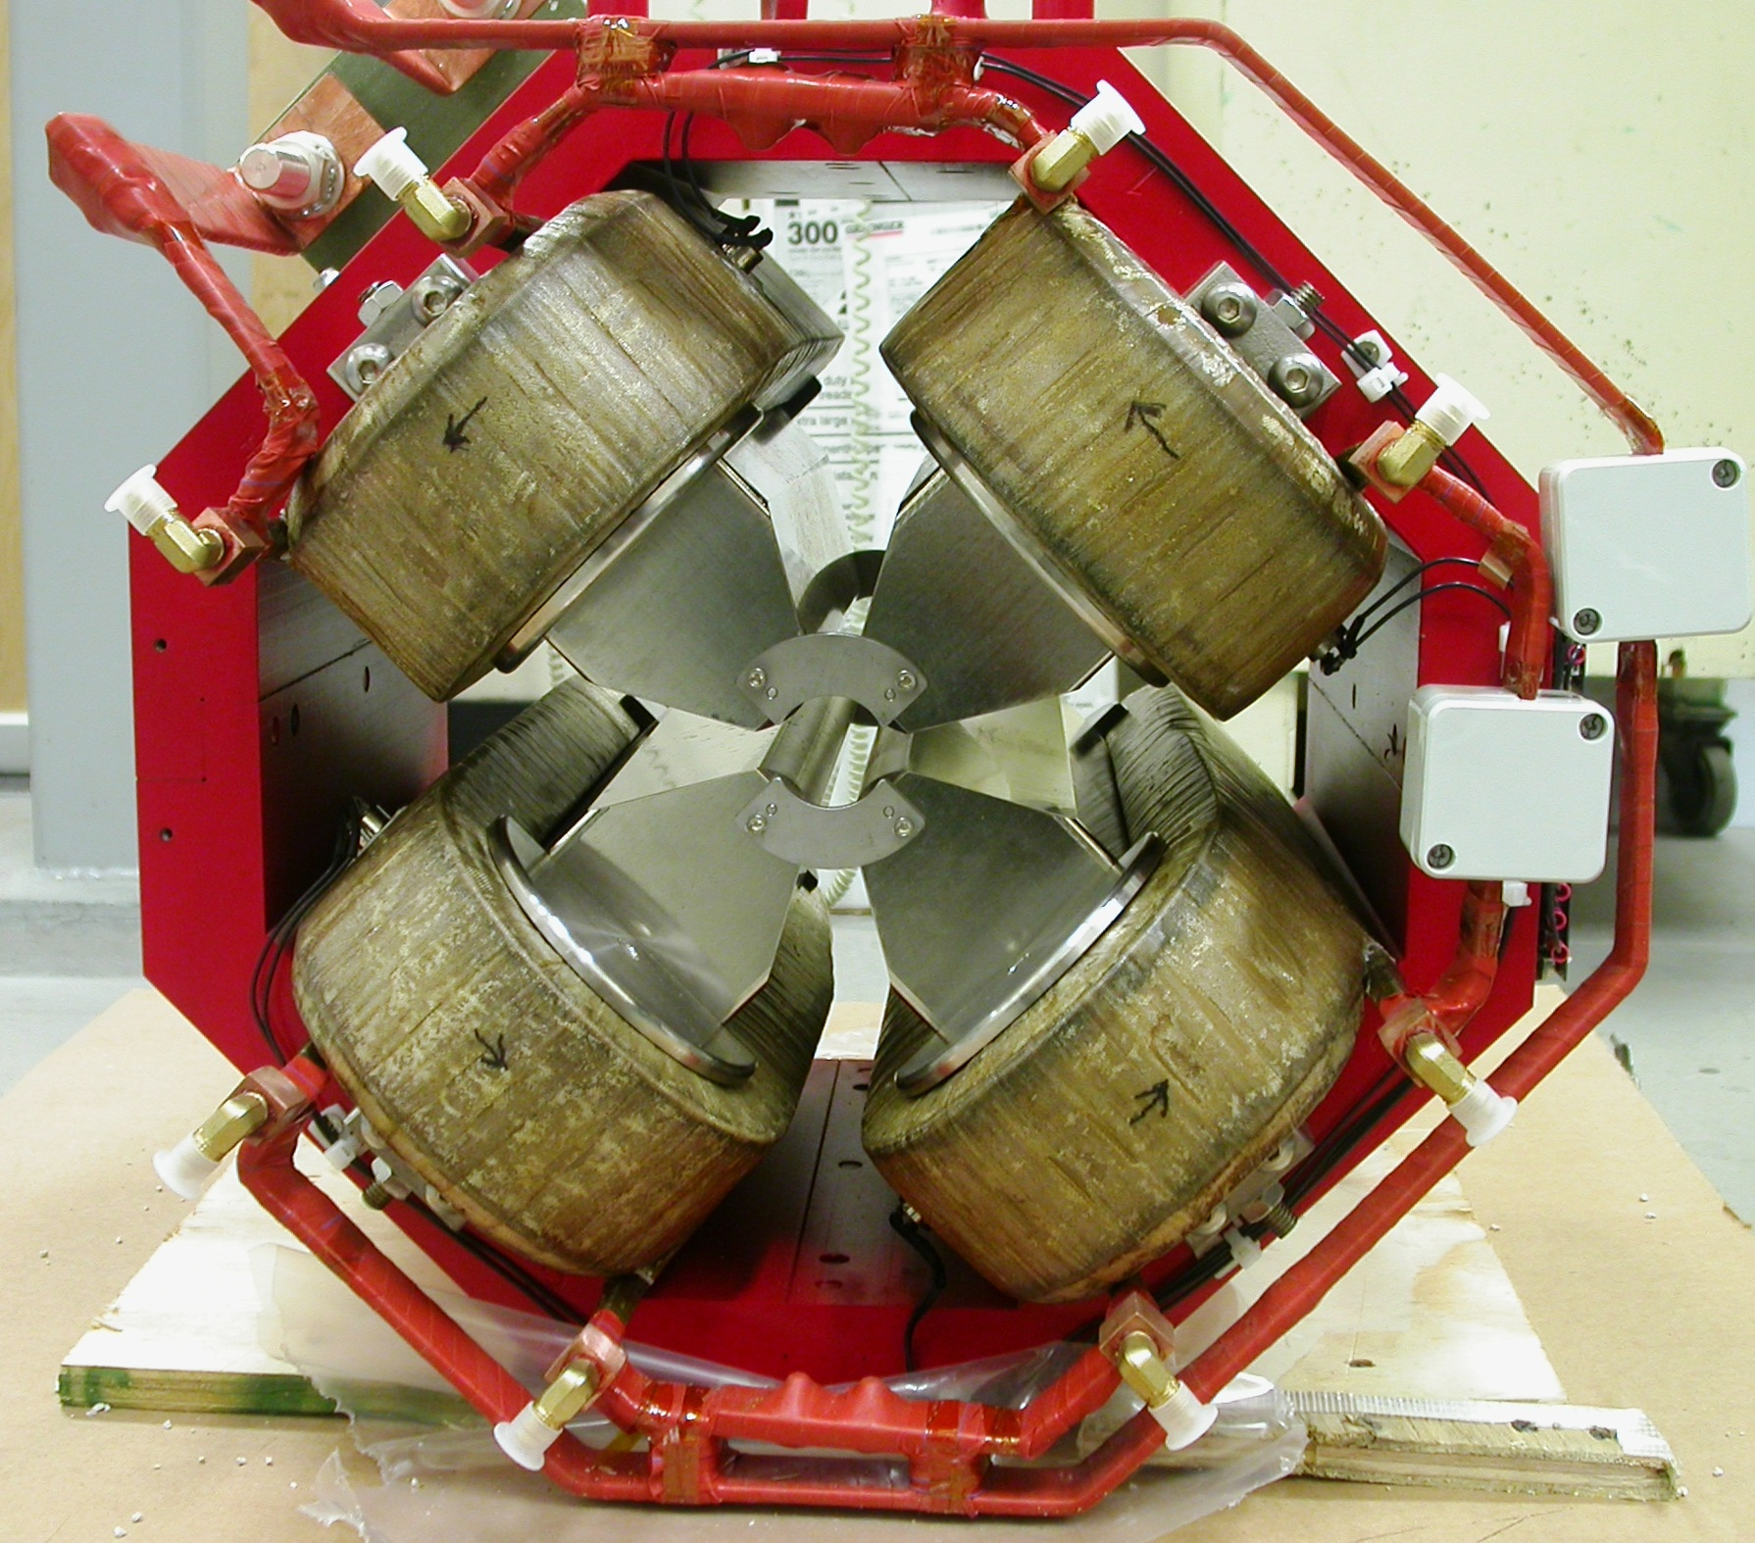  +X  +Y  Front View | 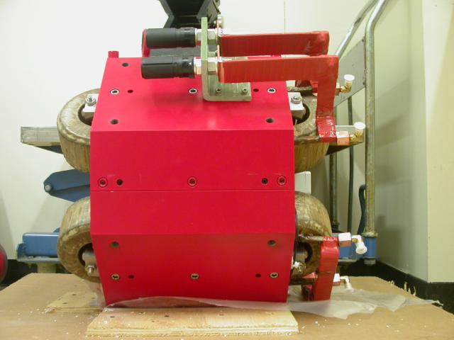  +Z  +Y  Side View

Tooling Ball Measurements/Locations

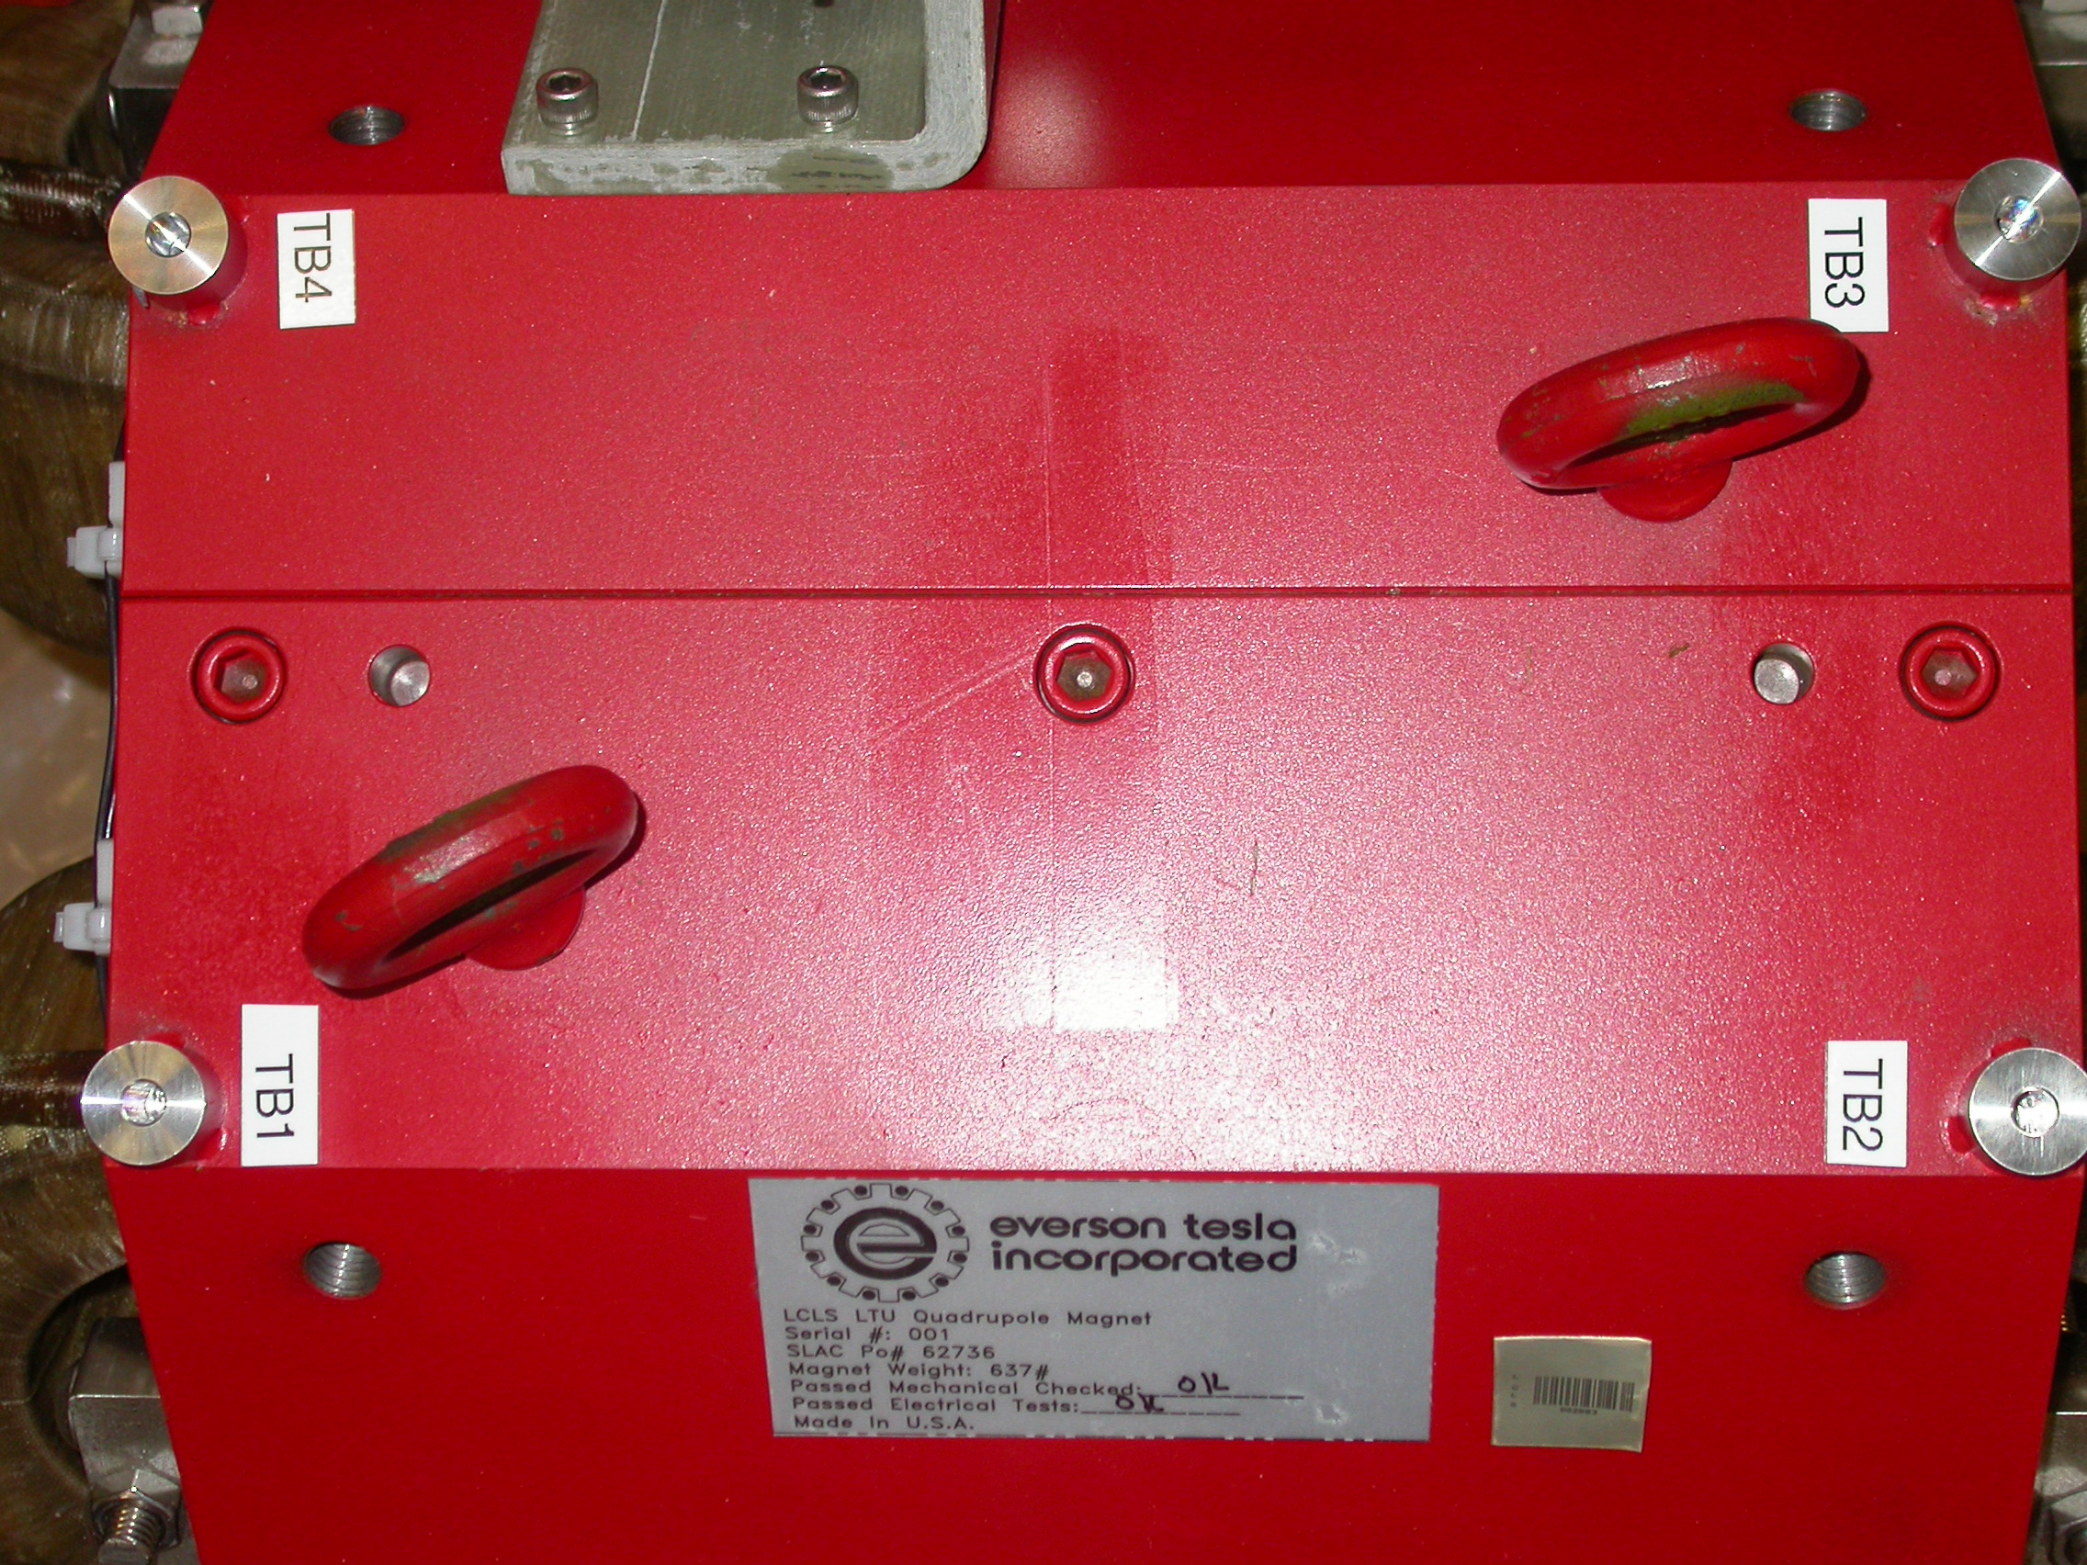
+X
+Z

Tooling Ball Adapter Cylinder Projected 1” Offset to the Tooling Ball Adapter Plane

Tooling Ball | Form | Cyl. Dia. | X | Y | Z | b
Proj. TB 1 | 0.00019 | 0.25011 | 2.62352 | 10.20889 | 5.60625 | 0.00010
Proj. TB 2 | 0.00019 | 0.24990 | 2.63690 | 10.20569 | -5.59686 | 0.00015
Proj. TB 3 | 0.00011 | 0.24995 | -2.67945 | 10.20133 | -5.60844 | 0.00018
Proj. TB 4 | 0.00078 | 0.24984 | -2.67361 | 10.20447 | 5.60311 | 0.00038

.
Pole Data
*Data looking from Downstream End



Side | Pole Dist A-C | Pole Dist B-D | Gap 1 | Gap 2 | Gap 3 | Gap 4
Downstream End (+Z) | 1.25997 | 1.25977 | 0.43422 | 0.43477 | 0.42998 | 0.44133
Upstream End (-Z) | 1.25967 | 1.26010 | 0.43298 | 0.43417 | 0.42880 | 0.44020

