
LCLS Injector Dogleg Dipole Magnet
FIDUCIALIZATION REPORT

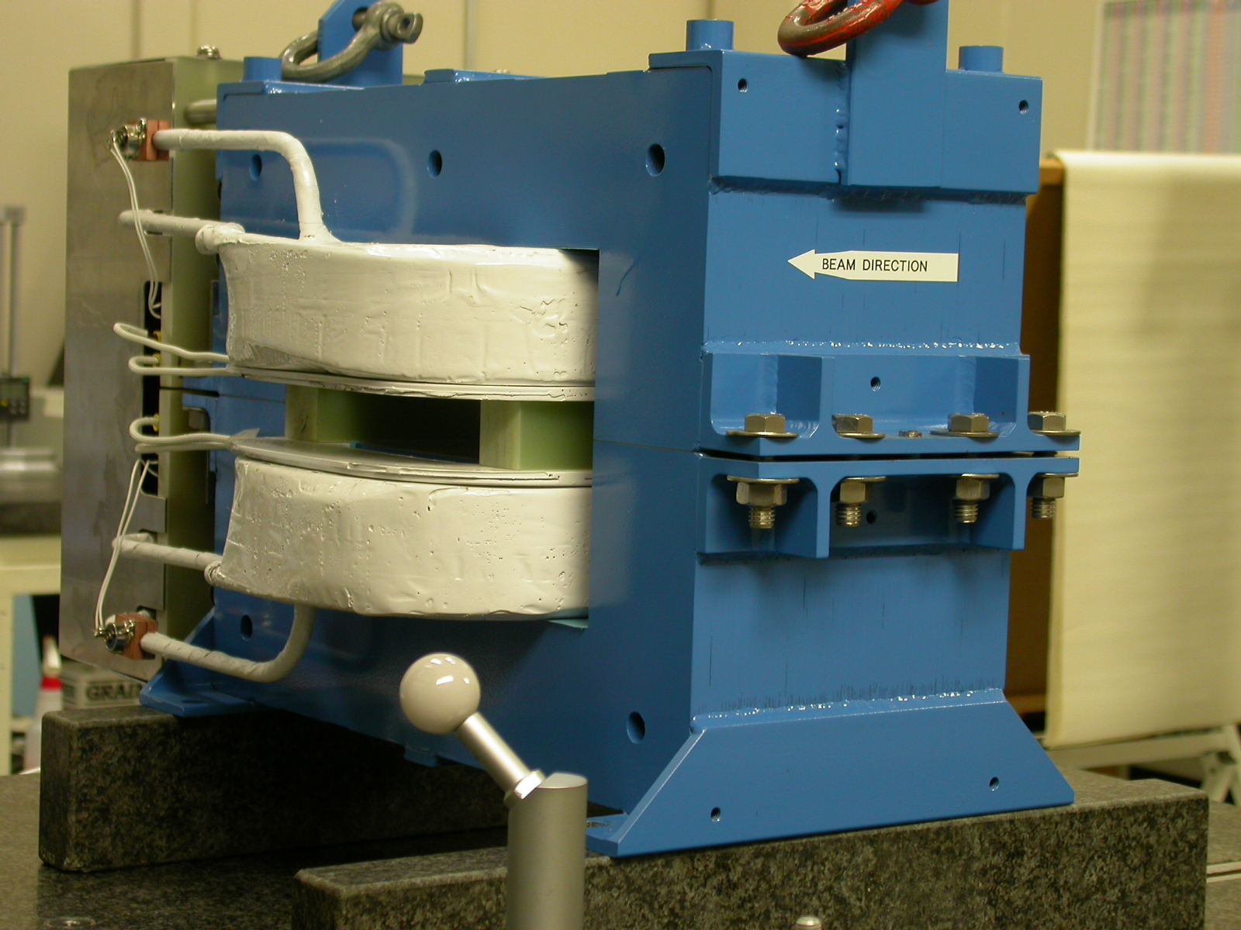

Inspector: | Keith Caban
Responsible Engineer: | Roger Carr
Date: | Monday, May 15, 2006
Work Order/Charge No.: | 92-4217-3
Serial Number | 000437

Part Set-up – Coordinate System Set-up

Planar Alignment

- Mid-Plane of the magnet

Spatial Alignment

- Bottom pole plane
  - -Y plane

“Z” Zero

- Mid-Plane of the magnet

“X” & “Y” Zero

- X zero is created by the symmetry point of the inner stainless steel where coils lie.

    - Both ends of both sides.
      - Create lines which is y axis.
        - This Creates X- zero
- Symmetry of pole planes
  - This creates Y- zero
Z+

+Y  +Z  ISO | 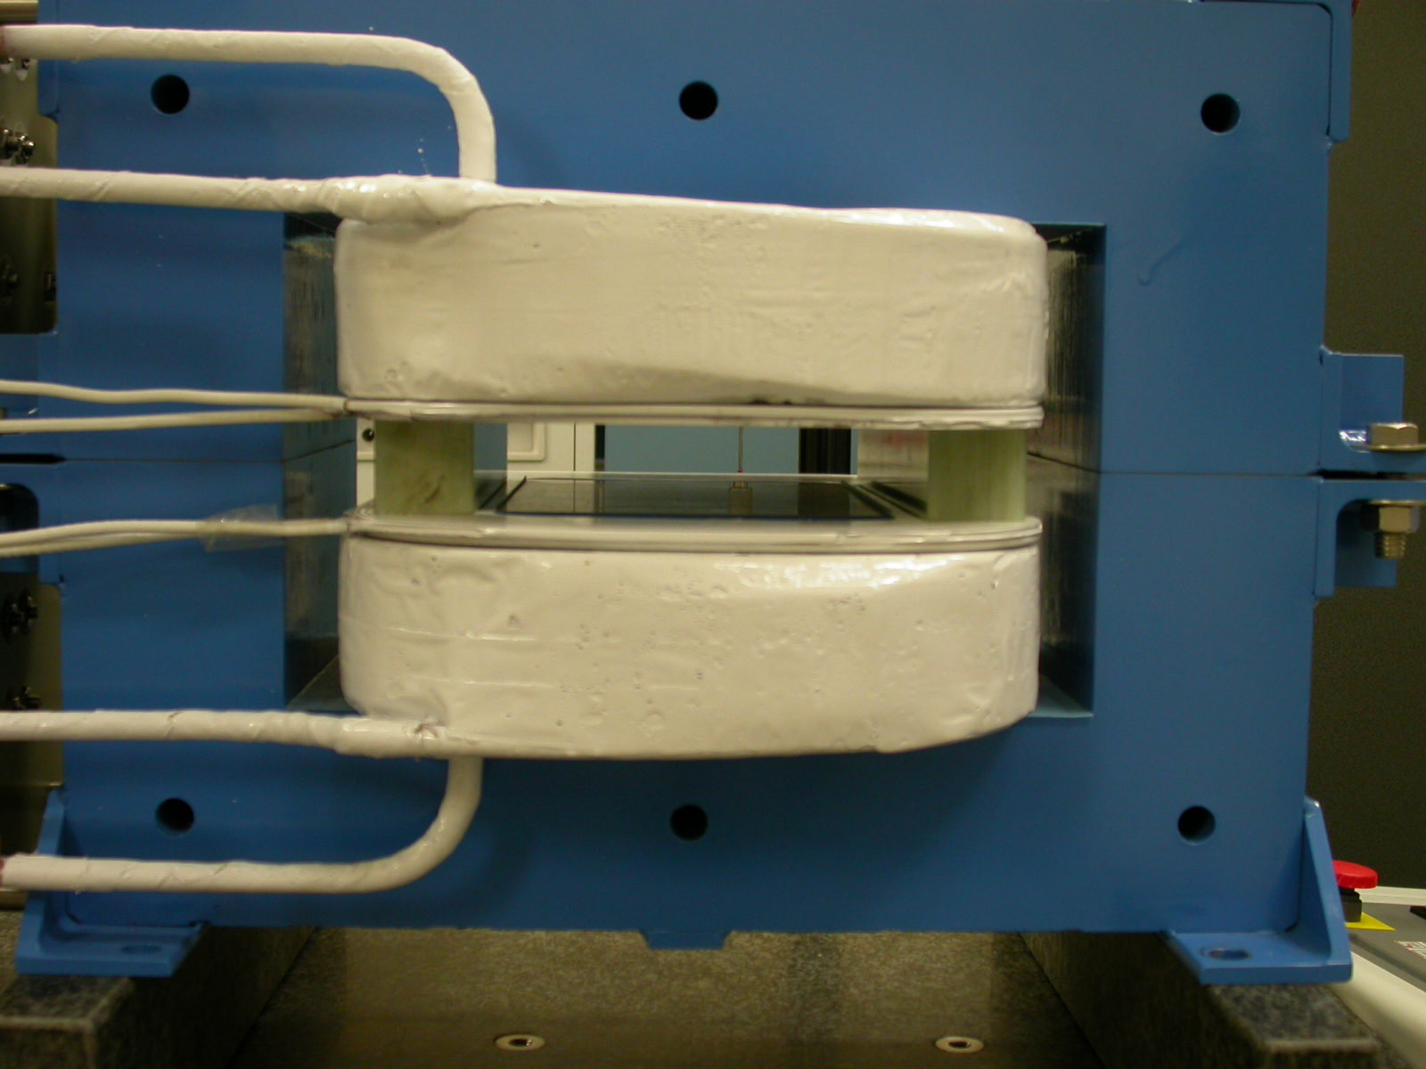  +Y  +X  BACK VIEW

Tooling Ball Measurements/Locations

Top of magnet; view from “+Y”

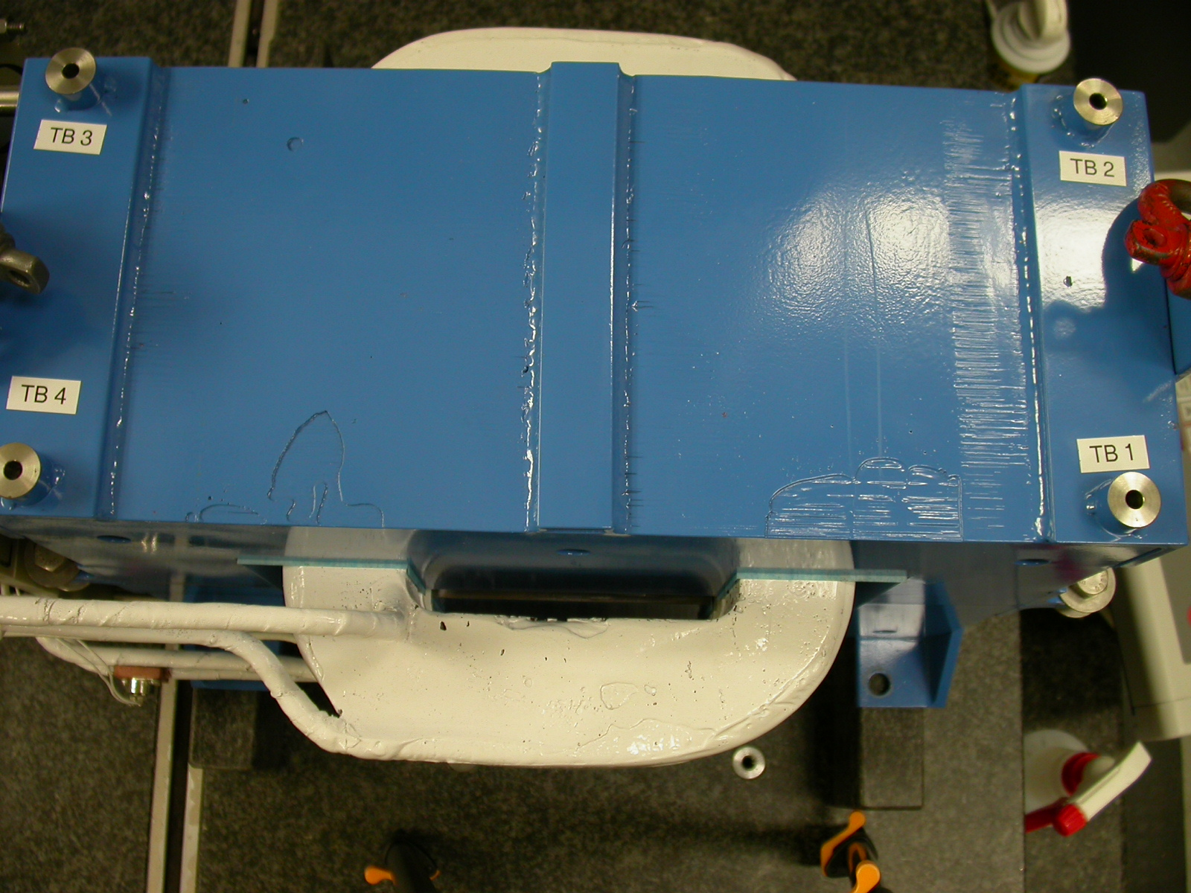
+X
+Z

+X
+Z

Tooling Ball | FORM | DIAMETER | X | Y | Z
TB 1 | 0.00094 | 0.49676 | 7.31527 | 7.77509 | 2.90755
TB 2**** | 0.00177 | 0.48952 | 7.30949 | 7.77900 | -2.89354
TB 3 | 0.00073 | 0.49641 | -7.32221 | 7.78232 | -2.89451
TB 4^ | 0.00125 | 0.49310 | -7.32441 | 7.78207 | 2.91233

**** - denotes bad tooling ball socket holder, part was out of round and undersized had to use a smaller shaft 0.2475 because standard did not fit hole.
**** Y value changed 7/28/06 reamed out hole to size.
^ - denotes that tooling ball socket holder was oversized more than normal see form and diameter size.

View From +Z
Additional Requested Measurements

Parallelism of pole planes


- // = 0.00088
A
B
C
D

