
LCLS Dipole Magnet
FIDUCIALIZATION REPORT

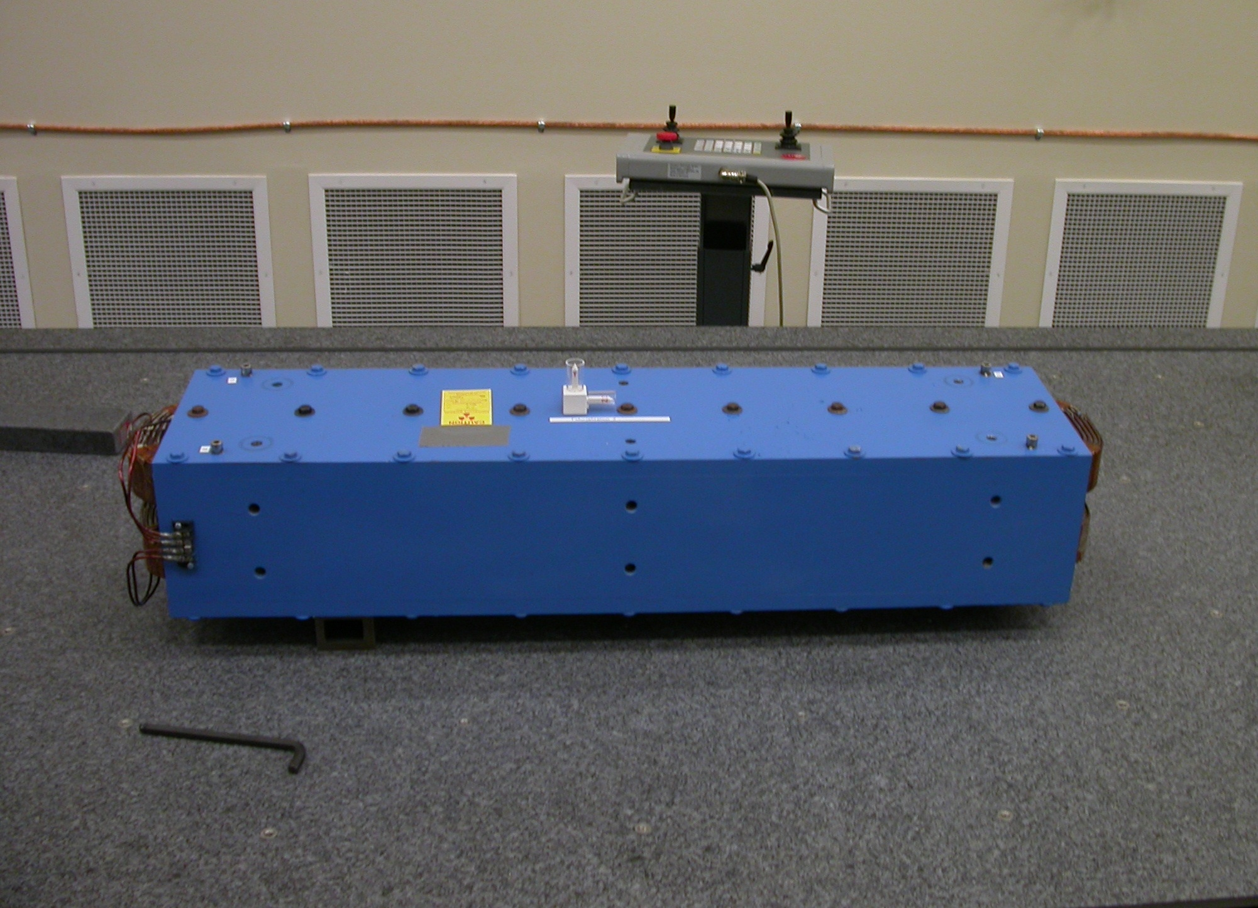

Inspector: | Ed Reese
Responsible Engineer: | Carl Rago
Date: | Monday, February 12, 2007
Work Order/Charge No.: | 21697-1
Serial Number | 000354
URL of Fiducial Report: | \\Web002\www-group\met\Quality\FIDUCIAL REPORTS\LCLS DIPOLE\000354.PDF

Part Set-up – Coordinate System Set-up

Planar Alignment

- Symmetry Axis between inner side plates of housing

Spatial Alignment

- Symmetry Plane between upper and lower poles

“Z” Zero

- Symmetry Point between faces perpendicular to beam

“X” Zero

- Symmetry Axis between Inner side plate of housing

“Y” Zero

- Symmetry Plane between upper and lower poles

-Z End View
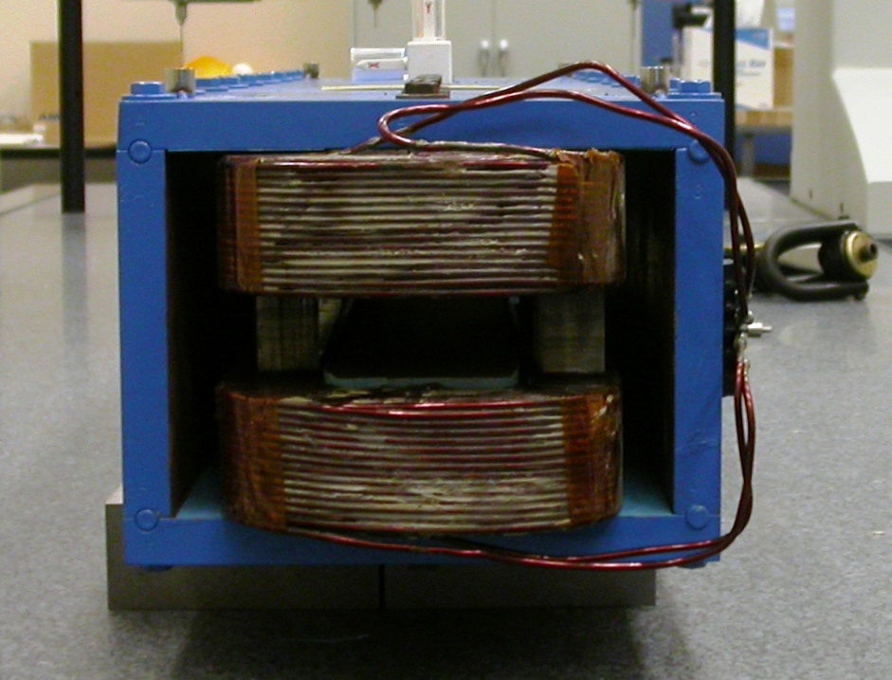

+Y

+X

Tooling Ball Measurements/Locations

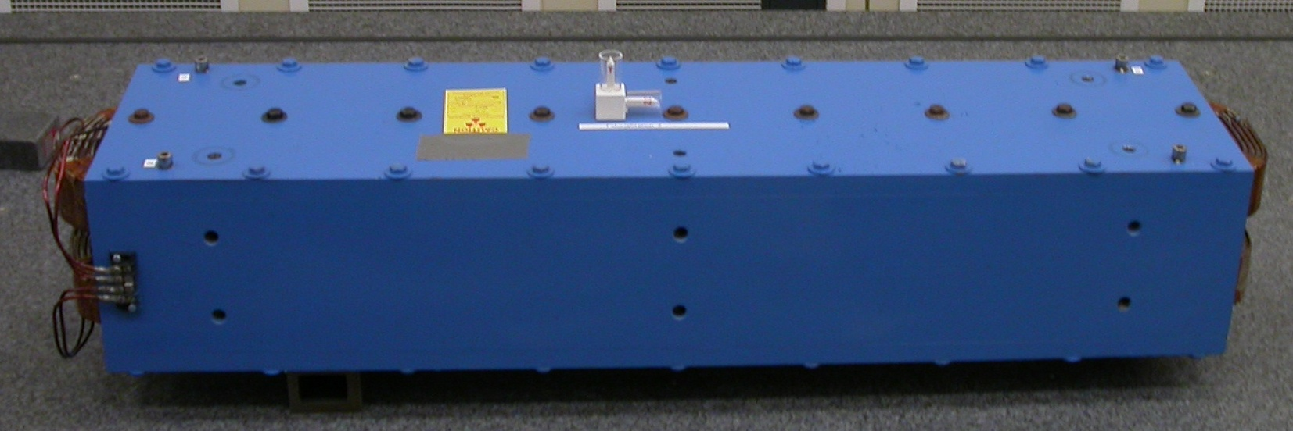
TB1
TB2
TB3
TB4

Tooling Ball | FORM | DIAMETER | X | Y | Z
TB 1 | 0.00002 | 0.50000 | 3.87609 | 5.16472 | -17.03492
TB 2 | 0.00046 | 0.49832 | -3.85739 | 5.16609 | -16.97847
TB 3 | 0.00013 | 0.49758 | 3.92304 | 5.16869 | 16.97503
TB 4 | 0.00011 | 0.49921 | -3.86078 | 5.16535 | 16.99323

Additional Requested Measurements

LOCATION | POLE DISTANCE
-X/-Z | 1.37563
+X/-Z | 1.37646
-X/+Z | 1.37886
+X/+Z | 1.38027

