
LCLS BXKIK MAGNET
FIDUCIALIZATION REPORT

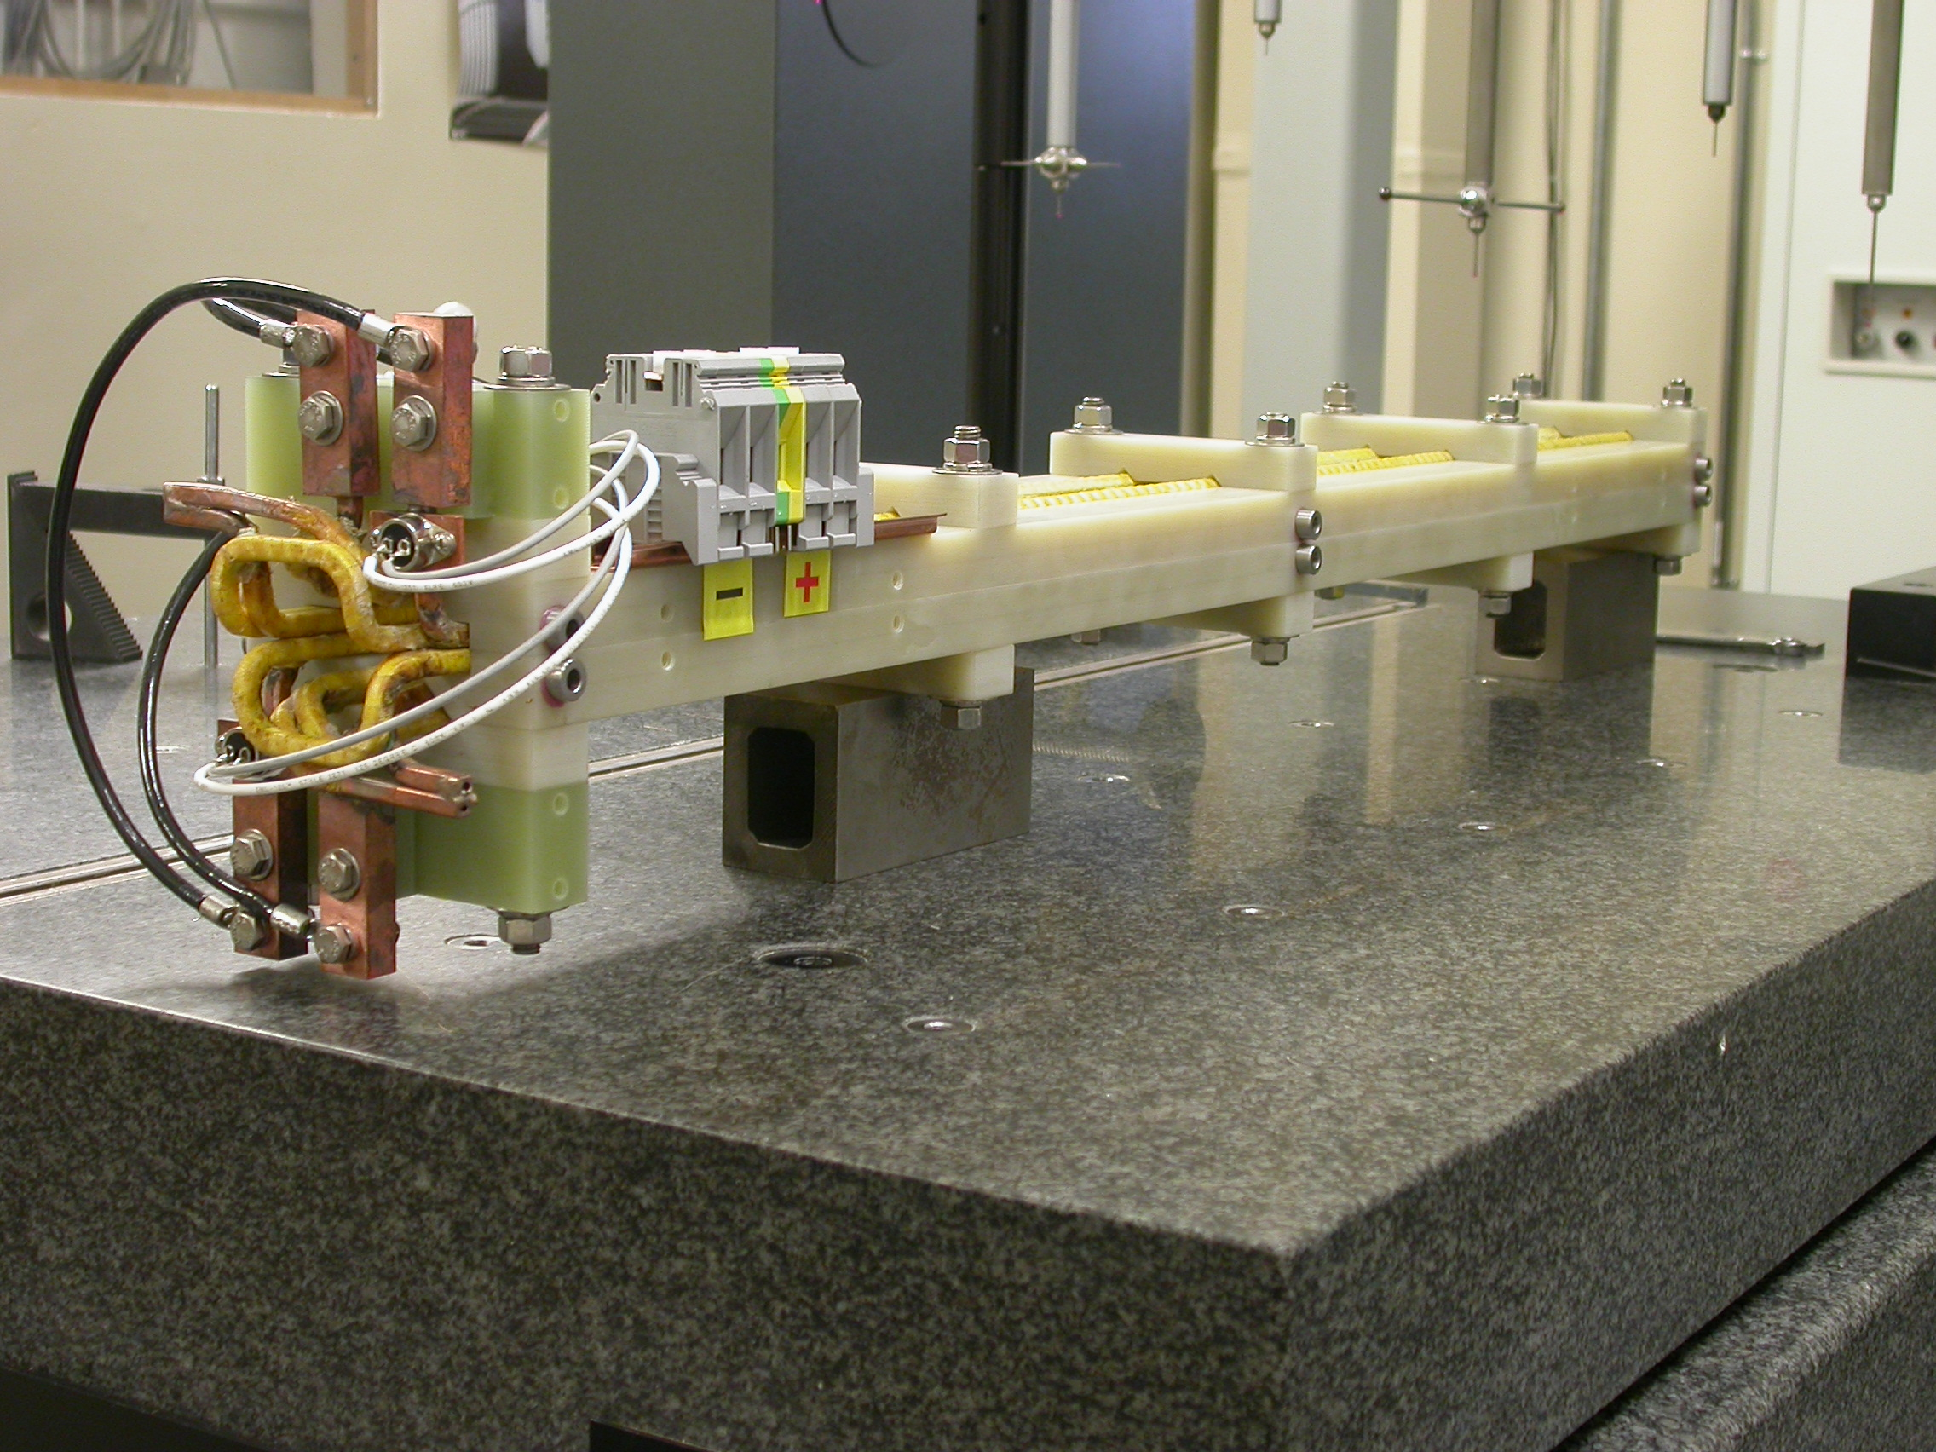

Inspector: | Keith Caban
Responsible Engineer: | Carl Rago
Date: | Monday, November 05, 2007
Work Order/Charge No.: | 23306-1
Serial Number: | None given (PART #: SA-380-330-01)
URL of Fiducial Report: | \\Web002\www-group\met\Quality\FIDUCIAL REPORTS\LCLS BXKIK MAGNET\23306-1.PDF

Part Set-up – Coordinate System Set-up

Spatial Alignment

- Mid-plane of upper and lower split planes (g-10)

Planar Alignment

- Symetry line of the lower half section (even TB numbers)

“Z” Zero

- Mid-plane of lower half section in the long direction.

“X” & “Y” Zero

- Geometric axis of the poles of the magnet.

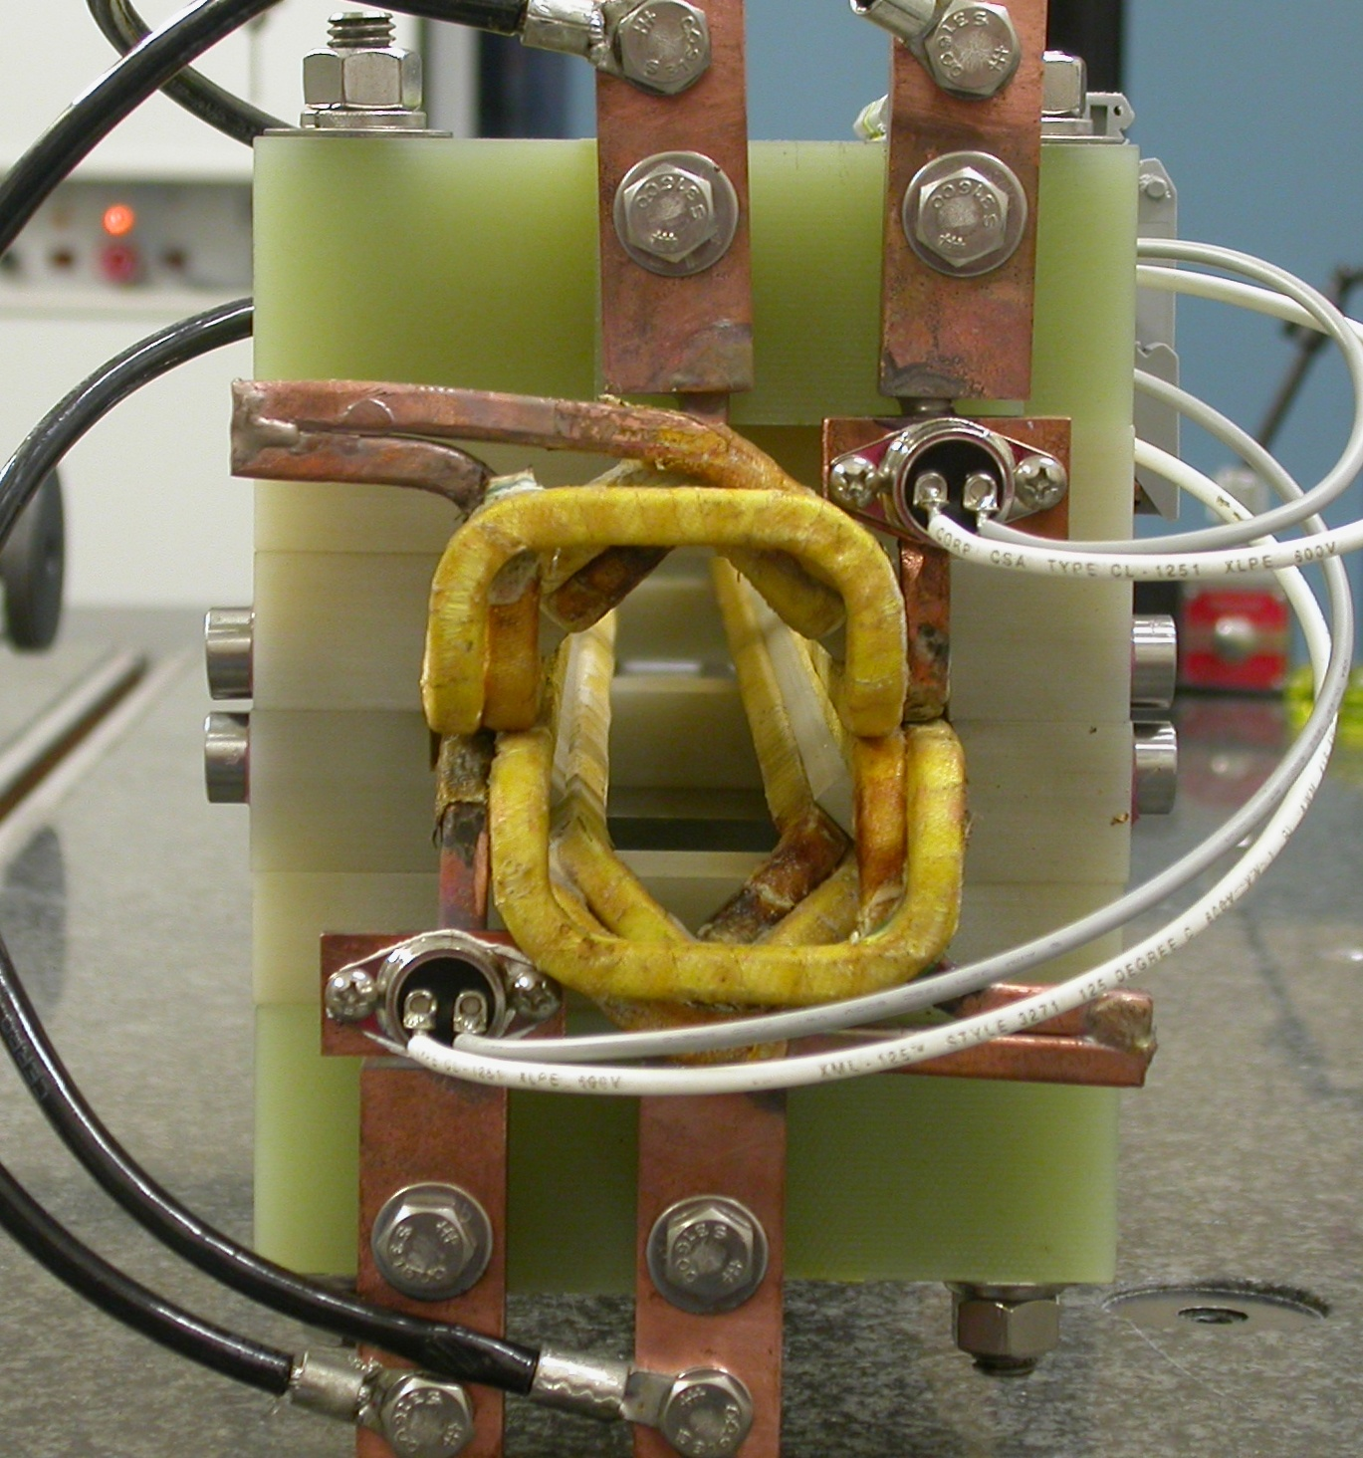  +X  +Y  Front View | 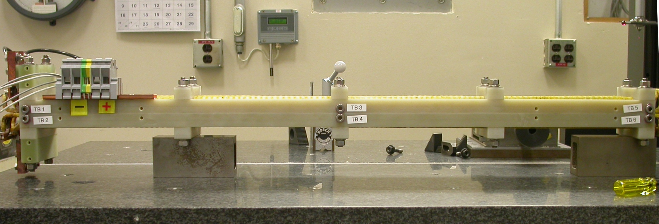  +Z  +Y  Side View

Tooling Ball Measurements/Locations
Looking from –X side
+Y
+Z
Looking from +X side
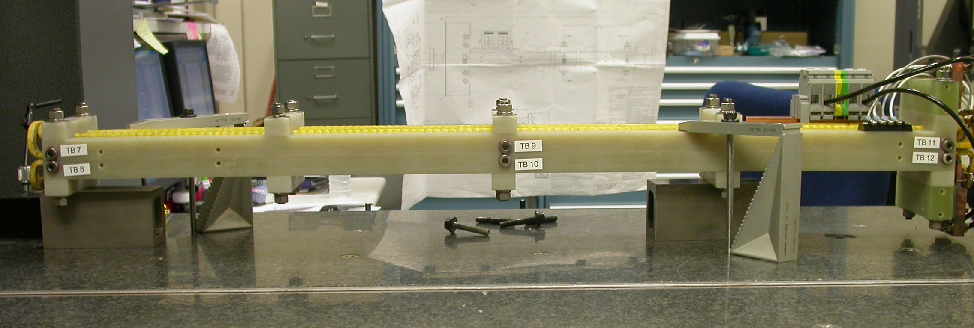
+Y
+Z

Tooling Balls Measured with ½” Tooling Ball Socket & 1” Extension
Tooling Ball | FORM | Sph. Dia. | X | Y | Z
TB 1 | 0.00007 | 0.49984 | 3.54735 | 0.31793 | 19.08222
TB 2 | 0.00023 | 0.49730 | 3.56770 | -0.25679 | 19.08810
TB 3 | 0.00002 | 0.49989 | 3.54005 | 0.27789 | -0.00999
TB 4 | 0.00005 | 0.49973 | 3.56750 | -0.29329 | -0.00084
TB 5 | 0.00011 | 0.49933 | 3.53656 | 0.26982 | -19.09116
TB 6 | 0.00016 | 0.49985 | 3.55664 | -0.30683 | -19.07853
TB 7 | 0.00020 | 0.49907 | -3.56199 | 0.27136 | -19.16259
TB 8 | 0.00031 | 0.49966 | -3.54925 | -0.28586 | -19.16764
TB 9 | 0.00007 | 0.49993 | -3.55868 | 0.26449 | -0.08056
TB 10 | 0.00007 | 0.49988 | -3.56632 | -0.31086 | -0.09115
TB 11 | 0.00006 | 0.49940 | -3.55553 | 0.21856 | 18.98555
TB 12 | 0.00005 | 0.49993 | -3.56264 | -0.29745 | 18.99311

