
LCLS BX3 DIPOLE MAGNET
FIDUCIALIZATION REPORT

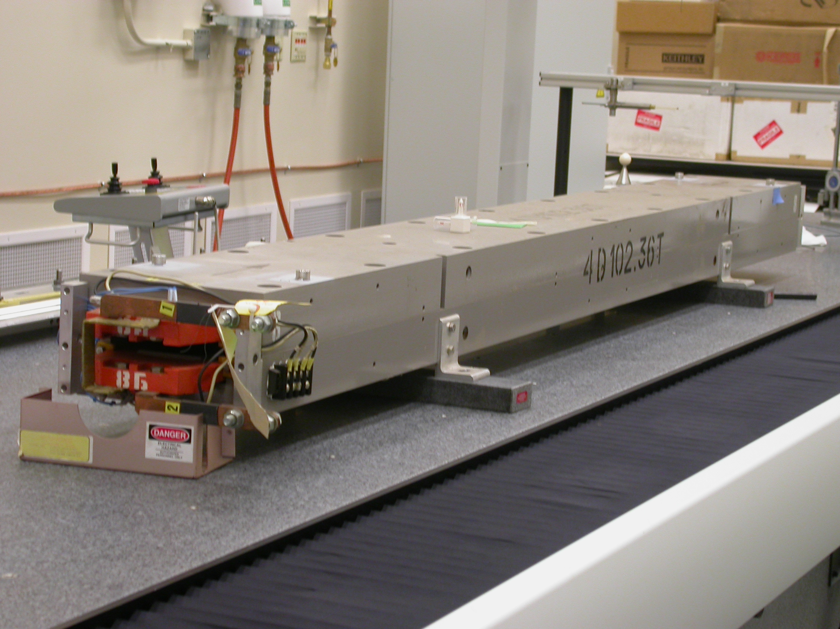

Inspector: | Ed Reese
Responsible Engineer: | Carl Rago
Date: | Wednesday, February 28, 2007
Work Order/Charge No.: | 21698-1
Serial Number | 000324
URL of Fiducial Report: | \\Web002\www-group\met\Quality\FIDUCIAL REPORTS\LCLS BX3 DIPOLE\000324.PDF

Part Set-up – Coordinate System Set-up

Planar Alignment

- Symmetry Axis between inner side plates of housing

Spatial Alignment

- Symmetry Plane between upper and lower poles

“Z” Zero

- Symmetry Point between faces perpendicular to beam

“X” Zero

- Symmetry Axis between Inner side plate of housing

“Y” Zero

- Symmetry Plane between upper and lower poles

Tooling Ball Measurements/Locations

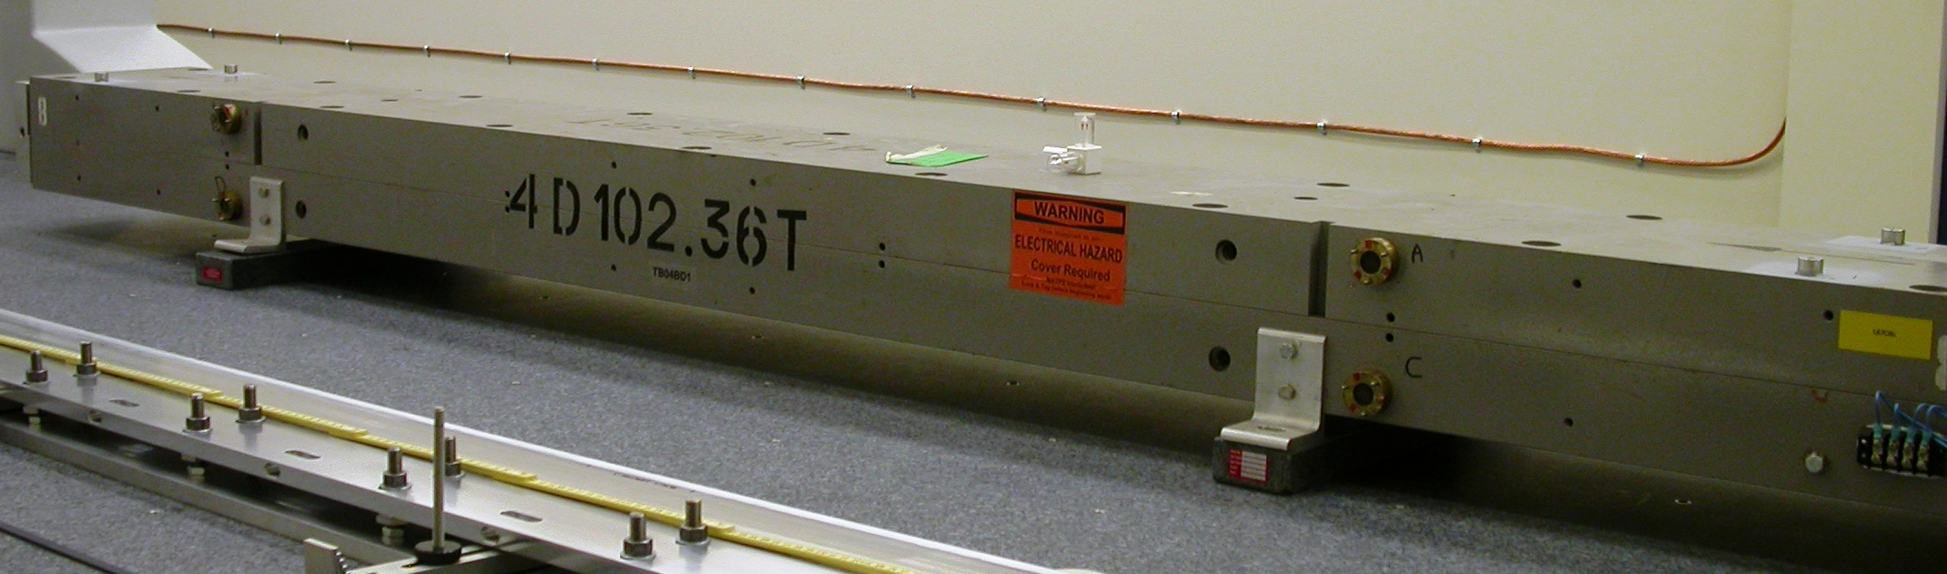
Top Tooling Ball Sockets

Tooling Ball | FORM | DIAMETER | X | Y | Z
TB 1 | 0.00004 | 0.49716 | 4.31466 | 4.64516 | -45.16716
TB 2 | 0.00001 | 0.49620 | -4.32652 | 4.64494 | -45.18730
TB 3 | 0.00004 | 0.49503 | 4.29690 | 4.64534 | 45.14764
TB 4 | 0.00004 | 0.49667 | -4.11248 | 4.64778 | 45.16518

Side Optical/Magnetic Precision Sphere Holder

Tooling Ball | FORM | DIAMETER | X | Y | Z
A | 0.00004 | 1.50015 | 6.62089 | 2.14091 | -31.39265
B | 0.00006 | 1.50013 | 6.61203 | 2.15606 | 31.31260
C | 0.00005 | 1.50014 | 6.63972 | -2.17013 | -31.37837
D | 0.00007 | 1.50018 | 6.62863 | -2.15091 | 31.30864

Additional Requested Measurements

LOCATION | POLE DISTANCE
-X/-Z | 0.90781
+X/-Z | 0.90790
-X/+Z | 0.90641
+X/+Z | 0.90647

