
LCLS BX3 DIPOLE MAGNET
FIDUCIALIZATION REPORT

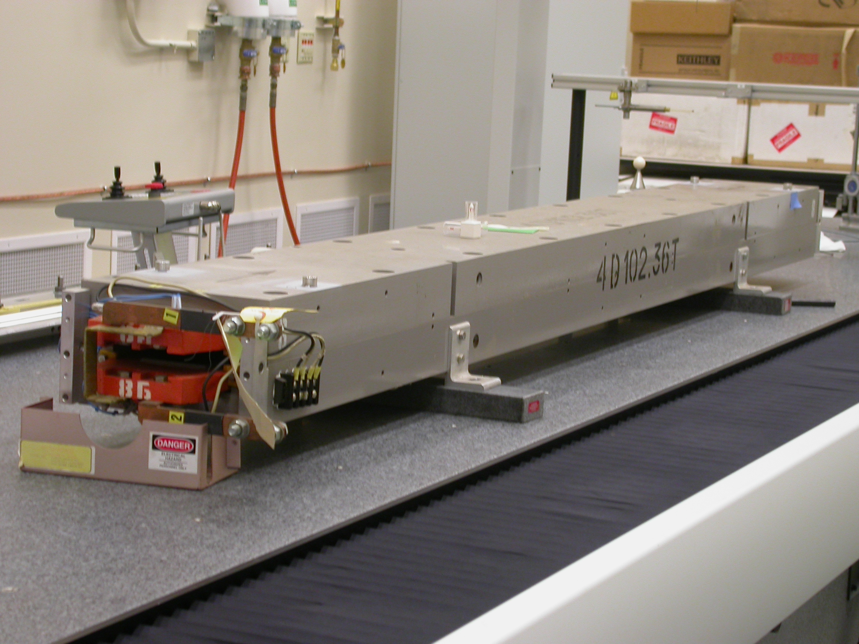

Inspector: | Ed Reese
Responsible Engineer: | Carl Rago
Date: | Wednesday, February 14, 2007
Work Order/Charge No.: | 21698-1
Serial Number | 000241
URL of Fiducial Report: | \\Web002\www-group\met\Quality\FIDUCIAL REPORTS\LCLS BX3 DIPOLE\000241.PDF

Part Set-up – Coordinate System Set-up

Planar Alignment

- Symmetry Axis between inner side plates of housing

Spatial Alignment

- Symmetry Plane between upper and lower poles

“Z” Zero

- Symmetry Point between faces perpendicular to beam

“X” Zero

- Symmetry Axis between Inner side plate of housing

“Y” Zero

- Symmetry Plane between upper and lower poles

Tooling Ball Measurements/Locations

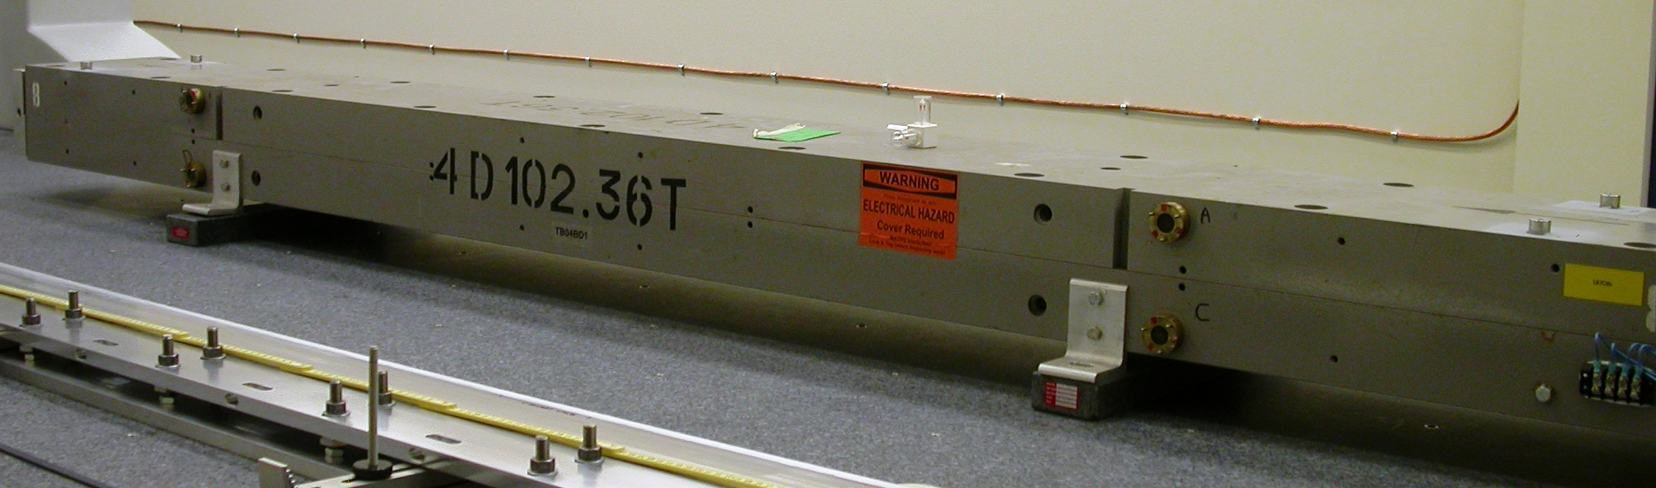
Top Tooling Ball Sockets

Tooling Ball | FORM | DIAMETER | X | Y | Z
TB 1 | 0.00036 | 0.49763 | 4.30566 | 4.63857 | -45.15252
TB 2 | 0.00044 | 0.49661 | -4.33228 | 4.63909 | -45.17474
TB 3 | 0.00030 | 0.49682 | 4.40152 | 4.63892 | 45.14911
TB 4 | 0.00097 | 0.49764 | -4.31995 | 4.64642 | 45.15378

Side Optical/Magnetic Precision Sphere Holder

Tooling Ball | FORM | DIAMETER | X | Y | Z
A | 0.00001 | 1.50003 | 6.63787 | 2.09729 | -31.36457
B | 0.00001 | 1.50000 | 6.63426 | 2.12659 | 31.36137
C | 0.00003 | 1.50001 | 6.63735 | -1.85395 | -31.37030
D | 0.00003 | 1.50004 | 6.62845 | -2.09760 | 31.37185

Additional Requested Measurements

LOCATION | POLE DISTANCE
-X/-Z | 0.90647
+X/-Z | 0.90565
-X/+Z | 0.91433
+X/+Z | 0.91102

