
LCLS BFW WIRECARD ASSY
INSPECTION/FIDUCIAL REPORT

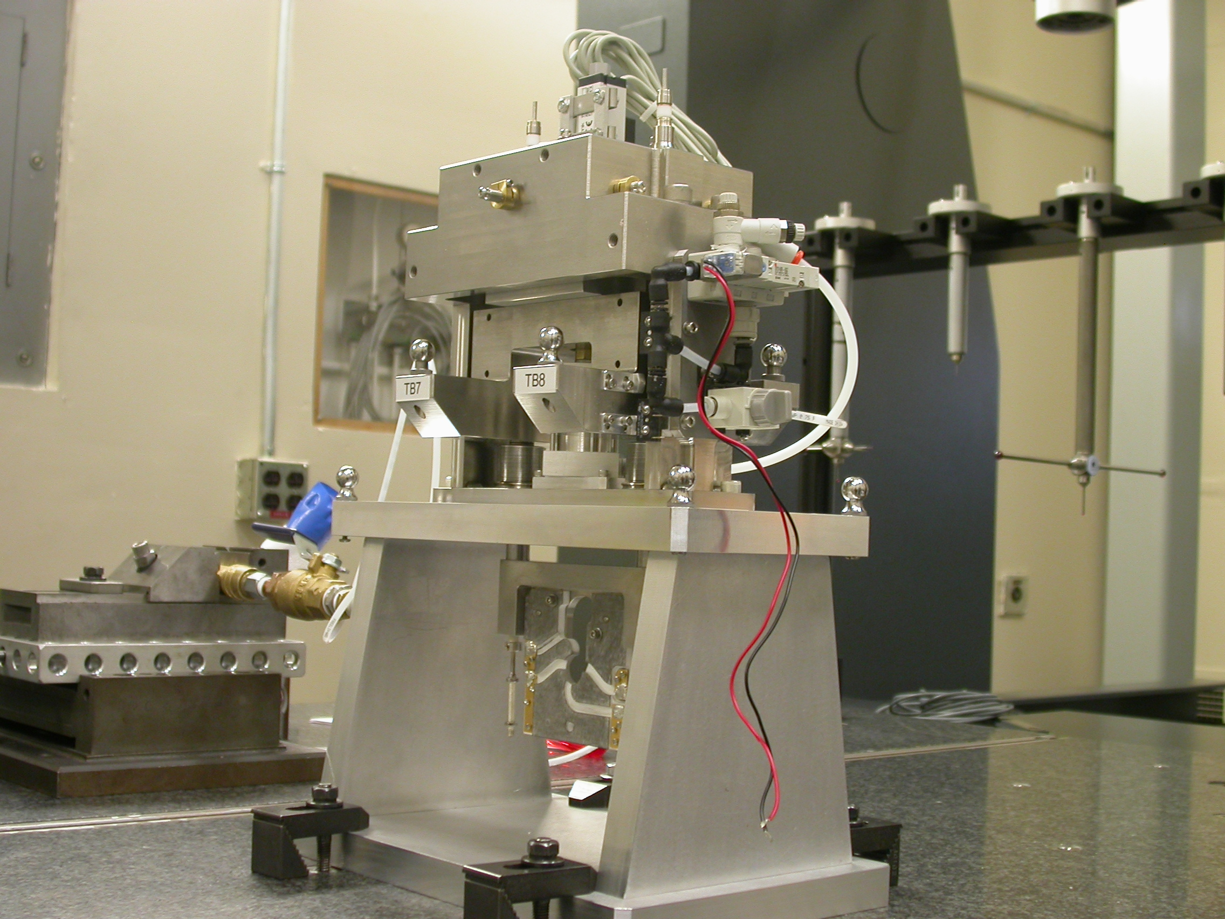

Inspector: | Keith Caban
Responsible Engineer: | Venkat Srinivasan
Date: | Monday, July 14, 2008
Work Order/Charge No.: | 23800-1
Serial Number: | BFW – 38 / VC – 38 / WC – 39 / BASE – 07
Units of Measure: | Metric – Millimeters (mm.)
URL | http://www-group/met/Quality/FIDUCIAL%20REPORTS/LCLS%20BFW/BFW-38_VC-38_WC-39_BAS-07.pdf

Coordinate System Setups

Bench CSY (BENCH$CSY)
(The only CSY in Both States of measurement - out and under vacuum)

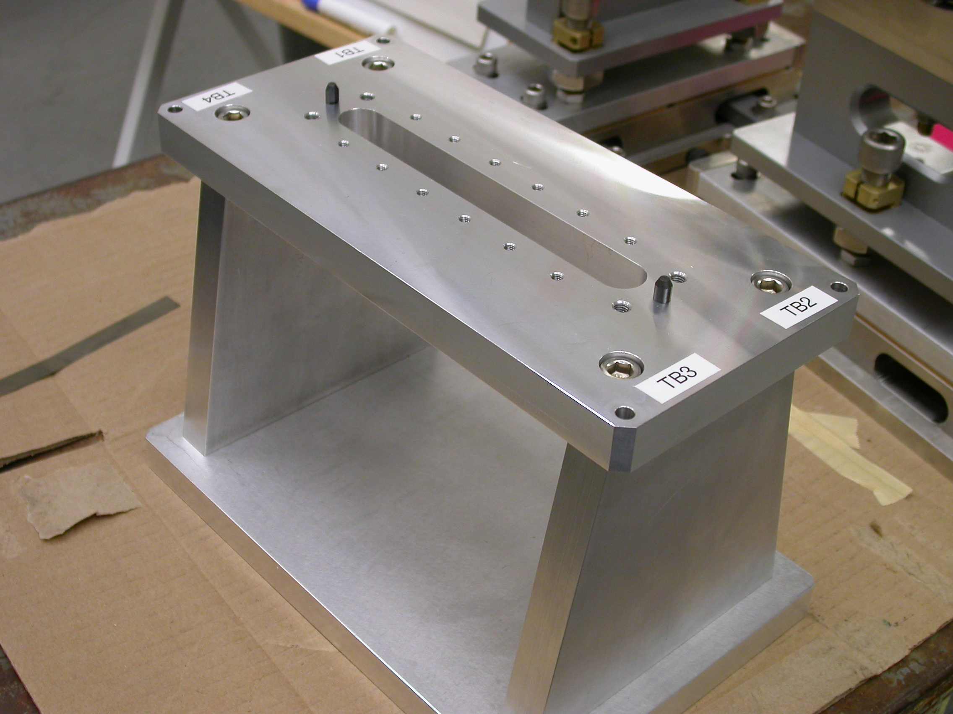
+Y
+Z
+X

- Plane measurement on top of Bench to set zero in Y and is the Spatial Alignment.
- Measure Pin and Diamond Pin to get centers, create a line between the two center points and this sets zero in Z and is the Planar Alignment.
- Take the symmetry point of the two pins this sets zero in X.

Bench Tooling Ball CSY (BTB$CSY)
- Create a plane using Tooling Balls 1, 2, & 3
  - This sets Zero in Y and is the spatial alignment
- Create an axis/line using TB’s 2 to 1 (+X)
  - This is the planar alignment
- TB 2 is a single point that sets zero in X, Y, Z.

BFW Tooling Ball CSY (BFWTB$CSY)
- Create a plane using Tooling Balls 5, 6, & 7
  - This sets Zero in Y and is the spatial alignment
- Create an axis/line using TB’s 6 to 5 (+X)
  - This is the planar alignment
- TB 6 is a single point that sets zero in X, Y, Z.

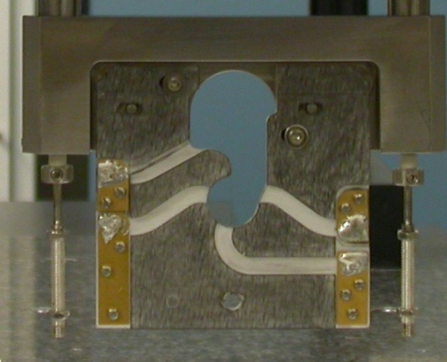  Transformation  Y+  X+  View from Z+ or Downstream | 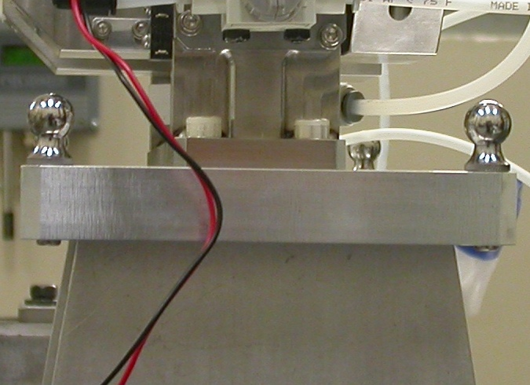  Y+  Z+  View from X+ Side
Wire CSY (WIRE$CSY)

- Back Plane (-Z) Side sets Zero in Z and is the Spatial Alignment
- Looking from +Z Side, Bottom of Card Sets Zero is the Planar Alignment
- The Intersection of the Left Side of the Card and the Bottom, sets Zero in X & Y

Wire offset from Edges per T. Nakashima’s Optical Measurement

Wire | Wire Location | Wire Diameter
Vertical Wire (X Location from Card) | 39.6126 | 0.0380
Horizontal Wire (Y Location from Card) | 37.0110 | 0.0374

Support Stand CSY (BASE$CSY)

- A plane on Torque Fixture sets Zero in Y and is the Spatial Alignment
- The symmetry of the outer surfaces where “X” fine adjustments are sets zero in X.
- A line where the Torque Fixture 2X Dowel pins sets zero in Z and is the Planar Alignment.

Beamline CSY (BEAMLINE$CSY)

- Use the BENCH$CSY setup except use the Torque Fixture plate to set zero in Y and the Spatial Alignment, transform +258.67 in Y to replicate Theoretical Beamline Center
- This coordinate system will tell us where the Wire Crosshairs are to a theoretical Beam Centerline.
- The wires should be offset ~ -0.400 in X, -0.200 in Y.

Statistical Data (mm.)
Out of Vacuum
10 Cycles (10 recordings)
Card Locations
CSY = BENCH$CSY

STATS | X-POS CARD | X-INTPT CARD | Y-INTPT CARD
AVG. | 0.02806 | -40.26004 | -94.99857
Range | 0.04965 | 0.05820 | 0.01042
St. Dev. | 0.01965 | 0.02300 | 0.00384

Wire Location

CSY = BEAMLINE$CSY
Stats | X | Y
AVG. | -0.39848 | -0.26912
Range | 0.04959 | 0.00664
St. Dev. | 0.01963 | 0.00207
Nom. | -0.40000 | -0.20000
RMS Tol | 0.06500 | 0.03000

Transformation WIRE$CSY TO BENCH$CSY
Stats | X | Y | Z | APA_PXPY | PA_PYPZ | PA_PXPZ
AVG. | -0.39848 | -58.26912 | -2.56477 | -0.39201 | 89.91474 | 89.95953
Range | 0.04959 | 0.00664 | 0.03438 | 0.01336 | 0.00999 | 0.00357
St. Dev. | 0.01963 | 0.00207 | 0.00895 | 0.00511 | 0.00253 | 0.00141
RMS Tol | 0.06500 | 0.03000 | - | - | - | -

Transformation WIRE$CSY to BFWTB$CSY
Stats | X | Y | Z | APA_PXPY | PA_PYPZ | PA_PXPZ
AVG. | 94.88325 | -160.69708 | 35.68105 | -0.03332 | 89.86921 | 89.94096
Range | 0.00247 | 0.00098 | 0.00248 | 0.00099 | 0.00110 | 0.00103
St. Dev. | 0.00075 | 0.00026 | 0.00070 | 0.00030 | 0.00032 | 0.00037
RMS Tol | 0.06500 | 0.03000 | - | - | - | -

Under Vacuum
10 Cycles (10 recordings)
TB 5-8 Locations
CSY = BENCH$CSY

TB 5 | X | Y | Z
AVG. | 94.56503 | 101.97441 | -38.14357
Range | 0.00427 | 0.01482 | 0.01346
St. Dev. | 0.00130 | 0.00423 | 0.00376
RMS Tol | 0.06500 | 0.03000 | -

TB 6 | X | Y | Z
AVG. | -94.31132 | 103.18903 | -38.06952
Range | 0.00556 | 0.01816 | 0.00802
St. Dev. | 0.00162 | 0.00508 | 0.00231
RMS Tol | 0.06500 | 0.03000 | -

TB 7 | X | Y | Z
AVG. | -51.14223 | 102.89817 | 67.77066
Range | 0.01680 | 0.00312 | 0.00233
St. Dev. | 0.00480 | 0.00109 | 0.00068
RMS Tol | 0.06500 | 0.03000 | -

TB 8 | X | Y | Z
AVG. | 51.45049 | 102.24043 | 67.70802
Range | 0.01677 | 0.01836 | 0.00883
St. Dev. | 0.00484 | 0.00531 | 0.00256
RMS Tol | 0.06500 | 0.03000 | -

Wire Location

CSY = BEAMLINE$CSY
Stats | X | Y
AVG. | -0.45104 | -0.23889
Range | 0.03670 | 0.00218
St. Dev. | 0.01052 | 0.00069
Nom. | -0.40000 | -0.20000
RMS Tol | 0.06500 | 0.03000

Transformation WIRE$CSY TO BENCH$CSY
Stats | X | Y | Z | APA_PXPY | PA_PYPZ | PA_PXPZ
AVG. | -0.45087 | -58.11919 | -2.44603 | -0.40181 | 89.87709 | 89.91823
Range | 0.03670 | 0.00217 | 0.01360 | 0.00976 | 0.00580 | 0.00654
St. Dev. | 0.01052 | 0.00069 | 0.00368 | 0.00279 | 0.00157 | 0.00183
RMS Tol | 0.06500 | 0.03000 | - | - | - | -

Locations of ¼-20 Jo-Plugs Cylinders Intersected into Plane projected 12.7mm away from surface replicating a ½” (12.7mm) offset to center of Tooling Ball.

CSY = BEAMLINE$CSY
INTPT | X | Y | Z
1 | -27.11016 | 227.54089 | 68.34193
2 | 26.87549 | 227.53671 | 68.33005
3 | 79.74517 | 180.18034 | -68.67804
4 | -79.99668 | 180.10394 | -68.65493

