
LCLS BFW WIRECARD ASSY
INSPECTION/FIDUCIAL REPORT

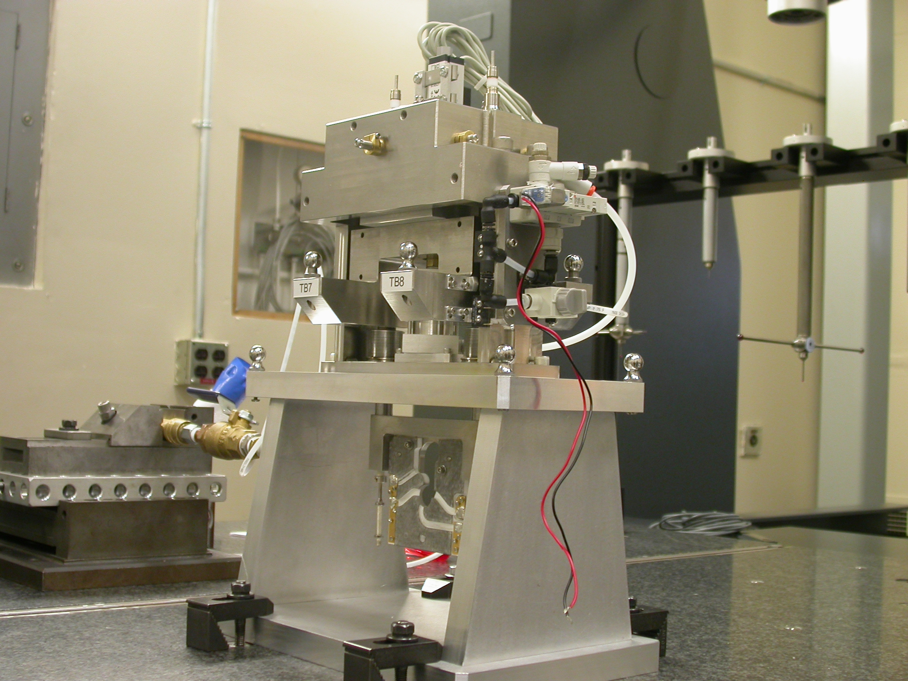

Inspector: | Keith Caban
Responsible Engineer: | Don Schafer
Date: | Thursday, July 31, 2008
Work Order/Charge No.: | 23800-1
Serial Number: | BFW – 35 / VC – 35 / WC – 35 / BASE – 01
Units of Measure: | Metric – Millimeters (mm.)
URL | http://www-group/met/Quality/FIDUCIAL%20REPORTS/LCLS%20BFW/BFW-35_VC-35_WC-35_BAS-01.pdf

Coordinate System Setups

Bench CSY (BENCH$CSY)
(The only CSY in Both States of measurement - out and under vacuum)

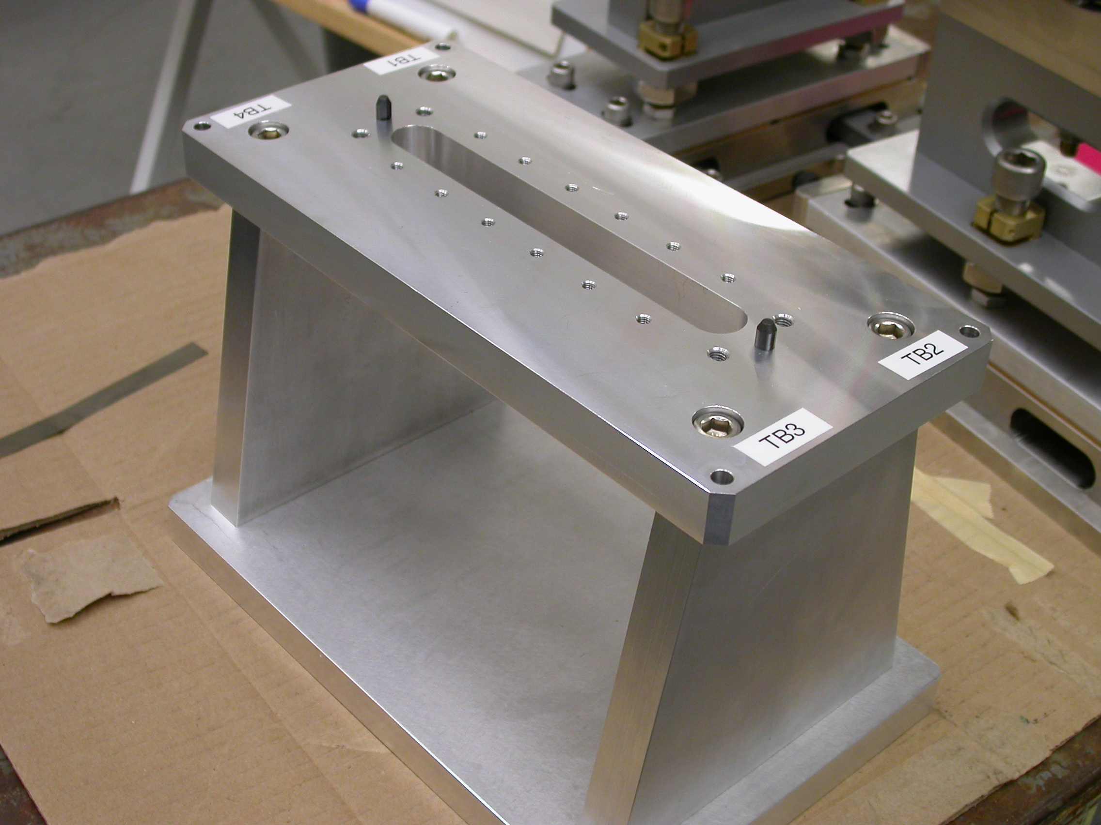
+Y
+Z
+X

- Plane measurement on top of Bench to set zero in Y and is the Spatial Alignment.
- Measure Pin and Diamond Pin to get centers, create a line between the two center points and this sets zero in Z and is the Planar Alignment.
- Take the symmetry point of the two pins this sets zero in X.

Bench Tooling Ball CSY (BTB$CSY)
- Create a plane using Tooling Balls 1, 2, & 3
  - This sets Zero in Y and is the spatial alignment
- Create an axis/line using TB’s 2 to 1 (+X)
  - This is the planar alignment
- TB 2 is a single point that sets zero in X, Y, Z.

BFW Tooling Ball CSY (BFWTB$CSY)
- Create a plane using Tooling Balls 5, 6, & 7
  - This sets Zero in Y and is the spatial alignment
- Create an axis/line using TB’s 6 to 5 (+X)
  - This is the planar alignment
- TB 6 is a single point that sets zero in X, Y, Z.

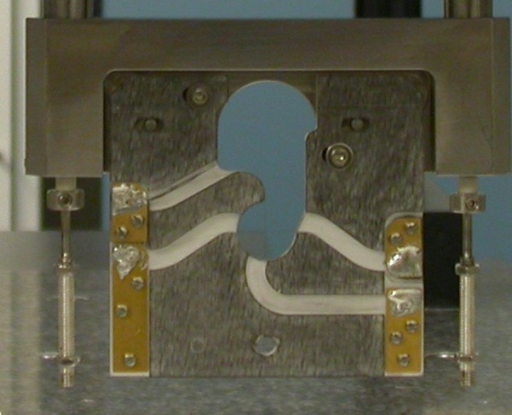  Transformation  Y+  X+  View from Z+ or Downstream | 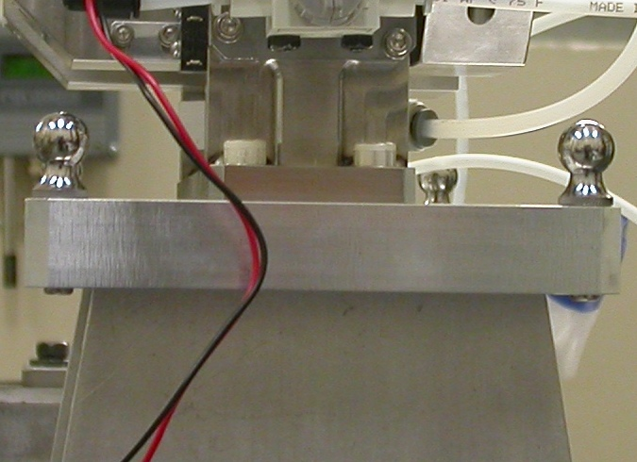  Y+  Z+  View from X+ Side
Wire CSY (WIRE$CSY)

- Back Plane (-Z) Side sets Zero in Z and is the Spatial Alignment
- Looking from +Z Side, Bottom of Card Sets Zero is the Planar Alignment
- The Intersection of the Left Side of the Card and the Bottom, sets Zero in X & Y

Wire offset from Edges per T. Nakashima’s Optical Measurement

Wire | Wire Location | Wire Diameter
Vertical Wire (X Location from Card) | 39.6104 | 0.0364
Horizontal Wire (Y Location from Card) | 37.0127 | 0.0386

Support Stand CSY (BASE$CSY)

- A plane on Torque Fixture sets Zero in Y and is the Spatial Alignment
- The symmetry of the outer surfaces where “X” fine adjustments are sets zero in X.
- A line where the Torque Fixture 2X Dowel pins sets zero in Z and is the Planar Alignment.

Beamline CSY (BEAMLINE$CSY)

- Use the BENCH$CSY setup except use the Torque Fixture plate to set zero in Y and the Spatial Alignment, transform +258.67 in Y to replicate Theoretical Beamline Center
- This coordinate system will tell us where the Wire Crosshairs are to a theoretical Beam Centerline.
- The wires should be offset ~ -0.400 in X, -0.200 in Y.

Statistical Data (mm.)
Out of Vacuum
10 Cycles (10 recordings)
Card Locations
CSY = BENCH$CSY

STATS | X-POS CARD | X-INTPT CARD | Y-INTPT CARD
AVG. | -0.02822 | -39.93728 | -95.29372
Range | 0.00243 | 0.00209 | 0.00164
St. Dev. | 0.00071 | 0.00065 | 0.00051

Wire Location

CSY = BEAMLINE$CSY
Stats | X | Y
AVG. | -0.45175 | -0.16163
Range | 0.00288 | 0.00108
St. Dev. | 0.00086 | 0.00036
Nom. | -0.40000 | -0.20000
RMS Tol | 0.06500 | 0.03000

Transformation WIRE$CSY TO BENCH$CSY
Stats | X | Y | Z | APA_PXPY | PA_PYPZ | PA_PXPZ
AVG. | -0.45175 | -58.16163 | -2.28115 | 0.19025 | 89.92843 | 89.97805
Range | 0.00288 | 0.00108 | 0.00185 | 0.00086 | 0.00070 | 0.00060
St. Dev. | 0.00086 | 0.00036 | 0.00069 | 0.00031 | 0.00021 | 0.00019
RMS Tol | 0.06500 | 0.03000 | - | - | - | -

Transformation WIRE$CSY to BFWTB$CSY
Stats | X | Y | Z | APA_PXPY | PA_PYPZ | PA_PXPZ
AVG. | 93.39463 | -160.45806 | 35.68550 | 0.11685 | 89.87504 | 90.05300
Range | 0.00353 | 0.00224 | 0.00472 | 0.00067 | 0.00160 | 0.00087
St. Dev. | 0.00101 | 0.00064 | 0.00158 | 0.00024 | 0.00058 | 0.00032
RMS Tol | 0.06500 | 0.03000 | - | - | - | -

Under Vacuum
10 Cycles (10 recordings)
TB 5-8 Locations
CSY = BENCH$CSY

TB 5 | X | Y | Z
AVG. | 94.74878 | 102.41031 | -38.05076
Range | 0.01387 | 0.01963 | 0.08295
St. Dev. | 0.00498 | 0.00682 | 0.02920
RMS Tol | 0.06500 | 0.03000 | -

TB 6 | X | Y | Z
AVG. | -94.09099 | 102.24746 | -37.67278
Range | 0.01324 | 0.00725 | 0.01696
St. Dev. | 0.00473 | 0.00291 | 0.00665
RMS Tol | 0.06500 | 0.03000 | -

TB 7 | X | Y | Z
AVG. | -50.76989 | 102.19398 | 68.05610
Range | 0.04166 | 0.02013 | 0.00589
St. Dev. | 0.01487 | 0.00731 | 0.00180
RMS Tol | 0.06500 | 0.03000 | -

TB 8 | X | Y | Z
AVG. | 51.76830 | 102.27916 | 67.86615
Range | 0.04146 | 0.00737 | 0.05984
St. Dev. | 0.01490 | 0.00255 | 0.02119
RMS Tol | 0.06500 | 0.03000 | -

Wire Location

CSY = BEAMLINE$CSY
Stats | X | Y
AVG. | -0.49408 | -0.24157
Range | 0.01610 | 0.00255
St. Dev. | 0.00614 | 0.00077
Nom. | -0.40000 | -0.20000
RMS Tol | 0.06500 | 0.03000

Transformation WIRE$CSY TO BENCH$CSY
Stats | X | Y | Z | APA_PXPY | PA_PYPZ | PA_PXPZ
AVG. | -0.48817 | -58.16121 | -2.31172 | 0.16636 | 89.92376 | 89.93835
Range | 0.01611 | 0.00256 | 0.00557 | 0.00781 | 0.01085 | 0.03032
St. Dev. | 0.00614 | 0.00077 | 0.00177 | 0.00290 | 0.00365 | 0.01086
RMS Tol | 0.06500 | 0.03000 | - | - | - | -

Locations of ¼-20 Jo-Plugs Cylinders Intersected into Plane projected 12.7mm away from surface replicating a ½” (12.7mm) offset to center of Tooling Ball.

CSY = BEAMLINE$CSY
INTPT | X | Y | Z
1 | -27.02567 | 227.43341 | 68.27202
2 | 26.98383 | 227.43782 | 68.25629
3 | 79.77405 | 179.96531 | -68.73934
4 | -79.93210 | 180.03912 | -68.68991

