
LCLS BFW WIRECARD ASSY
INSPECTION/FIDUCIAL REPORT

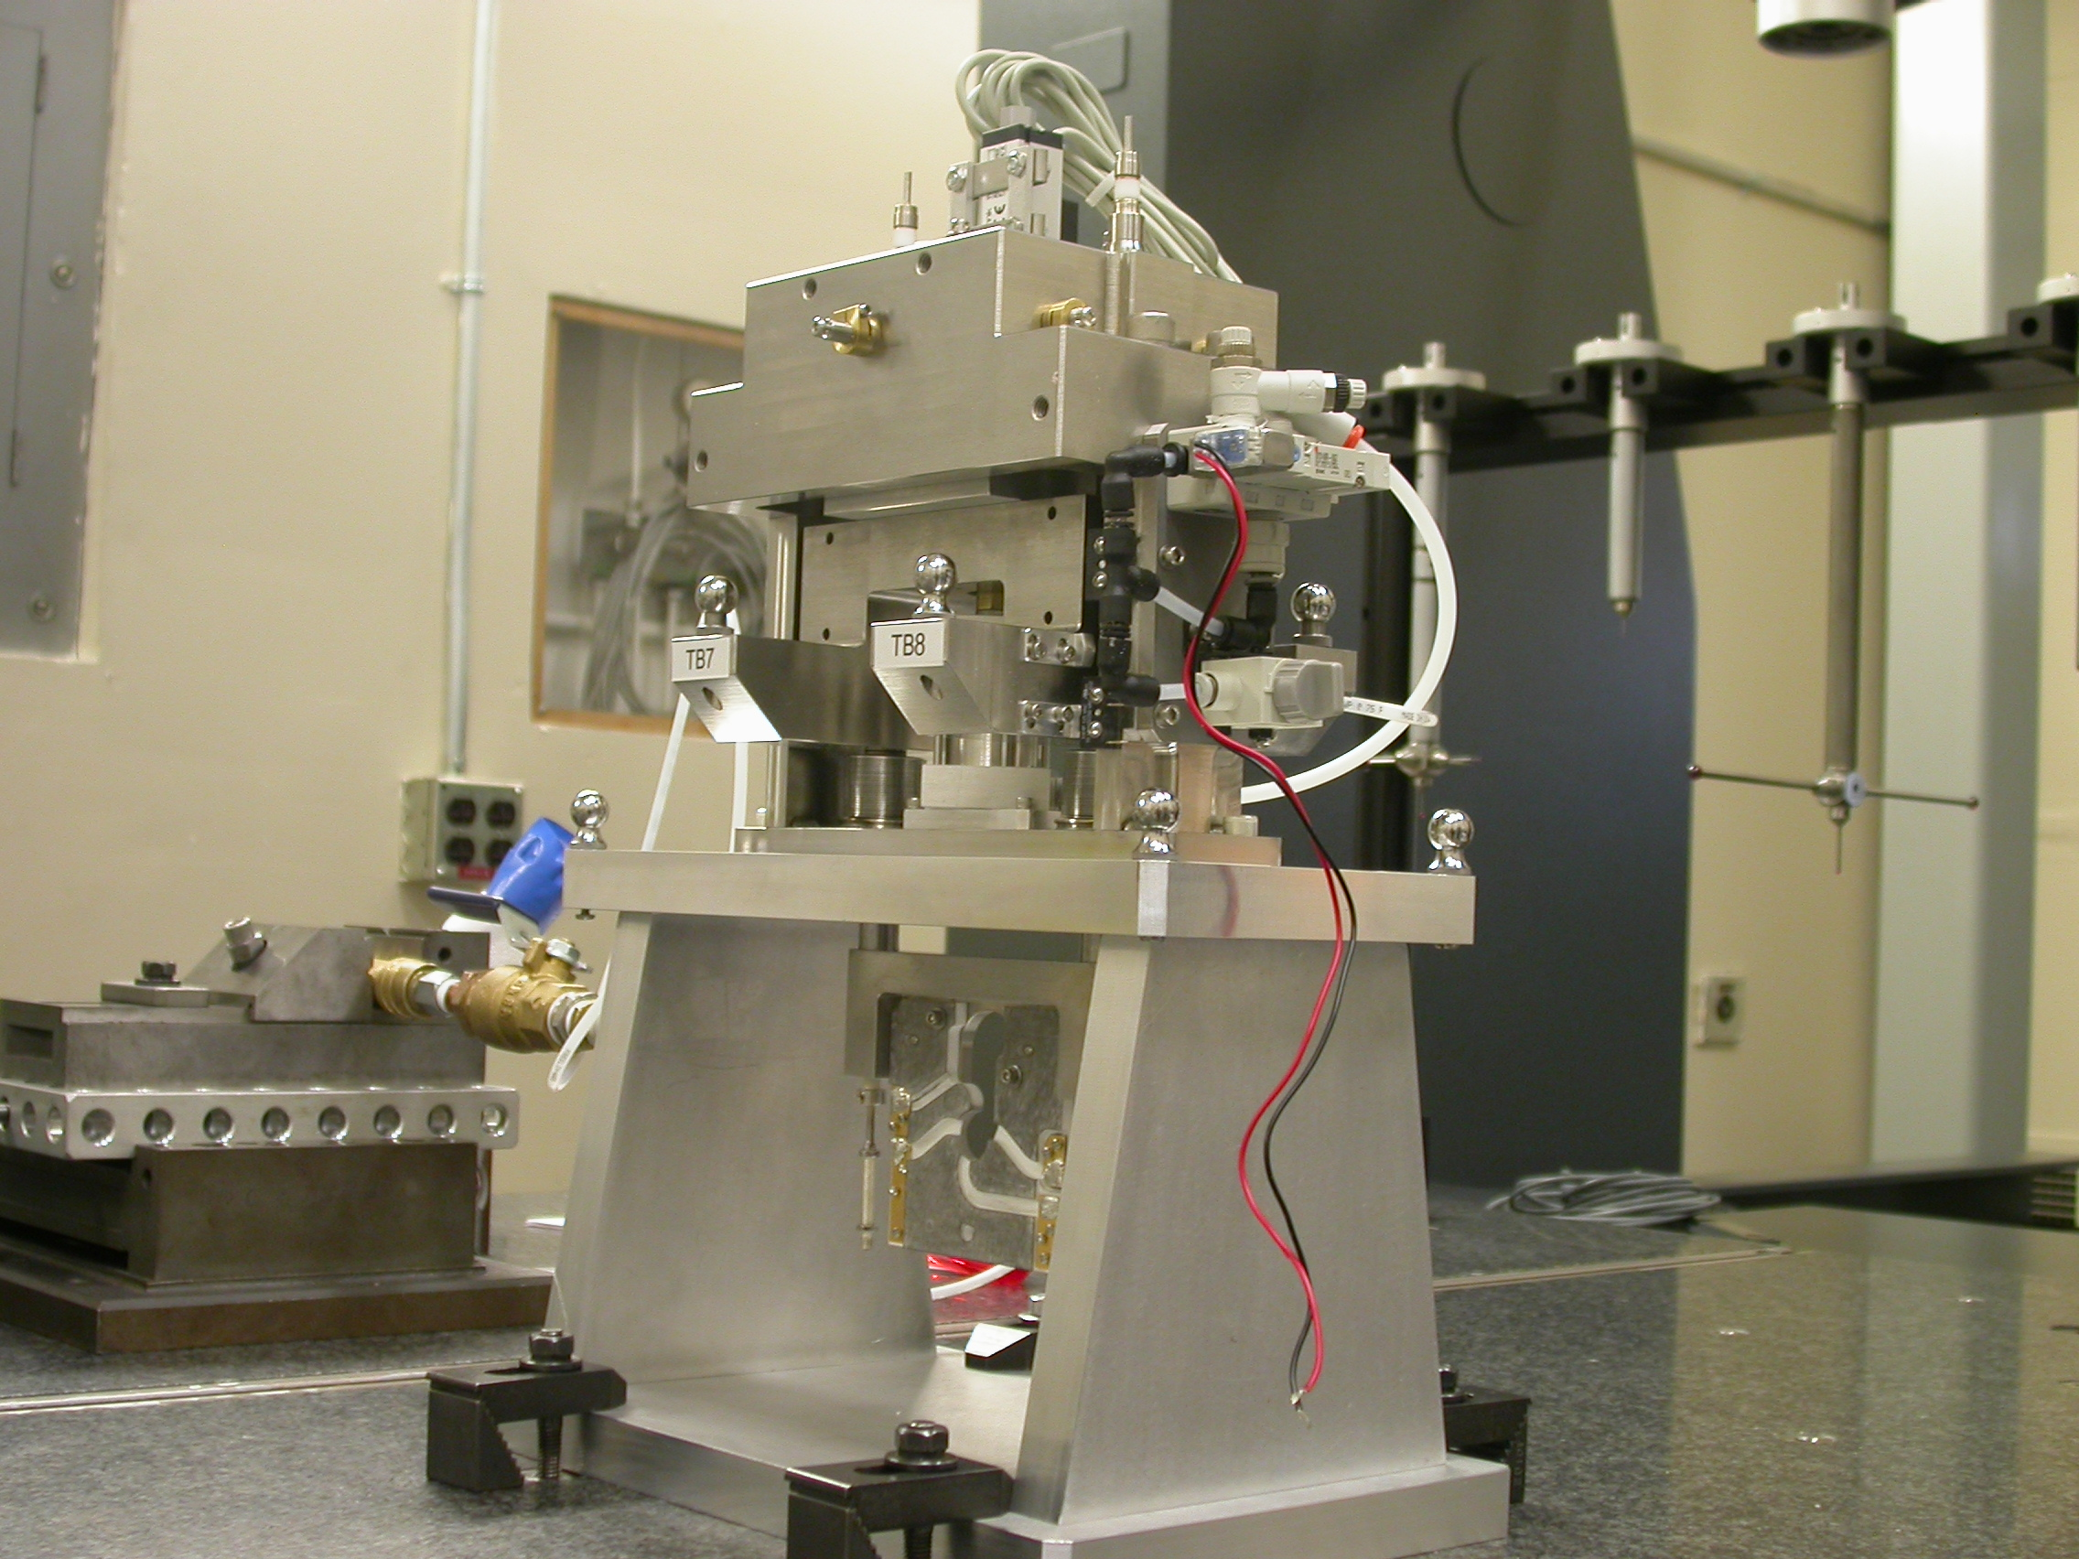

Inspector: | Keith Caban
Responsible Engineer: | Venkat Srinivasan
Date: | Thursday, July 03, 2008
Work Order/Charge No.: | 23800-1
Serial Number: | BFW – 16 / VC – 16 / WC – 16 / BASE – 18
Units of Measure: | Metric – Millimeters (mm.)
URL | http://www-group/met/Quality/FIDUCIAL%20REPORTS/LCLS%20BFW/BFW-16_VC-16_WC-16_BAS-18.pdf

Coordinate System Setups

Bench CSY (BENCH$CSY)
(The only CSY in Both States of measurement - out and under vacuum)

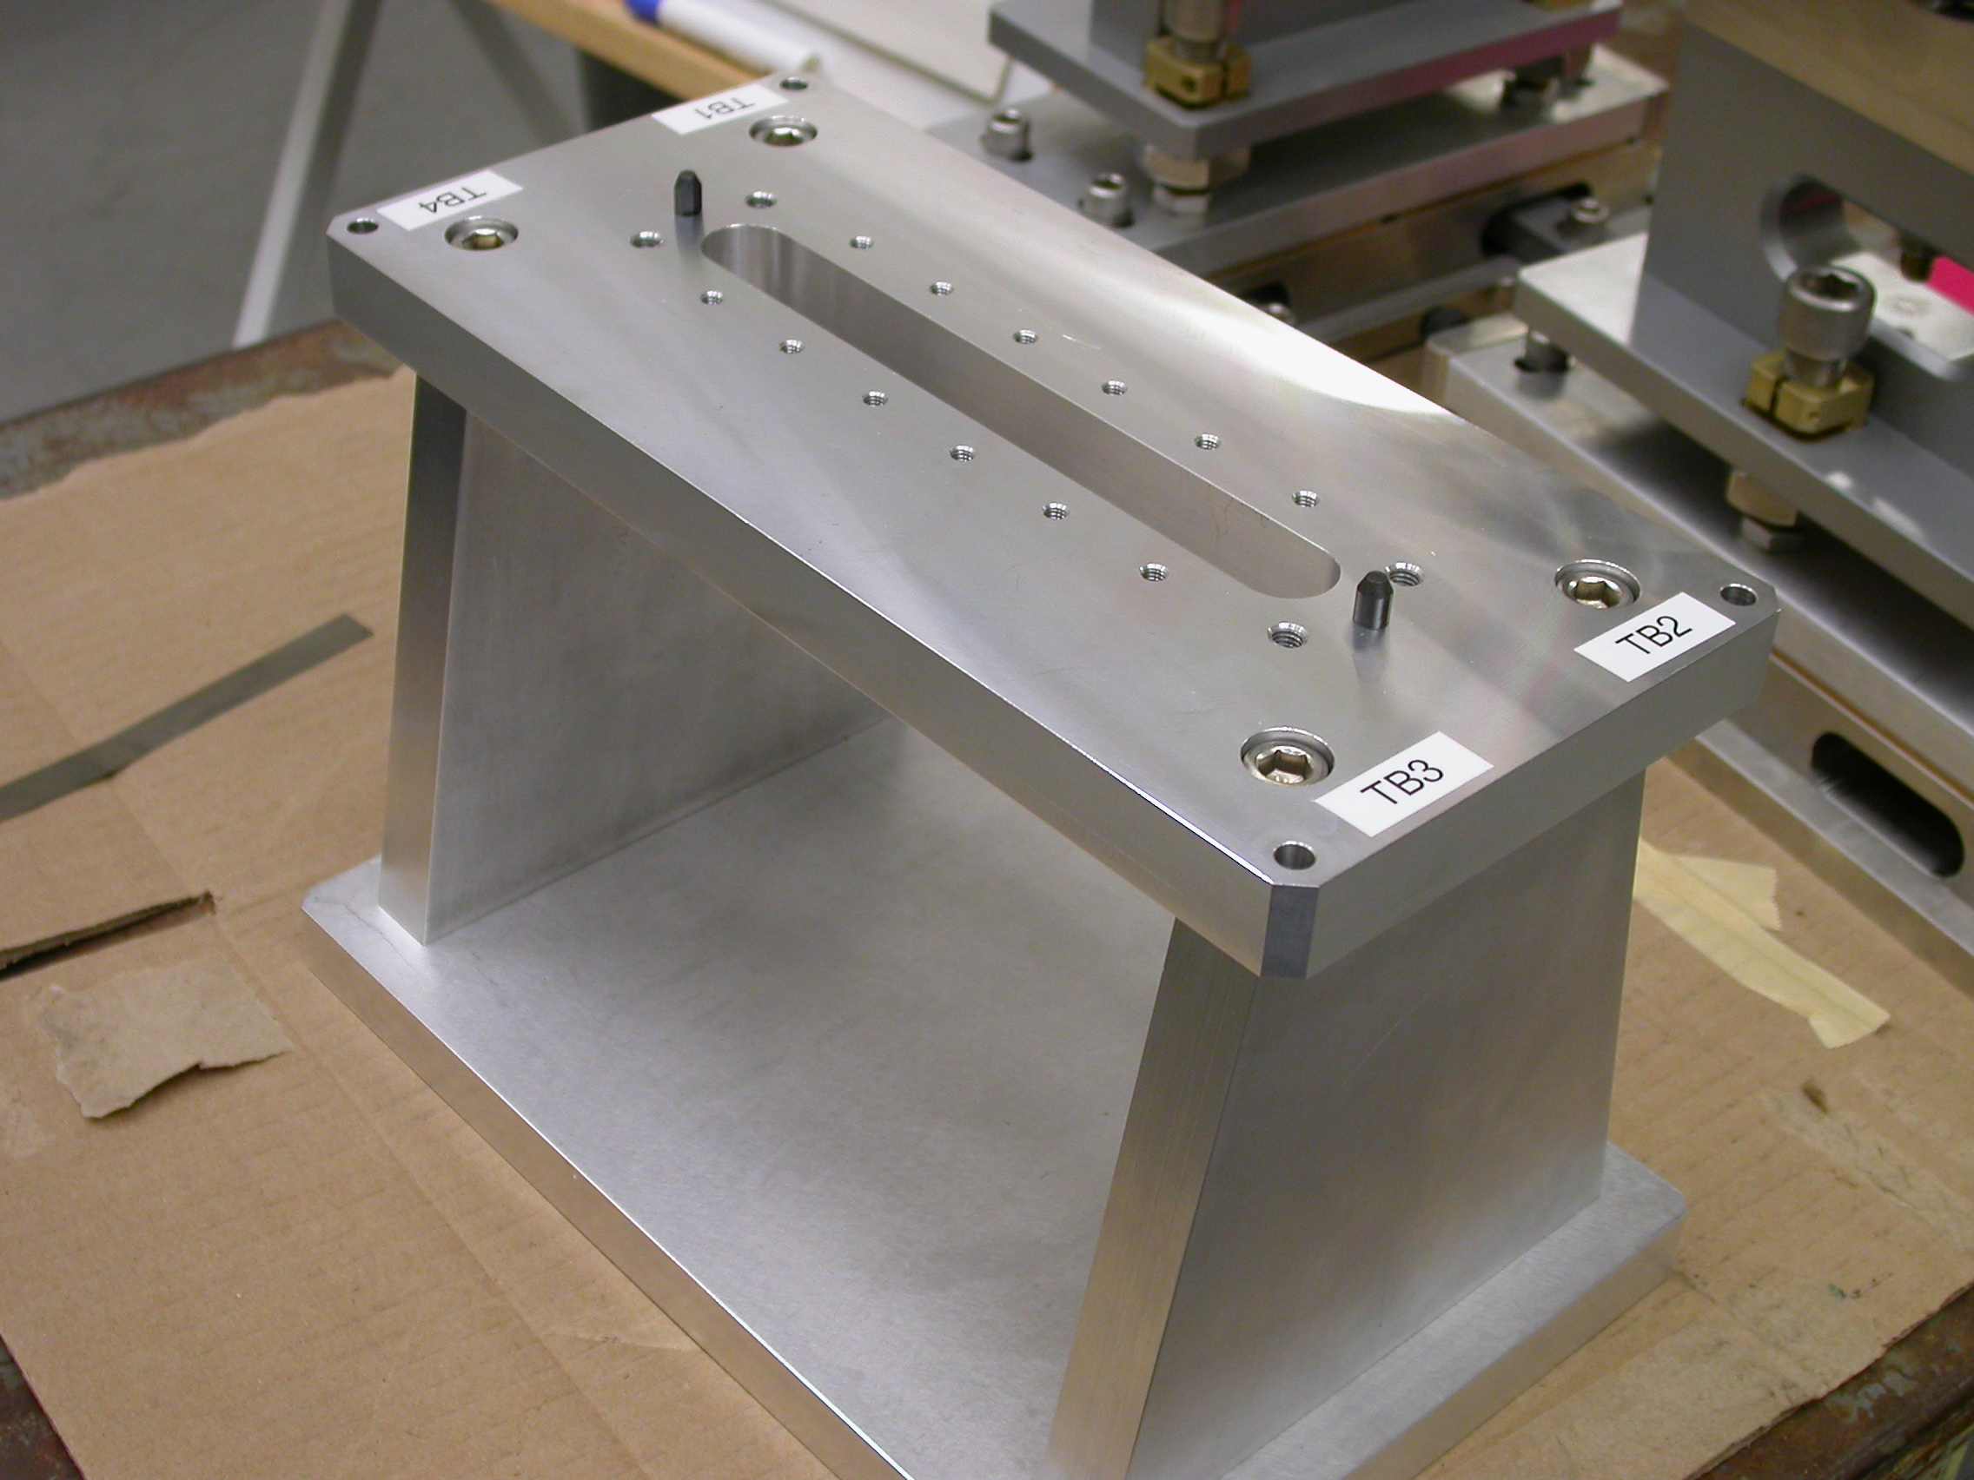
+Y
+Z
+X

- Plane measurement on top of Bench to set zero in Y and is the Spatial Alignment.
- Measure Pin and Diamond Pin to get centers, create a line between the two center points and this sets zero in Z and is the Planar Alignment.
- Take the symmetry point of the two pins this sets zero in X.

Bench Tooling Ball CSY (BTB$CSY)
- Create a plane using Tooling Balls 1, 2, & 3
  - This sets Zero in Y and is the spatial alignment
- Create an axis/line using TB’s 2 to 1 (+X)
  - This is the planar alignment
- TB 2 is a single point that sets zero in X, Y, Z.

BFW Tooling Ball CSY (BFWTB$CSY)
- Create a plane using Tooling Balls 5, 6, & 7
  - This sets Zero in Y and is the spatial alignment
- Create an axis/line using TB’s 6 to 5 (+X)
  - This is the planar alignment
- TB 6 is a single point that sets zero in X, Y, Z.

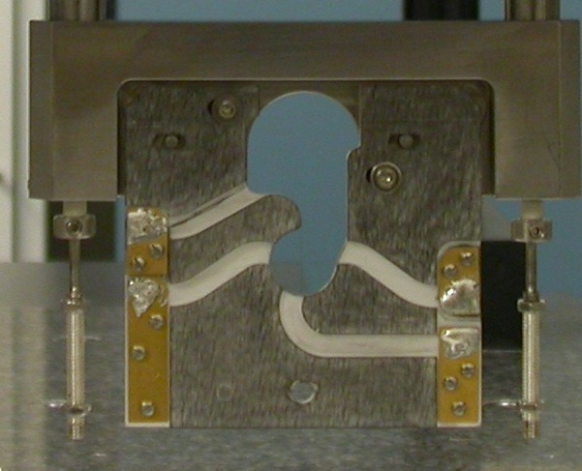  Transformation  Y+  X+  View from Z+ or Downstream | 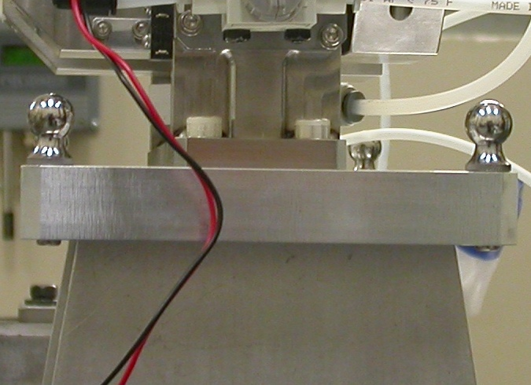  Y+  Z+  View from X+ Side
Wire CSY (WIRE$CSY)

- Back Plane (-Z) Side sets Zero in Z and is the Spatial Alignment
- Looking from +Z Side, Bottom of Card Sets Zero is the Planar Alignment
- The Intersection of the Left Side of the Card and the Bottom, sets Zero in X & Y

Wire offset from Edges per T. Nakashima’s Optical Measurement

Wire | Wire Location | Wire Diameter
Vertical Wire (X Location from Card) | 39.6075 | 0.0363
Horizontal Wire (Y Location from Card) | 37.0017 | 0.0392

Support Stand CSY (BASE$CSY)

- A plane on Torque Fixture sets Zero in Y and is the Spatial Alignment
- The symmetry of the outer surfaces where “X” fine adjustments are sets zero in X.
- A line where the Torque Fixture 2X Dowel pins sets zero in Z and is the Planar Alignment.

Beamline CSY (BEAMLINE$CSY)

- Use the BENCH$CSY setup except use the Torque Fixture plate to set zero in Y and the Spatial Alignment, transform +258.67 in Y to replicate Theoretical Beamline Center
- This coordinate system will tell us where the Wire Crosshairs are to a theoretical Beam Centerline.
- The wires should be offset ~ -0.400 in X, -0.200 in Y.

Statistical Data (mm.)
Out of Vacuum
10 Cycles (10 recordings)
Card Locations
CSY = BENCH$CSY

STATS | X-POS CARD | X-INTPT CARD | Y-INTPT CARD
AVG. | 0.03618 | -40.75043 | -95.44442
Range | 0.04412 | 0.14916 | 0.01012
St. Dev. | 0.01380 | 0.05168 | 0.00330

Wire Location

CSY = BEAMLINE$CSY
Stats | X | Y
AVG. | -0.38708 | -0.21622
Range | 0.04419 | 0.00165
St. Dev. | 0.01383 | 0.00066
Nom. | -0.40000 | -0.20000
RMS Tol | 0.06500 | 0.03000

Transformation WIRE$CSY TO BENCH$CSY
Stats | X | Y | Z | APA_PXPY | PA_PYPZ | PA_PXPZ
AVG. | -0.38708 | -58.21622 | -3.27770 | 0.33838 | 90.22179 | 90.00272
Range | 0.04419 | 0.00165 | 0.04419 | 0.01330 | 0.01141 | 0.00534
St. Dev. | 0.01383 | 0.00066 | 0.01376 | 0.00413 | 0.00356 | 0.00165
RMS Tol | 0.06500 | 0.03000 | - | - | - | -

Transformation WIRE$CSY to BFWTB$CSY
Stats | X | Y | Z | APA_PXPY | PA_PYPZ | PA_PXPZ
AVG. | 93.37386 | -160.84725 | 35.65308 | 0.02929 | 89.91594 | 89.98503
Range | 0.00594 | 0.00272 | 0.00441 | 0.00196 | 0.00169 | 0.00185
St. Dev. | 0.00178 | 0.00094 | 0.00122 | 0.00065 | 0.00047 | 0.00062
RMS Tol | 0.06500 | 0.03000 | - | - | - | -

Under Vacuum
10 Cycles (10 recordings)
TB 5-8 Locations
CSY = BENCH$CSY

TB 5 | X | Y | Z
AVG. | 94.21389 | 103.14434 | -37.76802
Range | 0.00737 | 0.00688 | 0.00820
St. Dev. | 0.00234 | 0.00258 | 0.00261
RMS Tol | 0.06500 | 0.03000 | -

TB 6 | X | Y | Z
AVG. | -94.64972 | 102.20924 | -37.52269
Range | 0.00758 | 0.00345 | 0.01027
St. Dev. | 0.00245 | 0.00116 | 0.00326
RMS Tol | 0.06500 | 0.03000 | -

TB 7 | X | Y | Z
AVG. | -51.39675 | 102.06872 | 68.26850
Range | 0.00326 | 0.00261 | 0.00566
St. Dev. | 0.00103 | 0.00086 | 0.00181
RMS Tol | 0.06500 | 0.03000 | -

TB 8 | X | Y | Z
AVG. | 51.18998 | 102.57942 | 68.11415
Range | 0.00353 | 0.00397 | 0.00421
St. Dev. | 0.00105 | 0.00152 | 0.00139
RMS Tol | 0.06500 | 0.03000 | -

Wire Location

CSY = BEAMLINE$CSY
Stats | X | Y
AVG. | -0.42515 | -0.27334
Range | 0.00764 | 0.00220
St. Dev. | 0.00269 | 0.00067
Nom. | -0.40000 | -0.20000
RMS Tol | 0.06500 | 0.03000

Transformation WIRE$CSY TO BENCH$CSY
Stats | X | Y | Z | APA_PXPY | PA_PYPZ | PA_PXPZ
AVG. | -0.43319 | -58.29120 | -2.53132 | 0.31350 | 90.10788 | 89.90961
Range | 0.00764 | 0.00220 | 0.00313 | 0.00300 | 0.00122 | 0.00561
St. Dev. | 0.00270 | 0.00075 | 0.00103 | 0.00109 | 0.00045 | 0.00177
RMS Tol | 0.06500 | 0.03000 | - | - | - | -

Locations of ¼-20 Jo-Plugs Cylinders Intersected into Plane projected 12.7mm away from surface replicating a ½” (12.7mm) offset to center of Tooling Ball.

CSY = BEAMLINE$CSY
INTPT | X | Y | Z
1 | -27.20282 | 227.55292 | 68.62271
2 | 26.83392 | 227.58422 | 68.57984
3 | 79.54441 | 180.36487 | -68.54096
4 | -80.09338 | 180.31729 | -68.41221

