
LCLS BFW WIRECARD ASSY
INSPECTION/FIDUCIAL REPORT

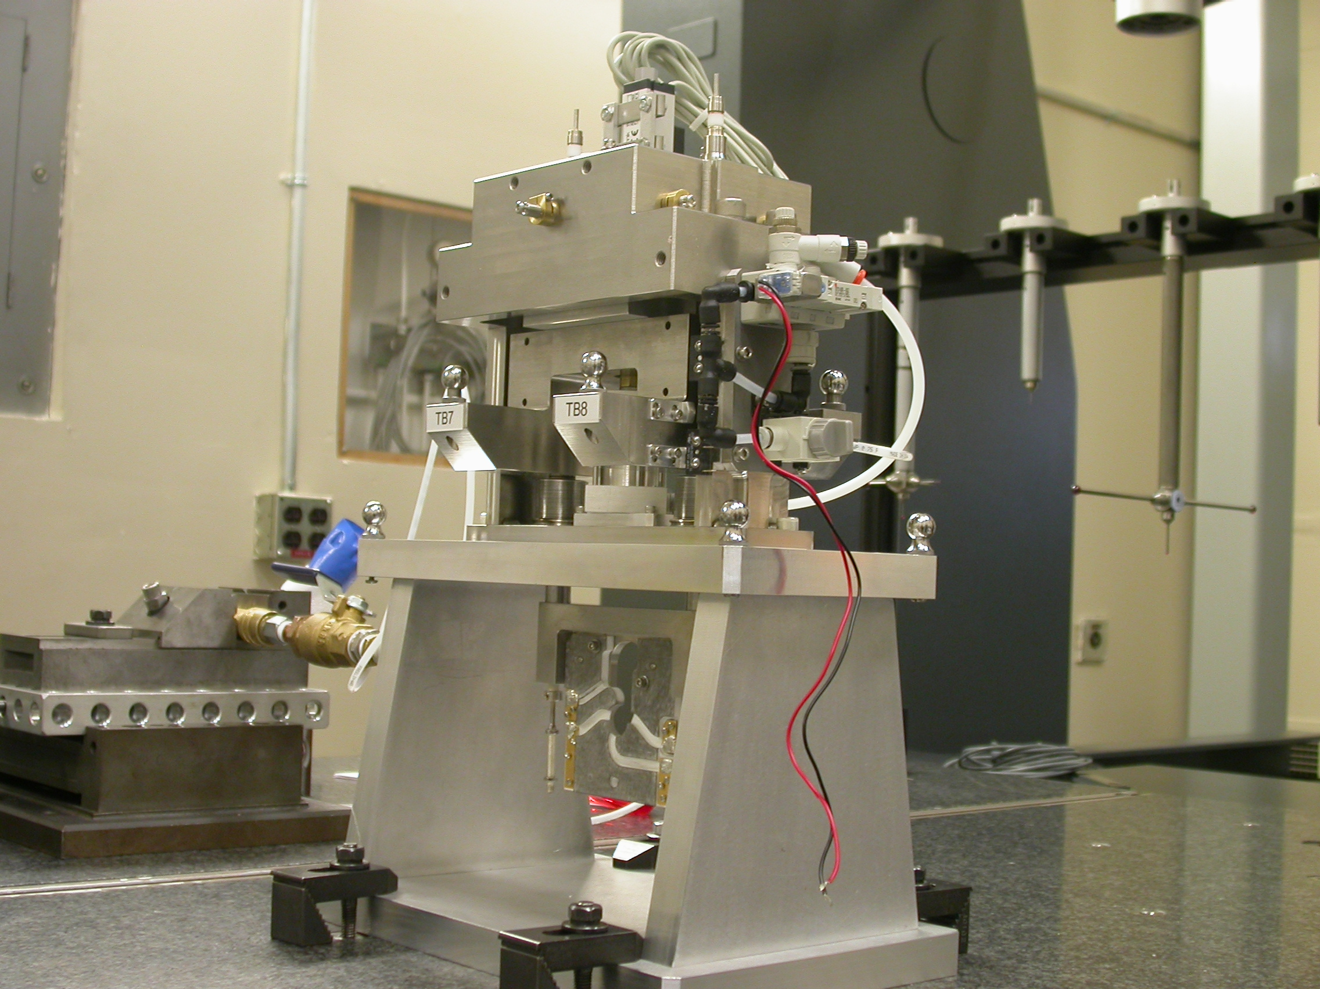

Inspector: | Keith Caban
Responsible Engineer: | Venkat Srinivasan
Date: | Tuesday, June 17, 2008
Work Order/Charge No.: | 23800-1
Serial Number: | BFW – 13 / VC – 13 / WC – 13 / BASE – 13
Units of Measure: | Metric – Millimeters (mm.)
URL | http://www-group/met/Quality/FIDUCIAL%20REPORTS/LCLS%20BFW/BFW-13_VC-13_WC-13_BAS-13.pdf

Coordinate System Setups

Bench CSY (BENCH$CSY)
(The only CSY in Both States of measurement - out and under vacuum)

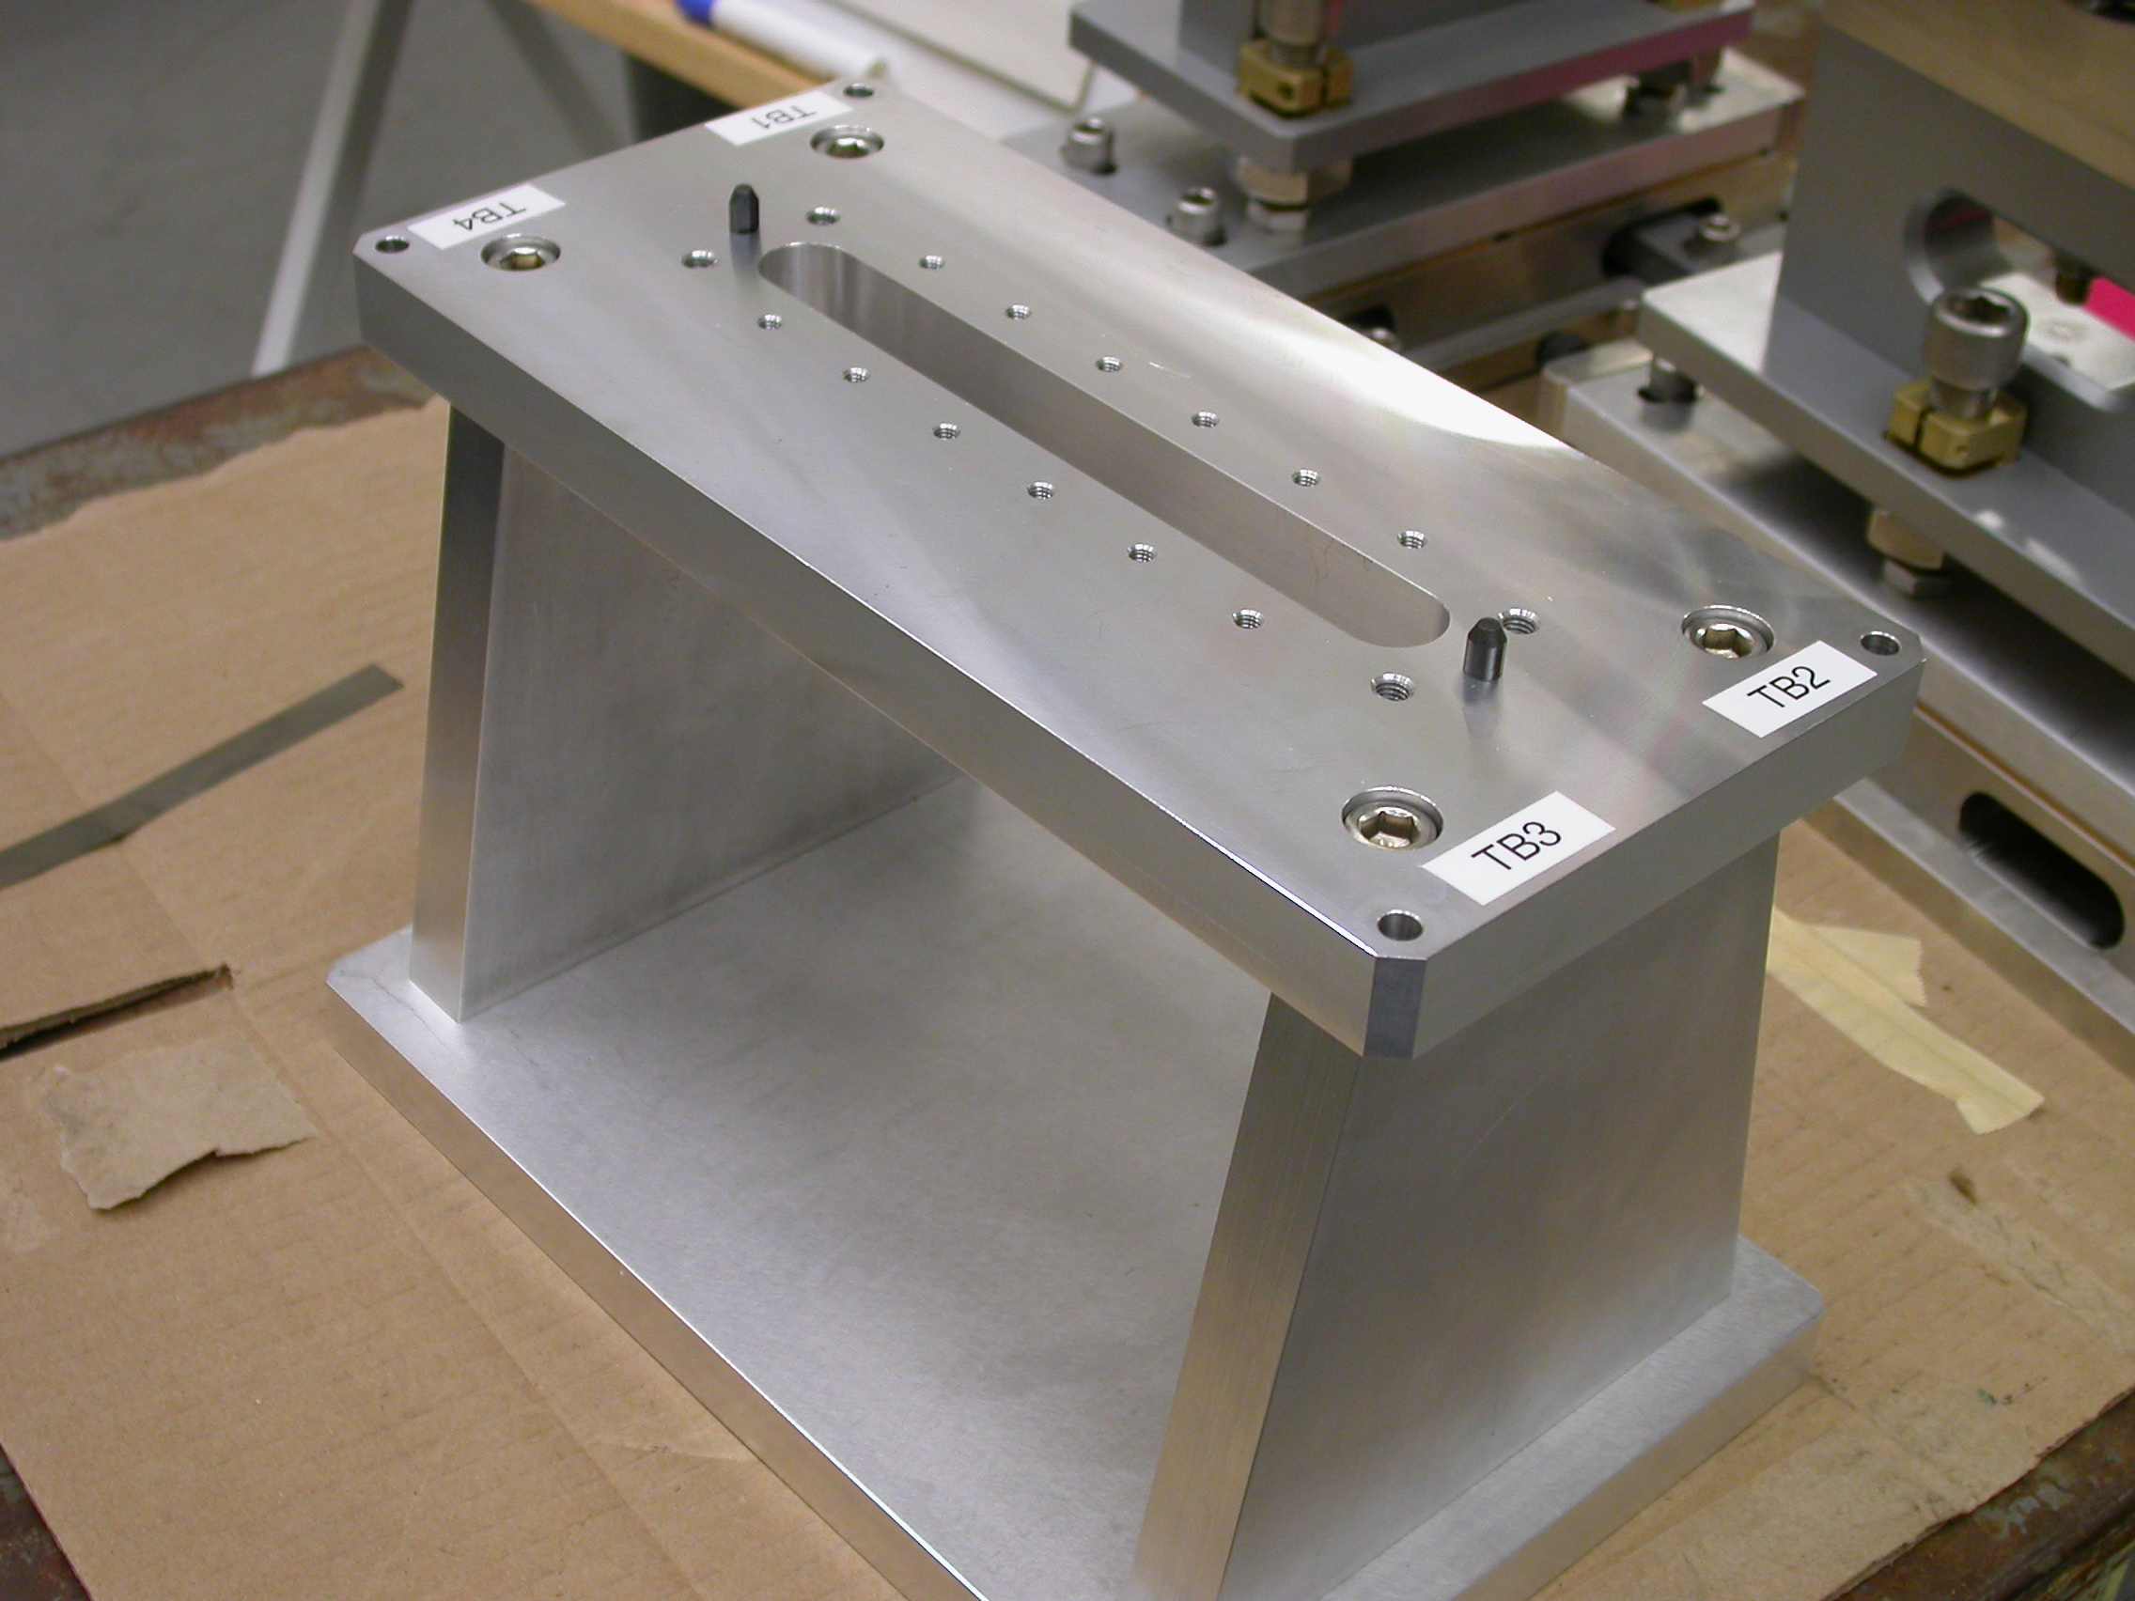
+Y
+Z
+X

- Plane measurement on top of Bench to set zero in Y and is the Spatial Alignment.
- Measure Pin and Diamond Pin to get centers, create a line between the two center points and this sets zero in Z and is the Planar Alignment.
- Take the symmetry point of the two pins this sets zero in X.

Bench Tooling Ball CSY (BTB$CSY)
- Create a plane using Tooling Balls 1, 2, & 3
  - This sets Zero in Y and is the spatial alignment
- Create an axis/line using TB’s 2 to 1 (+X)
  - This is the planar alignment
- TB 2 is a single point that sets zero in X, Y, Z.

BFW Tooling Ball CSY (BFWTB$CSY)
- Create a plane using Tooling Balls 5, 6, & 7
  - This sets Zero in Y and is the spatial alignment
- Create an axis/line using TB’s 6 to 5 (+X)
  - This is the planar alignment
- TB 6 is a single point that sets zero in X, Y, Z.

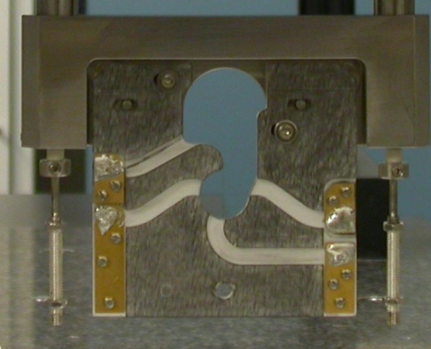  Transformation  Y+  X+  View from Z+ or Downstream | 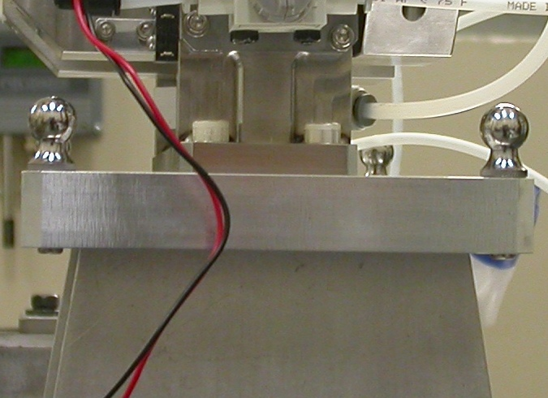  Y+  Z+  View from X+ Side
Wire CSY (WIRE$CSY)

- Back Plane (-Z) Side sets Zero in Z and is the Spatial Alignment
- Looking from +Z Side, Bottom of Card Sets Zero is the Planar Alignment
- The Intersection of the Left Side of the Card and the Bottom, sets Zero in X & Y

Wire offset from Edges per T. Nakashima’s Optical Measurement

Wire | Wire Location | Wire Diameter
Vertical Wire (X Location from Card) | 39.6044 | 0.0387
Horizontal Wire (Y Location from Card) | 37.0070 | 0.0402

Support Stand CSY (BASE$CSY)

- A plane on Torque Fixture sets Zero in Y and is the Spatial Alignment
- The symmetry of the outer surfaces where “X” fine adjustments are sets zero in X.
- A line where the Torque Fixture 2X Dowel pins sets zero in Z and is the Planar Alignment.

Beamline CSY (BEAMLINE$CSY)

- Use the BENCH$CSY setup except use the Torque Fixture plate to set zero in Y and the Spatial Alignment, transform +258.67 in Y to replicate Theoretical Beamline Center
- This coordinate system will tell us where the Wire Crosshairs are to a theoretical Beam Centerline.
- The wires should be offset ~ -0.400 in X, -0.200 in Y.

Statistical Data (mm.)
Out of Vacuum
10 Cycles (10 recordings)
Card Locations
CSY = BENCH$CSY

STATS | X-POS CARD | X-INTPT CARD | Y-INTPT CARD
AVG. | -0.00764 | -40.19406 | -94.90638
Range | 0.00347 | 0.00373 | 0.00097
St. Dev. | 0.00113 | 0.00127 | 0.00028

Wire Location

CSY = BEAMLINE$CSY
Stats | X | Y
AVG. | -0.43161 | -0.08121**
Range | 0.00335 | 0.00056
St. Dev. | 0.00110 | 0.00022
Nom. | -0.40000 | -0.20000
RMS Tol | 0.06500 | 0.03000
**Did not make “Y” adjustment outside of vacuum.

Transformation WIRE$CSY TO BENCH$CSY
Stats | X | Y | Z | APA_PXPY | PA_PYPZ | PA_PXPZ
AVG. | -0.43161 | -58.08121 | -2.74982 | -0.24985 | 89.86261 | 89.81926
Range | 0.00335 | 0.00056 | 0.00296 | 0.00097 | 0.00069 | 0.00103
St. Dev. | 0.00110 | 0.00022 | 0.00091 | 0.00036 | 0.00026 | 0.00030
RMS Tol | 0.06500 | 0.03000 | - | - | - | -

Transformation WIRE$CSY to BFWTB$CSY
Stats | X | Y | Z | APA_PXPY | PA_PYPZ | PA_PXPZ
AVG. | 94.48174 | -160.34396 | 35.90405 | -0.10883 | 89.73230 | 90.06517
Range | 0.00115 | 0.00052 | 0.00243 | 0.00046 | 0.00104 | 0.00046
St. Dev. | 0.00038 | 0.00017 | 0.00075 | 0.00016 | 0.00031 | 0.00014
RMS Tol | 0.06500 | 0.03000 | - | - | - | -

Under Vacuum
10 Cycles (10 recordings)
TB 5-8 Locations
CSY = BENCH$CSY

TB 5 | X | Y | Z
AVG. | 94.30514 | 101.81864 | -38.58959
Range | 0.01852 | 0.00597 | 0.02107
St. Dev. | 0.00683 | 0.00209 | 0.00831
RMS Tol | 0.06500 | 0.03000 | -

TB 6 | X | Y | Z
AVG. | -94.57432 | 102.40375 | -37.94866
Range | 0.01847 | 0.00651 | 0.02375
St. Dev. | 0.00683 | 0.00200 | 0.00886
RMS Tol | 0.06500 | 0.03000 | -

TB 7 | X | Y | Z
AVG. | -51.08183 | 102.28872 | 67.75400
Range | 0.00827 | 0.00138 | 0.01328
St. Dev. | 0.00295 | 0.00045 | 0.00496
RMS Tol | 0.06500 | 0.03000 | -

TB 8 | X | Y | Z
AVG. | 51.49276 | 101.97088 | 67.40274
Range | 0.00759 | 0.00570 | 0.01101
St. Dev. | 0.00263 | 0.00182 | 0.00390
RMS Tol | 0.06500 | 0.03000 | -

Wire Location

CSY = BEAMLINE$CSY
Stats | X | Y
AVG. | -0.46800 | -0.20406
Range | 0.01071 | 0.00112
St. Dev. | 0.00340 | 0.00038
Nom. | -0.40000 | -0.20000
RMS Tol | 0.06500 | 0.03000

Transformation WIRE$CSY TO BENCH$CSY
Stats | X | Y | Z | APA_PXPY | PA_PYPZ | PA_PXPZ
AVG. | -0.46856 | -58.22569 | -2.33584 | -0.28661 | 89.72204 | 89.87010
Range | 0.01071 | 0.00112 | 0.00581 | 0.00375 | 0.00178 | 0.01343
St. Dev. | 0.00368 | 0.00040 | 0.00182 | 0.00120 | 0.00055 | 0.00520
RMS Tol | 0.06500 | 0.03000 | - | - | - | -

Locations of ¼-20 Jo-Plugs Cylinders Intersected into Plane projected 12.7mm away from surface replicating a ½” (12.7mm) offset to center of Tooling Ball.

CSY = BEAMLINE$CSY
INTPT | X | Y | Z
1 | -26.98548 | 227.65687 | 68.40414
2 | 26.98643 | 227.64760 | 68.41702
3 | 79.87051 | 180.23185 | -68.58461
4 | -79.80670 | 180.24252 | -68.62311

