
LCLS BFW WIRECARD ASSY
INSPECTION/FIDUCIAL REPORT

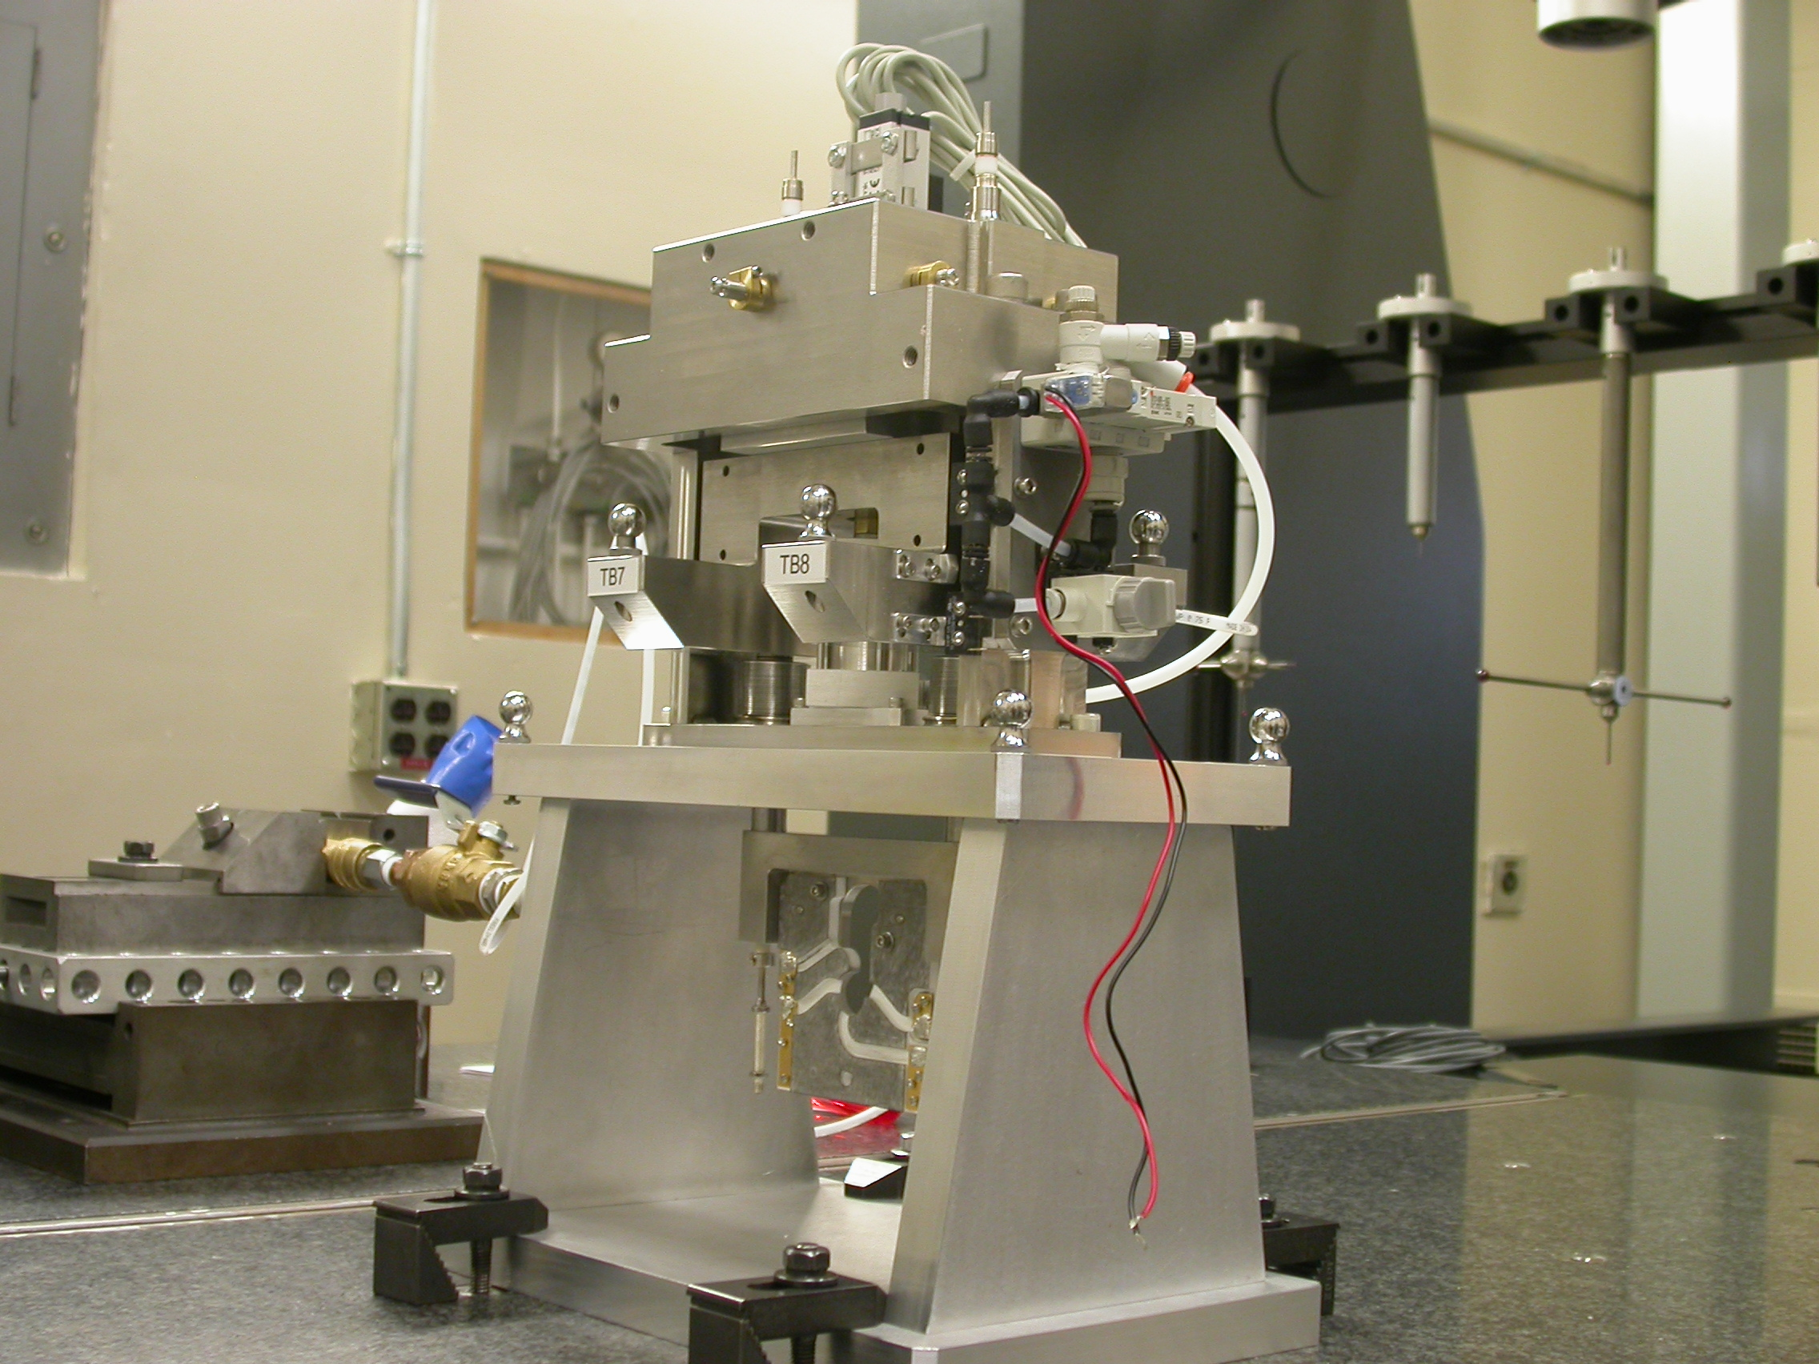

Inspector: | Keith Caban
Responsible Engineer: | Venkat Srinivasan
Date: | Friday, June 13 2008
Work Order/Charge No.: | 23800-1
Serial Number: | BFW – 12 / VC – 12 / WC – 12 / BASE – 17
Units of Measure: | Metric – Millimeters (mm.)
URL | http://www-group/met/Quality/FIDUCIAL%20REPORTS/LCLS%20BFW/BFW-12_VC-12_WC-12_BAS-17.pdf

Coordinate System Setups

Bench CSY (BENCH$CSY)
(The only CSY in Both States of measurement - out and under vacuum)

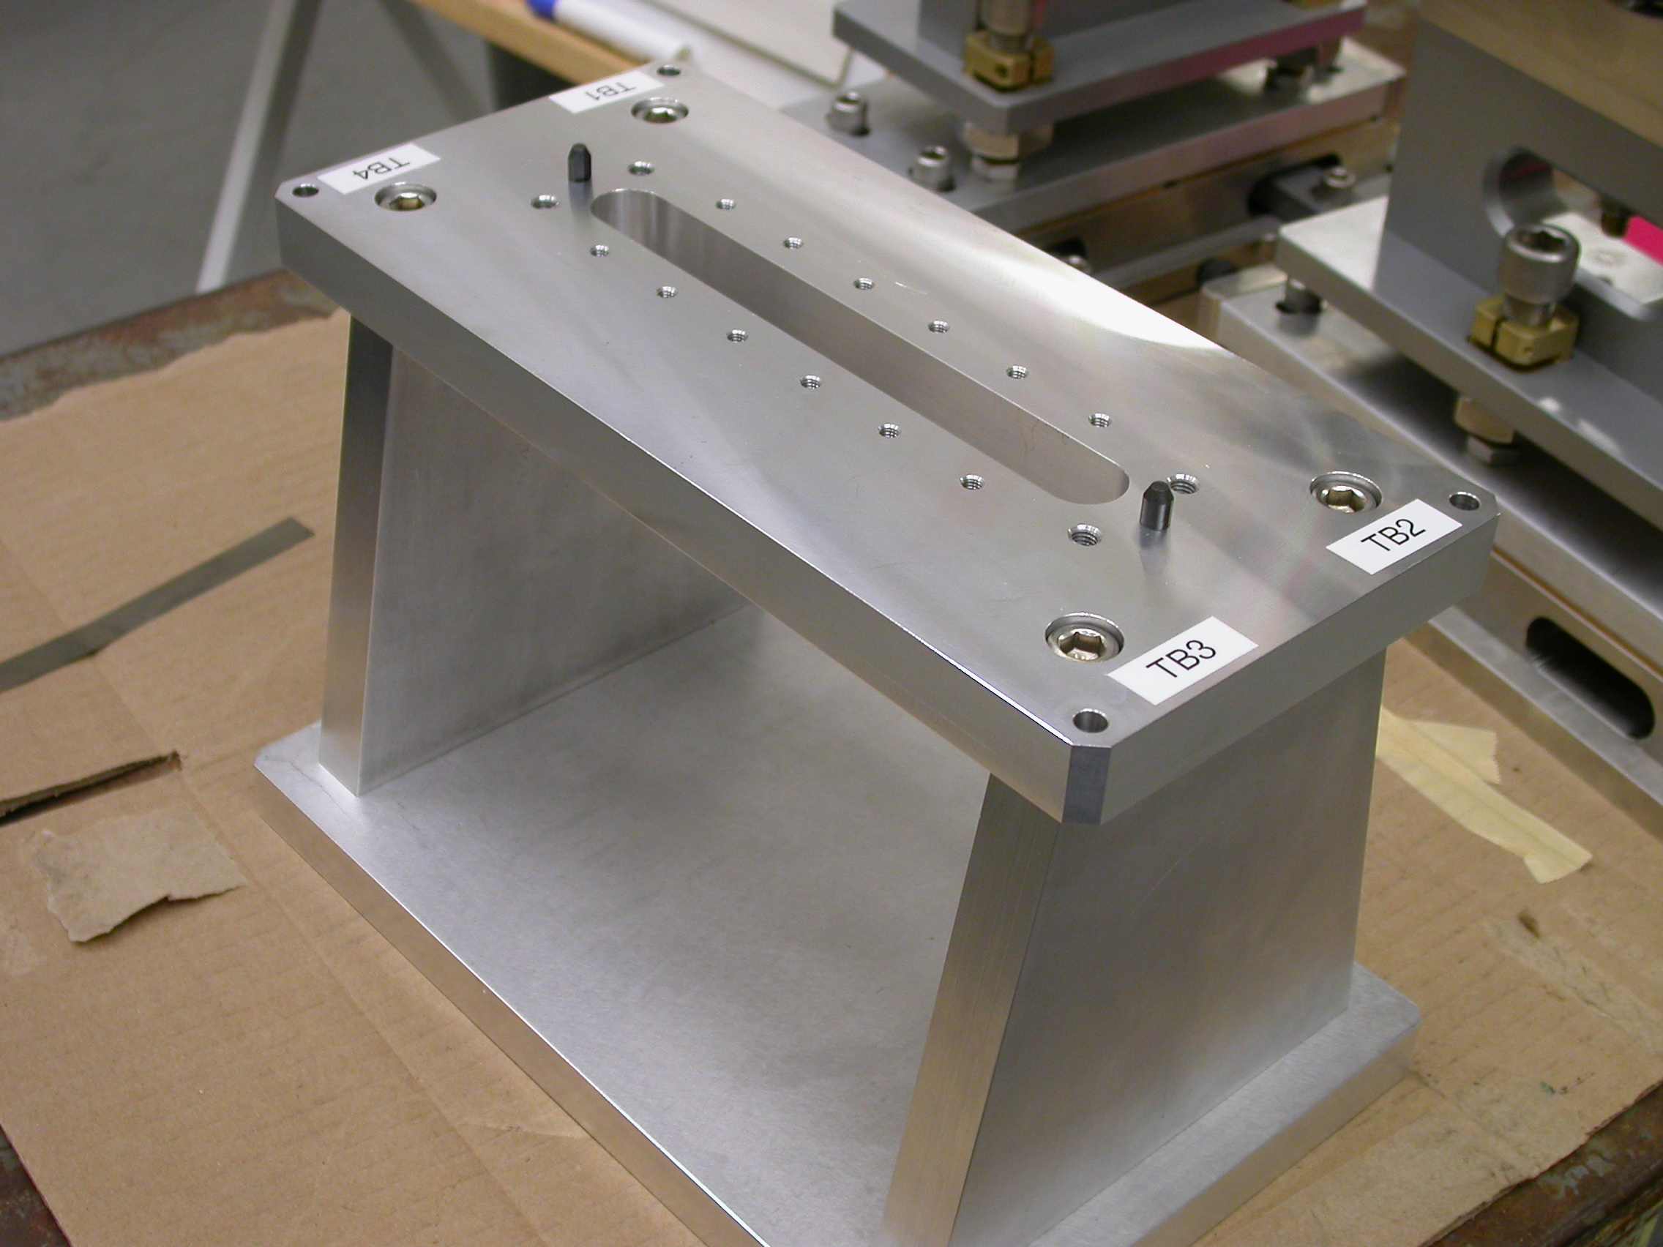
+Y
+Z
+X

- Plane measurement on top of Bench to set zero in Y and is the Spatial Alignment.
- Measure Pin and Diamond Pin to get centers, create a line between the two center points and this sets zero in Z and is the Planar Alignment.
- Take the symmetry point of the two pins this sets zero in X.

Bench Tooling Ball CSY (BTB$CSY)
- Create a plane using Tooling Balls 1, 2, & 3
  - This sets Zero in Y and is the spatial alignment
- Create an axis/line using TB’s 2 to 1 (+X)
  - This is the planar alignment
- TB 2 is a single point that sets zero in X, Y, Z.

BFW Tooling Ball CSY (BFWTB$CSY)
- Create a plane using Tooling Balls 5, 6, & 7
  - This sets Zero in Y and is the spatial alignment
- Create an axis/line using TB’s 6 to 5 (+X)
  - This is the planar alignment
- TB 6 is a single point that sets zero in X, Y, Z.

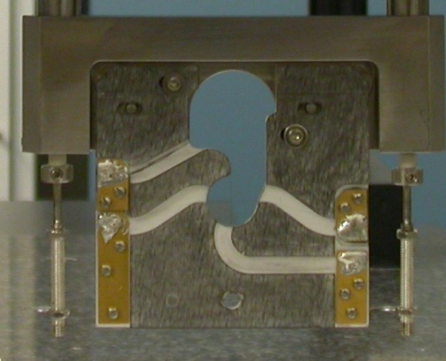  Transformation  Y+  X+  View from Z+ or Downstream | 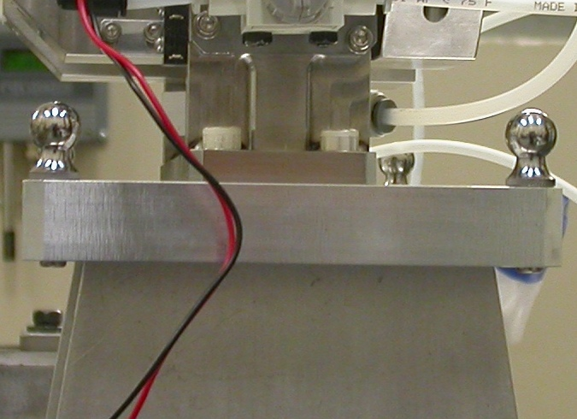  Y+  Z+  View from X+ Side
Wire CSY (WIRE$CSY)

- Back Plane (-Z) Side sets Zero in Z and is the Spatial Alignment
- Looking from +Z Side, Bottom of Card Sets Zero is the Planar Alignment
- The Intersection of the Left Side of the Card and the Bottom, sets Zero in X & Y

Wire offset from Edges per T. Nakashima’s Optical Measurement

Wire | Wire Location | Wire Diameter
Vertical Wire (X Location from Card) | 39.5963 | 0.0376
Horizontal Wire (Y Location from Card) | 36.9908 | 0.0413

Support Stand CSY (BASE$CSY)

- A plane on Torque Fixture sets Zero in Y and is the Spatial Alignment
- The symmetry of the outer surfaces where “X” fine adjustments are sets zero in X.
- A line where the Torque Fixture 2X Dowel pins sets zero in Z and is the Planar Alignment.

Beamline CSY (BEAMLINE$CSY)

- Use the BENCH$CSY setup except use the Torque Fixture plate to set zero in Y and the Spatial Alignment, transform +258.67 in Y to replicate Theoretical Beamline Center
- This coordinate system will tell us where the Wire Crosshairs are to a theoretical Beam Centerline.
- The wires should be offset ~ -0.400 in X, -0.200 in Y.

Statistical Data (mm.)
Out of Vacuum
10 Cycles (10 recordings)
Date: 06/02/08
Card Locations
CSY = BENCH$CSY

STATS | X-POS CARD | X-INTPT CARD | Y-INTPT CARD
AVG. | 0.01668 | -40.16612 | -95.40390
Range | 0.01713 | 0.02422 | 0.00779
St. Dev. | 0.00601 | 0.00726 | 0.00254

Wire Location

NOTE: Device was not cycled 10 times prior to vacuum. This measurement method was added on all devices after BFW #12 (Count #5). This does not affect the functionality of the device since BFW translation data is accurately recorded before vacuum, and BFW position and repeatability data are recorded after vacuum

Transformation WIRE$CSY TO BENCH$CSY
Stats | X | Y | Z | APA_PXPY | PA_PYPZ | PA_PXPZ
AVG. | -0.42173 | -58.61506 | -3.03308 | -0.28261 | 90.02656 | 89.60155
Range | 0.01717 | 0.00917 | 0.04540 | 0.00914 | 0.01114 | 0.00423
St. Dev. | 0.00596 | 0.00303 | 0.01404 | 0.00284 | 0.00341 | 0.00123
RMS Tol | 0.06500 | 0.03000 | - | - | - | -

Transformation WIRE$CSY to BFWTB$CSY
Stats | X | Y | Z | APA_PXPY | PA_PYPZ | PA_PXPZ
AVG. | 94.38934 | -160.79138 | 35.62403 | -0.13668 | 89.83456 | 89.82401
Range | 0.00595 | 0.00611 | 0.02598 | 0.00475 | 0.00623 | 0.00292
St. Dev. | 0.00168 | 0.00199 | 0.00756 | 0.00132 | 0.00179 | 0.00086
RMS Tol | 0.06500 | 0.03000 | - | - | - | -

Under Vacuum
200 Cycles (14 recordings)
Date: 06/03/08 (Did not pass RMS)
TB 5-8 Locations
CSY = BENCH$CSY

TB 5 | X | Y | Z
AVG. | 94.38209 | 102.09440 | -38.37162
Range | 0.10018 | 0.19281 | 0.05689
St. Dev. | 0.03272 | 0.07647 | 0.01984
RMS Tol | 0.06500 | 0.03000 | -

TB 6 | X | Y | Z
AVG. | -94.49539 | 102.33838 | -37.55954
Range | 0.09997 | 0.13242 | 0.02661
St. Dev. | 0.03272 | 0.05230 | 0.00751
RMS Tol | 0.06500 | 0.03000 | -

TB 7 | X | Y | Z
AVG. | -50.90705 | 102.23077 | 68.09083
Range | 0.10472 | 0.03820 | 0.02603
St. Dev. | 0.04092 | 0.01486 | 0.00724
RMS Tol | 0.06500 | 0.03000 | -

TB 8 | X | Y | Z
AVG. | 51.66240 | 102.10535 | 67.64517
Range | 0.10416 | 0.13559 | 0.03968
St. Dev. | 0.04084 | 0.05455 | 0.01515
RMS Tol | 0.06500 | 0.03000 | -

Wire Location

Transformation WIRE$CSY TO BENCH$CSY
Stats | X | Y | Z | APA_PXPY | PA_PYPZ | PA_PXPZ
AVG. | -0.16137 | -58.59492 | -2.40223 | -0.21368 | 89.85858 | 89.57545
Range | 0.37711 | 0.03681 | 0.01153 | 0.09862 | 0.01233 | 0.02012
St. Dev. | 0.14489 | 0.01465 | 0.00345 | 0.03904 | 0.00456 | 0.00652
RMS Tol | 0.06500 | 0.03000 | - | - | - | -

Note: After this test the device was put on hold per Venkat Srinivasan. It was decided not to do the 200 rigorous cycles, therefore, changing our cycle testing format.

New Vacuum Testing Format
- 10 Continuous cycles and Record Data.
- After each cycle to the “Down Position,” wait 1 minute before cycling the device to take another reading.
- This has been ratified by LCLS Physics. Actual usage in the field will tend to be sporadic. As per Heinz-Dieter Nuhn, a single BFW may be used as little as once a week. This suggests that repeated pounding with cycling time of less than 1 second may not correspond with accurate simulation of actual usage patterns. Further, the device has shown degraded performance under such repeated fast cycling conditions. For further explanations, contact Venkat Srinivasan (SLAC, 650-926-2631) or Jim Bailey (Argonne, 630-252-5306)

Under Vacuum (New Vacuum Testing Format)
10 Cycles (10 recordings)
Date: 06/06/08 (Passes RMS)
TB 5-8 Locations
CSY = BENCH$CSY

TB 5 | X | Y | Z
AVG. | 94.33196 | 102.38456 | -38.32288
Range | 0.05302 | 0.06716 | 0.03526
St. Dev. | 0.01849 | 0.02199 | 0.01159
RMS Tol | 0.06500 | 0.03000 | -

TB 6 | X | Y | Z
AVG. | -94.54507 | 102.87021 | -37.44166
Range | 0.05268 | 0.04891 | 0.03780
St. Dev. | 0.01835 | 0.01565 | 0.01444
RMS Tol | 0.06500 | 0.03000 | -

TB 7 | X | Y | Z
AVG. | -50.91331 | 102.68316 | 68.19318
Range | 0.03940 | 0.01828 | 0.02349
St. Dev. | 0.01132 | 0.00561 | 0.00887
RMS Tol | 0.06500 | 0.03000 | -

TB 8 | X | Y | Z
AVG. | 51.65781 | 102.43699 | 67.70747
Range | 0.03953 | 0.04645 | 0.02118
St. Dev. | 0.01136 | 0.01510 | 0.00627
RMS Tol | 0.06500 | 0.03000 | -

Under Vacuum (New Vacuum Testing Format) Cont…
Wire Location

CSY = BEAMLINE$CSY
Stats | X | Y
AVG. | -0.40433 | -0.18282
Range | 0.11261 | 0.00886
St. Dev. | 0.03133 | 0.00259
Nom. | -0.40000 | -0.20000
RMS Tol | 0.06500 | 0.03000

Locations of ¼-20 Jo-Plugs Cylinders Intersected into Plane projected 12.7mm away from surface replicating a ½” (12.7mm) offset to center of Tooling Ball.

CSY = BEAMLINE$CSY
INTPT | X | Y | Z
1 | -27.10957 | 227.52515 | 68.78973
2 | 26.92714 | 227.53492 | 68.74626
3 | 79.70496 | 180.44321 | -68.40215
4 | -79.98042 | 180.33467 | -68.26046

