
LCLS BFW WIRECARD ASSY
INSPECTION/FIDUCIAL REPORT

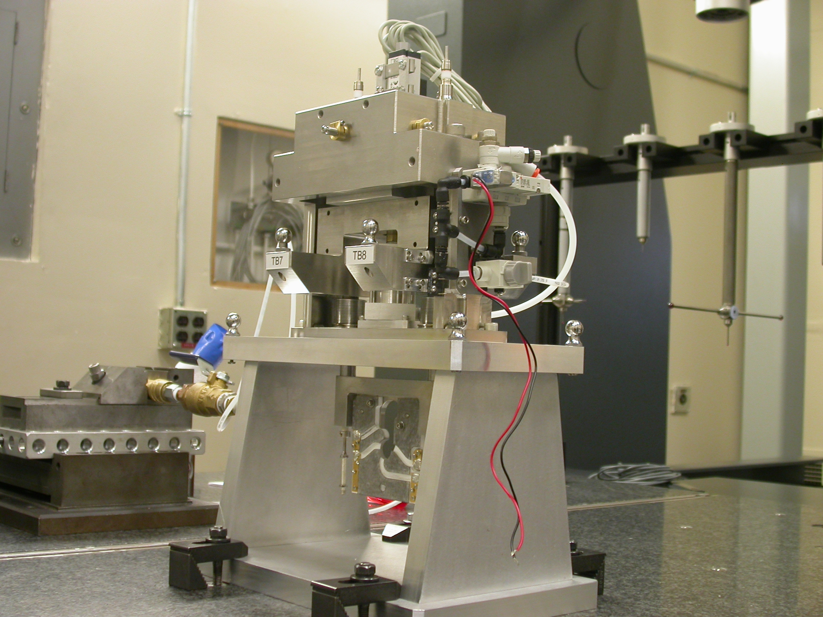

Inspector: | Keith Caban
Responsible Engineer: | Venkat Srinvivasan
Date: | Thursday, May 29, 2008  Revised Thursday, September 25, 2008
Work Order/Charge No.: | 23800-1
Serial Number: | BFW – 06 / VC – 06 / WC – 38 / BASE – 19
Units of Measure: | Metric – Millimeters (mm.)
URL | http://www-group/met/Quality/FIDUCIAL%20REPORTS/LCLS%20BFW/BFW-06_VC-06_WC-38_BAS-19.pdf

Coordinate System Setups

Bench CSY (BENCH$CSY)
(The only CSY in Both States of measurement - out and under vacuum)

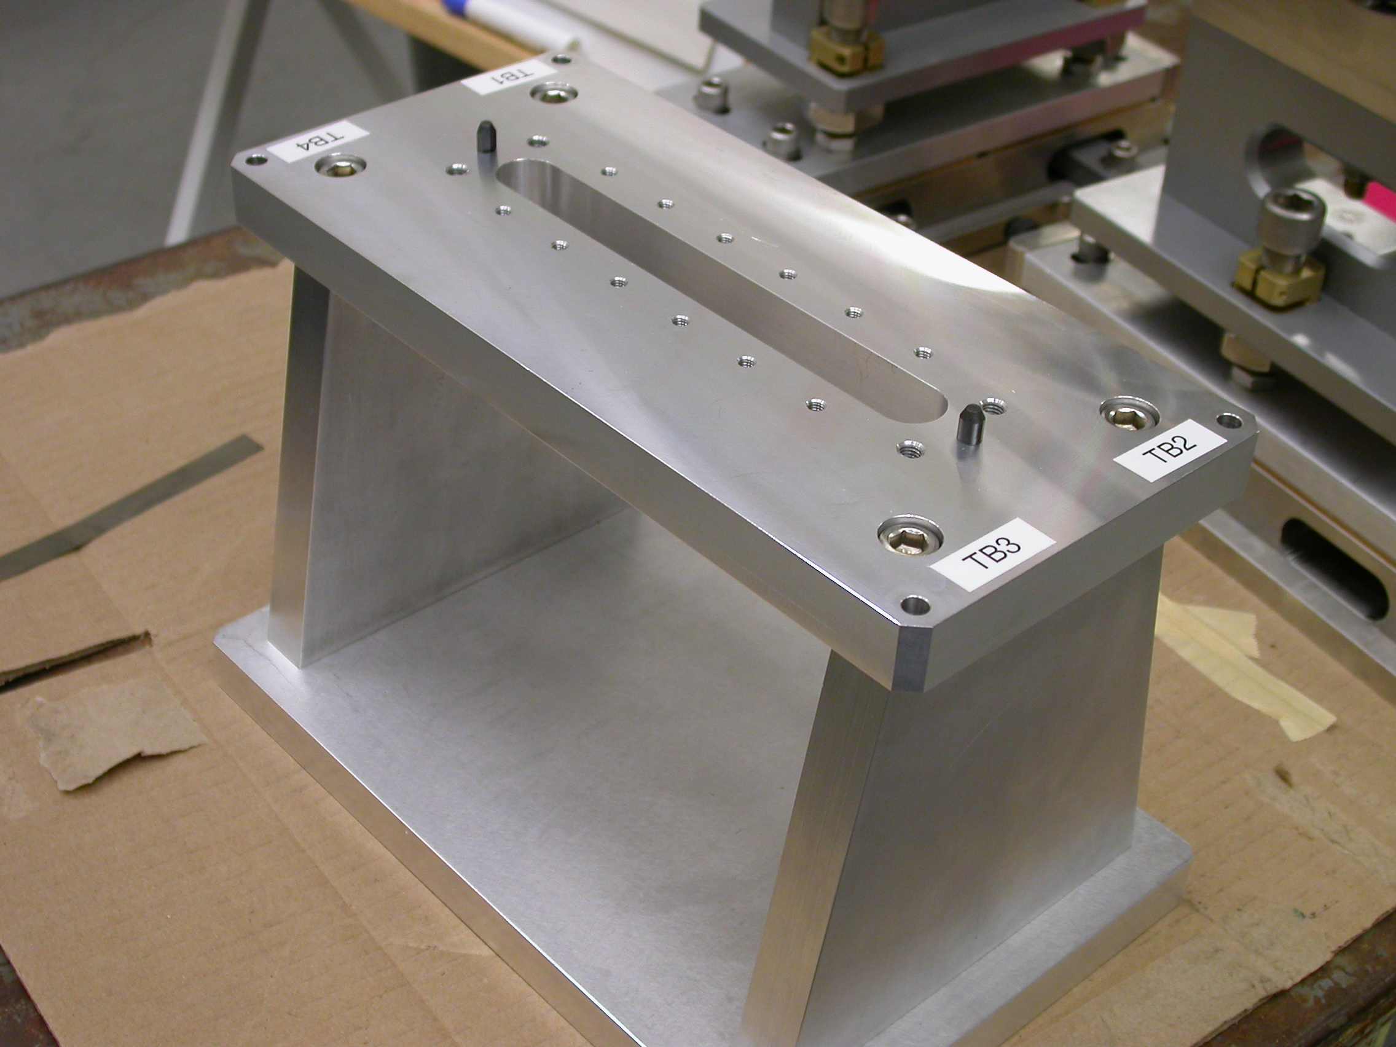
+Y
+Z
+X

- Plane measurement on top of Bench to set zero in Y and is the Spatial Alignment.
- Measure Pin and Diamond Pin to get centers, create a line between the two center points and this sets zero in Z and is the Planar Alignment.
- Take the symmetry point of the two pins this sets zero in X.

Bench Tooling Ball CSY (BTB$CSY)
- Create a plane using Tooling Balls 1, 2, & 3
  - This sets Zero in Y and is the spatial alignment
- Create an axis/line using TB’s 2 to 1 (+X)
  - This is the planar alignment
- TB 2 is a single point that sets zero in X, Y, Z.

BFW Tooling Ball CSY (BFWTB$CSY)
- Create a plane using Tooling Balls 5, 6, & 7
  - This sets Zero in Y and is the spatial alignment
- Create an axis/line using TB’s 6 to 5 (+X)
  - This is the planar alignment
- TB 6 is a single point that sets zero in X, Y, Z.

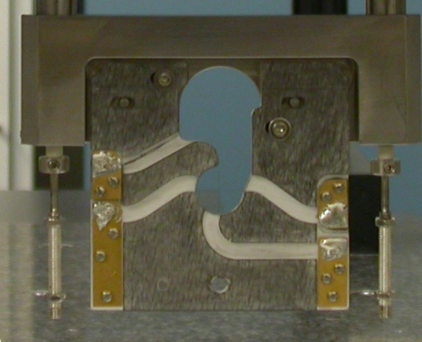  Transformation  Y+  X+  View from Z+ or Downstream | 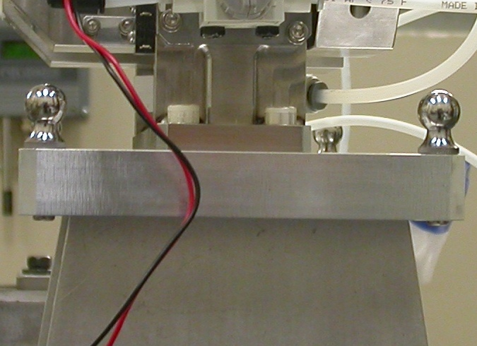  Y+  Z+  View from X+ Side
Wire CSY (WIRE$CSY)

- Back Plane (-Z) Side sets Zero in Z and is the Spatial Alignment
- Looking from +Z Side, Bottom of Card Sets Zero is the Planar Alignment
- The Intersection of the Left Side of the Card and the Bottom, sets Zero in X & Y

Wire offset from Edges per T. Nakashima’s Optical Measurement

Wire | Wire Location | Wire Diameter
Vertical Wire (X Location from Card) | 39.6181 | 0.0366
Horizontal Wire (Y Location from Card) | 37.0054 | 0.0365

Support Stand CSY (BASE$CSY)

- A plane on Torque Fixture sets Zero in Y and is the Spatial Alignment
- The symmetry of the outer surfaces where “X” fine adjustments are sets zero in X.
- A line where the Torque Fixture 2X Dowel pins sets zero in Z and is the Planar Alignment.

Beamline CSY (BEAMLINE$CSY)

- Use the BENCH$CSY setup except use the Torque Fixture plate to set zero in Y and the Spatial Alignment, transform +258.67 in Y to replicate Theoretical Beamline Center
- This coordinate system will tell us where the Wire Crosshairs are to a theoretical Beam Centerline.
- The wires should be offset ~ -0.400 in X, -0.200 in Y.

Statistical Data (mm.)
Out of Vacuum
100 Cycles (20 recordings)
Card Locations
CSY = BENCH$CSY

STATS | X-POS CARD | X-INTPT CARD | Y-INTPT CARD
AVG. | -0.09725 | -40.29089 | -96.93552
Range | 0.05948 | 0.09160 | 0.22572
St. Dev. | 0.02090 | 0.03136 | 0.08479

Wire Location
Initially Not Calculated/Measured on this BFW, Measurements/Stats are done from MMF CMM Cycle of 10 by Ed Reese (09/25/08, No Vacuum).
CSY = BEAMLINE$CSY
Stats | X | Y
AVG. | -0.57021 | -0.22564
Range | 0.00520 | 0.01150
St. Dev. | 0.00166 | 0.00347
Nom. | -0.40000 | -0.20000
RMS Tol | 0.06500 | 0.03000

Transformation WIRE$CSY TO BENCH$CSY
Stats | X | Y | Z | APA_PXPY | PA_PYPZ | PA_PXPZ
AVG. | -0.51399 | -60.12884 | -2.86736 | -0.28130 | 89.98078 | 89.92737
Range | 0.06073 | 0.22526 | 0.11724 | 0.01021 | 0.03742 | 0.06978
St. Dev. | 0.02133 | 0.08458 | 0.03778 | 0.00294 | 0.01311 | 0.02606
RMS Tol | 0.06500 | 0.03000 | - | - | - | -

Transformation WIRE$CSY to BFWTB$CSY
Stats | X | Y | Z | APA_PXPY | PA_PYPZ | PA_PXPZ
AVG. | 94.61569 | -160.39996 | 35.64864 | -0.07569 | 89.86374 | 89.91773
Range | 0.00485 | 0.01781 | 0.02760 | 0.00874 | 0.01422 | 0.01376
St. Dev. | 0.00120 | 0.00476 | 0.00686 | 0.00214 | 0.00383 | 0.00346
RMS Tol | 0.06500 | 0.03000 | - | - | - | -

Under Vacuum
200 Cycles (22 recordings)
TB 5-8 Locations
CSY = BENCH$CSY

TB 5 | X | Y | Z
AVG. | 94.35345 | 99.89047 | -38.00066
Range | 0.02112 | 0.05318 | 0.02755
St. Dev. | 0.00692 | 0.01749 | 0.00827
RMS Tol | 0.06500 | 0.03000 | -

TB 6 | X | Y | Z
AVG. | -94.51201 | 100.72217 | -38.16673
Range | 0.02155 | 0.06686 | 0.08398
St. Dev. | 0.00722 | 0.02302 | 0.02939
RMS Tol | 0.06500 | 0.03000 | -

TB 7 | X | Y | Z
AVG. | -51.47475 | 100.51288 | 67.71628
Range | 0.01560 | 0.09637 | 0.06926
St. Dev. | 0.00530 | 0.03353 | 0.02412
RMS Tol | 0.06500 | 0.03000 | -

TB 8 | X | Y | Z
AVG. | 51.09411 | 100.07531 | 67.79779
Range | 0.01584 | 0.08831 | 0.03894
St. Dev. | 0.00540 | 0.03028 | 0.01278
RMS Tol | 0.06500 | 0.03000 | -

Wire Location

CSY = BEAMLINE$CSY
Not Calculated/Measured on this BFW (Not part of inspection at this point)
Stats | X | Y
AVG.
Range
St. Dev.
Nom. | -0.40000 | -0.20000
RMS Tol | 0.06500 | 0.03000

Transformation WIRE$CSY TO BENCH$CSY
Stats | X | Y | Z | APA_PXPY | PA_PYPZ | PA_PXPZ
AVG. | -0.63461 | -60.09341 | -2.45651 | -0.32926 | 89.87056 | 89.97055
Range | 0.00723 | 0.07090 | 0.00429 | 0.00559 | 0.01846 | 0.02030
St. Dev. | 0.00213 | 0.02421 | 0.00106 | 0.00180 | 0.00640 | 0.00686
RMS Tol | 0.06500 | 0.03000 | - | - | - | -

Locations of ¼-20 Jo-Plugs Cylinders Intersected into Plane projected 12.7mm away from surface replicating a ½” (12.7mm) offset to center of Tooling Ball.

CSY = BEAMLINE$CSY
Not Calculated/Measured on this BFW (Not part of inspection at this point)
INTPT | X | Y | Z
1
2
3
4

