
LCLS BFW WIRECARD ASSY
INSPECTION/FIDUCIAL REPORT

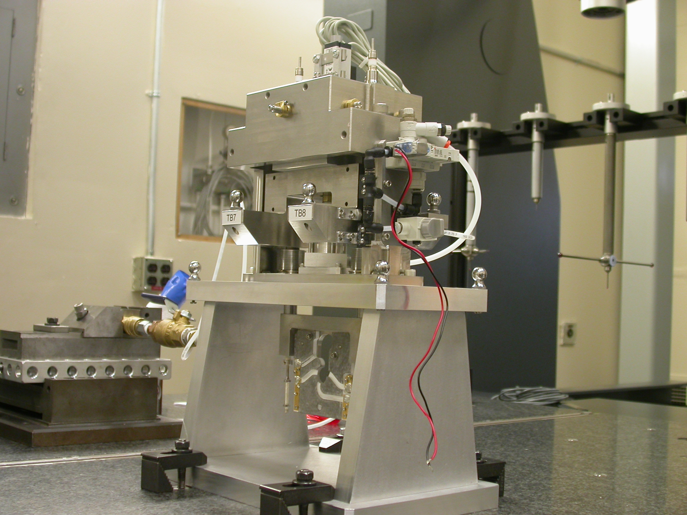

Inspector: | Keith Caban
Responsible Engineer: | Venkat Srinvivasan
Date: | Tuesday, May 20, 2008  Revised Tuesday, September 23, 2008
Work Order/Charge No.: | 23800-1
Serial Number: | BFW – 05 / VC – 05 / WC – 05 / BASE – 14
Units of Measure: | Metric – Millimeters (mm.)
URL | http://www-group/met/Quality/FIDUCIAL%20REPORTS/LCLS%20BFW/BFW-05_VC-05_WC-05_BAS-14.pdf

Coordinate System Setups

Bench CSY (BENCH$CSY)
(The only CSY in Both States of measurement - out and under vacuum)

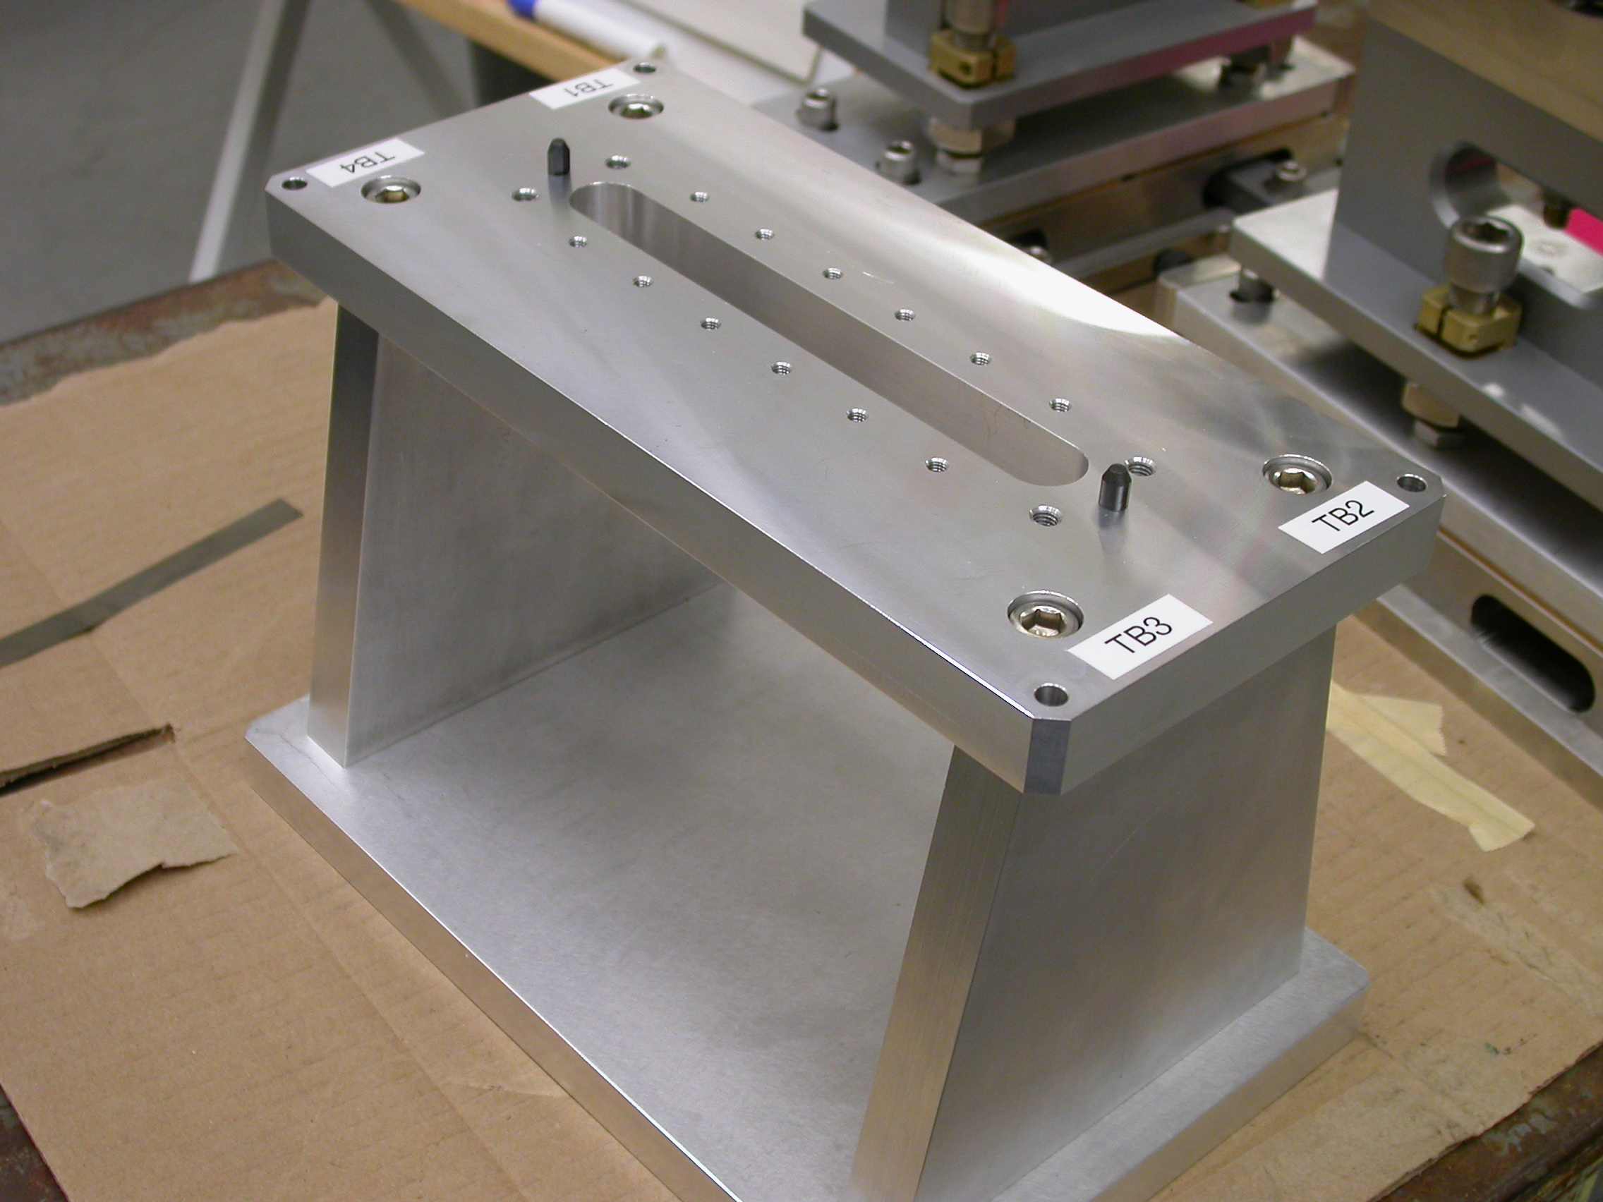
+Y
+Z
+X

- Plane measurement on top of Bench to set zero in Y and is the Spatial Alignment.
- Measure Pin and Diamond Pin to get centers, create a line between the two center points and this sets zero in Z and is the Planar Alignment.
- Take the symmetry point of the two pins this sets zero in X.

Bench Tooling Ball CSY (BTB$CSY)
- Create a plane using Tooling Balls 1, 2, & 3
  - This sets Zero in Y and is the spatial alignment
- Create an axis/line using TB’s 2 to 1 (+X)
  - This is the planar alignment
- TB 2 is a single point that sets zero in X, Y, Z.

BFW Tooling Ball CSY (BFWTB$CSY)
- Create a plane using Tooling Balls 5, 6, & 7
  - This sets Zero in Y and is the spatial alignment
- Create an axis/line using TB’s 6 to 5 (+X)
  - This is the planar alignment
- TB 6 is a single point that sets zero in X, Y, Z.

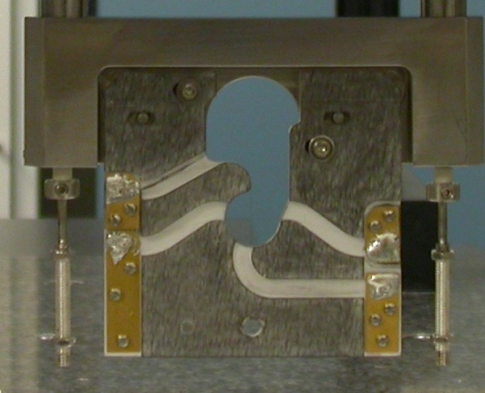  Transformation  Y+  X+  View from Z+ or Downstream | 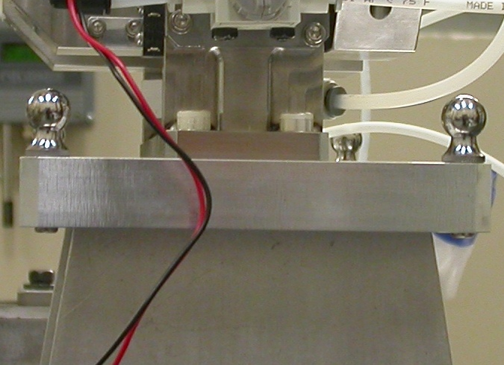  Y+  Z+  View from X+ Side
Wire CSY (WIRE$CSY)

- Back Plane (-Z) Side sets Zero in Z and is the Spatial Alignment
- Looking from +Z Side, Bottom of Card Sets Zero is the Planar Alignment
- The Intersection of the Left Side of the Card and the Bottom, sets Zero in X & Y

Wire offset from Edges per T. Nakashima’s Optical Measurement

Wire | Wire Location | Wire Diameter
Vertical Wire (X Location from Card) | 39.6203 | 0.0396
Horizontal Wire (Y Location from Card) | 37.0005 | 0.0388

Support Stand CSY (BASE$CSY)

- A plane on Torque Fixture sets Zero in Y and is the Spatial Alignment
- The symmetry of the outer surfaces where “X” fine adjustments are sets zero in X.
- A line where the Torque Fixture 2X Dowel pins sets zero in Z and is the Planar Alignment.

Beamline CSY (BEAMLINE$CSY)

- Use the BENCH$CSY setup except use the Torque Fixture plate to set zero in Y and the Spatial Alignment, transform +258.67 in Y to replicate Theoretical Beamline Center
- This coordinate system will tell us where the Wire Crosshairs are to a theoretical Beam Centerline.
- The wires should be offset ~ -0.400 in X, -0.200 in Y.

Statistical Data (mm.)
Out of Vacuum
10 Cycles (10 recordings)
Card Locations
CSY = BENCH$CSY

STATS | X-POS CARD | X-INTPT CARD | Y-INTPT CARD
AVG. | -0.17960 |  | -95.26975
Range | 0.18770 |  | 0.02724
St. Dev. | 0.05453 |  | 0.00751

Wire Location
Initially Not Calculated/Measured on this BFW, Measurements/Stats are done from MMF CMM Cycle of 10 by Ed Reese (09/23/08, No Vacuum).
CSY = BEAMLINE$CSY
Stats | X | Y
AVG. | -0.48704 | -0.16272
Range | 0.07320 | 0.00260
St. Dev. | 0.02167 | 0.00086
Nom. | -0.40000 | -0.20000
RMS Tol | 0.06500 | 0.03000

Transformation WIRE$CSY TO BENCH$CSY
Not Calculated/Measured on this BFW (Not part of inspection at this point)
Stats | X | Y | Z | APA_PXPY | PA_PYPZ | PA_PXPZ
AVG.
Range
St. Dev.
RMS Tol | 0.06500 | 0.03000 | - | - | - | -

Transformation WIRE$CSY to BFWTB$CSY
Stats | X | Y | Z | APA_PXPY | PA_PYPZ | PA_PXPZ
AVG. | 94.06780 | -160.55627 | 35.84900 | -0.06129 | 89.80929 | 90.08003
Range | 0.00501 | 0.00259 | 0.00680 | 0.00960 | 0.00432 | 0.00614
St. Dev. | 0.00148 | 0.00078 | 0.00194 | 0.00335 | 0.00131 | 0.00202
RMS Tol | 0.06500 | 0.03000 | - | - | - | -

Under Vacuum
100 Cycles (19 recordings)
TB 5-8 Locations
CSY = BENCH$CSY

TB 5 | X | Y | Z
AVG. | 94.69571 | 101.77761 | -37.84015
Range | 0.02387 | 0.05760 | 0.07799
St. Dev. | 0.00990 | 0.02328 | 0.01609
RMS Tol | 0.06500 | 0.03000 | -

TB 6 | X | Y | Z
AVG. | -94.18932 | 102.26439 | -38.11829
Range | 0.02376 | 0.06269 | 0.03070
St. Dev. | 0.01003 | 0.02588 | 0.00829
RMS Tol | 0.06500 | 0.03000 | -

TB 7 | X | Y | Z
AVG. | -51.21688 | 102.41837 | 67.78256
Range | 0.05890 | 0.03087 | 0.00834
St. Dev. | 0.01889 | 0.00669 | 0.00319
RMS Tol | 0.06500 | 0.03000 | -

TB 8 | X | Y | Z
AVG. | 51.36915 | 102.16770 | 67.93734
Range | 0.05914 | 0.05571 | 0.05202
St. Dev. | 0.01900 | 0.02362 | 0.01072
RMS Tol | 0.06500 | 0.03000 | -

Wire Location

CSY = BEAMLINE$CSY
Not Calculated/Measured on this BFW (Not part of inspection at this point)
Stats | X | Y
AVG.
Range
St. Dev.
Nom. | -0.40000 | -0.20000
RMS Tol | 0.06500 | 0.03000

Transformation WIRE$CSY TO BENCH$CSY
Stats | X | Y | Z | APA_PXPY | PA_PYPZ | PA_PXPZ
AVG. | -0.59190 | -58.45328 | -1.70882 | -0.21704 | 89.66425 | 90.18825
Range | 0.12873 | 0.00632 | 0.04771 | 0.03572 | 0.02332 | 0.03302
St. Dev. | 0.05344 | 0.00251 | 0.01851 | 0.01488 | 0.00731 | 0.00723
RMS Tol | 0.06500 | 0.03000 | - | - | - | -

Locations of ¼-20 Jo-Plugs Cylinders Intersected into Plane projected 12.7mm away from surface replicating a ½” (12.7mm) offset to center of Tooling Ball.

CSY = BEAMLINE$CSY
Not Calculated/Measured on this BFW (Not part of inspection at this point)
INTPT | X | Y | Z
1
2
3
4

