
LCLS BFW WIRECARD ASSY
FIDUCIAL REPORT

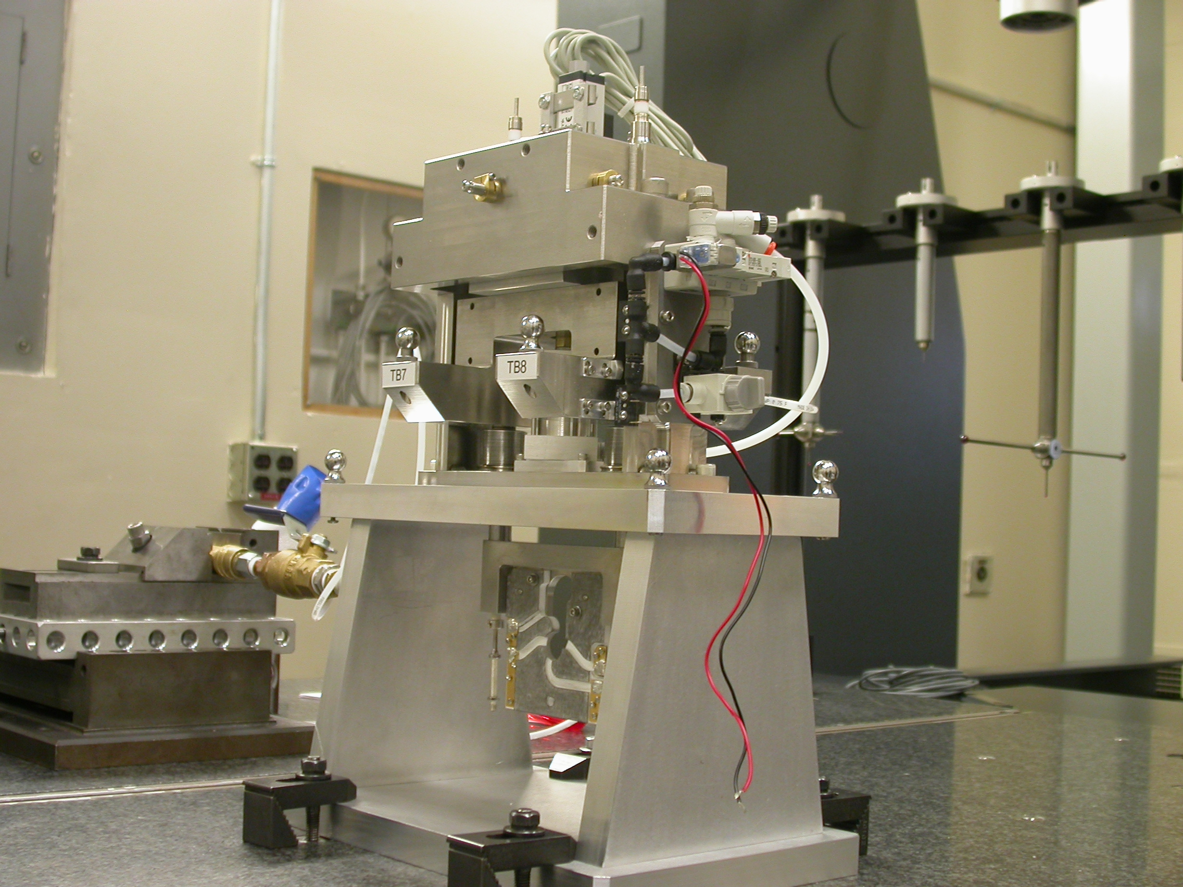

Inspector: | Keith Caban
Responsible Engineer: | Venkat Srinivasan
Date: | Monday, May 12, 2008
Work Order/Charge No.: | 23800-1
Serial Number: | BFW – 04 / WC – 02 / BASE – 09
URL | http://www-group/met/Quality/FIDUCIAL%20REPORTS/LCLS%20BFW/BFW-04_WC-02.pdf

Basic Procedure:

- Locate Bench and Bench CSY
- Install Top Portion of BFW
- Mount Wire Card and Center to Bench CSY
- 5 Cycles of Repeatability to Bench CSY of
  - Positions of Wire Card (Center, 2 Corners/Intersection Points)
  - 4 – BFW Fiducials (X,Y,Z locations)
- Create Wire Card CSY
- Transform to Wire Cross Hairs (Optical CMM Location Offset to Outer Datums of Card)
- Translate 4 – BFW Fiducials into Wire CSY
- Use 4X Screws to Secure the BFW in its Up or “In-Beam Position” for Transport and Girder Alignment
- Place BFW Chamber onto Support Stand, Set to Nominal Dimensions in X (0.000”) & Y (10.184”).
- Place Top portion of BFW onto BFW Chamber and Support Stand
  - Tighten down per ANL Torque Sequence/Specs
  - Coordinate with MFD Vacuum for Pump Down

Coordinate System Setups

Bench CSY
+Y
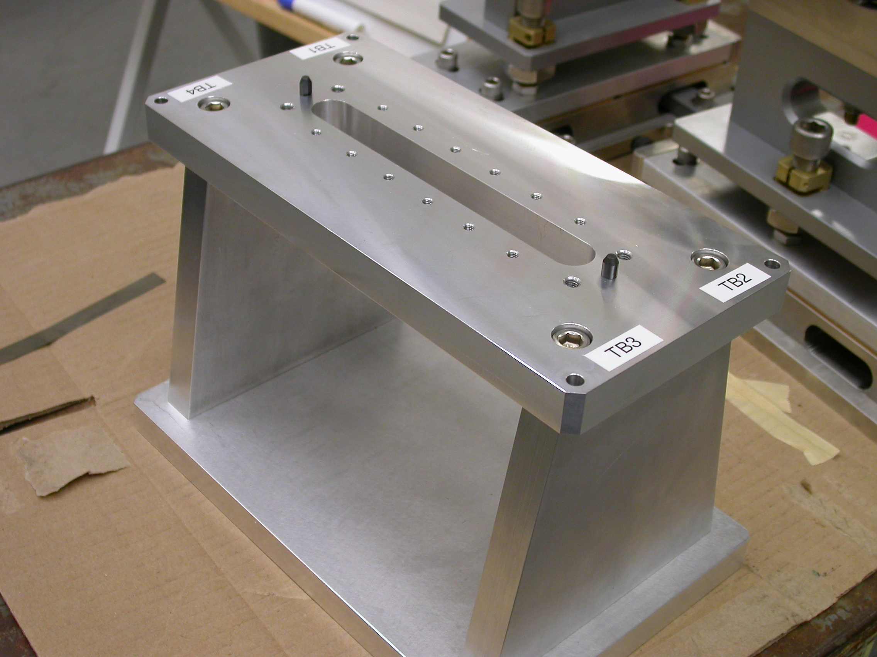
+Z
+X

- Plane measurement on top of Bench to set zero in Y and is the Spatial Alignment.

- Measure Pin and Diamond Pin to get centers, create a line between the two center points and this sets zero in Z and is the Planar Alignment.

- Take the symmetry point of the two pins this sets zero in X.
Wire CSY

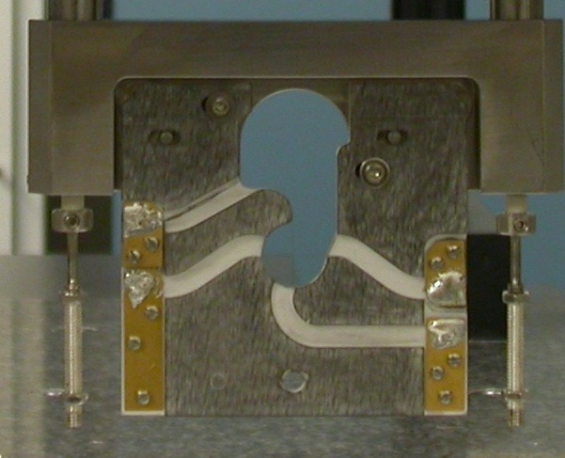  Transformation  Y+  X+  View from Z+ or Downstream | 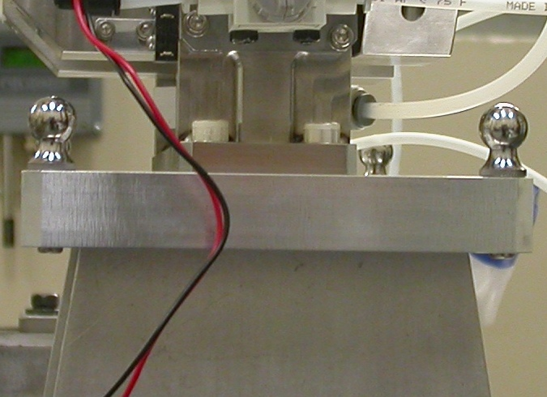  Y+  Z+  View from X+ Side

- Back Plane (-Z) Side sets Zero in Z and is the Spatial Alignment
- Looking from +Z Side, Bottom of Card Sets Zero is the Planar Alignment
- The Intersection of the Left Side of the Card and the Bottom, sets Zero in X & Y

Shift this CSY using the Optical CMM Output for the exact offsets (file in Sharepoint SV-VS122108-Wire.xls per Serialized Wire Card.

Transform TB’s into Wire CSY for Fiducial Numbers

**See Keith Caban or Venkat Srinivasan for Repeatability Data

Initial Repeatability Data 100 cycles used WC 00, switched after putting tabs on to Wirecard to WC-02

RMS Data

Out of Vacuum
Wirecard | SYM X | INT X | INT Y
00 | 0.05392 | 0.05929 | 0.00772

TB | X | Y | Z
5 | 0.00904 | 0.02075 | 0.00644
6 | 0.00892 | 0.02527 | 0.00616
7 | 0.01573 | 0.00285 | 0.00317
8 | 0.01572 | 0.02417 | 0.00364

Under Vacuum
TB | X | Y | Z
5 | 0.00777 | 0.01085 | 0.00439
6 | 0.00802 | 0.01239 | 0.00428
7 | 0.00656 | 0.00397 | 0.00407
8 | 0.00668 | 0.00911 | 0.00367

Fiducial Data

CSY : Wire$CSY (Wire Crosshair)

Wire Card is positioned in X to -0.01848 microns

Wire Card Offsets for WC - 02
(39.600) Vertical = 39.6258
(36.997) Horizontal = 37.0215

TB | Form | Diameter | X | Y | Z
5 | 0.00471 | 12.68243 | 94.94689 | 160.44747 | -35.07872
6 | 0.00117 | 12.67051 | -93.90597 | 160.51473 | -35.37761
7 | 0.00159 | 12.68254 | -50.96382 | 160.13127 | 70.51473
8 | 0.00723 | 12.64781 | 51.62755 | 160.12347 | 70.69432

BFW Support Assembly Alignment
Support Stand Tolerance

X ± 0.060mm or ± 0.0024
Y ± 0.040mm or ± 0.0016

Support Stand SN = 09

Chamber (Waveguide) Thickness = 0.263

Distance to the Top Flange (mating) = 12.46619

Position Y (10.1841) (Beamline) = 10.1840

Position X (0.0000) = -0.00130
Bottom of Form

