
LCLS BFW WIRECARD ASSY
INSPECTION/FIDUCIAL REPORT

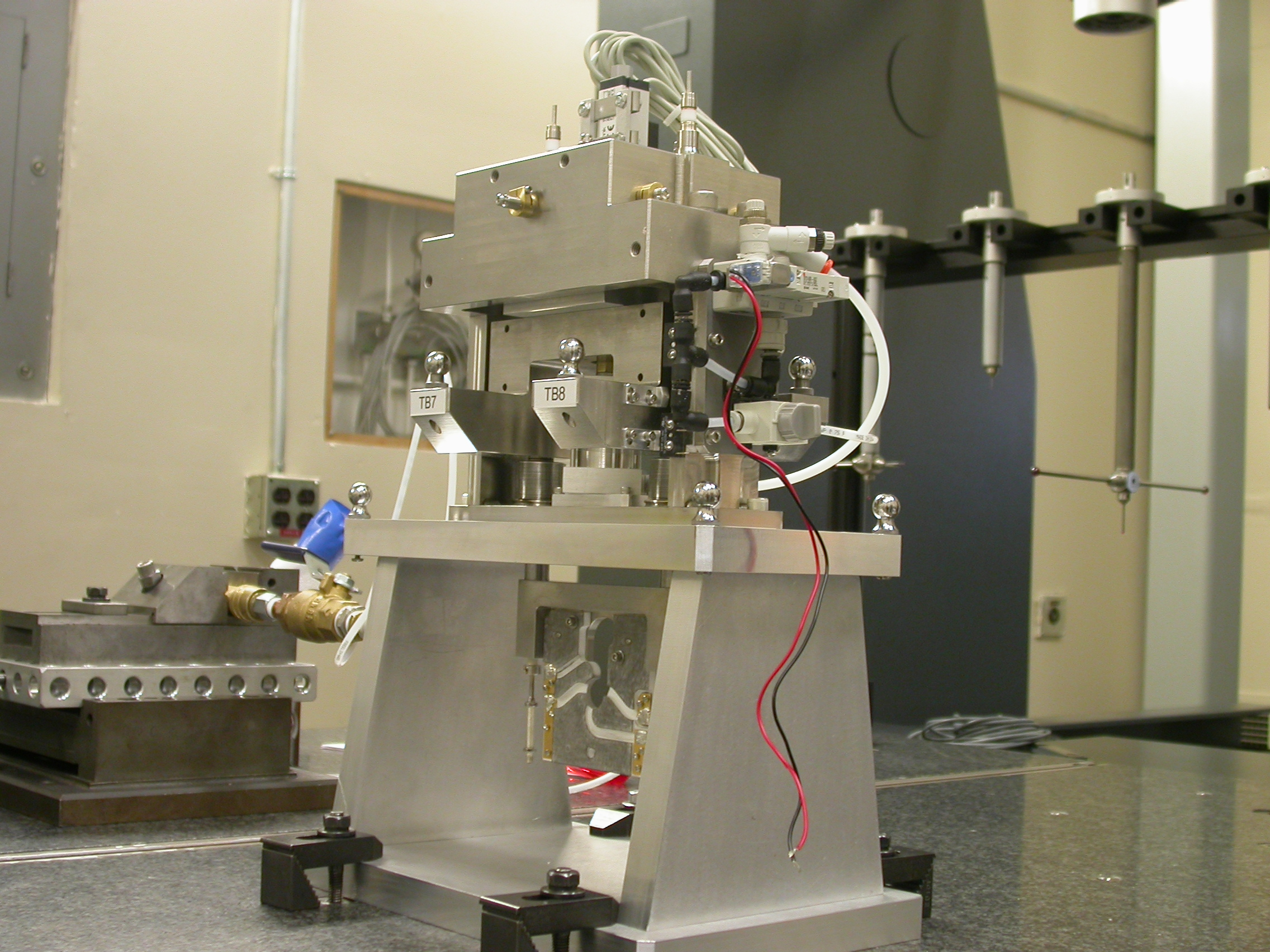

Inspector: | Keith Caban
Responsible Engineer: | Don Schafer
Date: | Thursday, September 25, 2008
Work Order/Charge No.: | 23800-1
Serial Number: | BFW – 03 / VC – 03 / WC – 03 / BASE – 06
Units of Measure: | Metric – Millimeters (mm.)
URL | http://www-group/met/Quality/FIDUCIAL%20REPORTS/LCLS%20BFW/BFW-03_VC-03_WC-03_BAS-06.pdf

Coordinate System Setups

Bench CSY (BENCH$CSY)
(The only CSY in Both States of measurement - out and under vacuum)

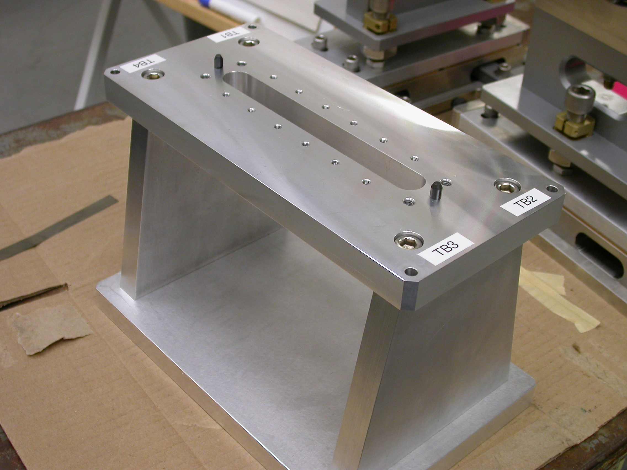
+Y
+Z
+X

- Plane measurement on top of Bench to set zero in Y and is the Spatial Alignment.
- Measure Pin and Diamond Pin to get centers, create a line between the two center points and this sets zero in Z and is the Planar Alignment.
- Take the symmetry point of the two pins this sets zero in X.

Bench Tooling Ball CSY (BTB$CSY)
- Create a plane using Tooling Balls 1, 2, & 3
  - This sets Zero in Y and is the spatial alignment
- Create an axis/line using TB’s 2 to 1 (+X)
  - This is the planar alignment
- TB 2 is a single point that sets zero in X, Y, Z.

BFW Tooling Ball CSY (BFWTB$CSY)
- Create a plane using Tooling Balls 5, 6, & 7
  - This sets Zero in Y and is the spatial alignment
- Create an axis/line using TB’s 6 to 5 (+X)
  - This is the planar alignment
- TB 6 is a single point that sets zero in X, Y, Z.

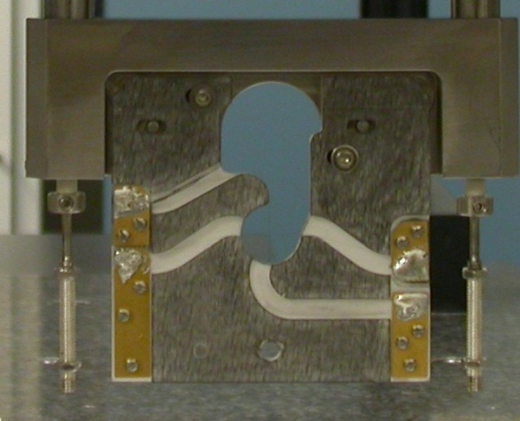  Transformation  Y+  X+  View from Z+ or Downstream | 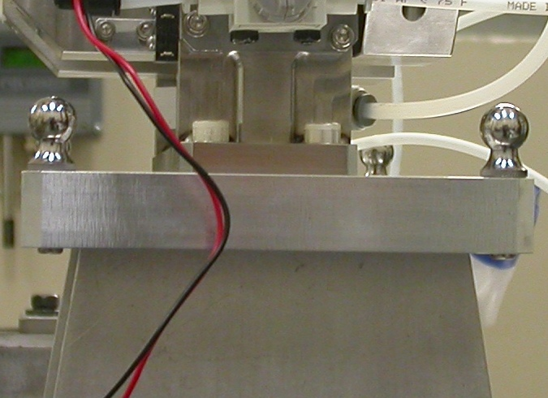  Y+  Z+  View from X+ Side
Wire CSY (WIRE$CSY)

- Back Plane (-Z) Side sets Zero in Z and is the Spatial Alignment
- Looking from +Z Side, Bottom of Card Sets Zero is the Planar Alignment
- The Intersection of the Left Side of the Card and the Bottom, sets Zero in X & Y

Wire offset from Edges per T. Nakashima’s Optical Measurement

Wire | Wire Location | Wire Diameter
Vertical Wire (X Location from Card) | 39.6287 | 0.0383
Horizontal Wire (Y Location from Card) | 37.0203 | 0.0376

Support Stand CSY (BASE$CSY)

- A plane on Torque Fixture sets Zero in Y and is the Spatial Alignment
- The symmetry of the outer surfaces where “X” fine adjustments are sets zero in X.
- A line where the Torque Fixture 2X Dowel pins sets zero in Z and is the Planar Alignment.

Beamline CSY (BEAMLINE$CSY)

- Use the BENCH$CSY setup except use the Torque Fixture plate to set zero in Y and the Spatial Alignment, transform +258.67 in Y to replicate Theoretical Beamline Center
- This coordinate system will tell us where the Wire Crosshairs are to a theoretical Beam Centerline.
- The wires should be offset ~ -0.400 in X, -0.200 in Y.

Statistical Data (mm.)
Out of Vacuum
10 Cycles (10 recordings)
Card Locations
CSY = BENCH$CSY

STATS | X-POS CARD | X-INTPT CARD | Y-INTPT CARD
AVG. | 0.01326 | -40.11954 | -95.13720
Range | 0.04735 | 0.05499 | 0.00608
St. Dev. | 0.01757 | 0.02048 | 0.00181

Wire Location

CSY = BEAMLINE$CSY
Stats | X | Y
AVG. | -0.40989 | -0.21438
Range | 0.04713 | 0.00765
St. Dev. | 0.01751 | 0.00243
Nom. | -0.40000 | -0.20000
RMS Tol | 0.06500 | 0.03000

Transformation WIRE$CSY TO BENCH$CSY
Stats | X | Y | Z | APA_PXPY | PA_PYPZ | PA_PXPZ
AVG. | -0.40989 | -58.21438 | -2.89980 | -0.12745 | 89.78871 | 90.01833
Range | 0.04713 | 0.00765 | 0.02342 | 0.01166 | 0.00722 | 0.00300
St. Dev. | 0.01751 | 0.00243 | 0.00845 | 0.00460 | 0.00242 | 0.00096
RMS Tol | 0.06500 | 0.03000 | - | - | - | -

Transformation WIRE$CSY to BFWTB$CSY
Stats | X | Y | Z | APA_PXPY | PA_PYPZ | PA_PXPZ
AVG. | 94.67784 | -160.26242 | 35.96923 | 0.11984 | 89.69677 | 90.09755
Range | 0.00108 | 0.00073 | 0.00495 | 0.00054 | 0.00176 | 0.00171
St. Dev. | 0.00030 | 0.00022 | 0.00137 | 0.00019 | 0.00062 | 0.00053
RMS Tol | 0.06500 | 0.03000 | - | - | - | -

Under Vacuum
10 Cycles (10 recordings)
TB 5-8 Locations
CSY = BENCH$CSY

TB 5 | X | Y | Z
AVG. | 94.27405 | 101.62454 | -38.78624
Range | 0.00511 | 0.00622 | 0.00280
St. Dev. | 0.00172 | 0.00209 | 0.00097
RMS Tol | 0.06500 | 0.03000 | -

TB 6 | X | Y | Z
AVG. | -94.60207 | 102.41988 | -38.08367
Range | 0.00488 | 0.00589 | 0.00300
St. Dev. | 0.00175 | 0.00202 | 0.00103
RMS Tol | 0.06500 | 0.03000 | -

TB 7 | X | Y | Z
AVG. | -51.09174 | 102.33596 | 67.57591
Range | 0.00396 | 0.00329 | 0.00193
St. Dev. | 0.00135 | 0.00105 | 0.00074
RMS Tol | 0.06500 | 0.03000 | -

TB 8 | X | Y | Z
AVG. | 51.49622 | 101.92488 | 67.21906
Range | 0.00480 | 0.00335 | 0.00283
St. Dev. | 0.00161 | 0.00131 | 0.00093
RMS Tol | 0.06500 | 0.03000 | -

Wire Location

CSY = BEAMLINE$CSY
Stats | X | Y
AVG. | -0.46754 | -0.27058
Range | 0.01222 | 0.00148
St. Dev. | 0.00494 | 0.00044
Nom. | -0.40000 | -0.20000
RMS Tol | 0.06500 | 0.03000

Transformation WIRE$CSY TO BENCH$CSY
Stats | X | Y | Z | APA_PXPY | PA_PYPZ | PA_PXPZ
AVG. | -0.46591 | -58.20675 | -2.31692 | -0.12148 | 89.64268 | 89.88341
Range | 0.01222 | 0.00148 | 0.00149 | 0.00293 | 0.00037 | 0.00149
St. Dev. | 0.00494 | 0.00044 | 0.00042 | 0.00121 | 0.00012 | 0.00054
RMS Tol | 0.06500 | 0.03000 | - | - | - | -

Locations of ¼-20 Jo-Plugs Cylinders Intersected into Plane projected 12.7mm away from surface replicating a ½” (12.7mm) offset to center of Tooling Ball.

CSY = BEAMLINE$CSY
INTPT | X | Y | Z
1 | -26.84823 | 227.58876 | 68.58090
2 | 27.16408 | 227.57033 | 68.44907
3 | 79.61346 | 180.07157 | -68.67904
4 | -80.01894 | 180.14357 | -68.28114

