
LCLS BC 1 Magnet
FIDUCIALIZATION REPORT

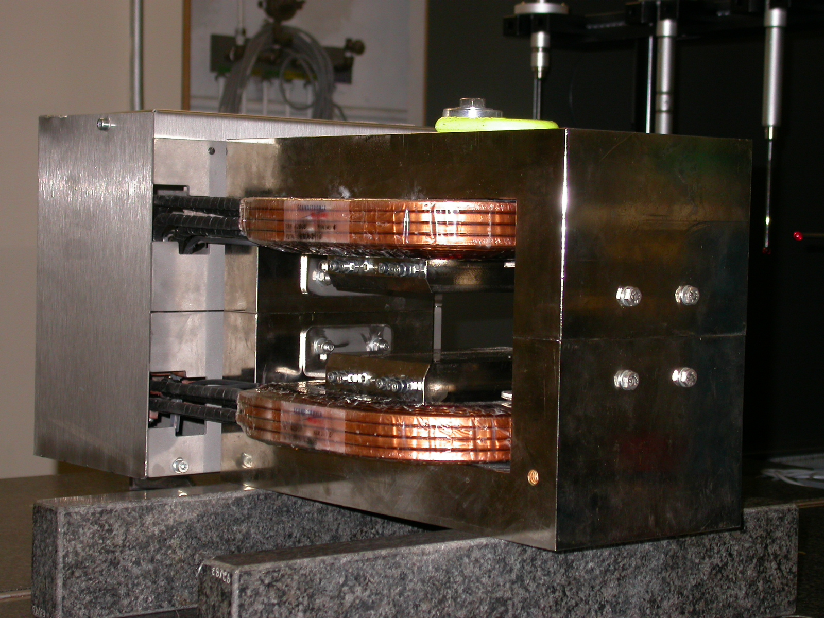

Inspector: | Keith Caban
Responsible Engineer: | Jose Chan
Date: | Wednesday, August 30, 2006
Work Order/Charge No.: | 92-4223-2
Serial Number: | 001079
URL of Fiducial Report: | \\Web002\www-group\met\Quality\FIDUCIAL REPORTS\LCLS BC1 MAGNETS\LCLS BC1 001079.pdf

Part Set-up – Coordinate System Set-up

Planar Alignment
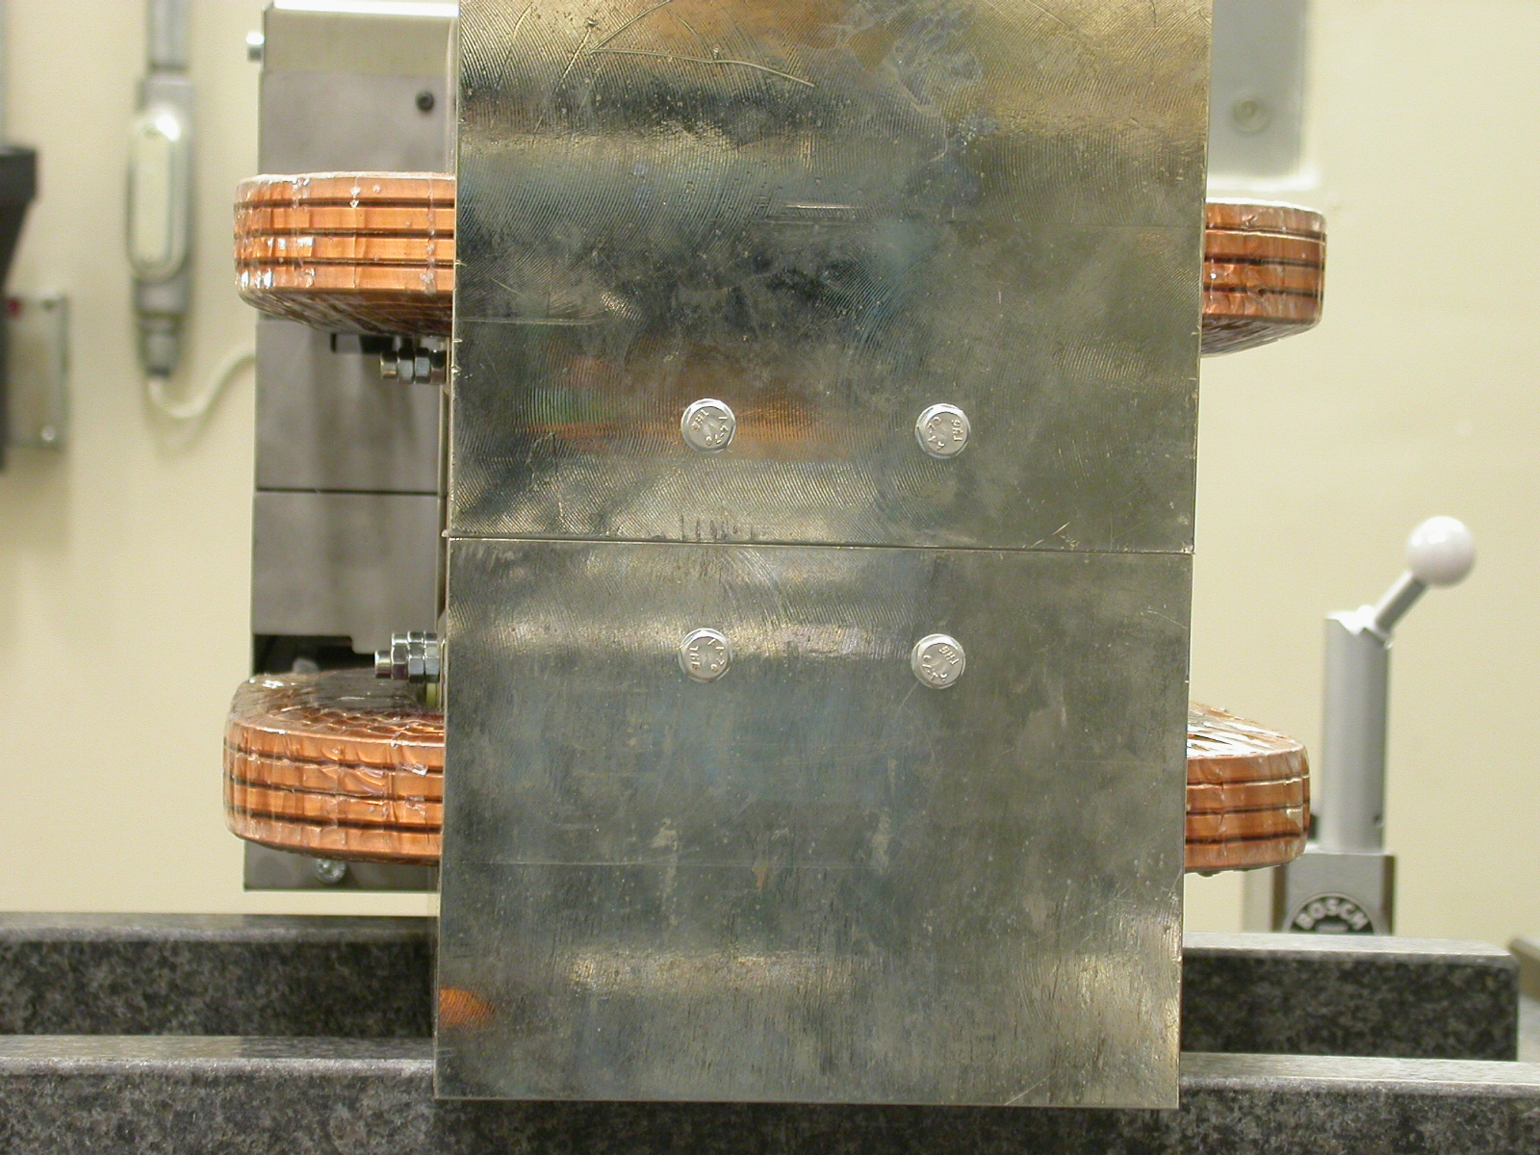
- Mid-Plane of the magnet

Spatial Alignment
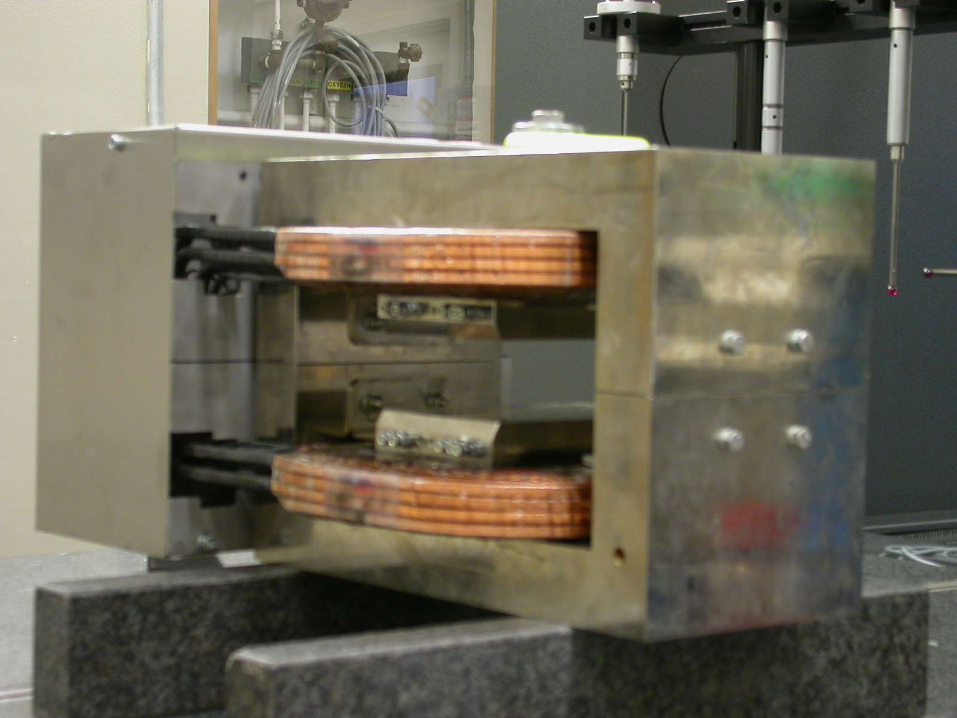
  - Top of magnet where label is.

“Z” Zero

- Mid-Plane of the magnet.

“X” & “Y” Zero

- X zero is created by the symmetry point of the inner stainless steel where coils lie.
    - Both ends of both sides.
      - Create lines which is y axis.
        - This Creates X- zero
- Symmetry of pole planes
  - This creates Y- zero

+Y  +Z | 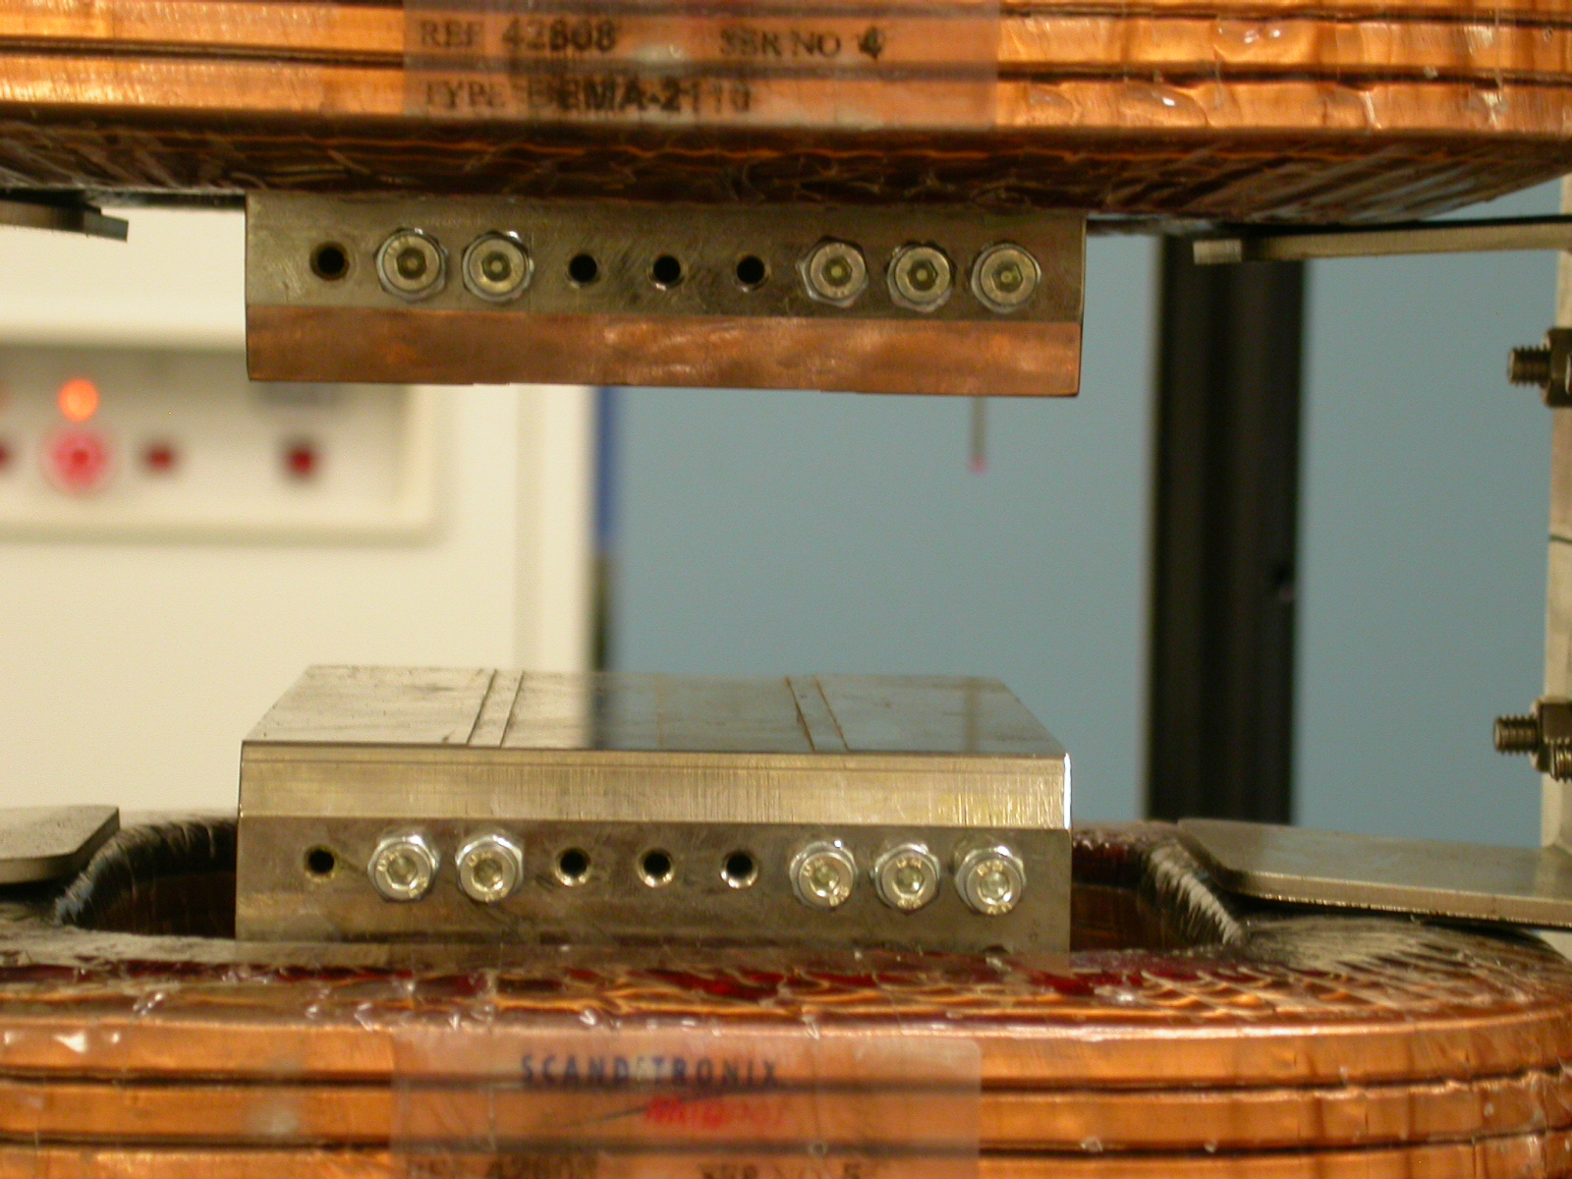  +Y  +X

Tooling Ball Measurements/Locations

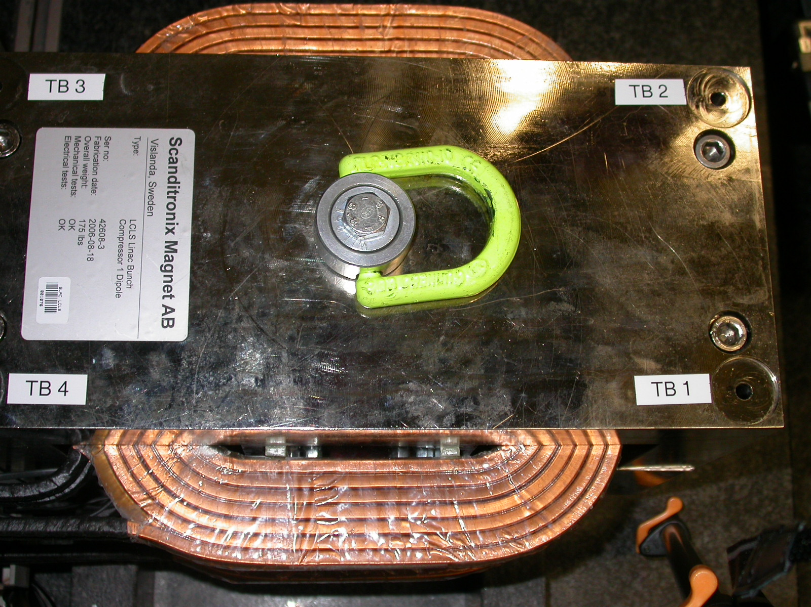
+X
+Z

Tooling Ball | FORM | DIAMETER | X | Y | Z
TB 1 | 0.00175 | 0.49348 | 6.04664 | 5.67496 | 2.53349
TB 2 | 0.00156 | 0.49437 | 6.04706 | 5.67498 | -2.53959
TB 3 | 0.00118 | 0.49697 | -6.04133 | 5.67492 | -2.53203
TB 4 | 0.00138 | 0.49555 | -6.04619 | 5.67602 | 2.52562

