LCLS BC 1 Magnet
FIDUCIALIZATION REPORT

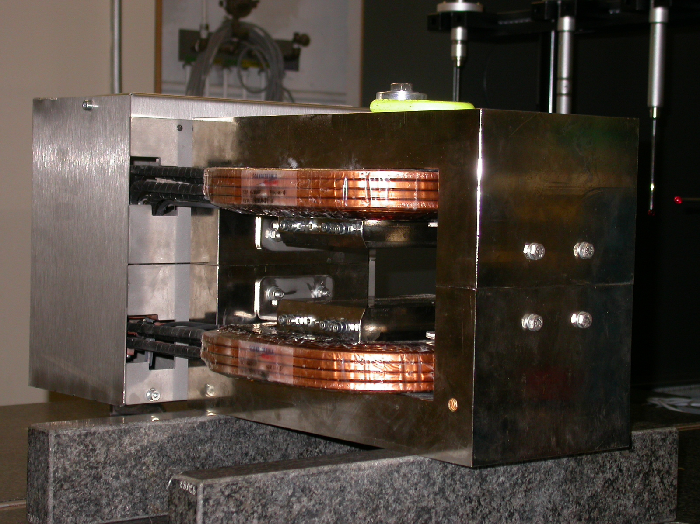

Inspector: | Keith Caban
Responsible Engineer: | Jose Chan
Date: | Tuesday, August 29, 2006
Work Order/Charge No.: | 92-4223-2
Serial Number: | 001076
URL of Fiducial Report: | \\Web002\www-group\met\Quality\FIDUCIAL REPORTS\LCLS BC1 MAGNETS\LCLS BC1 001076.pdf

Part Set-up – Coordinate System Set-up

Planar Alignment
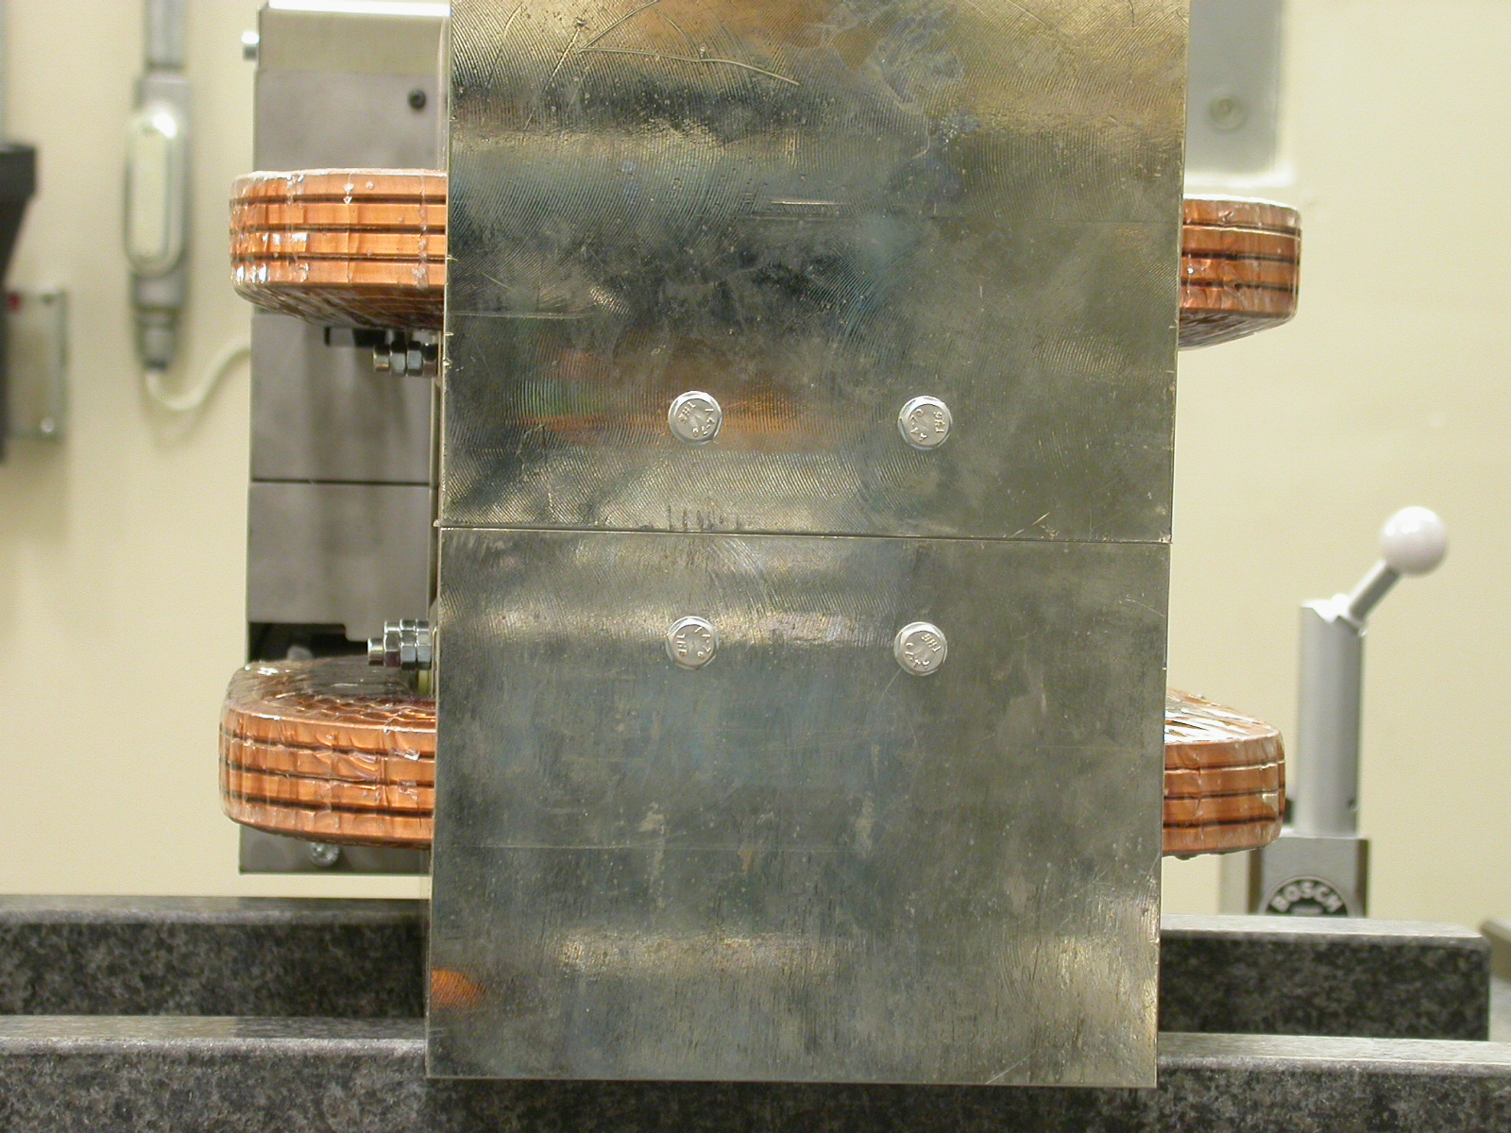
- Mid-Plane of the magnet

Spatial Alignment
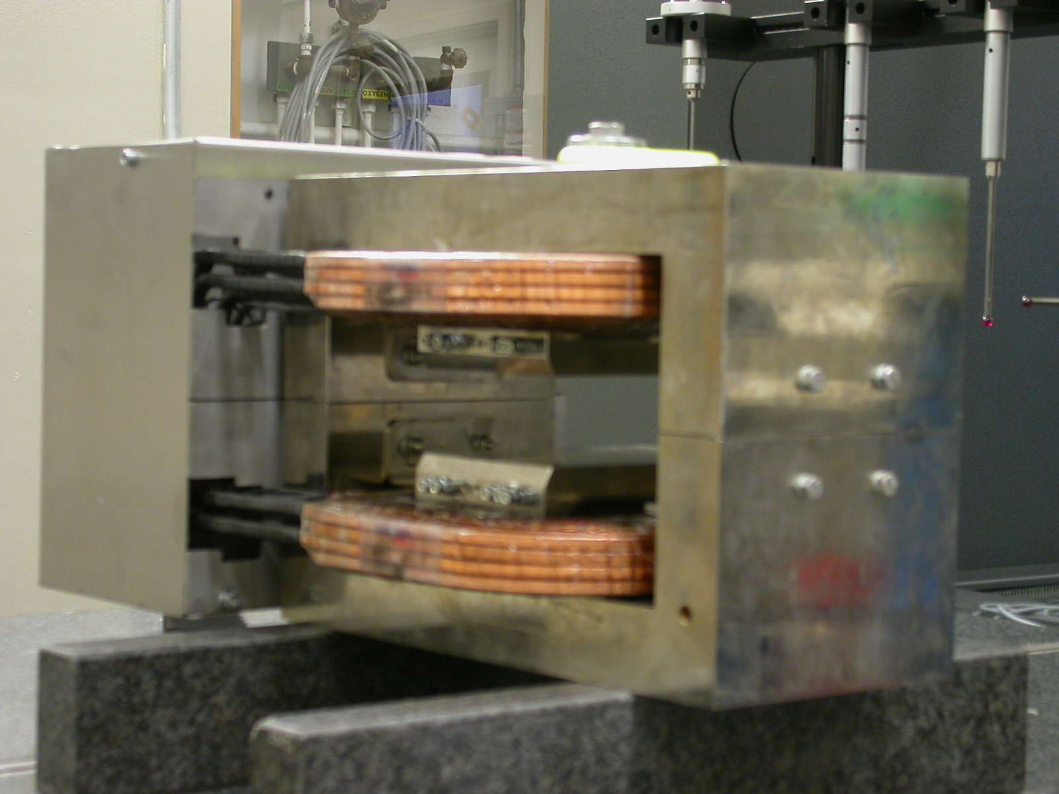
  - Top of magnet where label is.

“Z” Zero

- Mid-Plane of the magnet.

“X” & “Y” Zero

- X zero is created by the symmetry point of the inner stainless steel where coils lie.
    - Both ends of both sides.
      - Create lines which is y axis.
        - This Creates X- zero
- Symmetry of pole planes
  - This creates Y- zero

+Y  +Z | 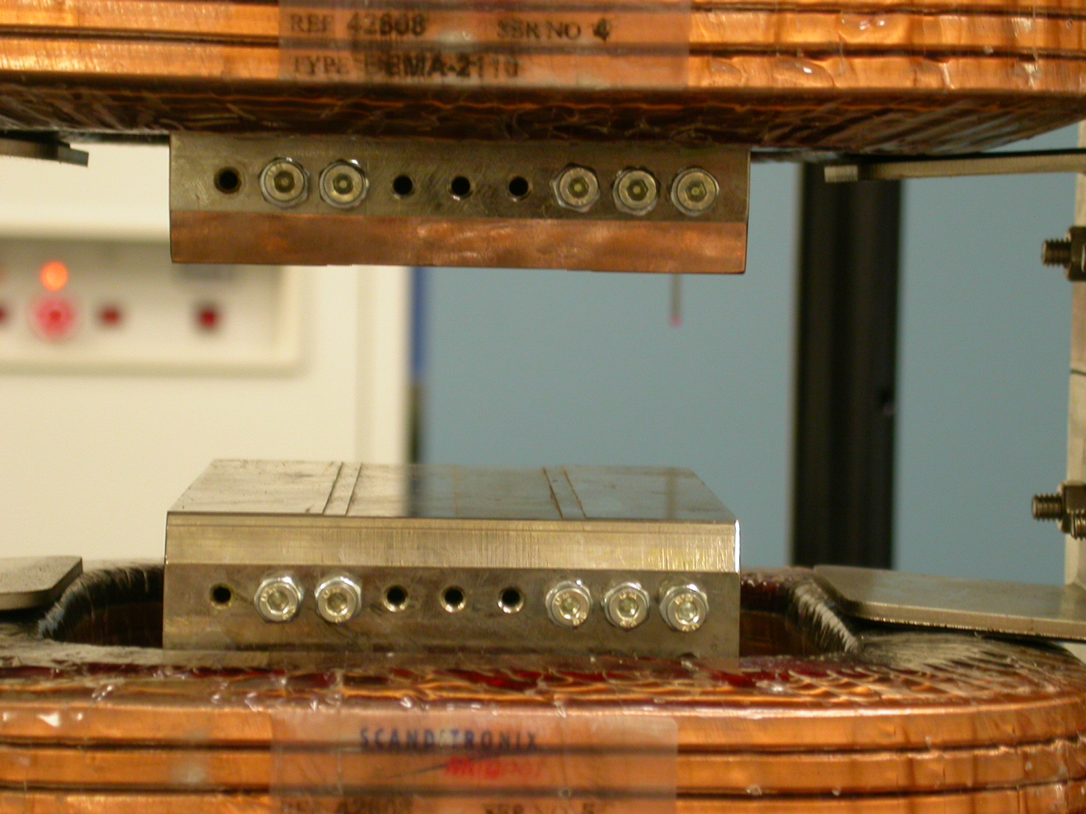  +Y  +X

Tooling Ball Measurements/Locations

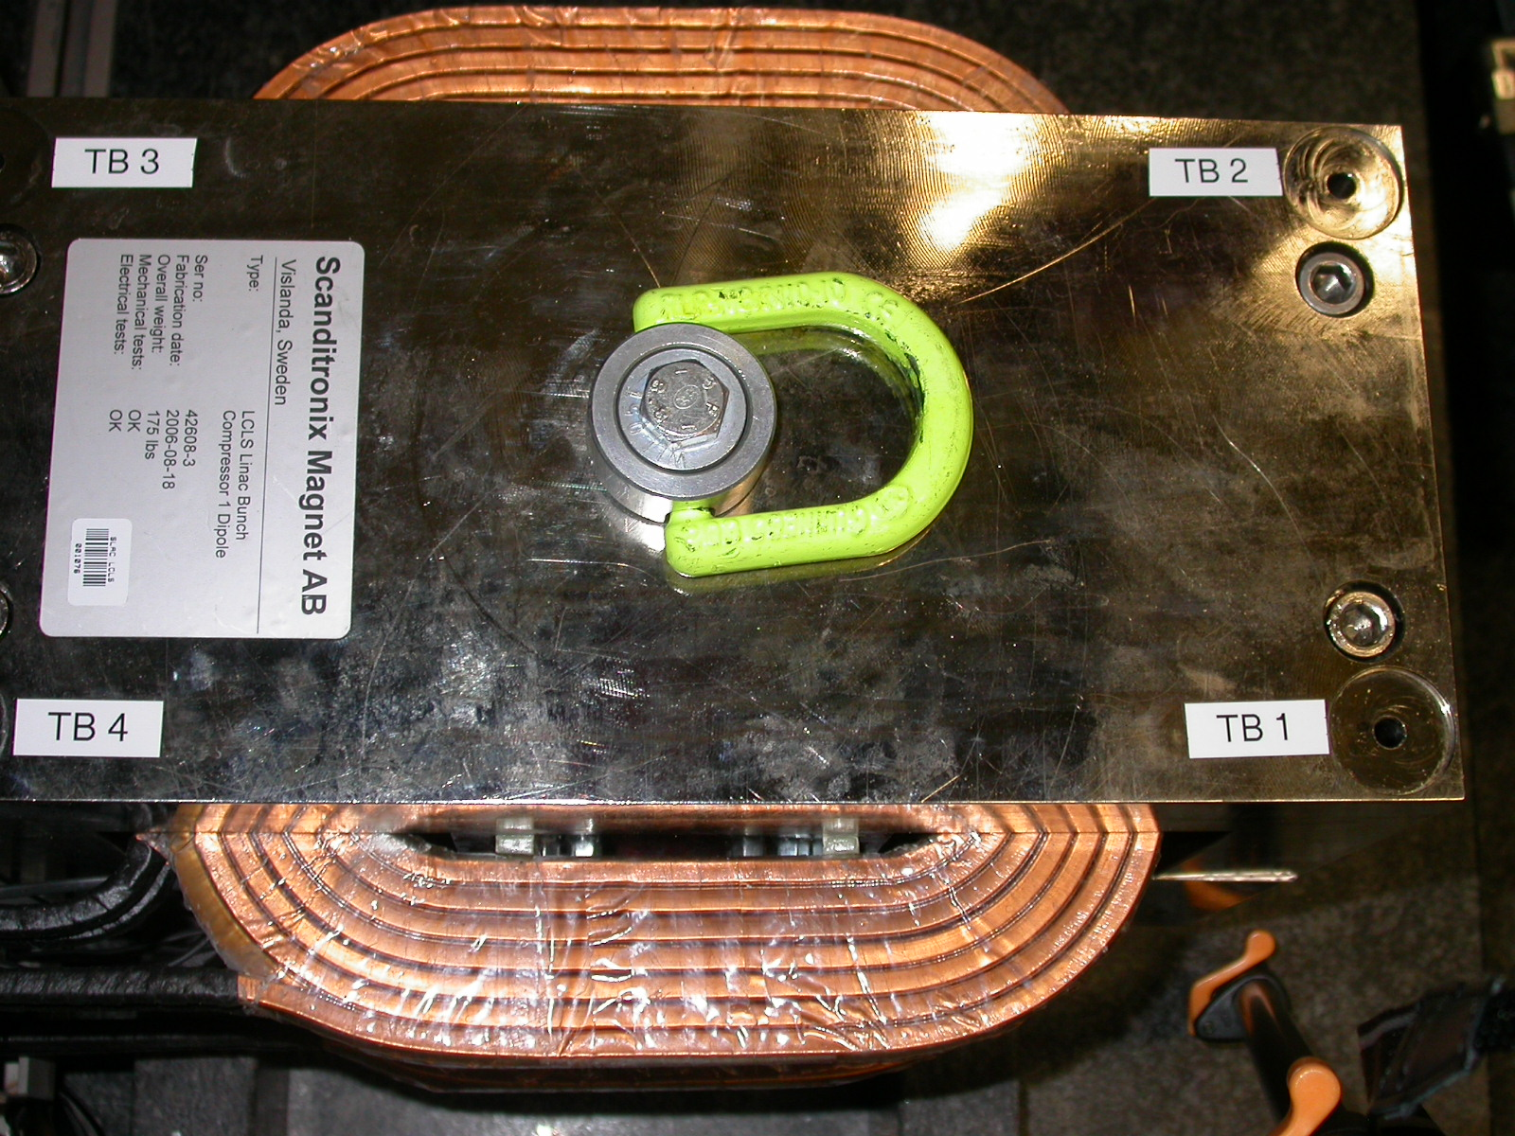
+X
+Z

Tooling Ball | FORM | DIAMETER | X | Y | Z
TB 1 | 0.00189 | 0.49281 | 6.04905 | 5.66664 | 2.53078
TB 2 | 0.00211 | 0.49180 | 6.05072 | 5.66678 | -2.52648
TB 3 | 0.00116 | 0.49521 | -6.04009 | 5.67943 | -2.53428
TB 4 | 0.00367 | 0.49124 | -6.04375 | 5.68181 | 2.54398

