

E163 Gun Spectrometer
FIDUCIALIZATION REPORT

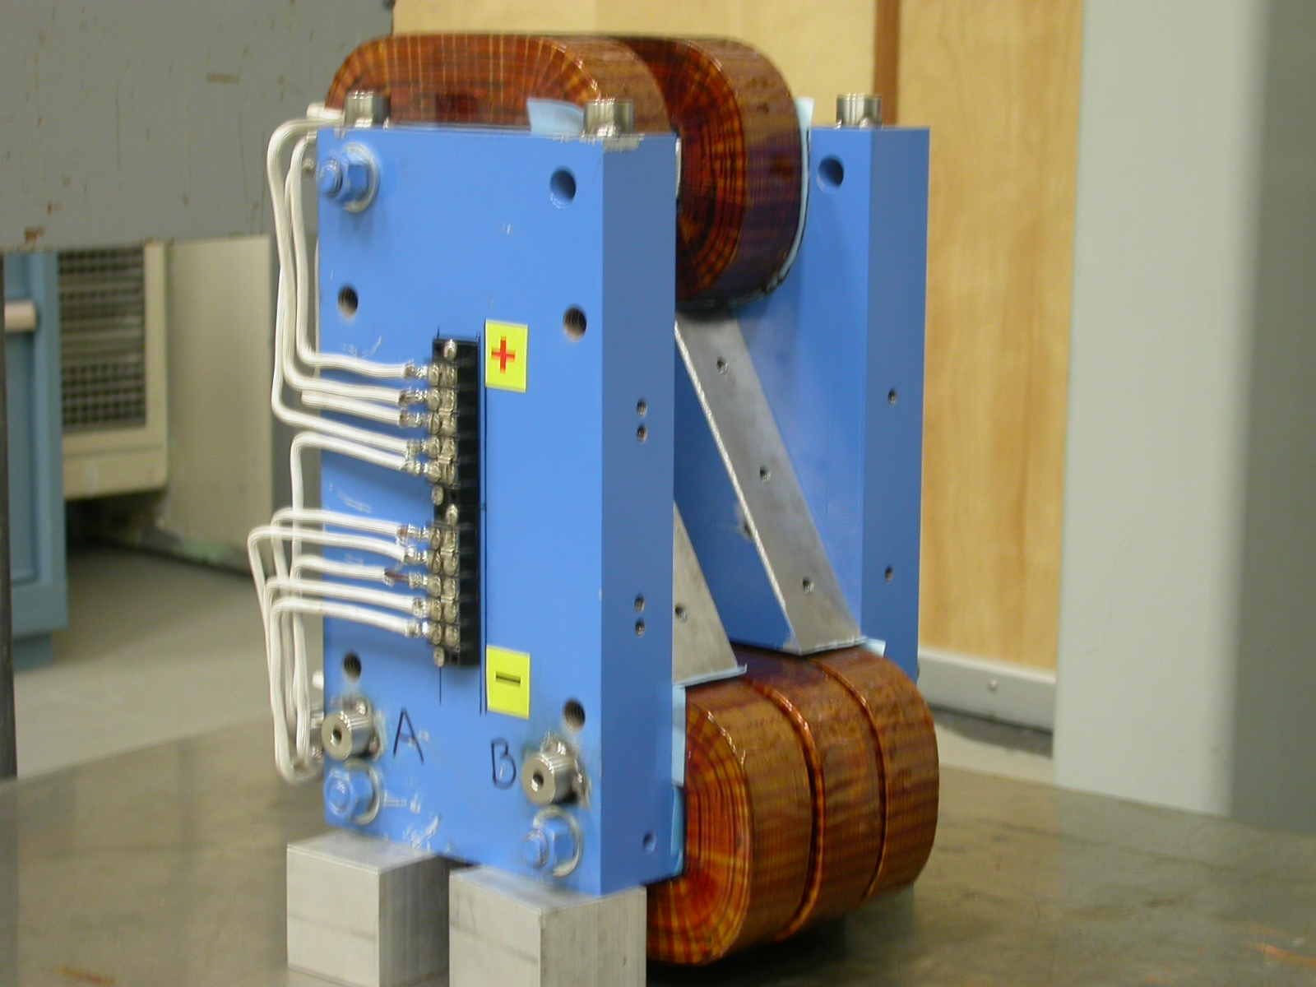

Inspector: Keith Caban
Engineer: Jim Spencer
Date: 06/10/05
Charge No: 12-1410-1
Mag. S/N: N/A

Fiducialization Coordinate System Set Up:

Magnet is set on 2 granite parallels as displayed in the photo below.

SIDE VIEW
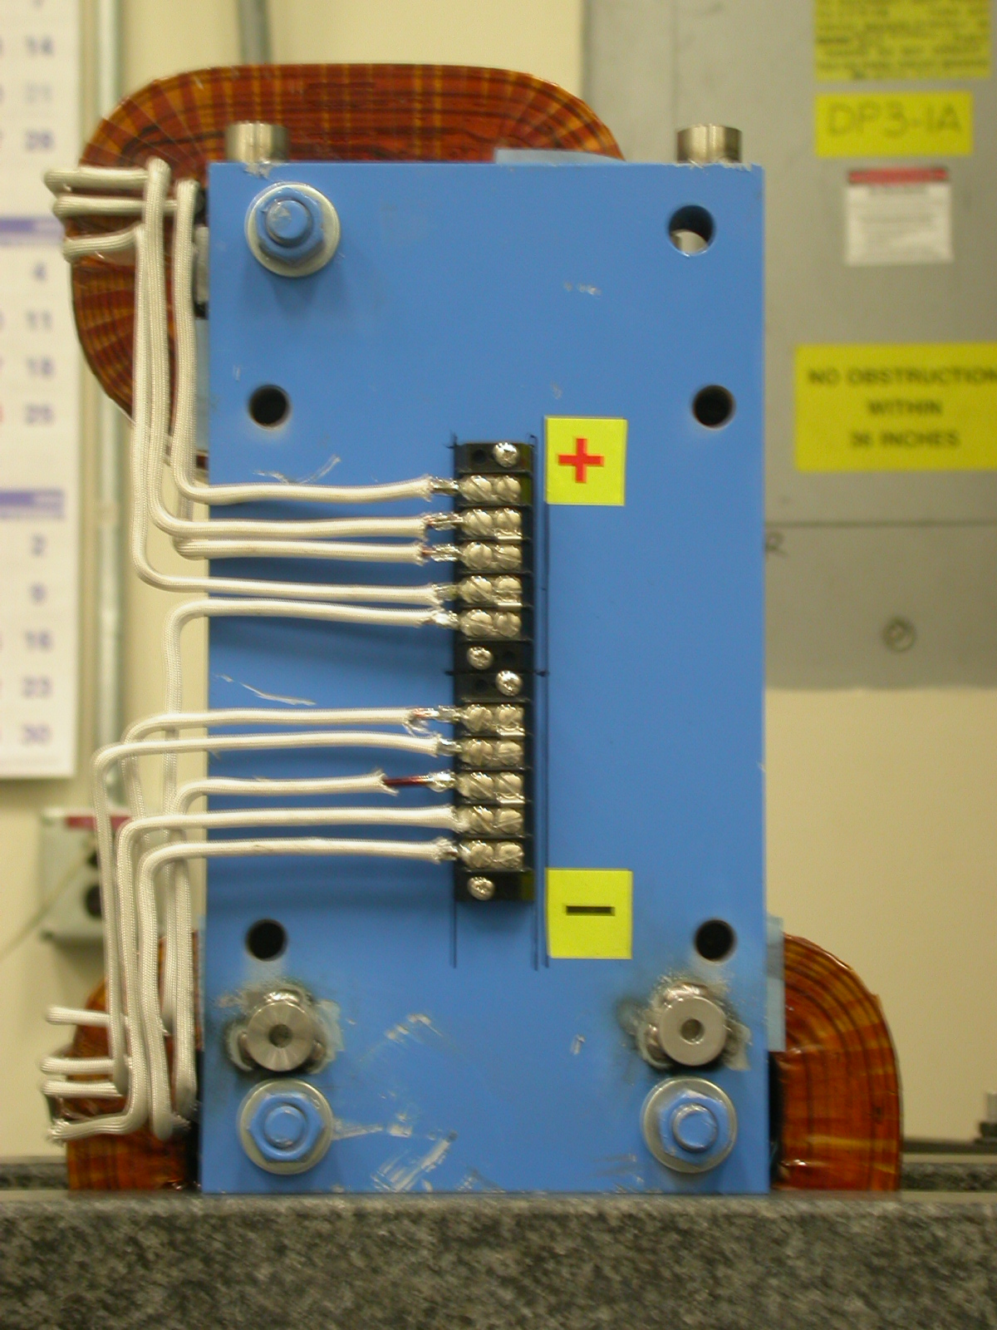
Z zero is set by the mid-plane of these 2 surfaces.
(Distance width = 6.2552”)

FRONT
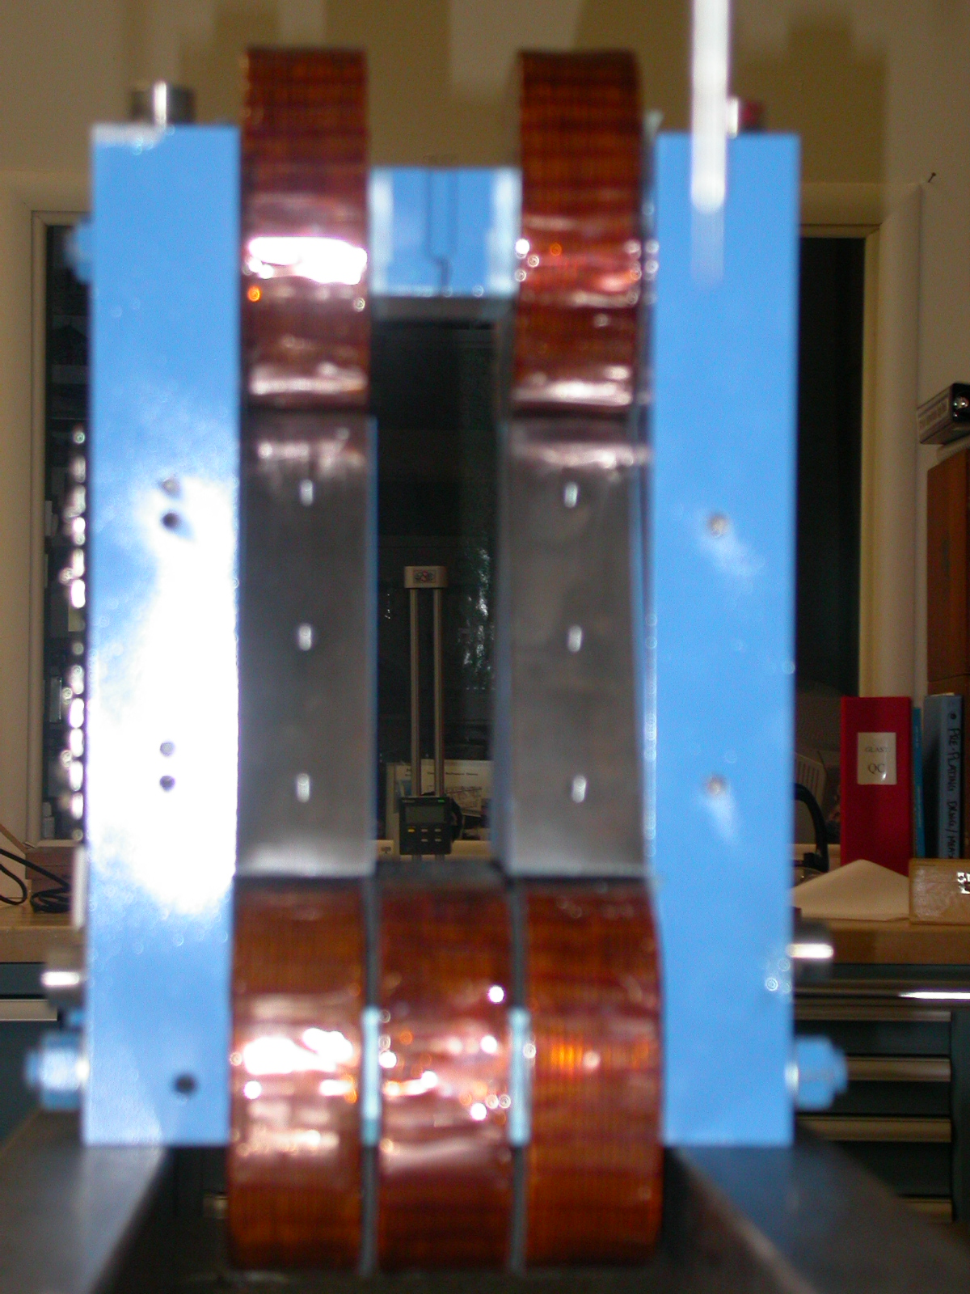
X zero is set by the mid-plane of these 2 surfaces.
(Distance between = 1.5740”)
ZOOM FRONT VIEW
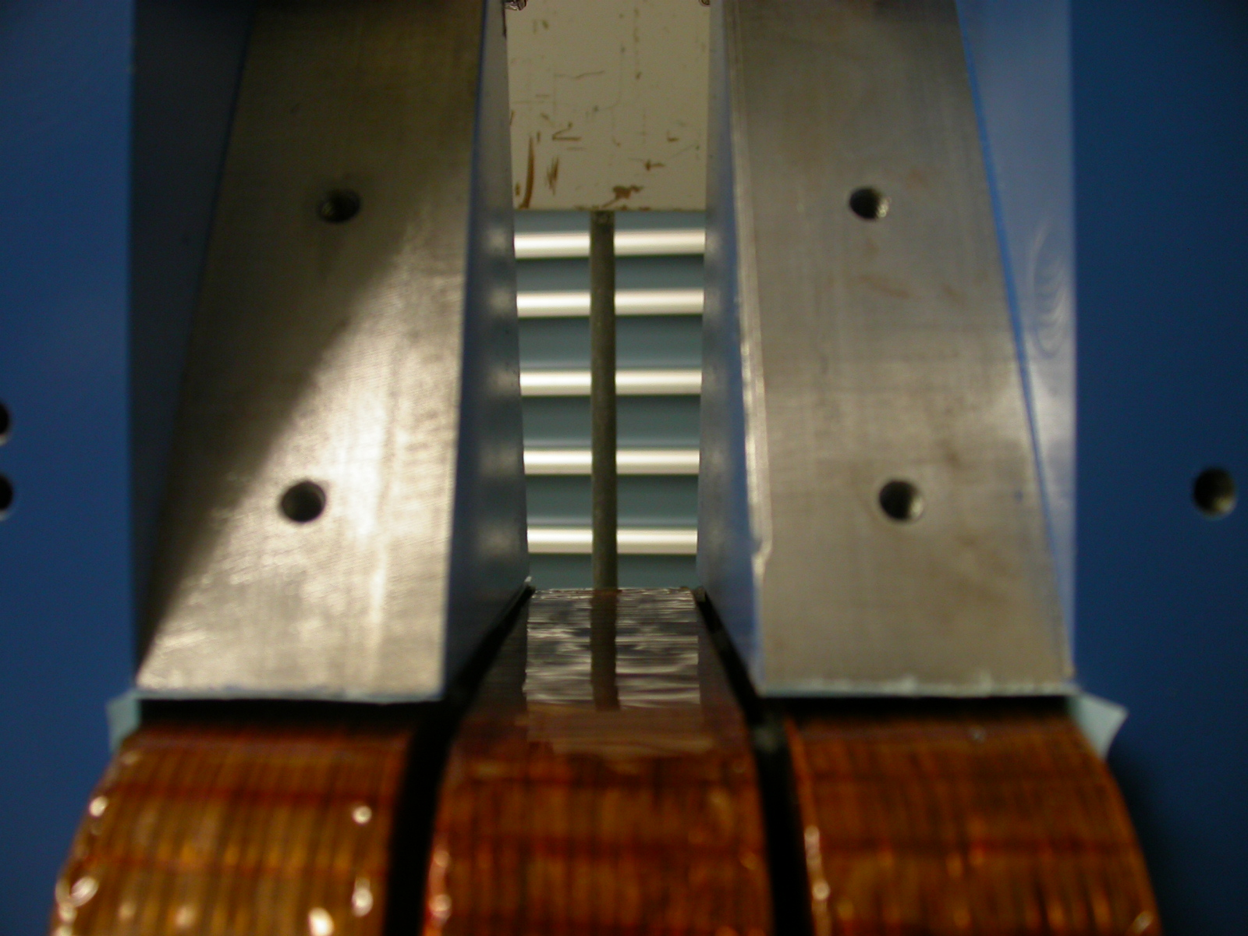
Y zero is the bottom of Triangular plates (2 ea) plane shifted up (green line) 1.500”. (Dist from Green Line to bottom where Granite Parallels = 3.060”)

3-D VIEW
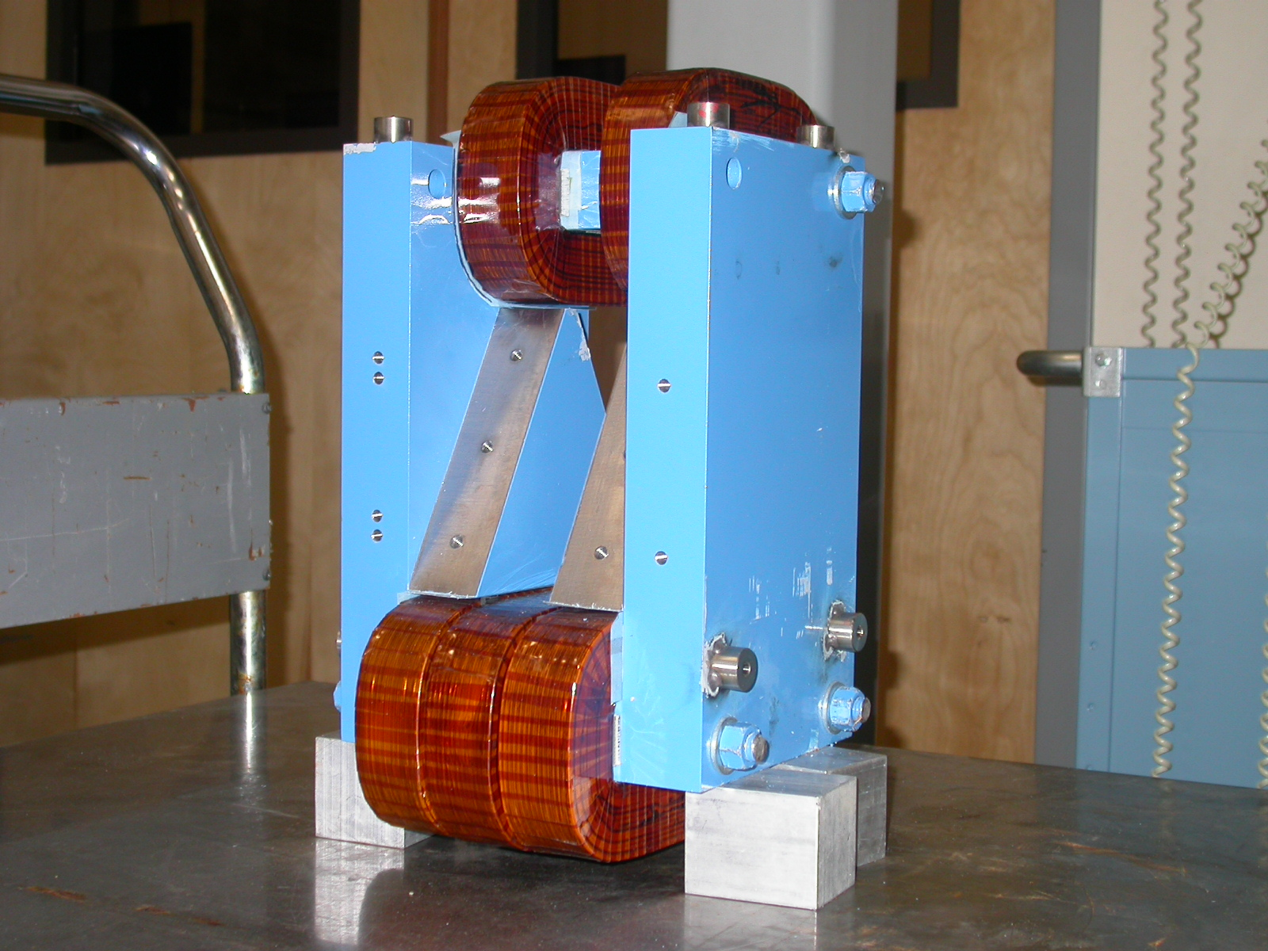

Tooling Ball Fiducials

- using ½” Diameter Tooling Balls w/ 1” Extension

TB’S A - D
+Z
+Y
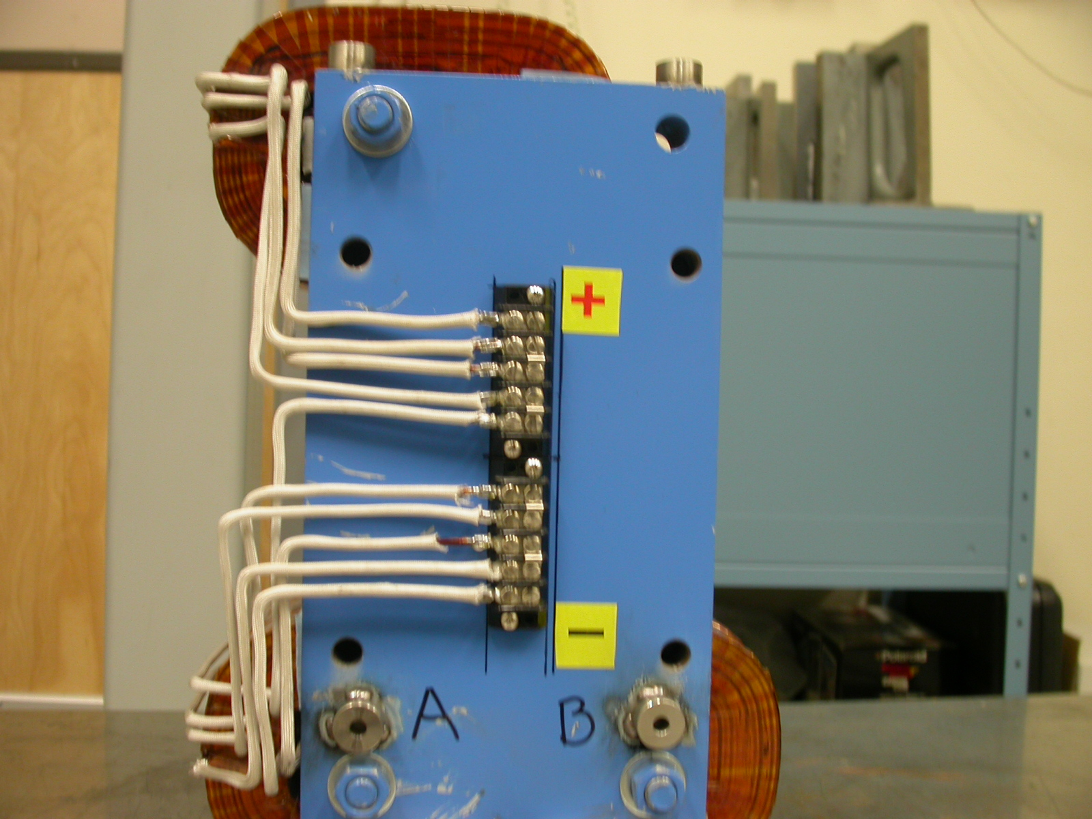

TB C & D ON OPPOSITE SIDE

TB | FORM | DIAMETER | X | Y | Z
TB A | 0.00030 | 0.49708 | -5.50796 | -2.80649 | -2.24880
TB B | 0.00038 | 0.49731 | -5.50348 | -2.77013 | 2.27880
TB C | 0.00048 | 0.49797 | 5.50324 | -2.41333 | 2.44159
TB D | 0.00021 | 0.49870 | 5.49870 | -2.31543 | -2.26850

TB’S E - H
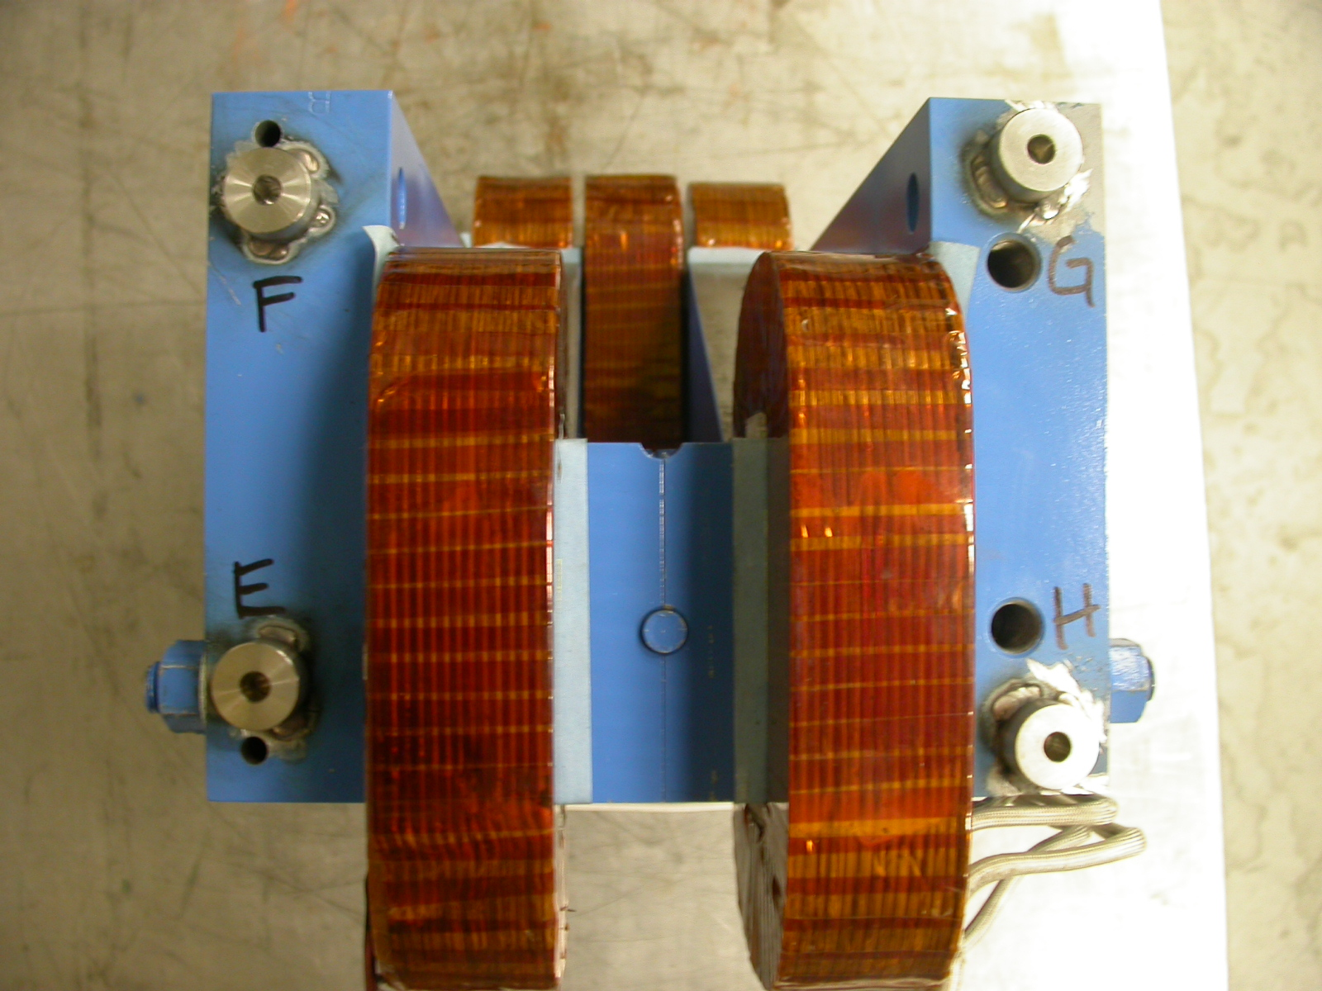
-X
+Z

TB | FORM | DIAMETER | X | Y | Z
TB E | 0.00053 | 0.49804 | 3.43368 | 8.45147 | -2.07726
TB F | 0.00029 | 0.49977 | 3.37223 | 8.45125 | 2.11399
TB G | 0.00054 | 0.49777 | -3.25546 | 8.44859 | 2.53822
TB H | 0.00056 | 0.49726 | -3.35994 | 8.45149 | -2.60550

