

NLCTA Dipole Magnet
FIDUCIALIZATION REPORT

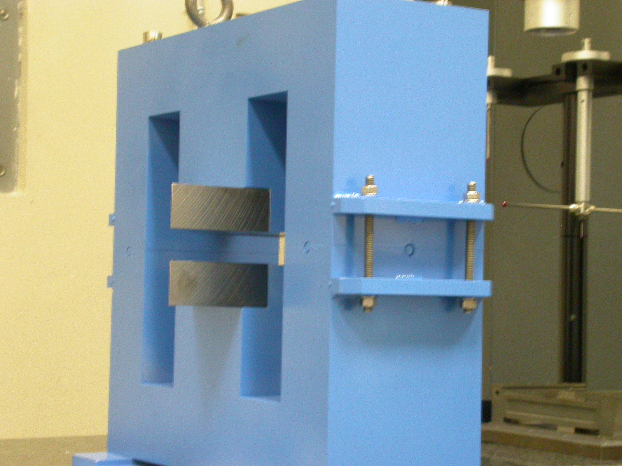

Inspector: Keith Caban
Engineer: Jim Spencer
Date: 09/13/05
Charge No: 12-1410-1
Mag. S/N: B

Fiducialization Coordinate System Set Up:

Magnet is set on 2 granite parallels as displayed in the photo below.

SIDE VIEW
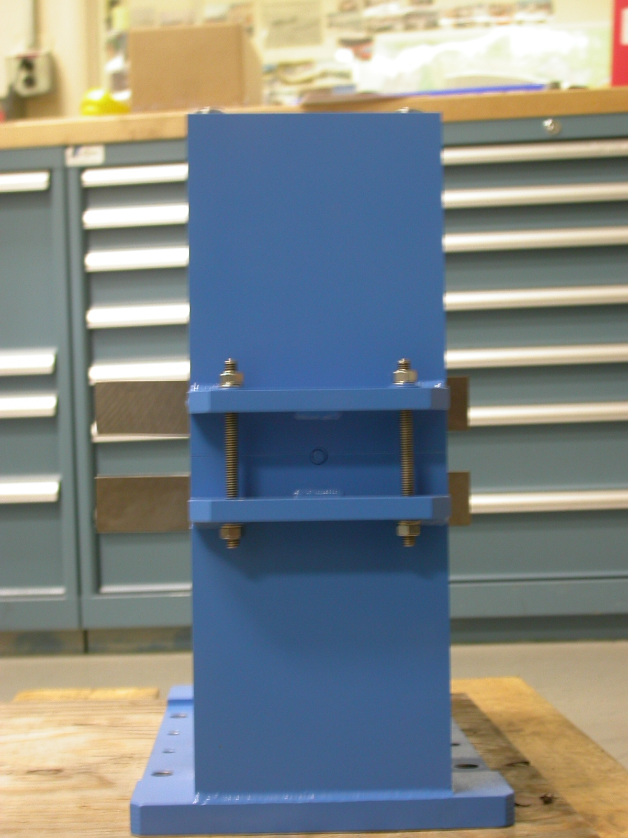
+Y
+Z
Z zero is set by the mid-plane of these 2 surfaces.
(Distance width = 6.0085”)

“B” Exit View ZOOM “B” Exit View
+Y
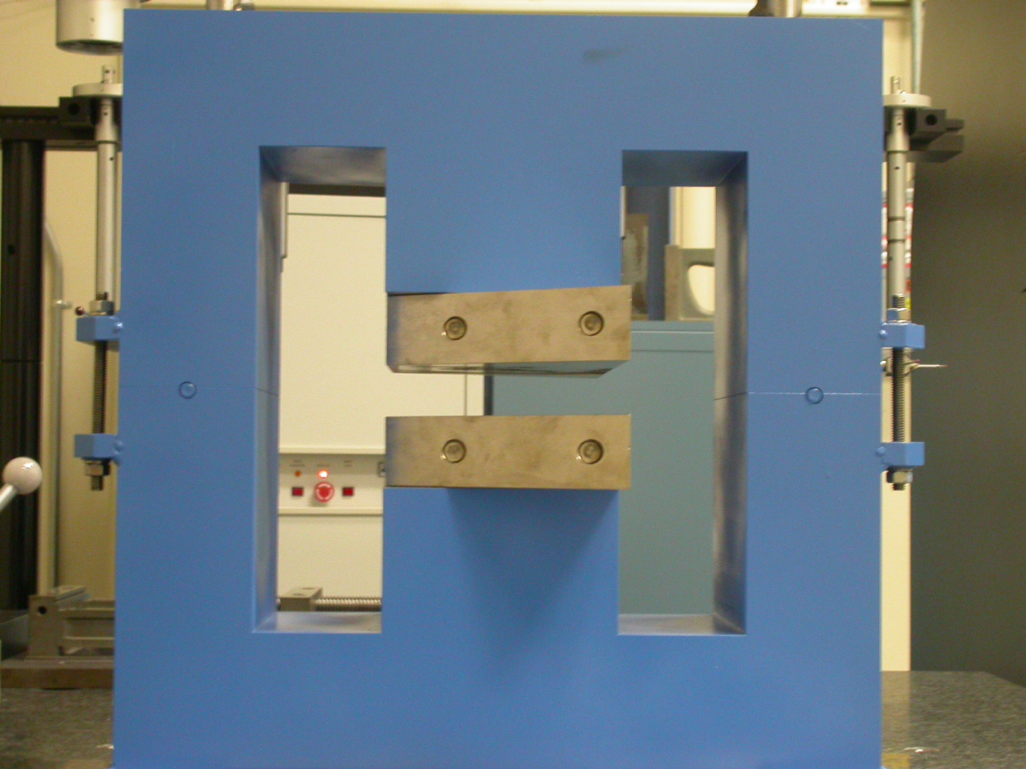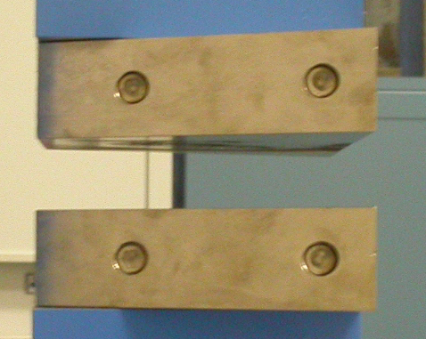
+1.000” OFFSET +X
+X
X & Y zero shown, with X offset 1.000” in +X
off of “True Magnet Center”.

---- Dashed Green line is Mechanical Magnet Centerline
3-D VIEW

+Y
+Z
+X

Tooling Ball Fiducials

- using ½” Diameter Tooling Balls w/ 1” Extension

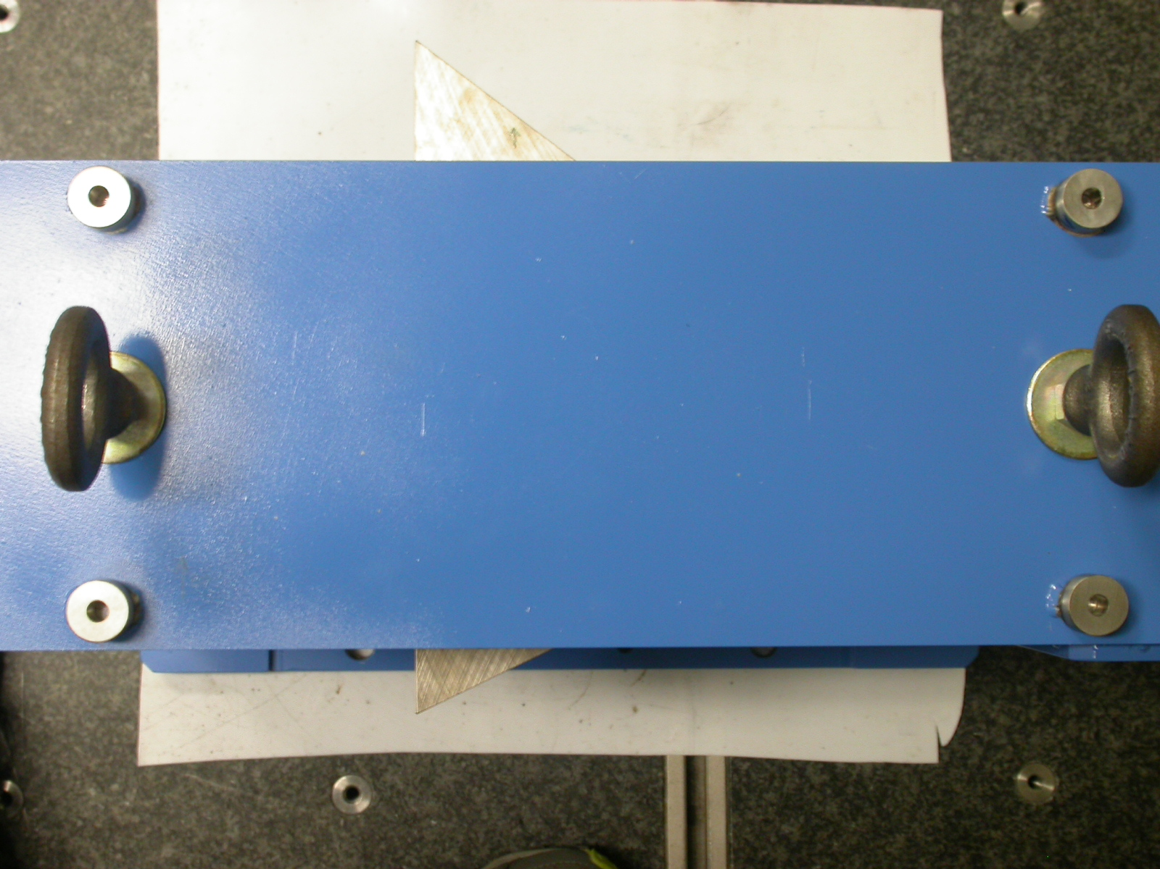
+X
+Z
TB 1
TB 2
TB 3
TB 4

Coordinates of Solid Green (Beam)
TB | FORM | DIAMETER | X | Y | Z
TB 1 | 0.00049 | 0.49793 | 5.04788 | 9.50555 | -2.50520
TB 2 | 0.00047 | 0.49724 | -7.03506 | 9.50644 | -2.49774
TB 3 | 0.00017 | 0.49926 | -7.01313 | 9.50743 | 2.47936
TB 4 | 0.00025 | 0.49827 | 5.04212 | 9.50313 | 2.48223
ANGLE OF LARGE TRIANGLE = 37.24°

