
QP2A Quadrupole Magnet
FIDUCIALIZATION REPORT

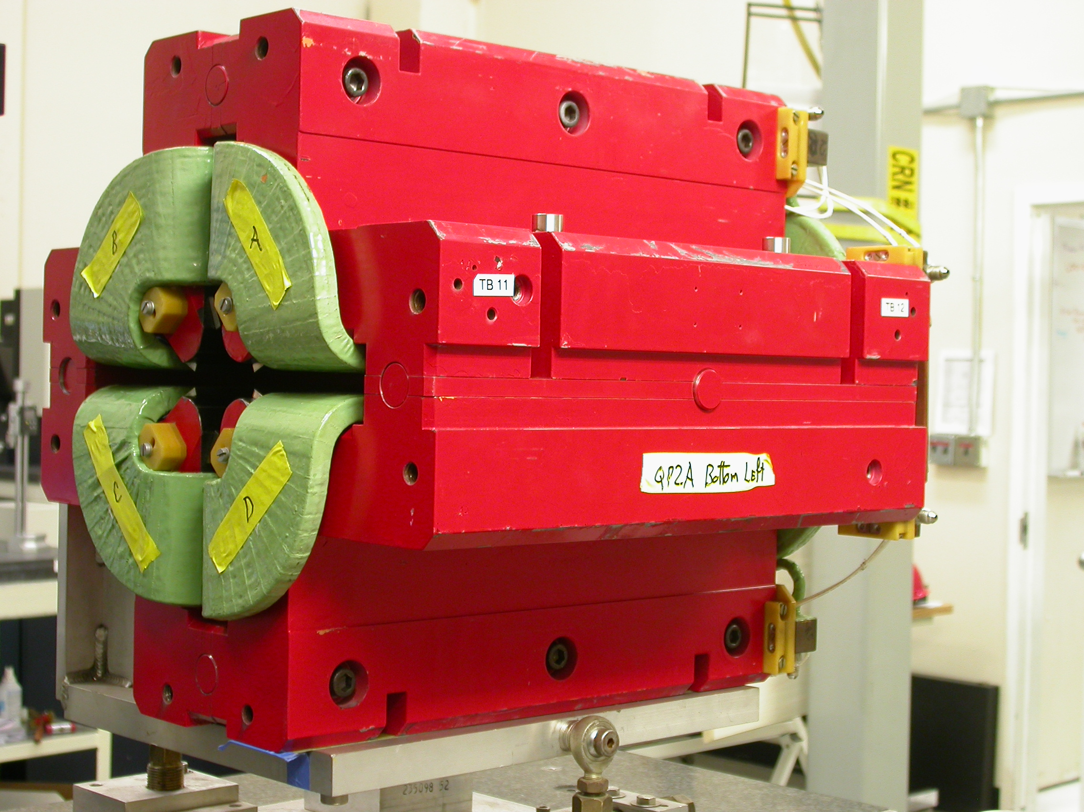

Inspector: | Keith Caban
Responsible Engineer: | Cherrill Spencer
Date: | Wednesday, April 09, 2008
Work Order/Charge No.: | 1111143
Serial Number: | QP2A
URL of Fiducial Report: | http://www-group.slac.stanford.edu/met/Quality/FIDUCIAL REPORTS/CHERRILL SPENCER/QP2A.PDF

Part Set-up – Coordinate System Set-up

Spatial Alignment

- Geometric axis of the poles of the magnet.

Planar Alignment

- Top Plane (+Y) of the Magnet (Top most surface).

“Z” Zero

- Mid-plane of the magnet (middle of upstream and downstream ends).

“X” & “Y” Zero

- Geometric axis of the poles of the magnet.

+Y  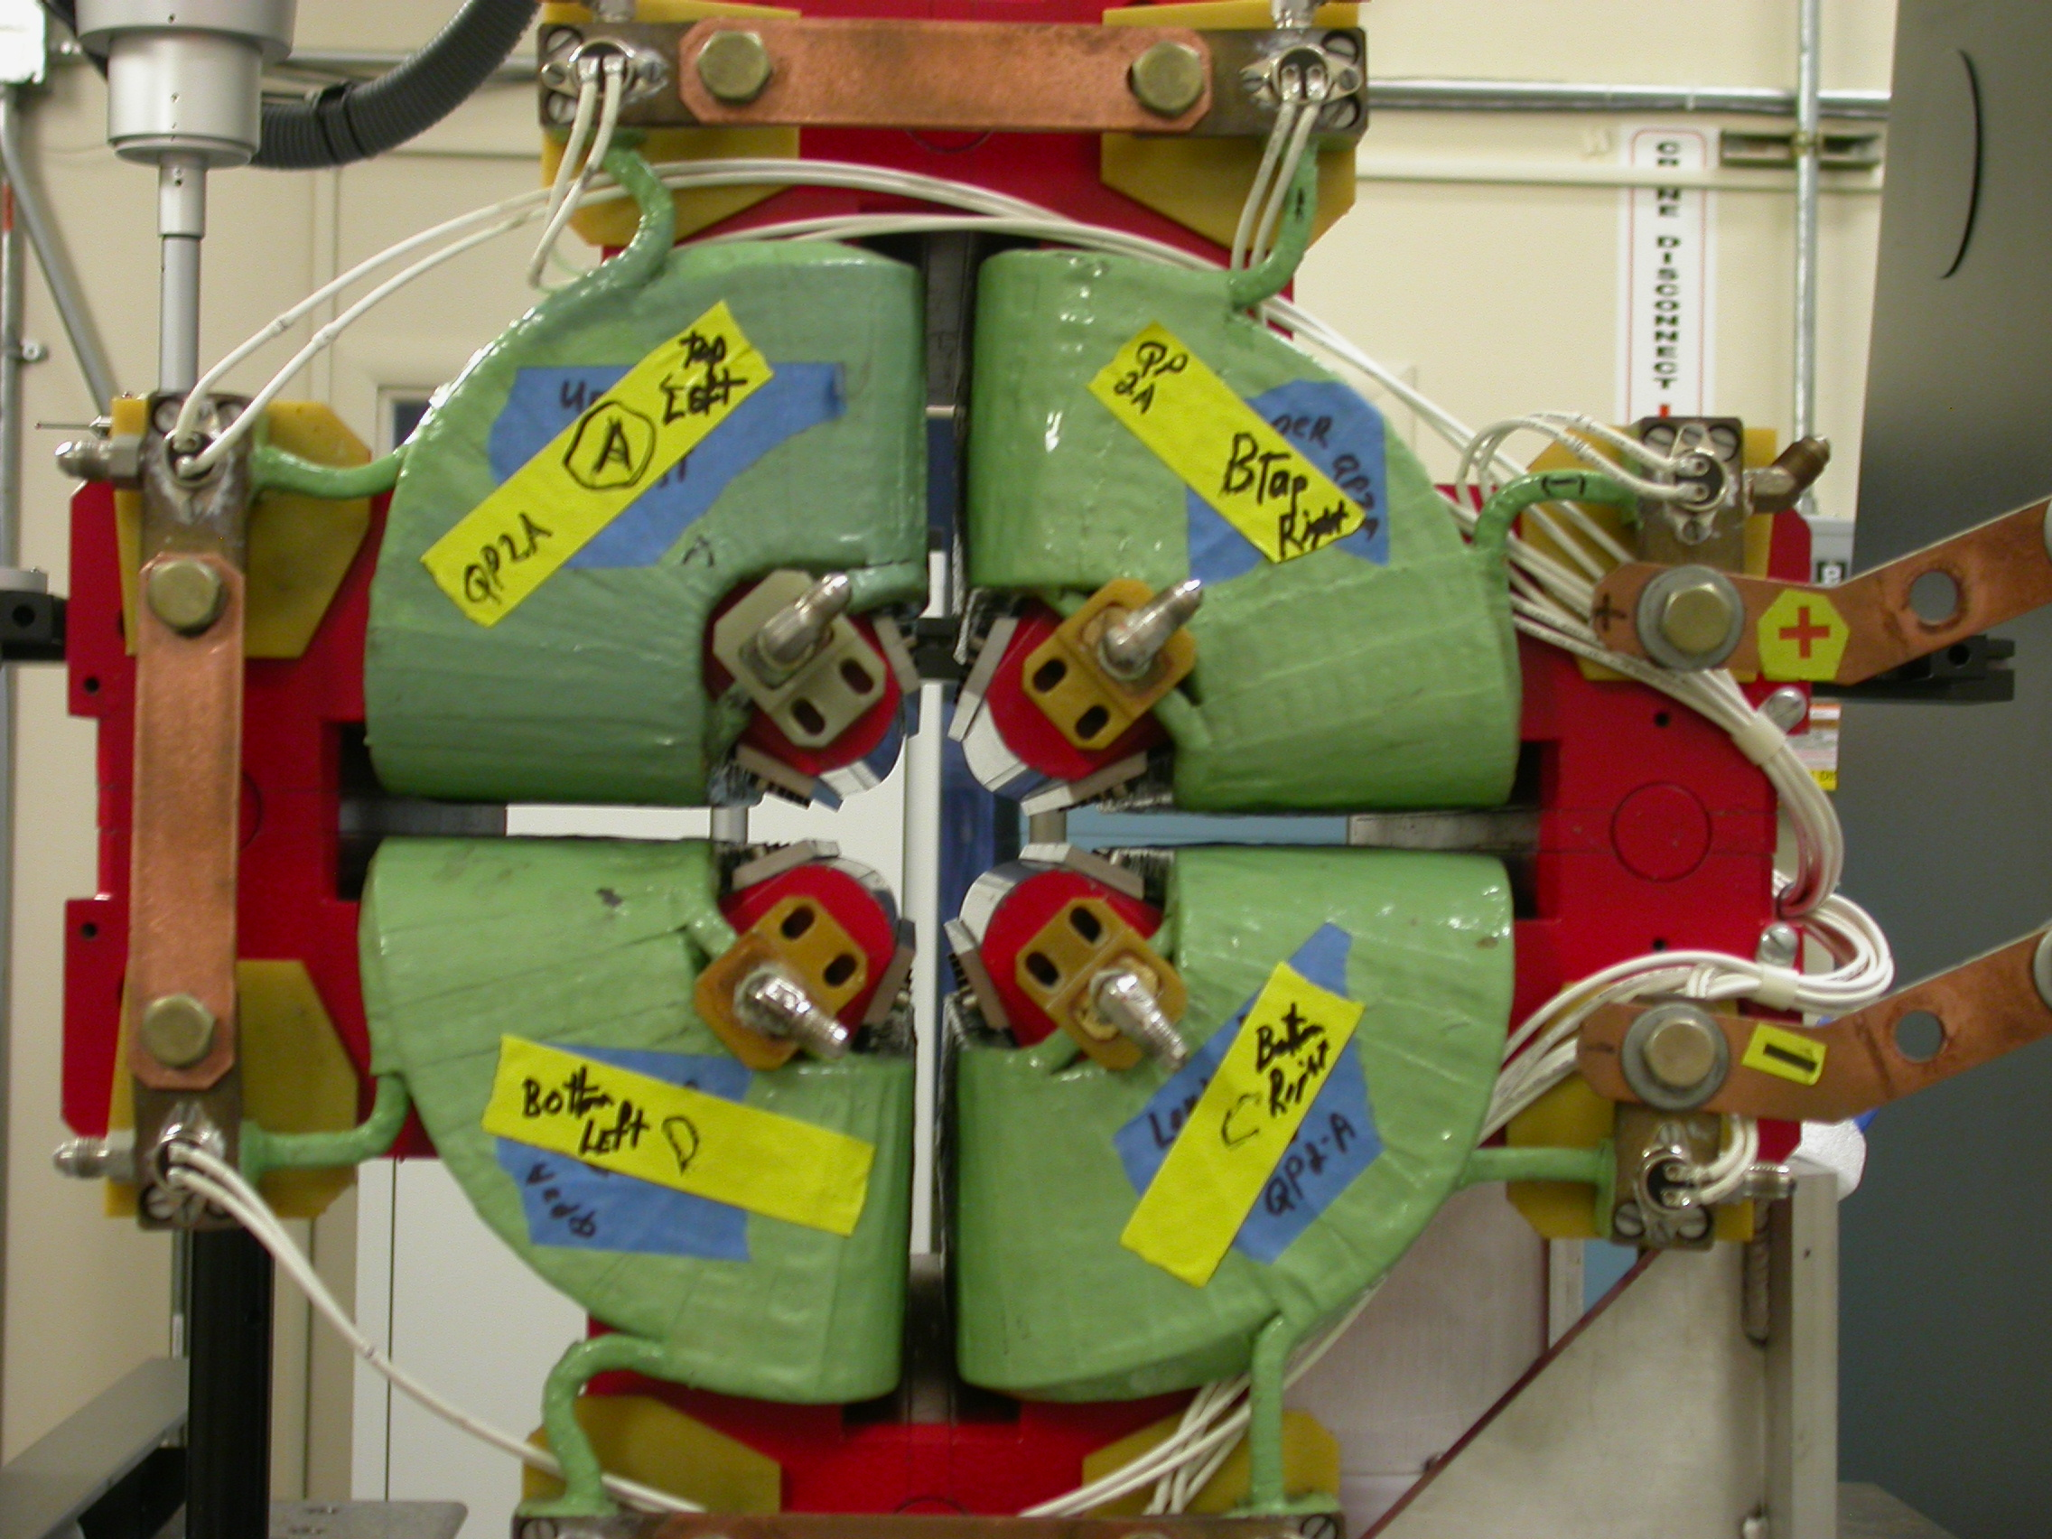  +X  Back View  (Looking from upstream side –Z) | 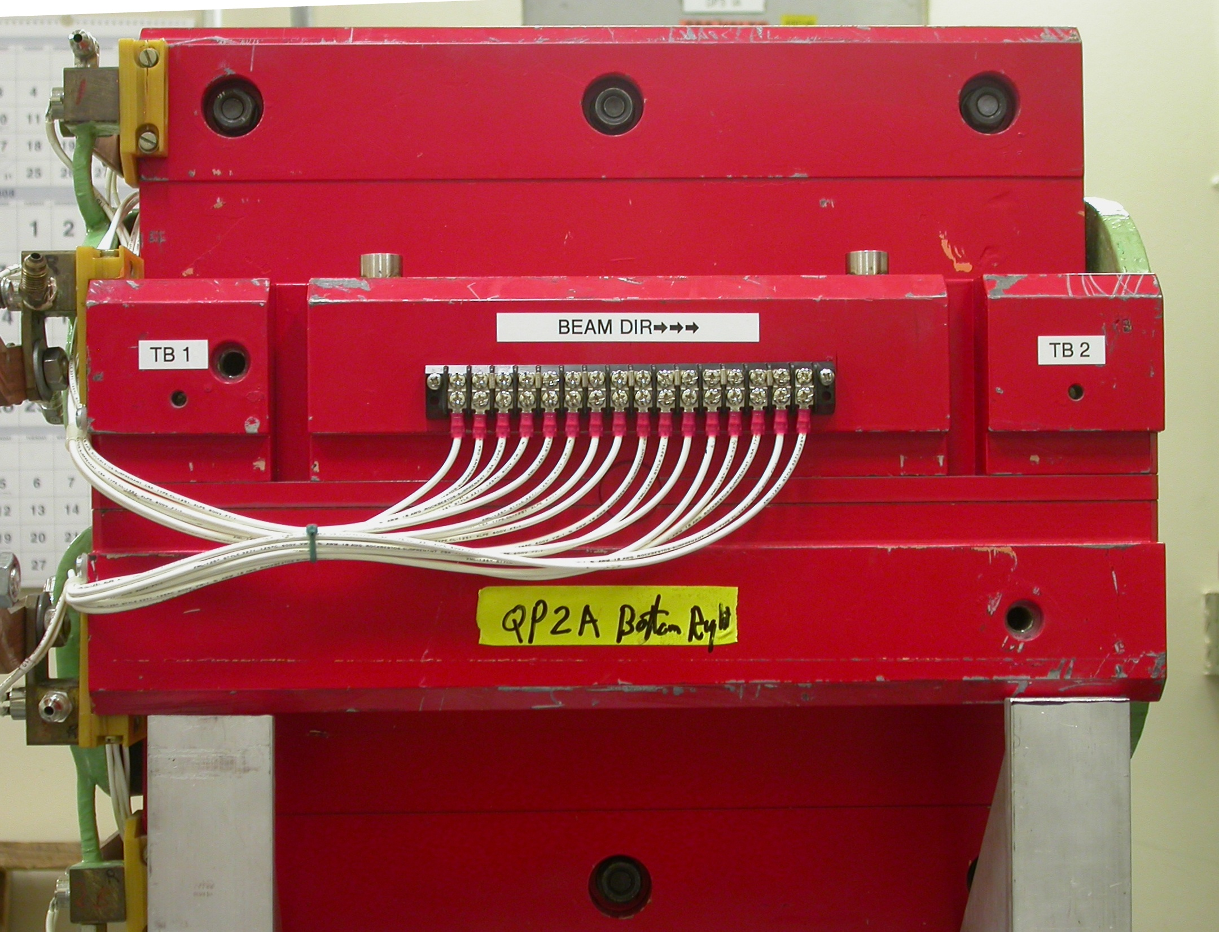  +Z  +Y  Side View  (looking from –X side)

Tooling Ball Locations

Tooling Ball | X | Y | Z
TB 1 | -9.88008 | 1.64207 | -7.35267
TB 2 | -9.87824 | 1.64368 | 7.36262
TB 3 | -7.15722 | 5.13769 | 4.17136
TB 4 | -7.12664 | 5.13582 | -4.15118
TB 5 | -1.51839 | 9.86381 | -7.35722
TB 6 | -1.51791 | 9.86547 | 7.35805
TB 7 | 1.65478 | 9.86474 | 7.35772
TB 8 | 1.65404 | 9.86857 | -7.35662
TB 9 | 7.19454 | 5.04300 | -4.16831
TB 10 | 7.18494 | 5.04085 | 4.16819
TB 11 | 9.87808 | 1.53397 | 7.35481
TB 12 | 9.87436 | 1.53186 | -7.35815

Pole Tip Additional Data
*Data looking from Downstream End (+Z End)

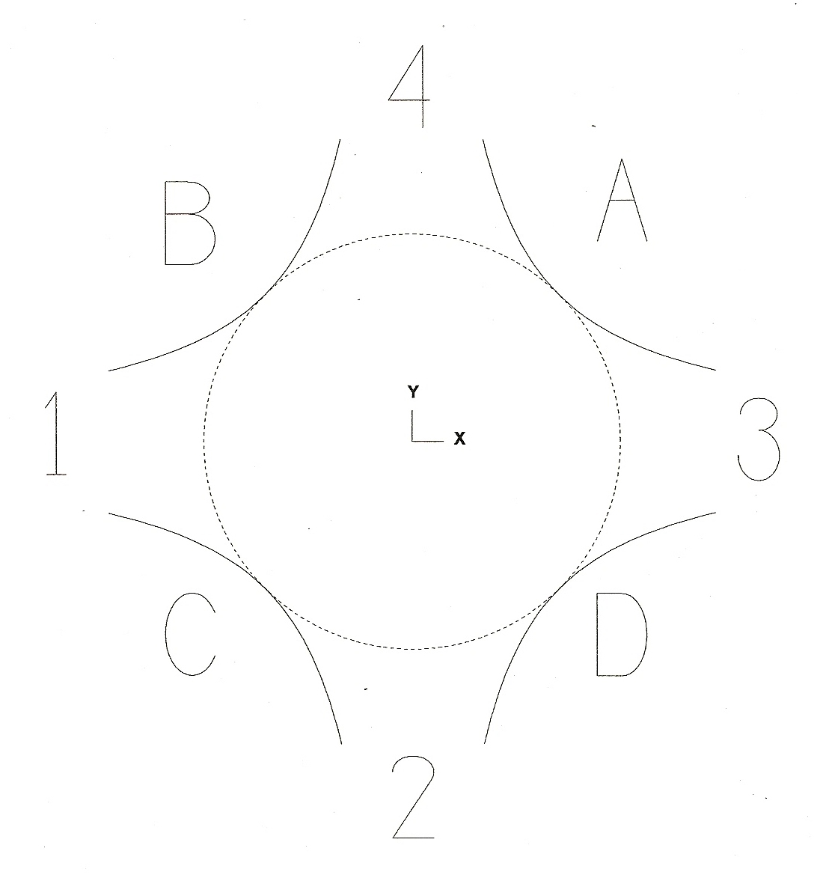

Side | Pole Dist A-C | Pole Dist B-D | Gap 1 | Gap 2 | Gap 3 | Gap 4
Downstream End (+Z) | 1.96975 | 1.97028 | 0.84895 | 0.85155 | 0.85360 | 0.85062
Upstream End (-Z) | 1.97016 | 1.96955 | 0.84858 | 0.85141 | 0.85334 | 0.85114

