
QC3 Quadrupole Magnet
FIDUCIALIZATION REPORT

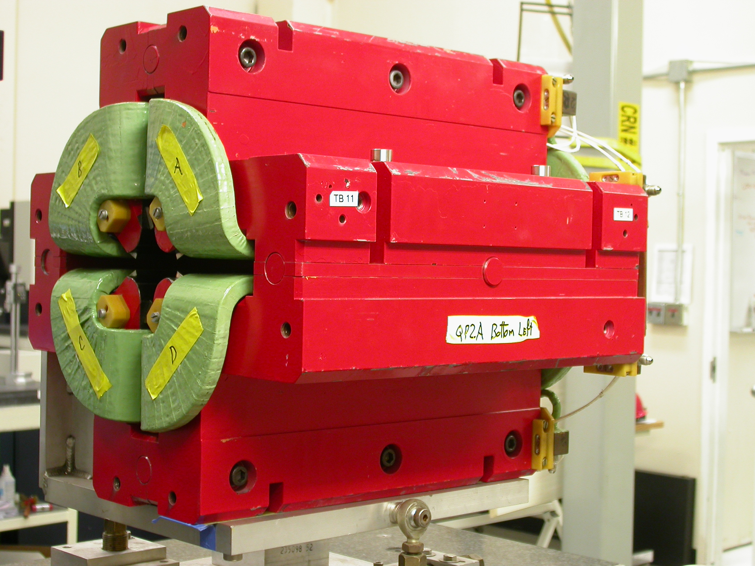
**Photo of QP2A, Not QC3

Inspector: | Keith Caban
Responsible Engineer: | Cherrill Spencer
Date: | Wednesday, April 09, 2008
Work Order/Charge No.: | 1111143
Serial Number: | QC3
URL of Fiducial Report: | http://www-group.slac.stanford.edu/met/Quality/FIDUCIAL REPORTS/CHERRILL SPENCER/QC3.PDF

Part Set-up – Coordinate System Set-up

Spatial Alignment

- Geometric axis of the poles of the magnet.

Planar Alignment

- Top Plane (+Y) of the Magnet (Top most surface).

“Z” Zero

- Mid-plane of the magnet (middle of upstream and downstream ends).

“X” & “Y” Zero

- Geometric axis of the poles of the magnet.

+Y  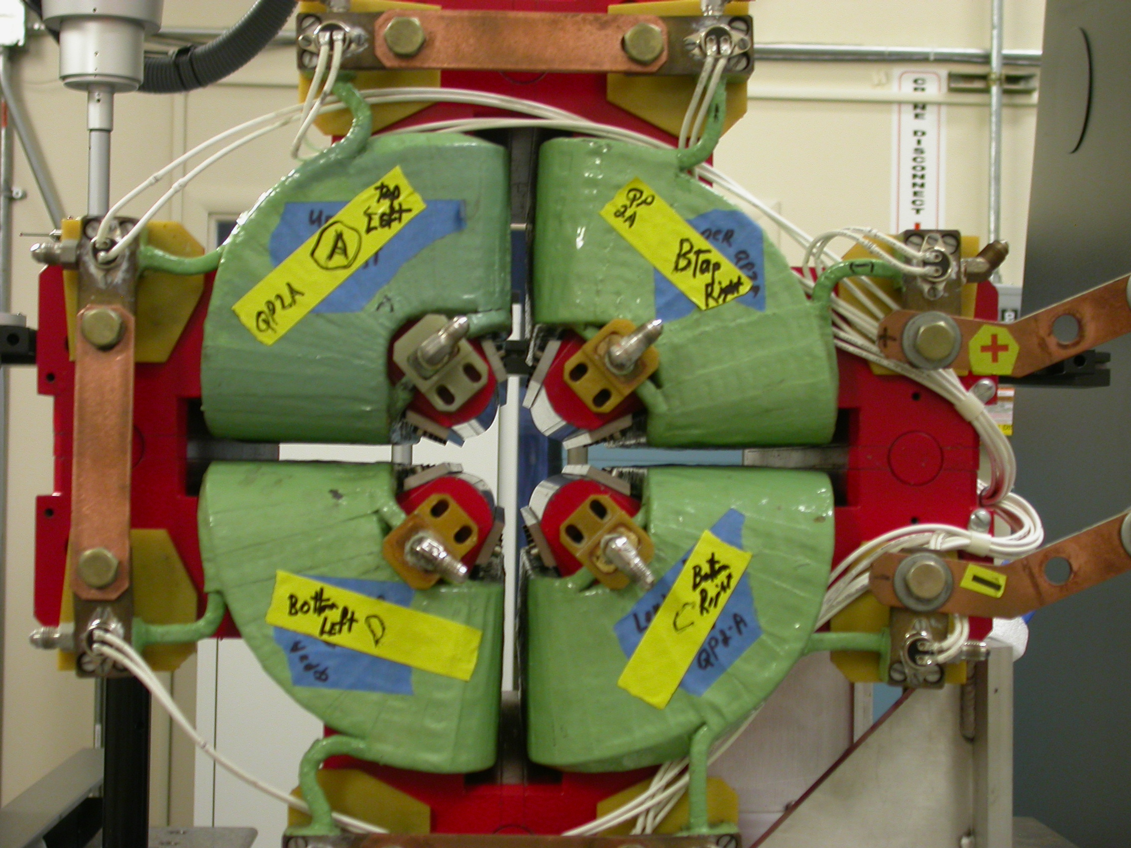  +X  Back View  (Looking from upstream side –Z) | 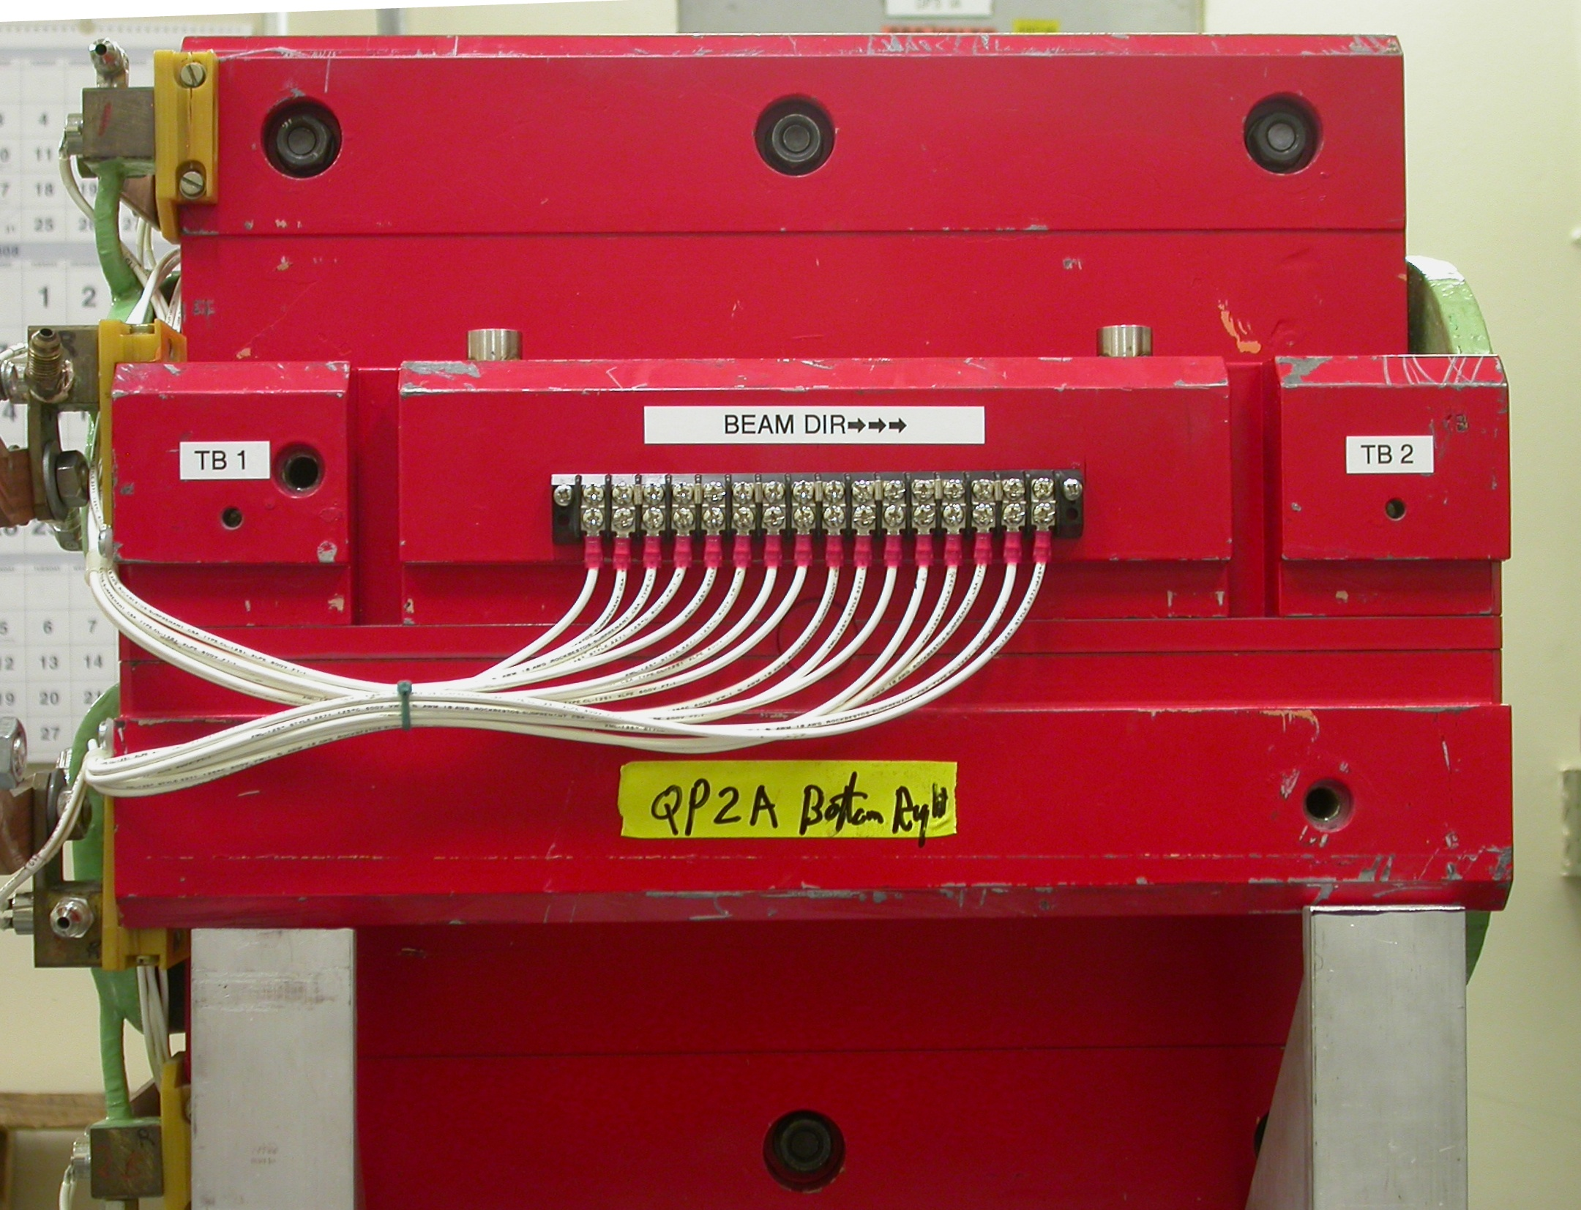  +Z  +Y  Side View  (looking from –X side)

Tooling Ball Locations

Tooling Ball | X | Y | Z
TB 1 | -9.86913 | 1.58922 | -7.37043
TB 2 | -9.87028 | 1.58966 | 7.35011
TB 3 | -7.17313 | 5.08962 | 4.13867
TB 4 | -7.16787 | 5.09117 | -4.18066
TB 5 | -1.60260 | 9.87313 | -7.36915
TB 6 | -1.60538 | 9.87194 | 7.34844
TB 7 | 1.57893 | 9.87330 | 7.34911
TB 8 | 1.58237 | 9.87250 | -7.36892
TB 9 | 7.16487 | 5.08915 | -4.18049
TB 10 | 7.16397 | 5.08932 | 4.15874
TB 11 | 9.86642 | 1.59377 | 7.34863
TB 12 | 9.86781 | 1.59381 | -7.37132

Pole Tip Additional Data
*Data looking from Downstream End (+Z End) **Revised correctly per C. Spencer 5/6/08)

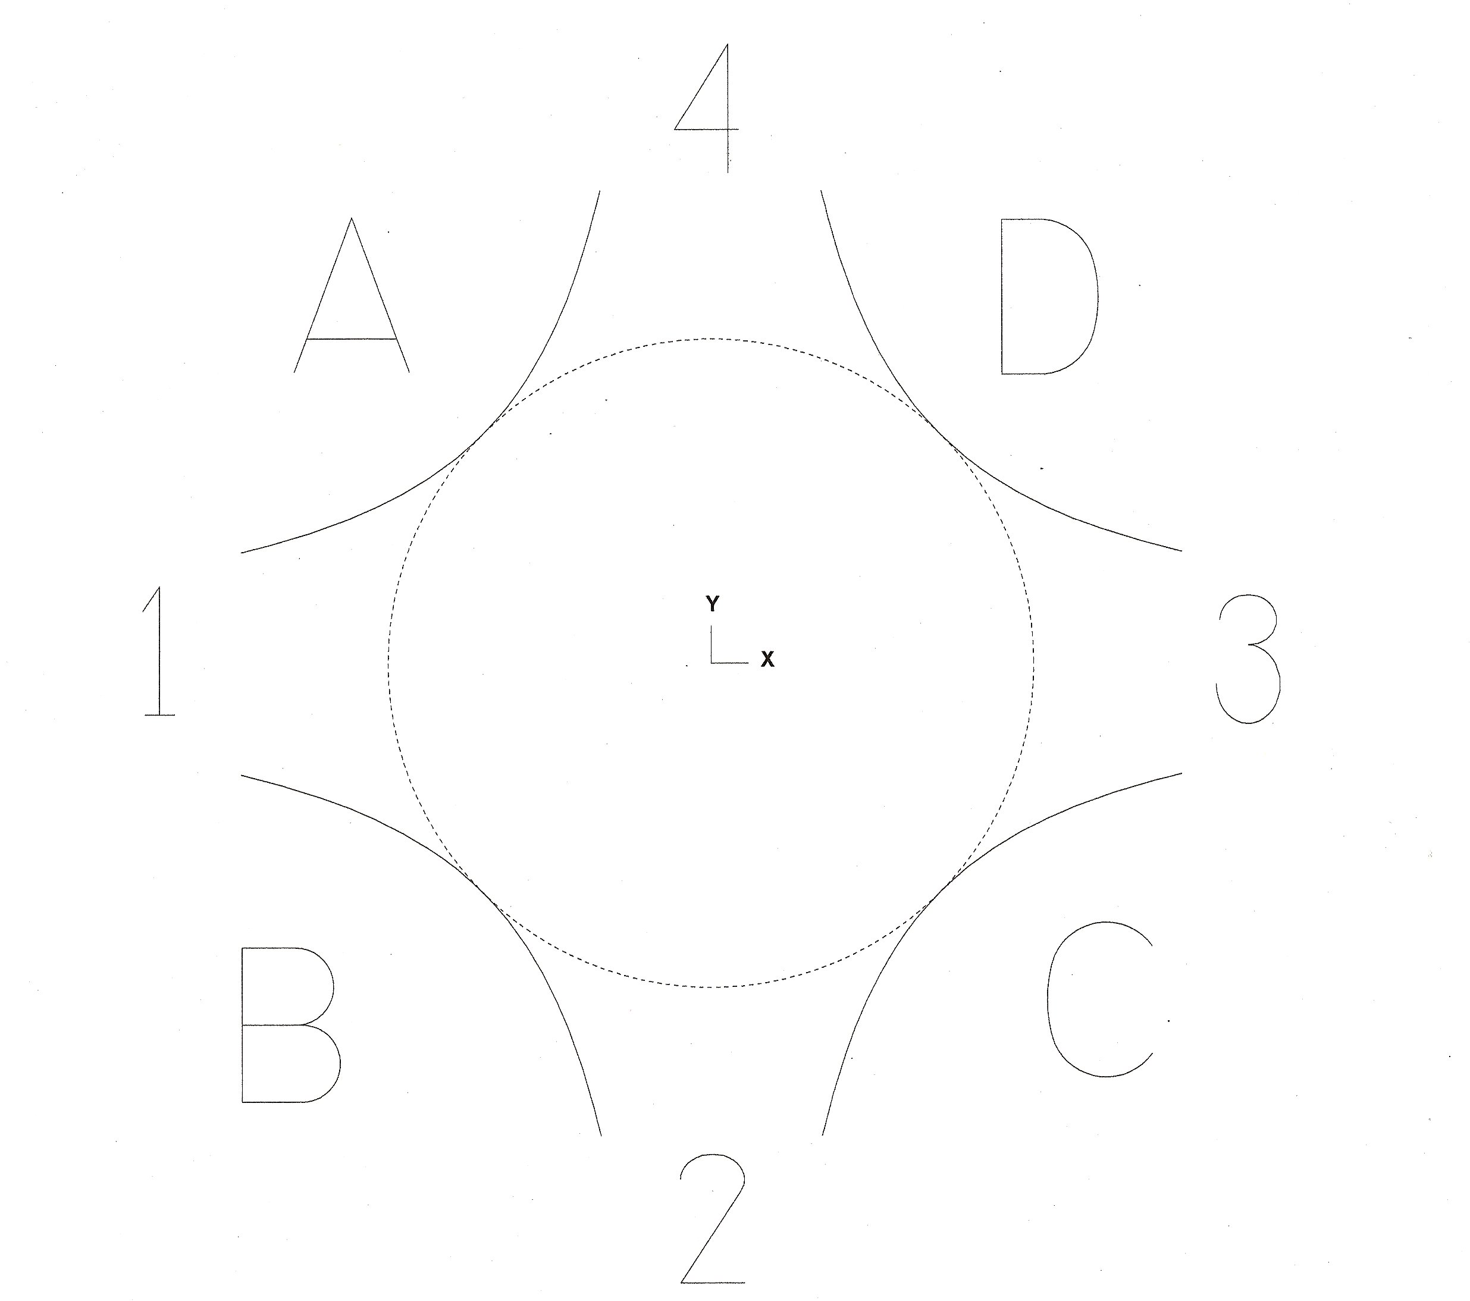

Side | Pole Dist A-C | Pole Dist B-D | Gap 1 | Gap 2 | Gap 3 | Gap 4
Downstream End (+Z) | 1.96992 | 1.96906 | 0.85141 | 0.85105 | 0.85170 | 0.85079
Upstream End (-Z) | 1.96933 | 1.96988 | 0.85130 | 0.85103 | 0.85176 | 0.85137

