
AFT2 REFURBISHED SEXTUPOLE MAGNET
FIDUCIALIZATION REPORT

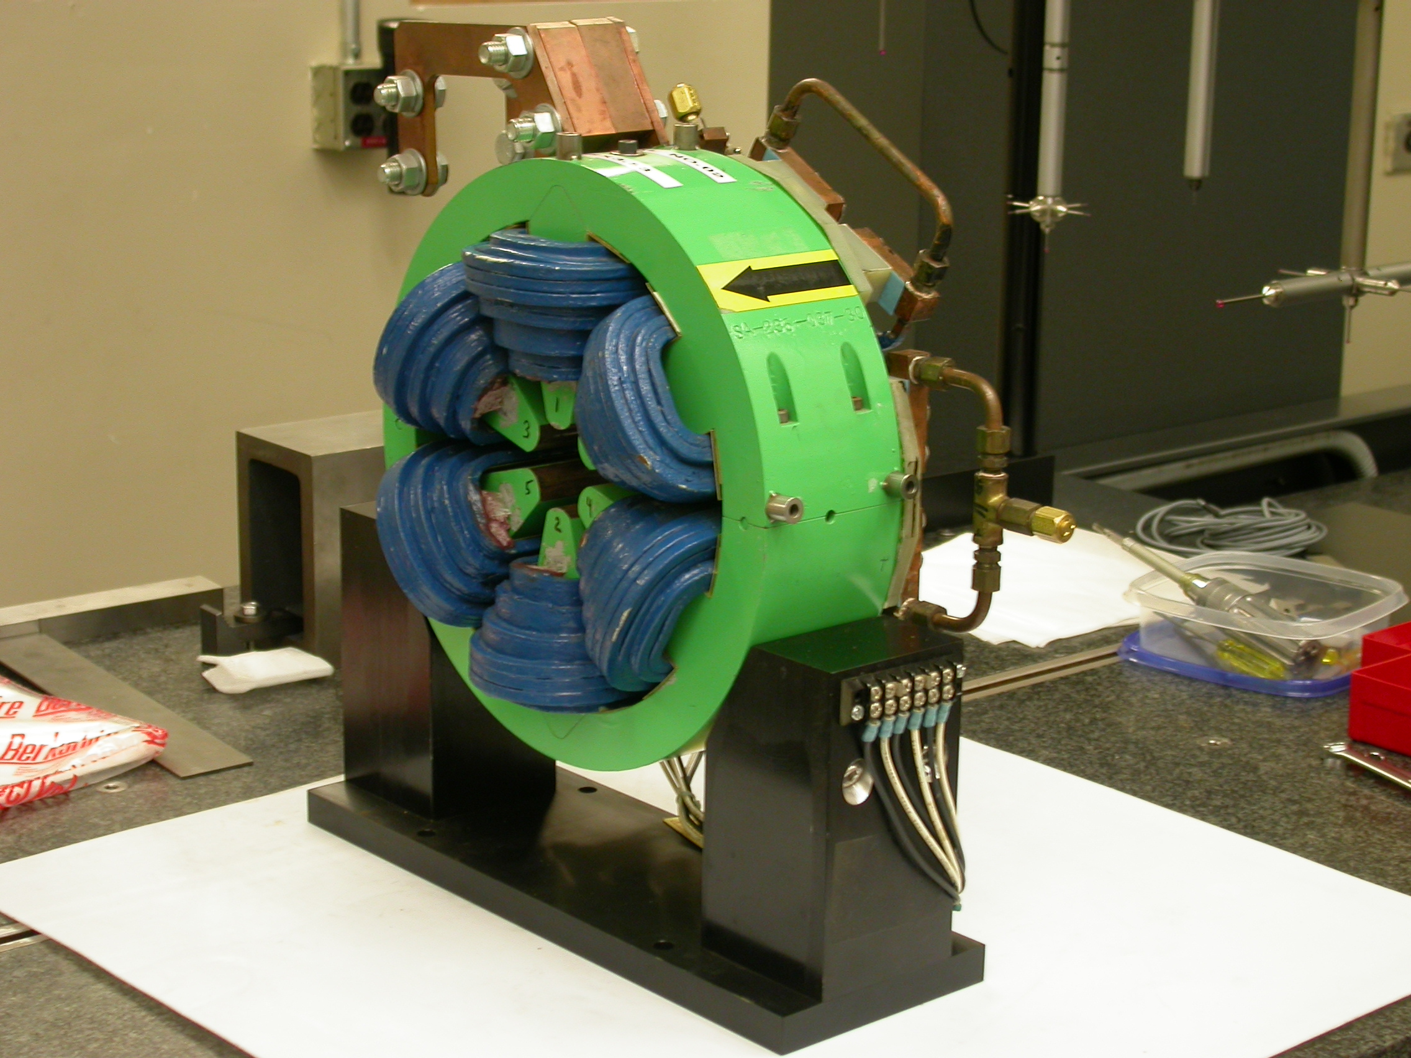

Inspector: | Keith Caban
Responsible Engineer: | Cherrill Spencer
Date: | Wednesday, August 20, 2008
Work Order/Charge No.: | 1111143
Serial Number: | 03
URL of Fiducial Report: | http://www-group.slac.stanford.edu/met/Quality/FIDUCIAL REPORTS/CHERRILL SPENCER/AFT2-SEXTUPOLE-03.PDF

Part Set-up – Coordinate System Set-up

Spatial Alignment

- Geometric axis of the poles of the magnet using 6 scans of each sextupole pole tip on each side (Terminal and Non Terminal sides) creating 2 circles on the pole tips. One on each side where Positive Z is on the Terminal Side of the Magnet.

Planar Alignment

- Radial Pole tip #1’s center and the geometric center of all poles to create an axis on the Terminal Side of the Magnet.

“Z” Zero

- Mid-plane of the magnet (middle of Terminal and Non Terminal ends).

“X” & “Y” Zero

- Geometric axis of the poles of the magnet.

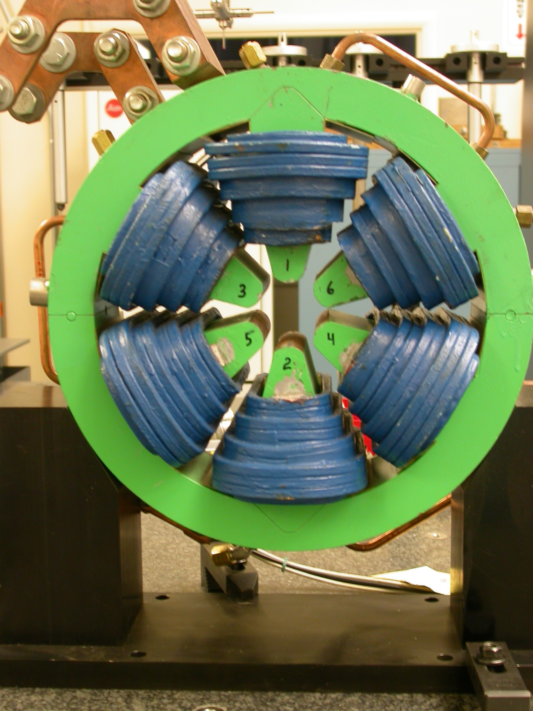  +X  +Y  Front View  (Looking from upstream side +Z) | 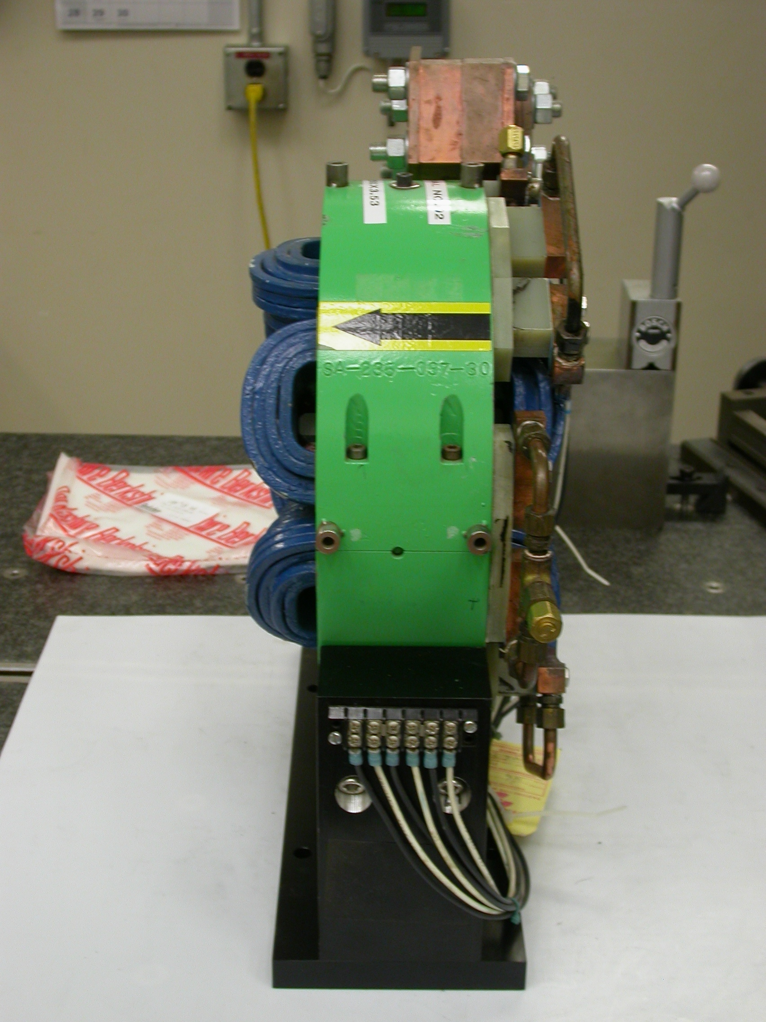  +Z  +Y  Side View  (looking from +X side)

Tooling Ball Locations for SN 03

Used Standard ½” Tooling Balls w/ 1” extension

Magnet CSY (stated above)

TB | FORM | DIA | X | Y | Z
1 | 0.00007 | 0.49718 | -7.67069 | 0.71867 | -1.09528
2 | 0.00007 | 0.49666 | -7.67316 | 0.66418 | 1.38705
3 | 0.00096 | 0.49621 | 3.72002 | 6.74363 | -1.51311
4 | 0.00025 | 0.49856 | 3.72517 | 6.73786 | 1.51014
5 | 0.00049 | 0.49724 | 7.66913 | 0.74464 | 1.35778
6 | 0.00075 | 0.49595 | 7.67371 | 0.70824 | -1.16086

Pole Tip Additional Data
 |  | Clocked to Pole 1
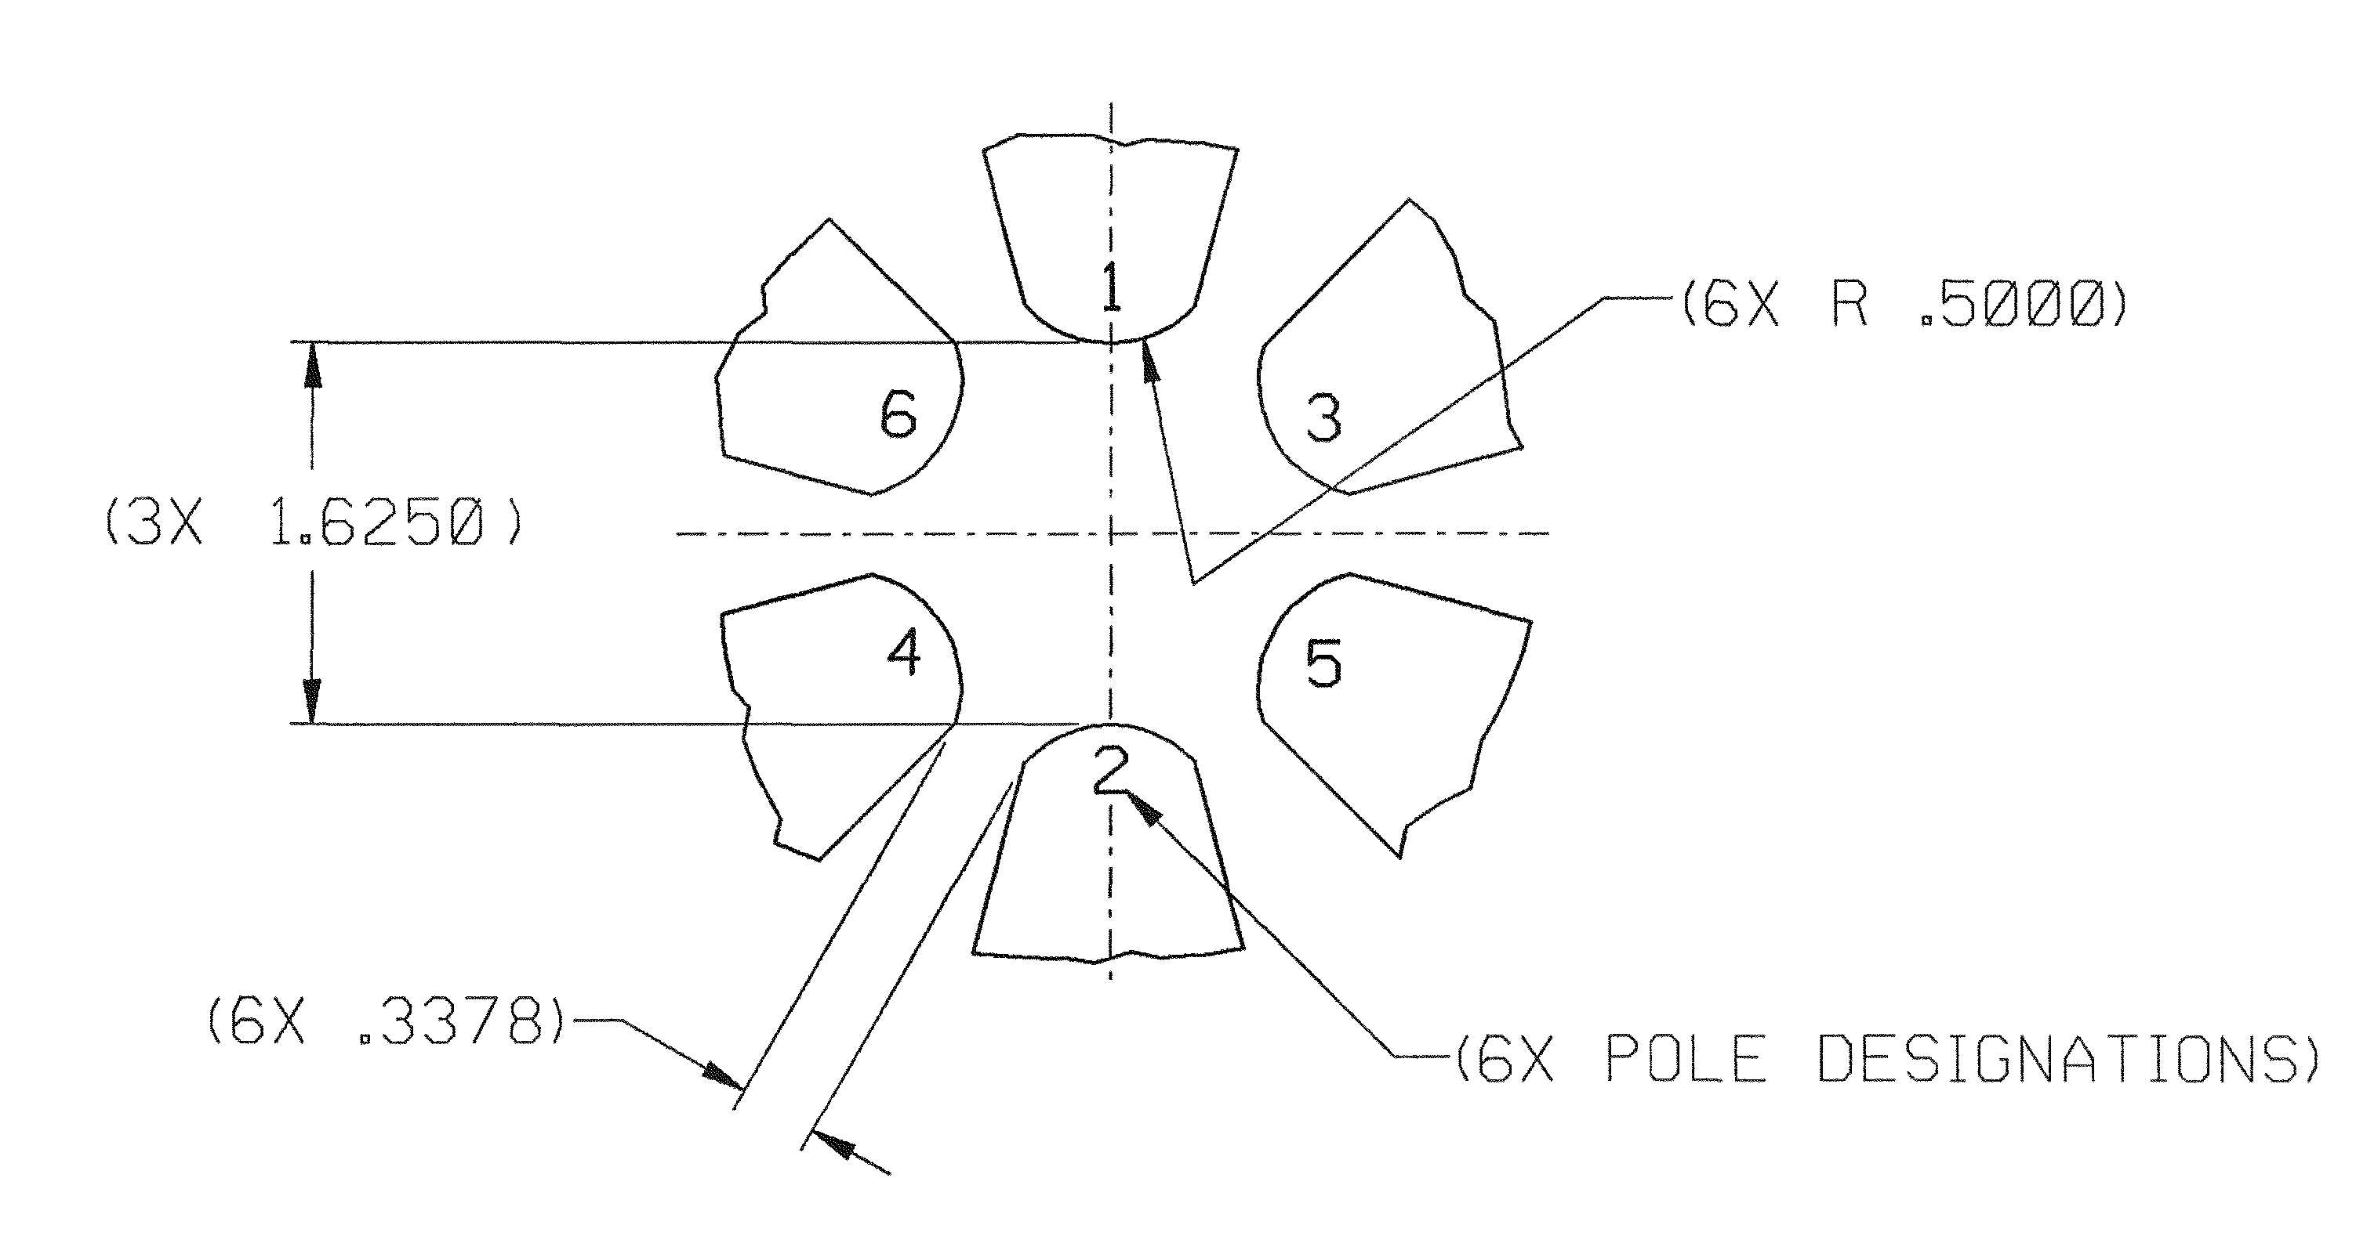
270°
180°
90°
0°
+Y
+X

Terminal Side | Radial Distance (0.8125) | Actual Angle of Pole w.r.t CSY | Deviation Angle to Pole (act-nom) | Radians | Micro Radians | Pole Tip Distance (1.625)
Pole Tip 1 | 0.81184 | 90.00362 | 0.00362 | 0.00006 | 63 | 1.62449
Pole Tip 2 | 0.81096 | 269.97197 | -0.02803 | -0.00049 | 489 | 1.62449
Pole Tip 3 | 0.81062 | 29.88278 | -0.11722 | -0.00205 | 2046 | 1.62622
Pole Tip 4 | 0.81532 | 209.87938 | -0.12062 | -0.00211 | 2105 | 1.62622
Pole Tip 5 | 0.81601 | 329.98529 | -0.01471 | -0.00026 | 257 | 1.62662
Pole Tip 6 | 0.81265 | 149.96277 | -0.03723 | -0.00065 | 650 | 1.62662
Non Terminal Side | Radial Distance (0.8125) | Actual Angle of Pole w.r.t CSY | Deviation Angle to Pole (act-nom) | Radians | Micro Radians | Pole Tip Distance (1.625)
Pole Tip 1 | 0.81058 | 90.09540 | 0.09540 | 0.00167 | 1665 | 1.62178
Pole Tip 2 | 0.81243 | 269.82272 | -0.17728 | -0.00309 | 3094 | 1.62178
Pole Tip 3 | 0.81233 | 29.88402 | -0.11598 | -0.00202 | 2024 | 1.62580
Pole Tip 4 | 0.81337 | 209.89425 | -0.10575 | -0.00185 | 1846 | 1.62580
Pole Tip 5 | 0.81429 | 329.90135 | -0.09865 | -0.00172 | 1722 | 1.62662
Pole Tip 6 | 0.80936 | 150.06597 | 0.06597 | 0.00115 | 1151 | 1.62662
 |  | Gap Nominal (0.3378) | Terminal Side | Non Terminal Side
 |  | 3-5 | 0.33669 | 0.33641
 |  | 4-6 | 0.33674 | 0.33697

 | Clocked to Pole 3, rotated -30° nominally
+X
+Y
0°
90°
180°
270°

Terminal Side | Radial Distance (0.8125) | Actual Angle of Pole w.r.t CSY | Deviation Angle to Pole (act-nom) | Radians | Micro Radians | Pole Tip Distance (1.625)
Pole Tip 1 | 0.81184 | 90.12085 | 0.12085 | 0.00211 | 2109 | 1.62449
Pole Tip 2 | 0.81096 | 270.08920 | 0.08920 | 0.00156 | 1557 | 1.62449
Pole Tip 3 | 0.81062 | 30.00000 | 0.00000 | 0.00000 | 0 | 1.62622
Pole Tip 4 | 0.81532 | 209.99661 | -0.00339 | -0.00006 | 59 | 1.62622
Pole Tip 5 | 0.81601 | 330.10251 | 0.10251 | 0.00179 | 1789 | 1.62662
Pole Tip 6 | 0.81265 | 150.08000 | 0.08000 | 0.00140 | 1396 | 1.62662
Non Terminal Side | Radial Distance (0.8125) | Actual Angle of Pole w.r.t CSY | Deviation Angle to Pole (act-nom) | Radians | Micro Radians | Pole Tip Distance (1.625)
Pole Tip 1 | 0.81058 | 90.21262 | 0.21262 | 0.00371 | 3711 | 1.62178
Pole Tip 2 | 0.81243 | 269.93994 | -0.06006 | -0.00105 | 1048 | 1.62178
Pole Tip 3 | 0.81233 | 30.00124 | 0.00124 | 0.00002 | 22 | 1.62580
Pole Tip 4 | 0.81337 | 210.01147 | 0.01147 | 0.00020 | 200 | 1.62580
Pole Tip 5 | 0.81429 | 330.01857 | 0.01857 | 0.00032 | 324 | 1.62662
Pole Tip 6 | 0.80936 | 150.18319 | 0.18319 | 0.00320 | 3197 | 1.62662
 |  | Gap Nominal (0.3378) | Terminal Side | Non Terminal Side
 |  | 3-5 | 0.33669 | 0.33641
 |  | 4-6 | 0.33674 | 0.33697

