
AFT2 REFURBISHED SEXTUPOLE MAGNET
FIDUCIALIZATION REPORT

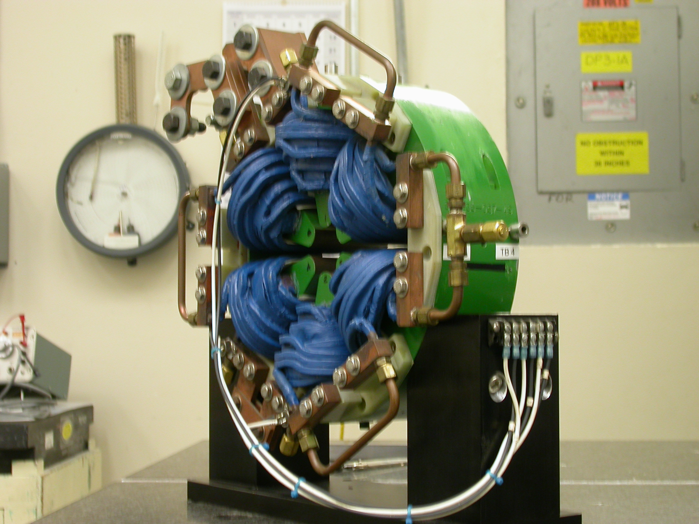

Inspector: | Keith Caban
Responsible Engineer: | Cherrill Spencer
Date: | Thursday, July 10, 2008
Work Order/Charge No.: | 1111143
Serial Number: | 01
URL of Fiducial Report: | http://www-group.slac.stanford.edu/met/Quality/FIDUCIAL REPORTS/CHERRILL SPENCER/AFT2-SEXTUPOLE-01.PDF

Part Set-up – Coordinate System Set-up

Spatial Alignment

- Geometric axis of the poles of the magnet using 6 scans of each sextupole pole tip on each side (Terminal and Non Terminal sides) creating 2 circles on the pole tips. One on each side where Positive Z is on the Terminal Side of the Magnet.

Planar Alignment

- Radial Pole tip #1’s center and the geometric center of all poles to create an axis on the Terminal Side of the Magnet.

“Z” Zero

- Mid-plane of the magnet (middle of Terminal and Non Terminal ends).

“X” & “Y” Zero

- Geometric axis of the poles of the magnet.

+Y  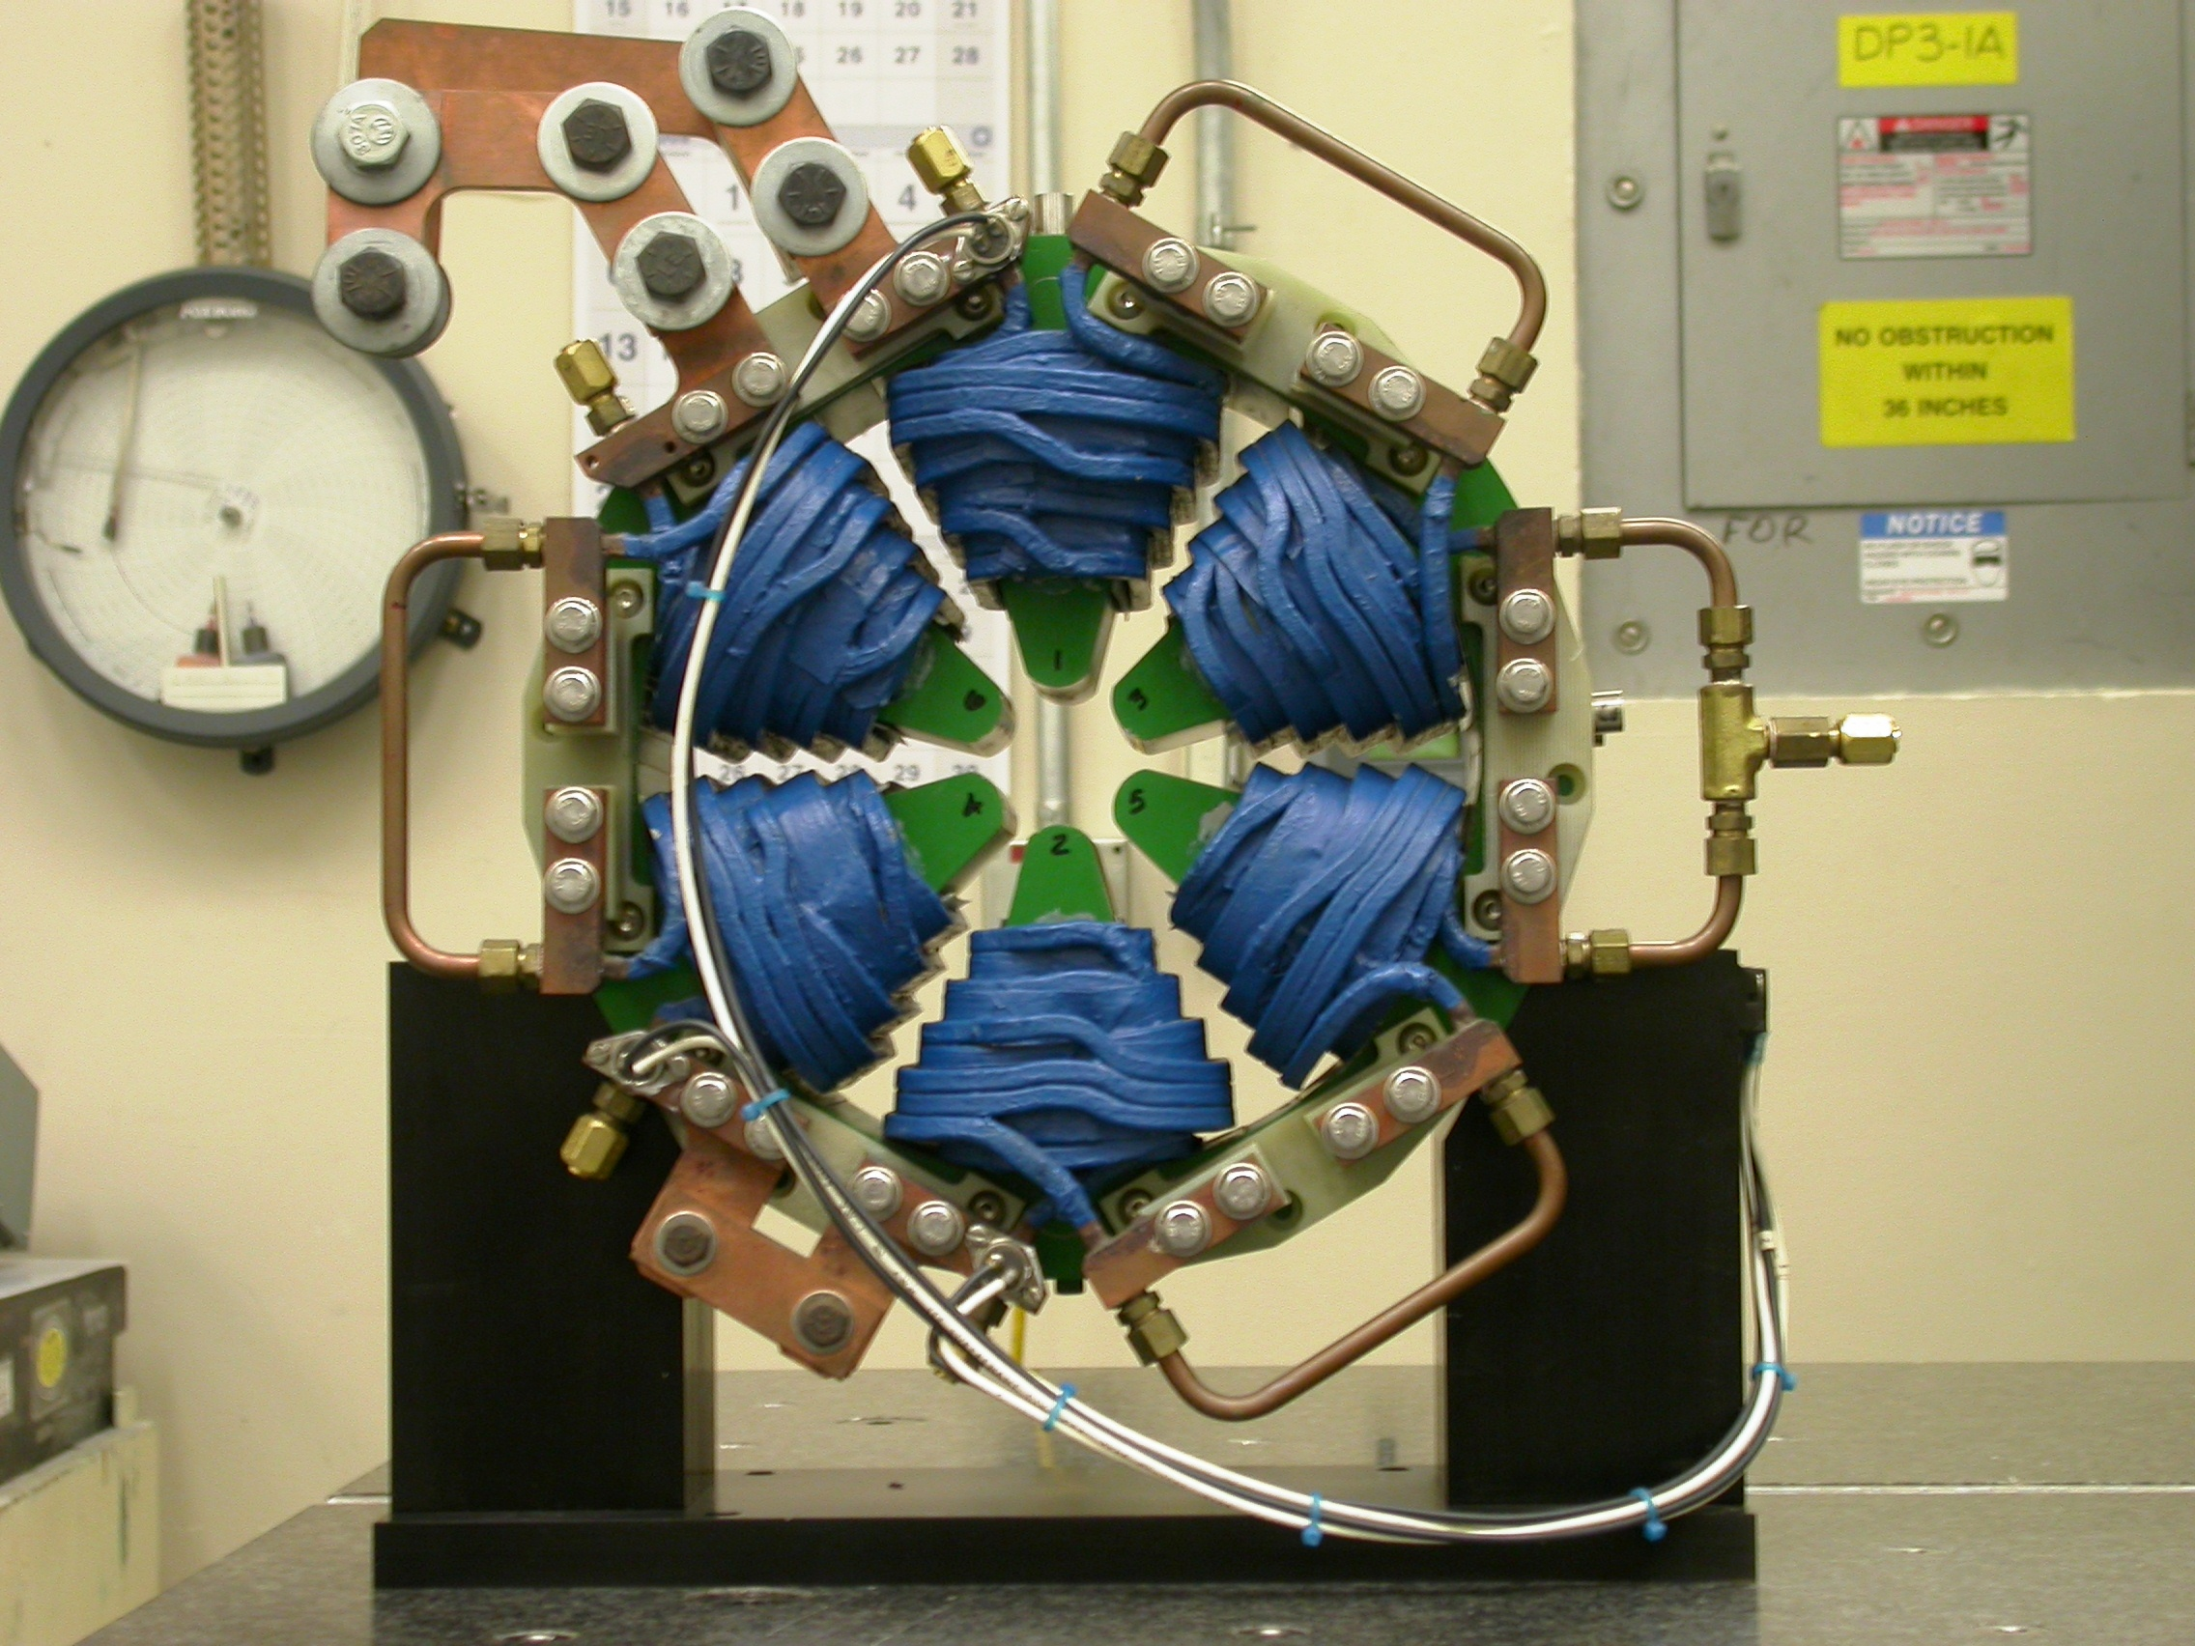  +X  Back View  (Looking from upstream side –Z) | 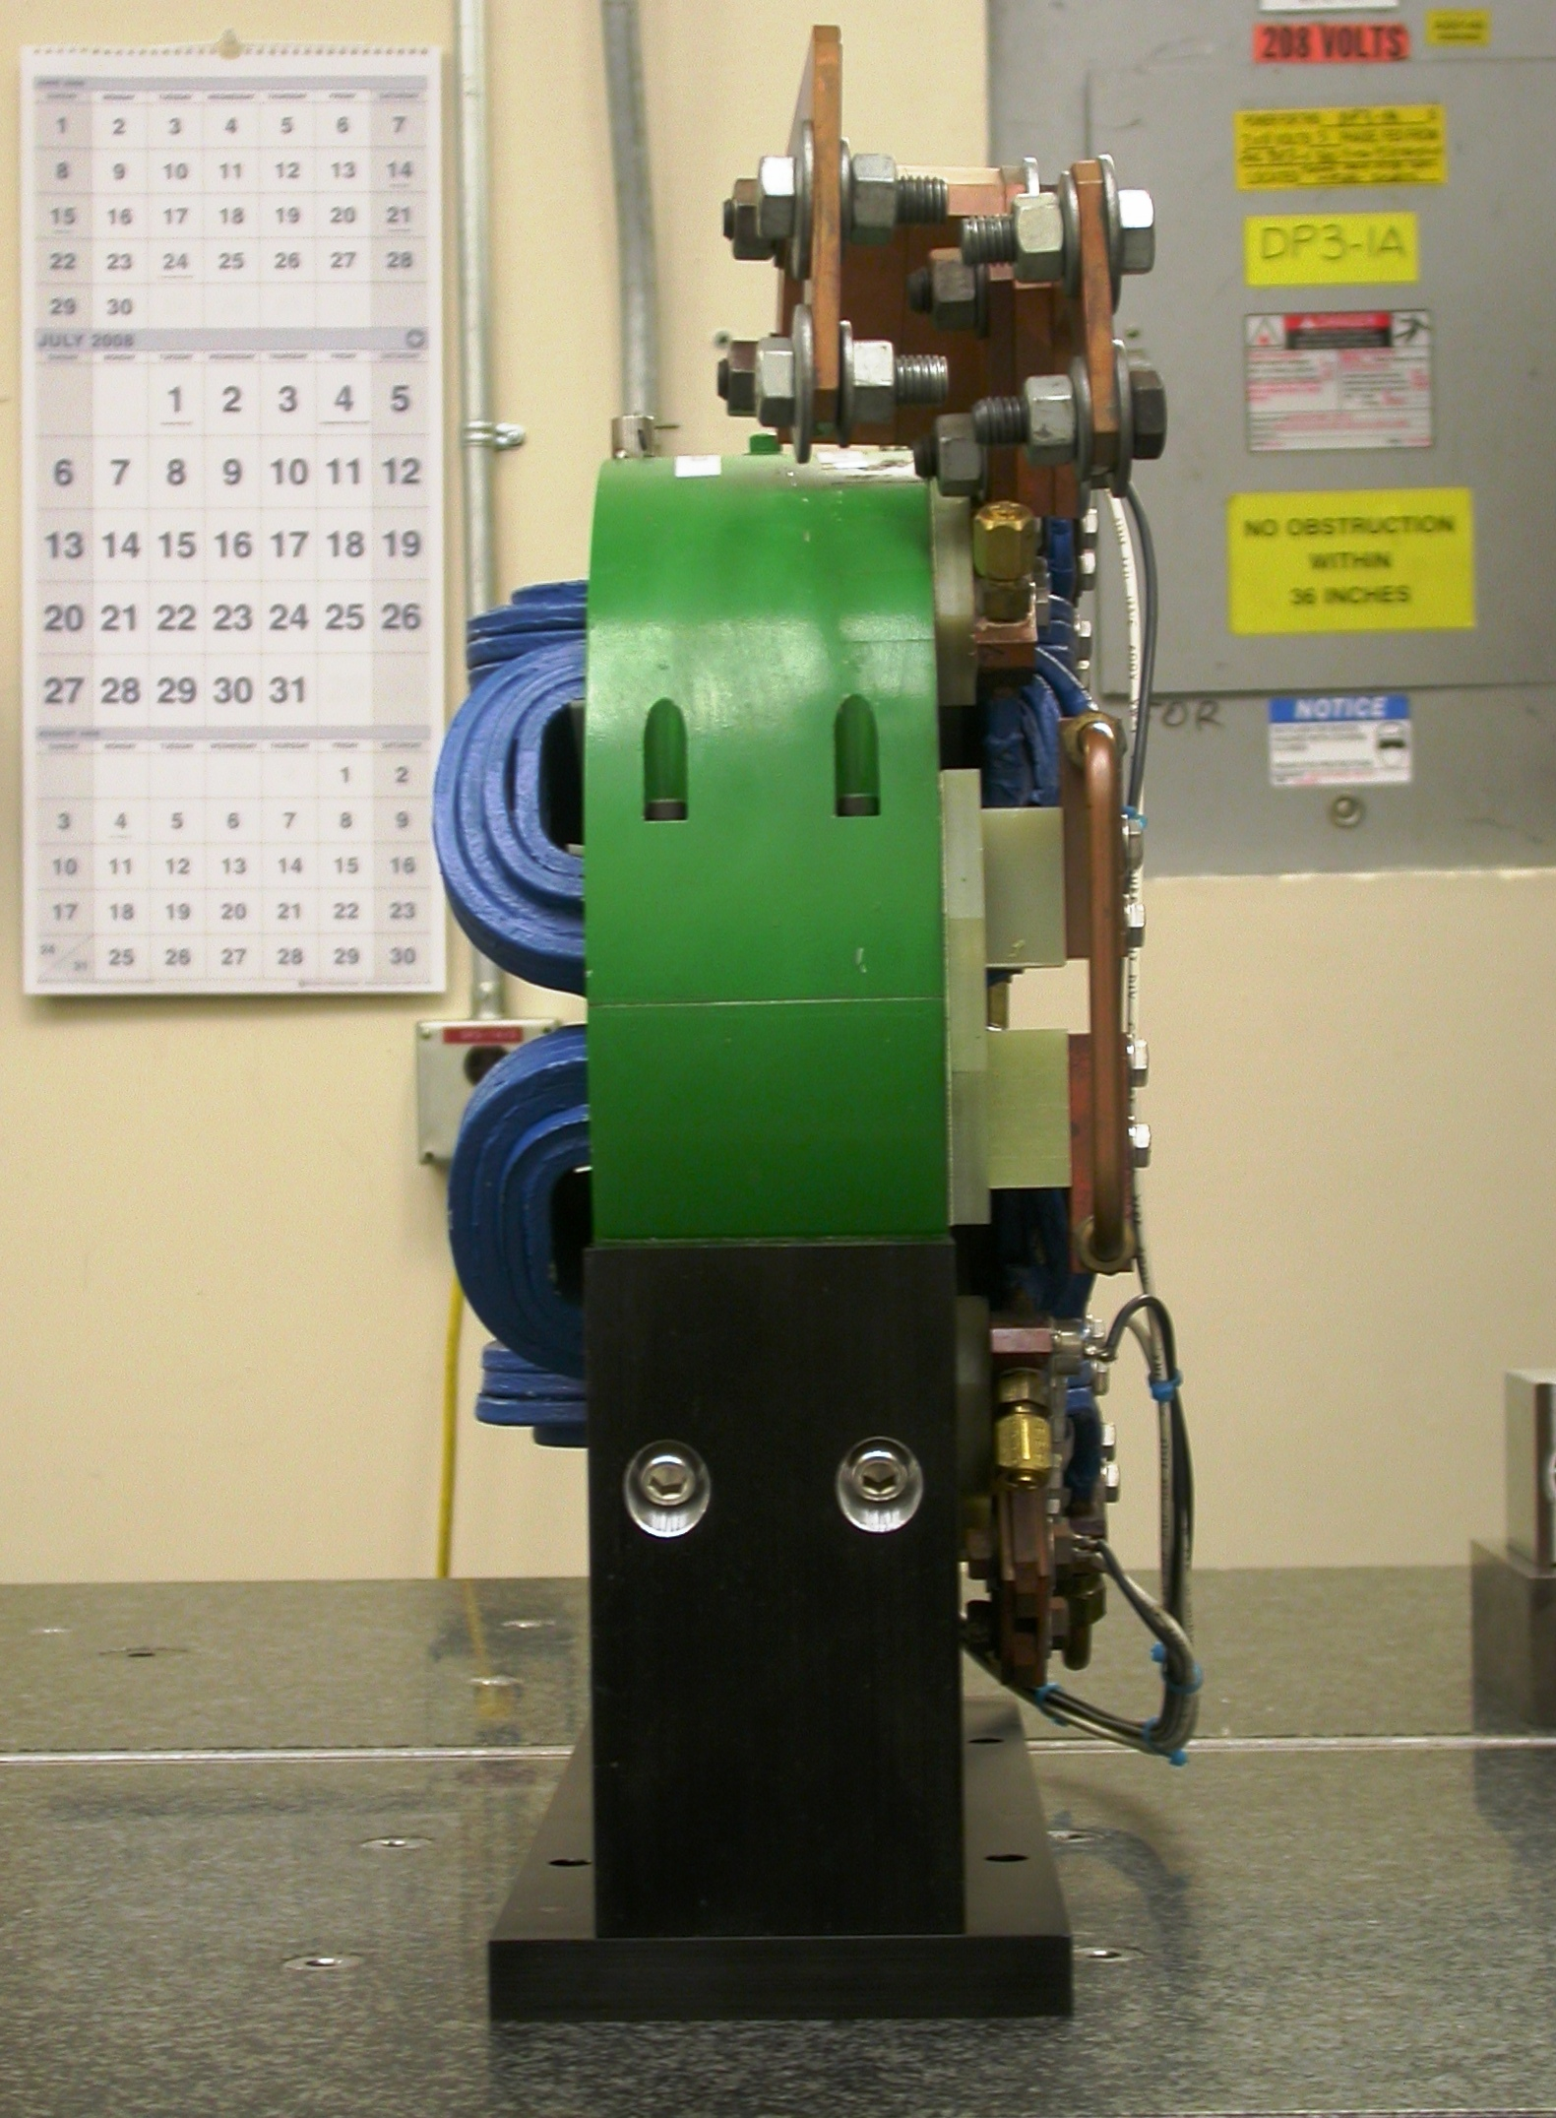  +Z  +Y  Side View  (looking from –X side)

Tooling Ball Locations for SN 01

Used Standard ½” Tooling Balls w/ 1” extension

TB | FORM | DIA | X | Y | Z
1 | 0.00038 | 0.49828 | -0.03306 | 7.70119 | -1.50600
2 | 0.00055 | 0.49668 | -0.00945 | 7.70276 | 1.50404
3 | 0.00033 | 0.49660 | 7.68513 | 0.53022 | 1.50775
4 | 0.00022 | 0.49715 | 7.68516 | 0.52165 | -1.50311

Pole Tip Additional Data
0° |  | 90° | +Y
  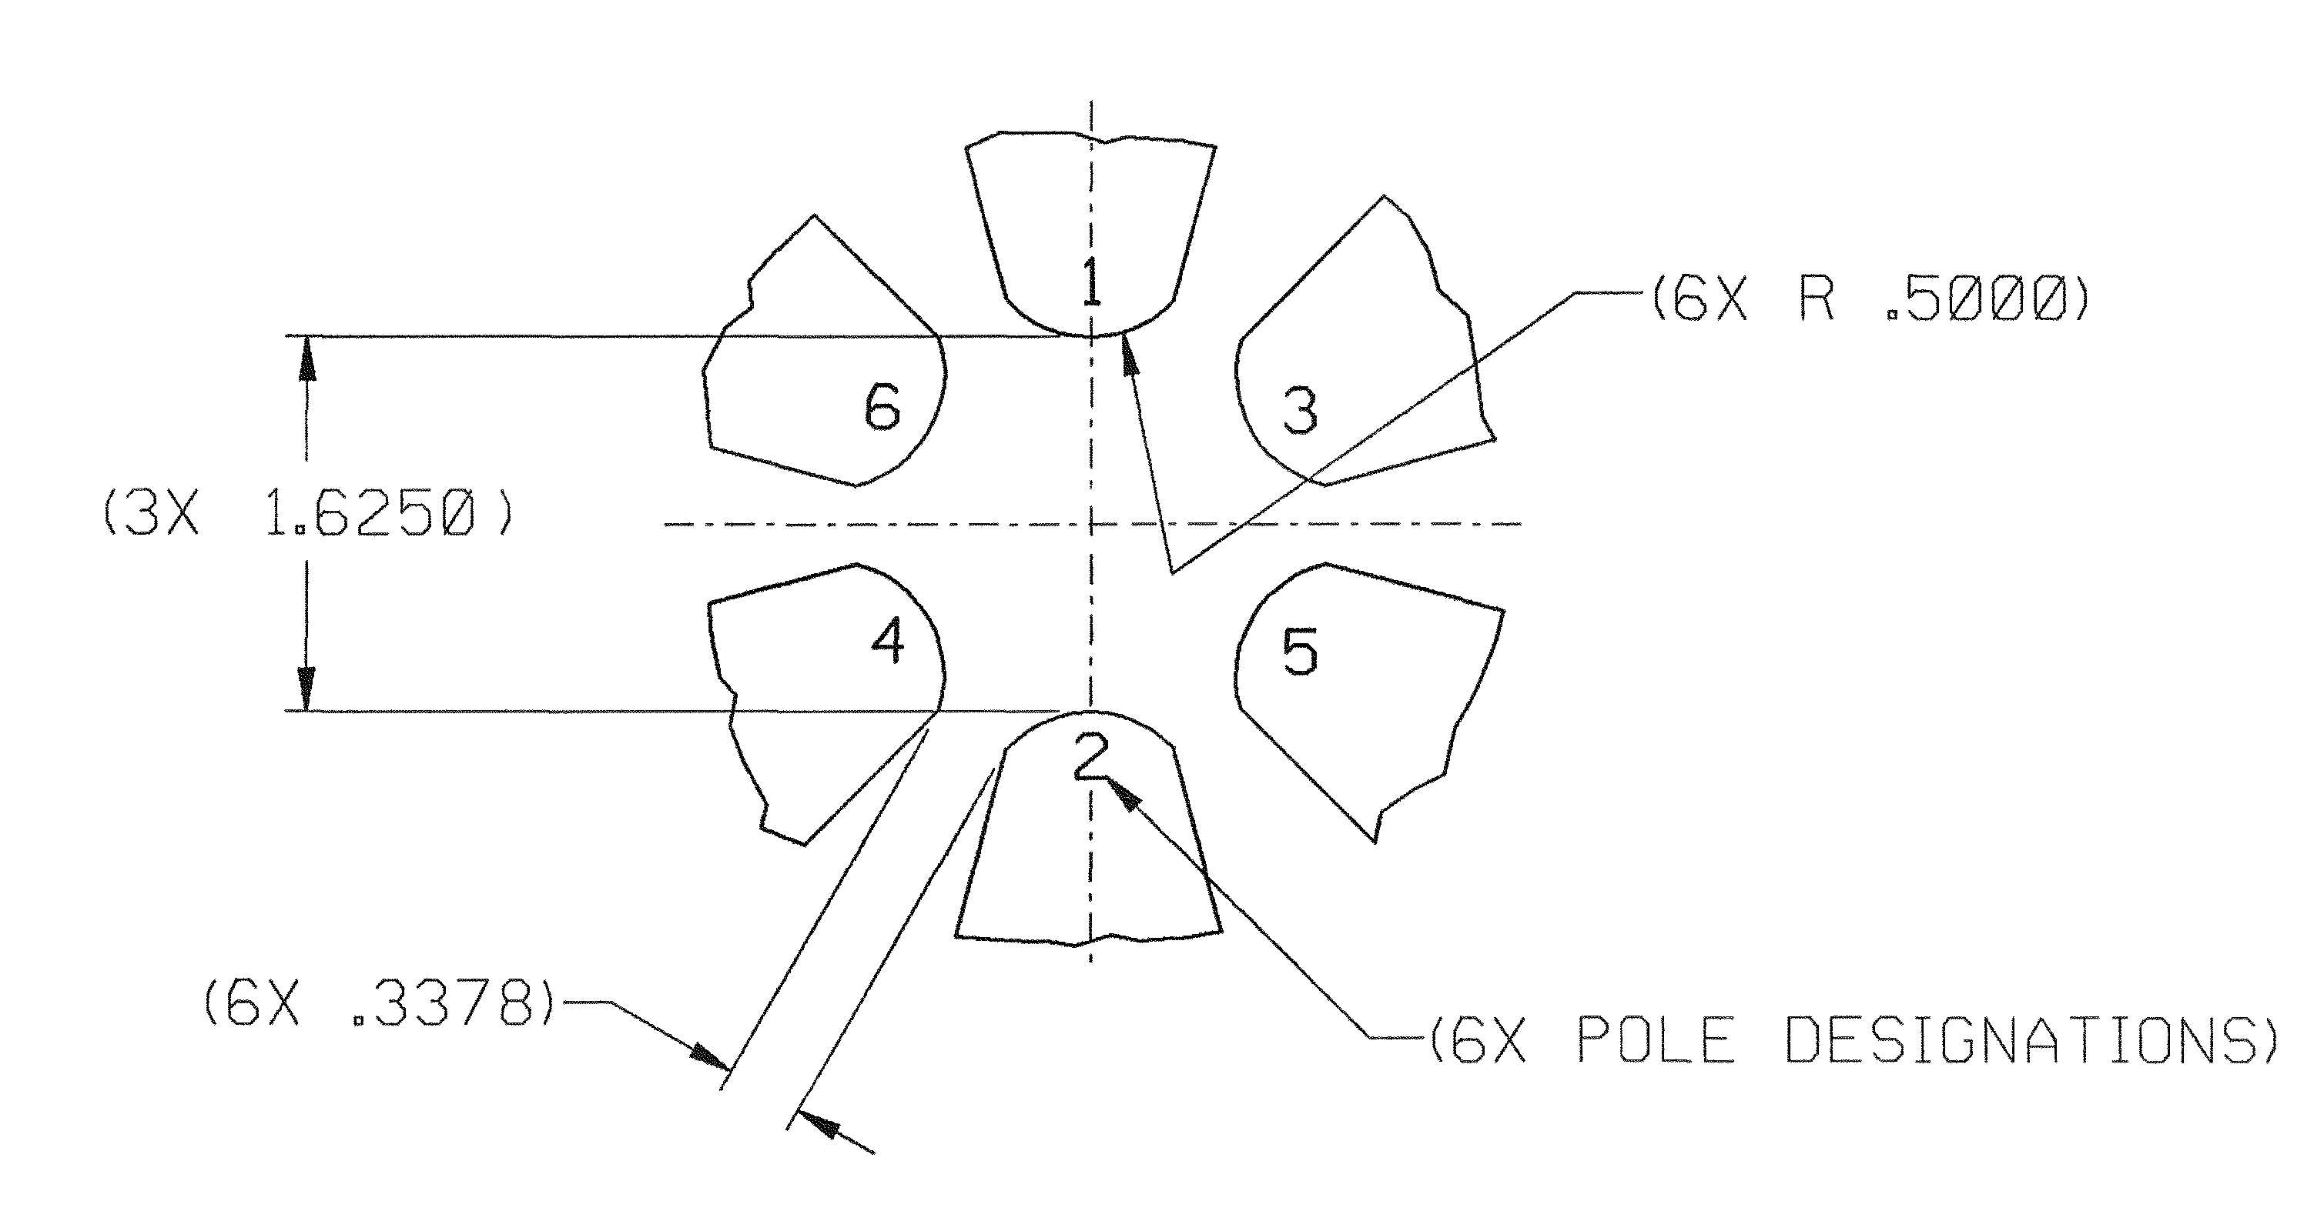
 | 180° |  |  | +X
 |  |  | 270°
Terminal Side | Radial Distance (0.8125) | Actual Angle of Pole w.r.t CSY | Deviation Angle to Pole (act-nom) | Radians | Micro Radians | Pole Tip Distance (1.625)
Pole Tip 1 | 0.81259 | 89.99818 | -0.00182 | -0.00003 | 32 | 1.62578
Pole Tip 2 | 0.81319 | 270.00990 | 0.00990 | 0.00017 | 173 | 1.62578
Pole Tip 3 | 0.81307 | 30.00924 | 0.00924 | 0.00016 | 161 | 1.62520
Pole Tip 4 | 0.81214 | 210.03683 | 0.03683 | 0.00064 | 643 | 1.62520
Pole Tip 5 | 0.81205 | 329.99841 | -0.00159 | -0.00003 | 28 | 1.62409
Pole Tip 6 | 0.81204 | 150.00534 | 0.00534 | 0.00009 | 93 | 1.62409
Non Terminal Side | Radial Distance (0.8125) | Actual Angle of Pole w.r.t CSY | Deviation Angle to Pole (act-nom) | Radians | Micro Radians | Pole Tip Distance (1.625)
Pole Tip 1 | 0.81225 | 90.02671 | 0.02671 | 0.00047 | 466 | 1.62635
Pole Tip 2 | 0.81314 | 269.99037 | -0.00963 | -0.00017 | 168 | 1.62635
Pole Tip 3 | 0.81249 | 30.00029 | 0.00029 | 0.00001 | 5 | 1.62468
Pole Tip 4 | 0.81220 | 210.07422 | 0.07422 | 0.00130 | 1295 | 1.62468
Pole Tip 5 | 0.81211 | 329.98648 | -0.01352 | -0.00024 | 236 | 1.62525
Pole Tip 6 | 0.81314 | 150.04443 | 0.04443 | 0.00078 | 775 | 1.62525
 |  | Gap Nominal (0.3378) | Terminal Side | Non Terminal Side
 |  | 3-5 | 0.33852 | 0.33956
 |  | 4-6 | 0.33929 | 0.33936

