
BLUE DIPOLE - ECHO 7 EXP. (3D4 MAGNET)
FIDUCIALIZATION REPORT

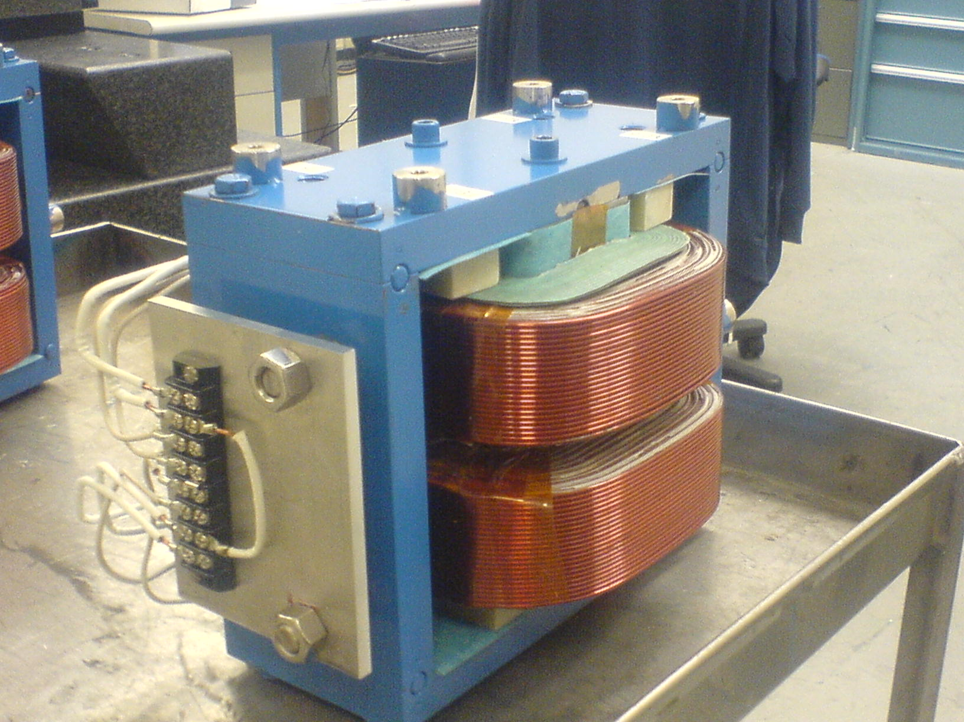

Inspector: | Keith Caban
Customer: | Dieter Walz
Date: | Monday, November 16, 2009
Work Order/Charge No.: | 8540022
Serial Number: | #14
Stamped Drwg. #: | n/a
URL of Fiducial Report: | \\Web002\www-group\met\Quality\FIDUCIAL REPORTS\BLUE-DIPOLE FFTB STEERING MAGNET\SN 14.pdf

Part Set-up – Coordinate System Set-up

Planar Alignment

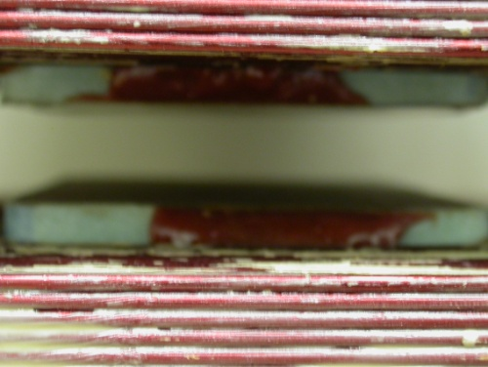
- Plane along bottom pole plane.

Spatial Alignment

- Plane of +Z face of magnet

“Z” Zero
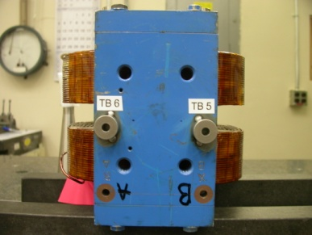
- Mid-Plane of the magnet. (see dashed planar alignment above)

“X” & “Y” Zero

- X zero is created by the symmetry point of the outer ends of the magnet where TB 5 & 6 are and opposite where the terminal strip is located.

- Symmetry plane of the pole planes
  - This creates Y- zero

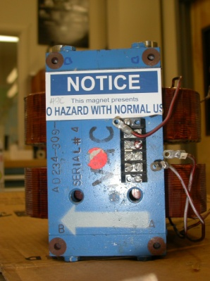  +Y  +Z | +Y  +X

Tooling Ball Measurements/Locations

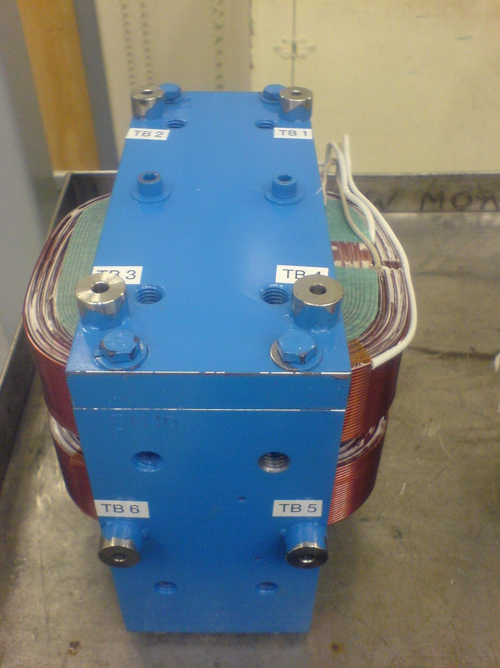
-X
+Y
-Z
Projected cylinder into 1” offset plane

Tooling Ball | Form | Diameter | X | Y | Z | Perpendicularity
TB 1 | 0.00040 | 0.25038 | 3.48903 | 5.48103 | 1.63282 | 0.00027
TB 2 | 0.00406 | 0.24998 | 3.47966 | 5.48098 | -1.65031 | 0.00205
TB 3 | 0.00181 | 0.24990 | -3.50476 | 5.48367 | -1.61475 | 0.00129
TB 4 | 0.00096 | 0.25018 | -3.49789 | 5.48147 | 1.64960 | 0.00032
TB 5 | 0.00228 | 0.24976 | -6.25032 | 0.00747 | 1.66379 | 0.00139
TB 6 | 0.00127 | 0.24927 | -6.25441 | -0.00575 | -1.61969 | 0.00107

Pole Tip Distance/Gaps (at location X, Z)

Station | Gap Distance | X | Z
1 | 0.60295 | -1.125 | -1.375
2 | 0.60288 | 1.125 | -1.375
3 | 0.60294 | 0.000 | 0.000
4 | 0.60293 | -1.125 | 1.375
5 | 0.60285 | 1.125 | 1.375
Avg. Gap | 0.60291 | - | -

