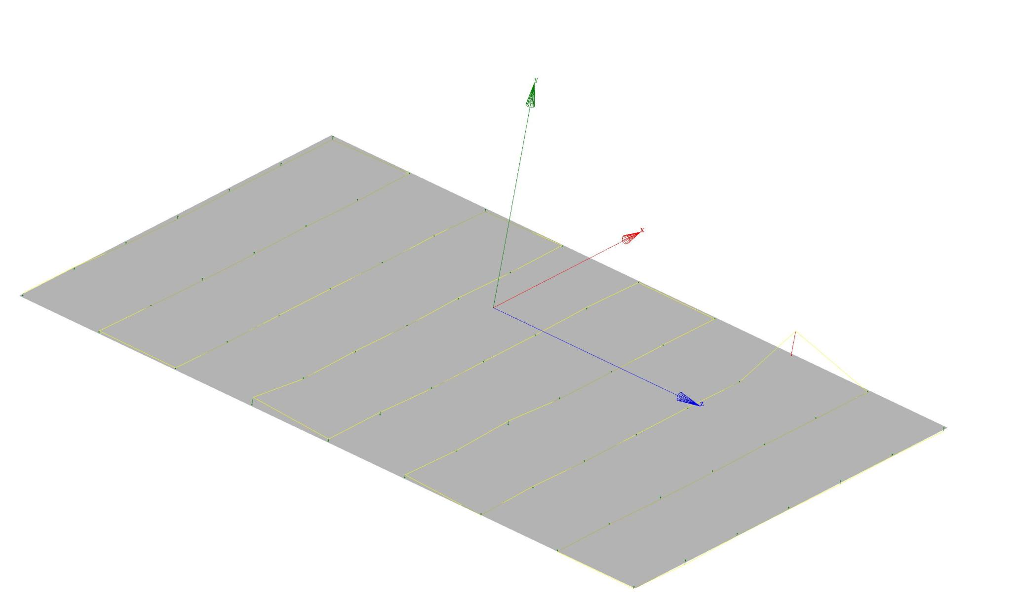
Lower Pole Plane Flatness/Deviation Plot

FLATNESS | MIN. | MAX.
0.00074 | -0.00011 | 0.00063

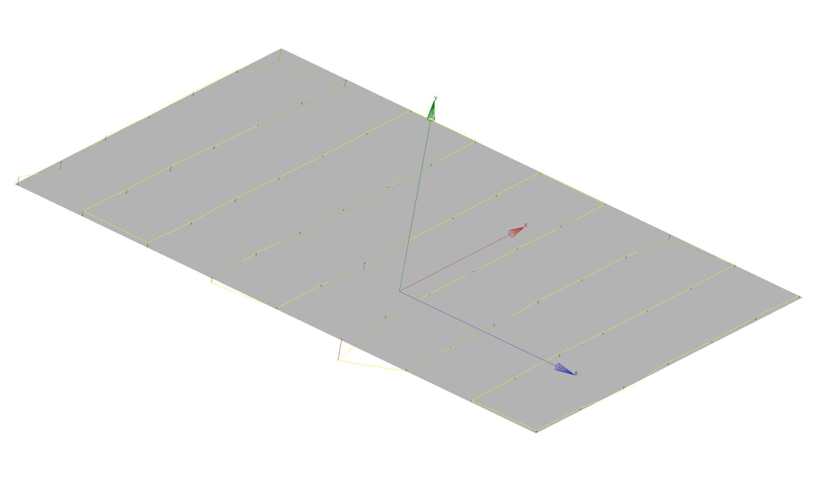
Upper Pole Plane Flatness/Deviation Plot

FLATNESS | MIN. | MAX.
0.00089 | -0.00023 | 0.00066

