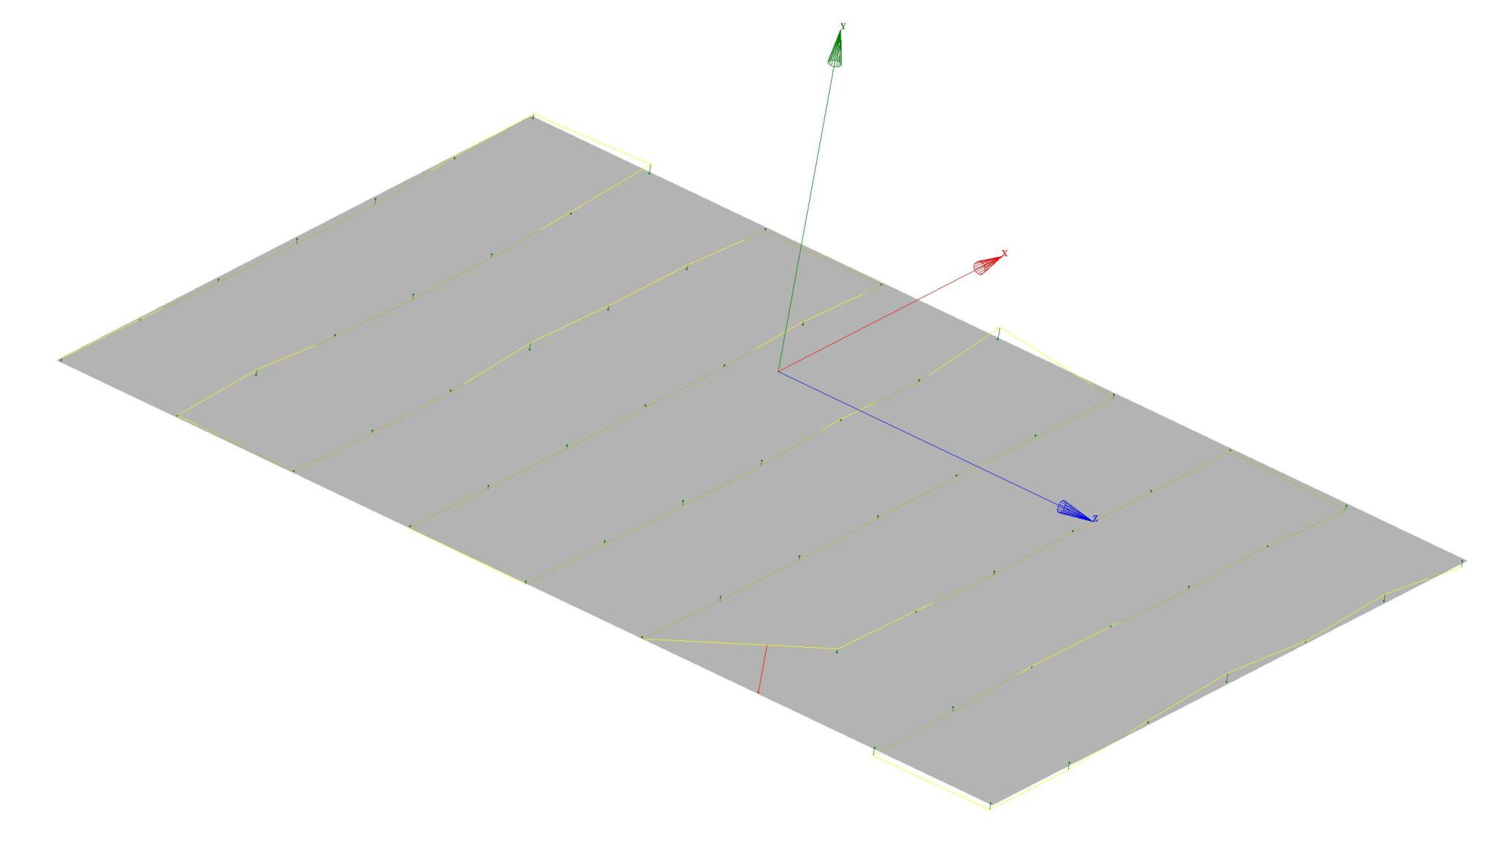
Lower Pole Plane Flatness/Deviation Plot

FLATNESS | MIN. | MAX.
0.00095 | -0.00014 | 0.00081

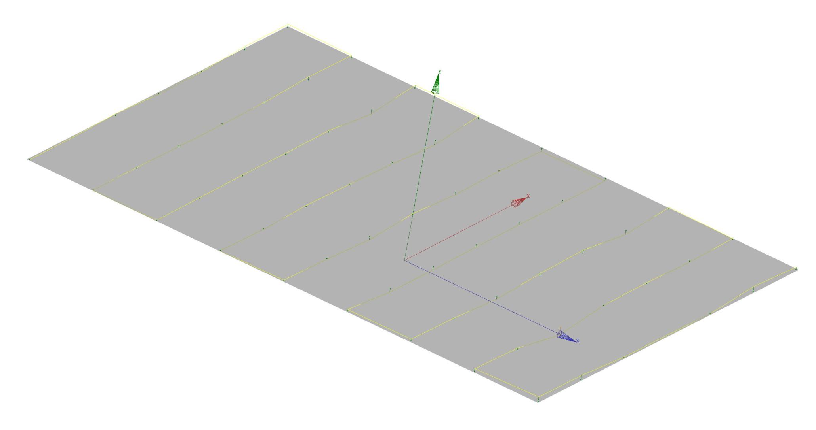
Upper Pole Plane Flatness/Deviation Plot

FLATNESS | MIN. | MAX.
0.00042 | -0.00016 | 0.00026

