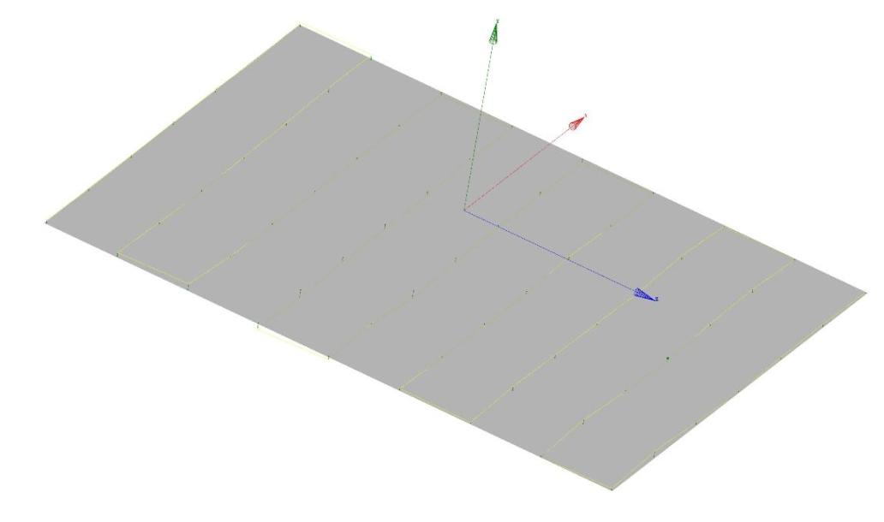
Lower Pole Plane Flatness/Deviation Plot

FLATNESS | MIN. | MAX.
0.00043 | -0.00025 | 0.00018

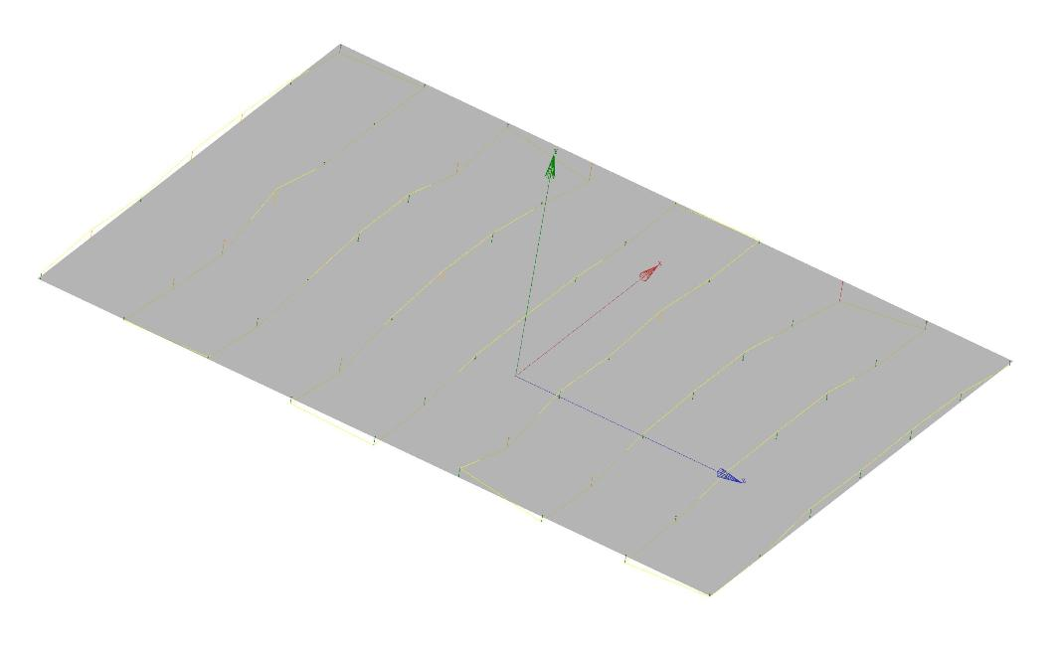
Upper Pole Plane Flatness/Deviation Plot

FLATNESS | MIN. | MAX.
0.00084 | -0.00034 | 0.00051

