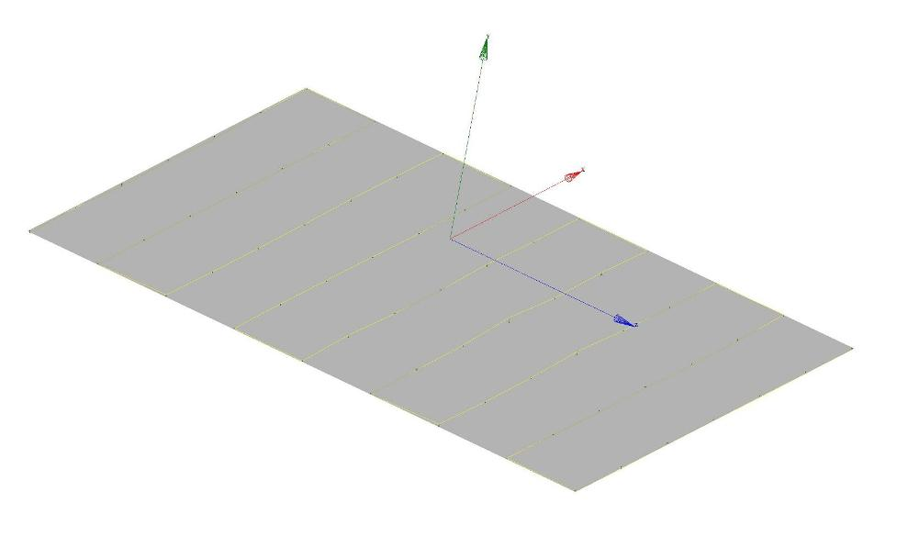
Lower Pole Plane Flatness/Deviation Plot

FLATNESS | MIN. | MAX.
0.00023 | -0.00009 | 0.00015

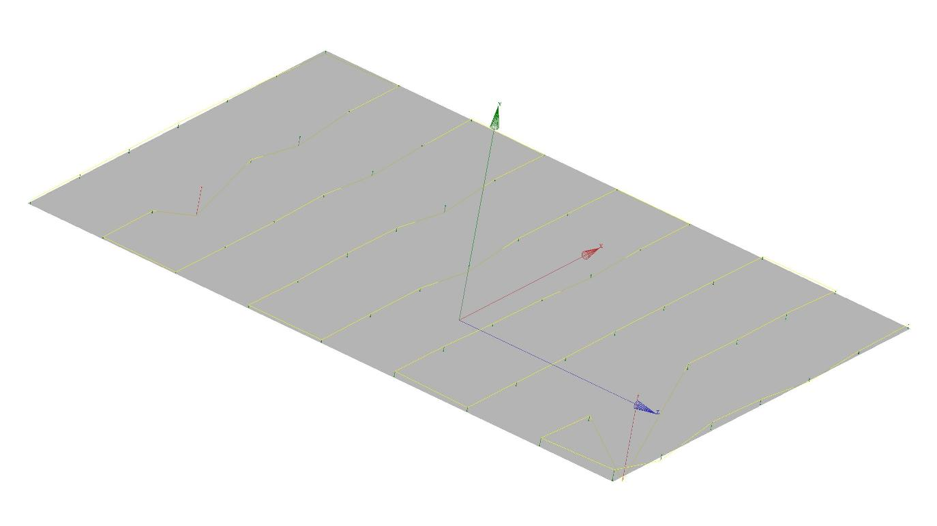
Upper Pole Plane Flatness/Deviation Plot
** LOTS OF RUST ON POLE, TRIED TO CLEAN AS BEST AS I COULD.
FLATNESS | MIN. | MAX.
0.00266 | -0.00029 | 0.00237

