BLUE DIPOLE - ECHO 7 EXP. (3D4 MAGNET)
FIDUCIALIZATION REPORT

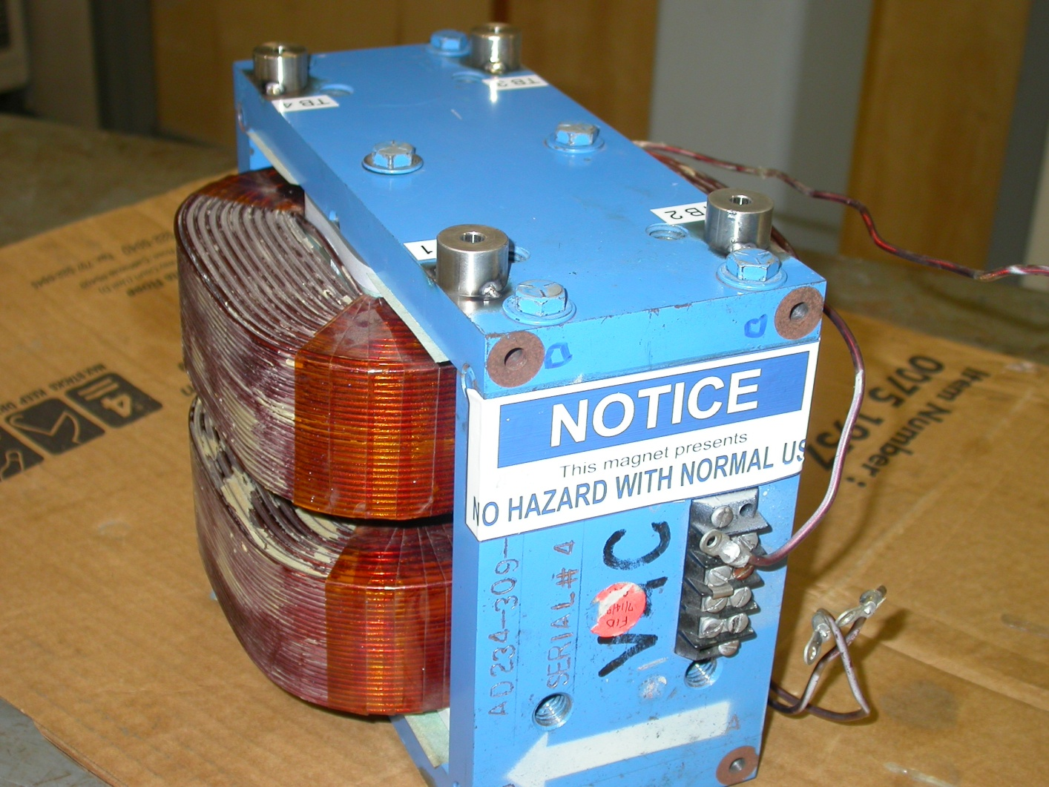

Inspector: | Keith Caban
Customer: | Dieter Walz
Date: | Monday, July 20, 2009
Work Order/Charge No.: | 09-3008
Serial Number: | #4
Stamped Drwg. #: | AD-234-309-91
URL of Fiducial Report: | \\Web002\www-group\met\Quality\FIDUCIAL REPORTS\BLUE-DIPOLE FFTB STEERING MAGNET\AD-234-309-91 SN-4.pdf

Part Set-up – Coordinate System Set-up

Planar Alignment

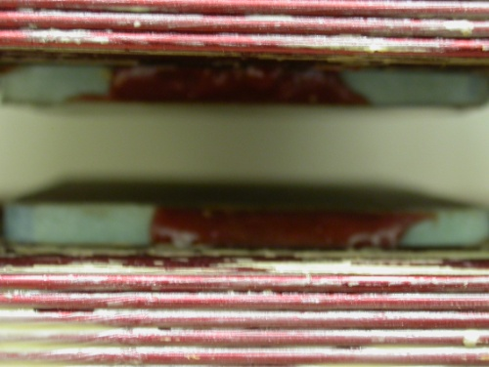
- Plane along bottom pole plane.

Spatial Alignment

- Plane of +Z face of magnet

“Z” Zero
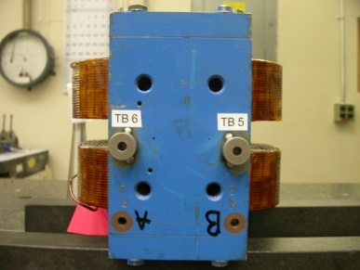
- Mid-Plane of the magnet. (see dashed planar alignment above)

“X” & “Y” Zero

- X zero is created by the symmetry point of the outer ends of the magnet where TB 5 & 6 are and opposite where the terminal strip is located.

- Symmetry plane of the pole planes
  - This creates Y- zero

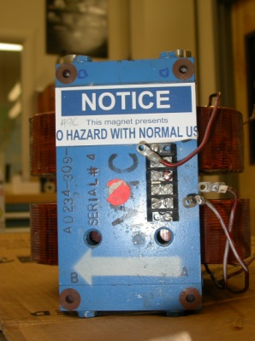  +Y  +Z | +X  +Y

Tooling Ball Measurements/Locations

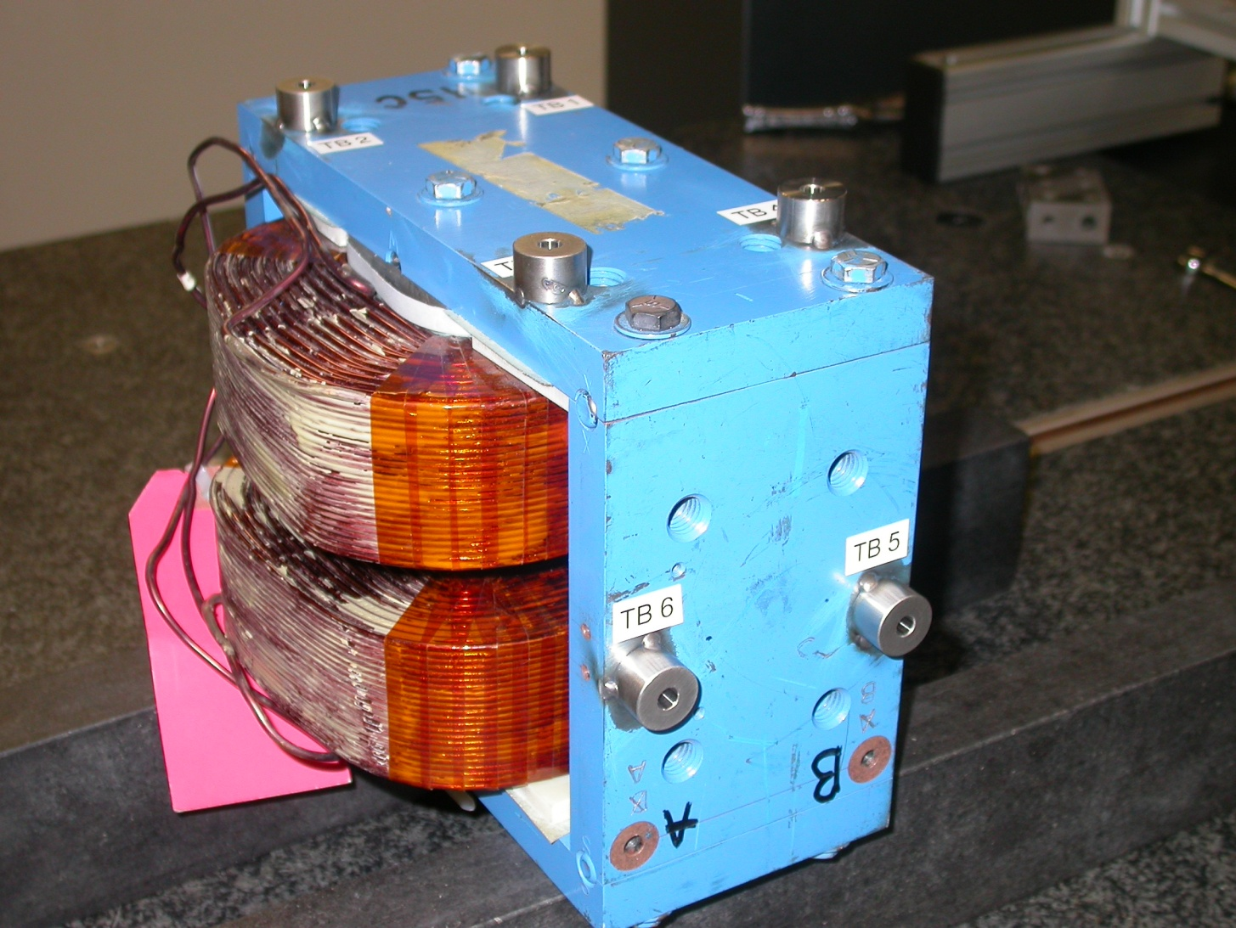
-Z
+Y
-X
Projected cylinder into 1” offset plane

Tooling Ball | Form | n | X | Y | Z | b
TB 1 | 0.00040 | 0.25046 | 3.48652 | 5.02925 | 1.63371 | 0.00038
TB 2 | 0.00034 | 0.25044 | 3.47357 | 5.02923 | -1.60505 | 0.00037
TB 3 | 0.00023 | 0.25047 | -3.51175 | 5.02701 | -1.62813 | 0.00040
TB 4 | 0.00022 | 0.25057 | -3.50771 | 5.02701 | 1.65017 | 0.00015
TB 5 | 0.00026 | 0.25045 | -6.26583 | 0.00721 | 1.64715 | 0.00044
TB 6 | 0.00028 | 0.25044 | -6.26892 | 0.00109 | -1.61752 | 0.00034

Pole Tip Distance/Gaps (at location X, Z)

Station | Gap Distance | X | Z
1 | 0.60022 | -1.125 | -1.375
2 | 0.60044 | 1.125 | -1.375
3 | 0.60041 | 0.000 | 0.000
4 | 0.60112 | -1.125 | 1.375
5 | 0.60099 | 1.125 | 1.375
Avg. Gap | 0.60064 | - | -

