
BLUE DIPOLE - ECHO 7 EXP. (3D4 MAGNET)
FIDUCIALIZATION REPORT

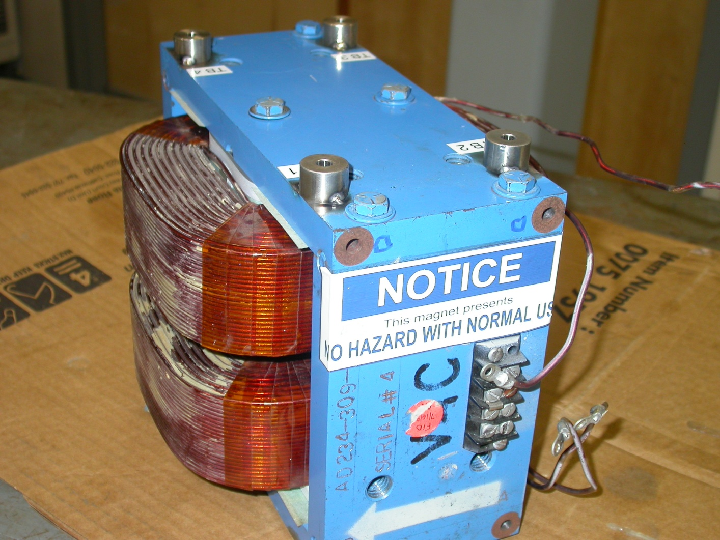

Inspector: | Keith Caban
Customer: | Dieter Walz
Date: | Tuesday, July 21, 2009
Work Order/Charge No.: | 09-3008
Serial Number: | #01
Stamped Drwg. #: | AD-234-309-91
URL of Fiducial Report: | \\Web002\www-group\met\Quality\FIDUCIAL REPORTS\BLUE-DIPOLE FFTB STEERING MAGNET\AD-234-309-91 SN-01.pdf

Part Set-up – Coordinate System Set-up

Planar Alignment

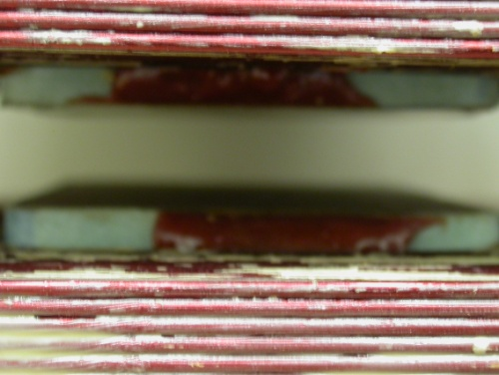
- Plane along bottom pole plane.

Spatial Alignment

- Plane of +Z face of magnet

“Z” Zero
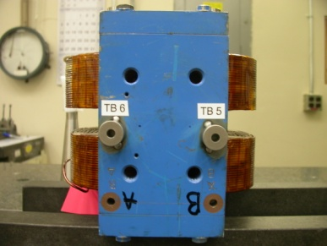
- Mid-Plane of the magnet. (see dashed planar alignment above)

“X” & “Y” Zero

- X zero is created by the symmetry point of the outer ends of the magnet where TB 5 & 6 are and opposite where the terminal strip is located.

- Symmetry plane of the pole planes
  - This creates Y- zero

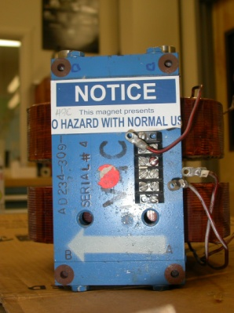  +Y  +Z | +Y  +X

Tooling Ball Measurements/Locations

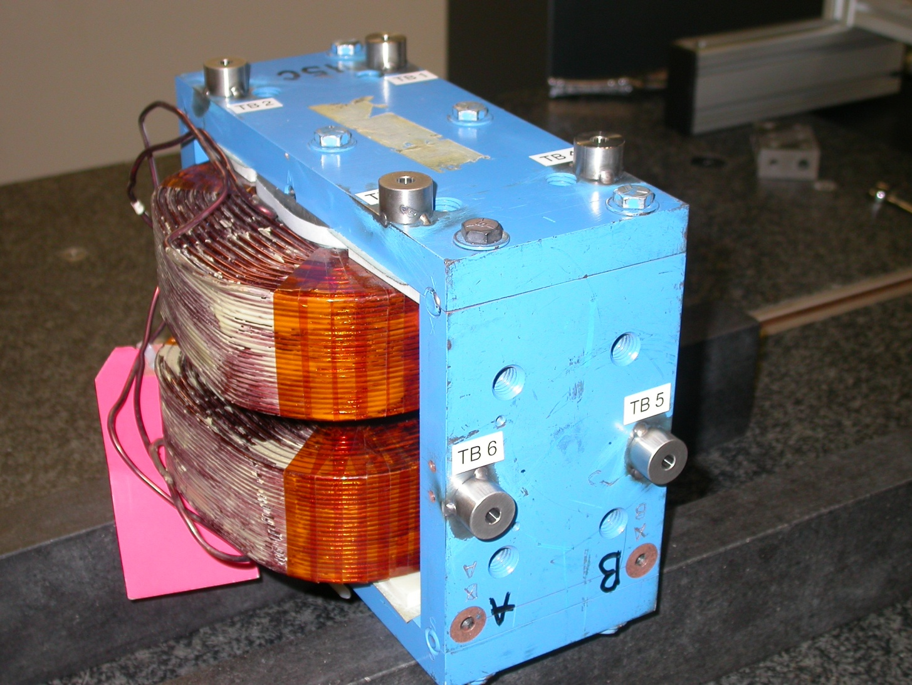
-X
+Y
-Z
Projected cylinder into 1” offset plane

Tooling Ball | Form | n | X | Y | Z | b
TB 1 | 0.00019 | 0.25045 | 3.49230 | 5.01430 | 1.59952 | 0.00026
TB 2 | 0.00021 | 0.25040 | 3.48730 | 5.01294 | -1.62702 | 0.00045
TB 3 | 0.00027 | 0.25044 | -3.50404 | 5.01531 | -1.64536 | 0.00047
TB 4 | 0.00016 | 0.25045 | -3.49781 | 5.01420 | 1.61212 | 0.00049
TB 5 | 0.00020 | 0.25046 | -6.25890 | 0.00261 | 1.62028 | 0.00024
TB 6 | 0.00021 | 0.25048 | -6.24774 | 0.00441 | -1.63648 | 0.00028

Pole Tip Distance/Gaps (at location X, Z)

Station | Gap Distance | X | Z
1 | 0.59857 | -1.125 | -1.375
2 | 0.59886 | 1.125 | -1.375
3 | 0.59866 | 0.000 | 0.000
4 | 0.59861 | -1.125 | 1.375
5 | 0.59876 | 1.125 | 1.375
Avg. Gap | 0.59868 | - | -

