
BLUE DIPOLE - ECHO 7 EXP. (3D4 MAGNET)
FIDUCIALIZATION REPORT

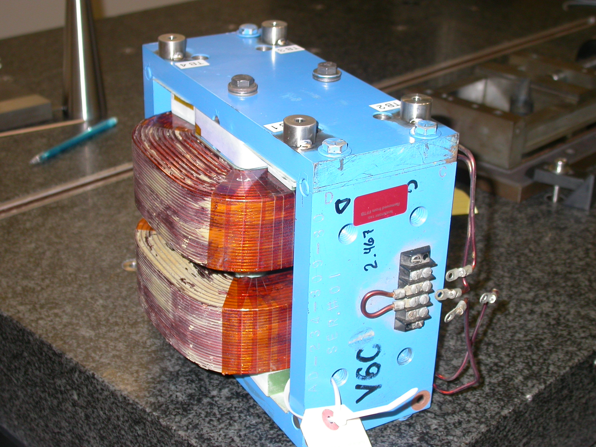

Inspector: | Keith Caban
Customer: | Dieter Walz
Date: | Tuesday, July 21, 2009
Work Order/Charge No.: | 09-3008
Serial Number: | #6 (Formerly #01)
Stamped Drwg. #: | AD-234-309-80
URL of Fiducial Report: | \\Web002\www-group\met\Quality\FIDUCIAL REPORTS\BLUE-DIPOLE FFTB STEERING MAGNET\AD-234-309-80 SN-6.pdf

Part Set-up – Coordinate System Set-up

Planar Alignment

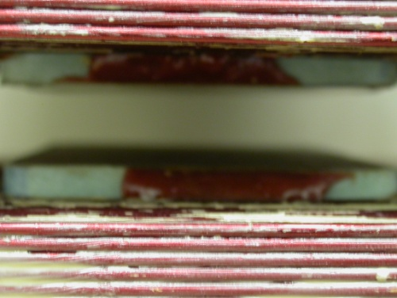
- Plane along bottom pole plane.

Spatial Alignment

- Plane of +Z face of magnet

“Z” Zero
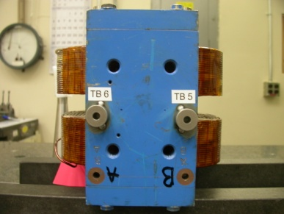
- Mid-Plane of the magnet. (see dashed planar alignment above)

“X” & “Y” Zero

- X zero is created by the symmetry point of the outer ends of the magnet where TB 5 & 6 are and opposite where the terminal strip is located.

- Symmetry plane of the pole planes
  - This creates Y- zero

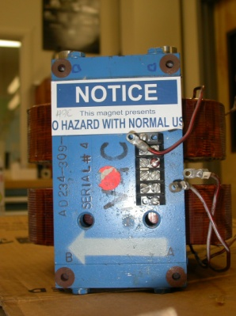  +Y  +Z | +Y  +X

Tooling Ball Measurements/Locations

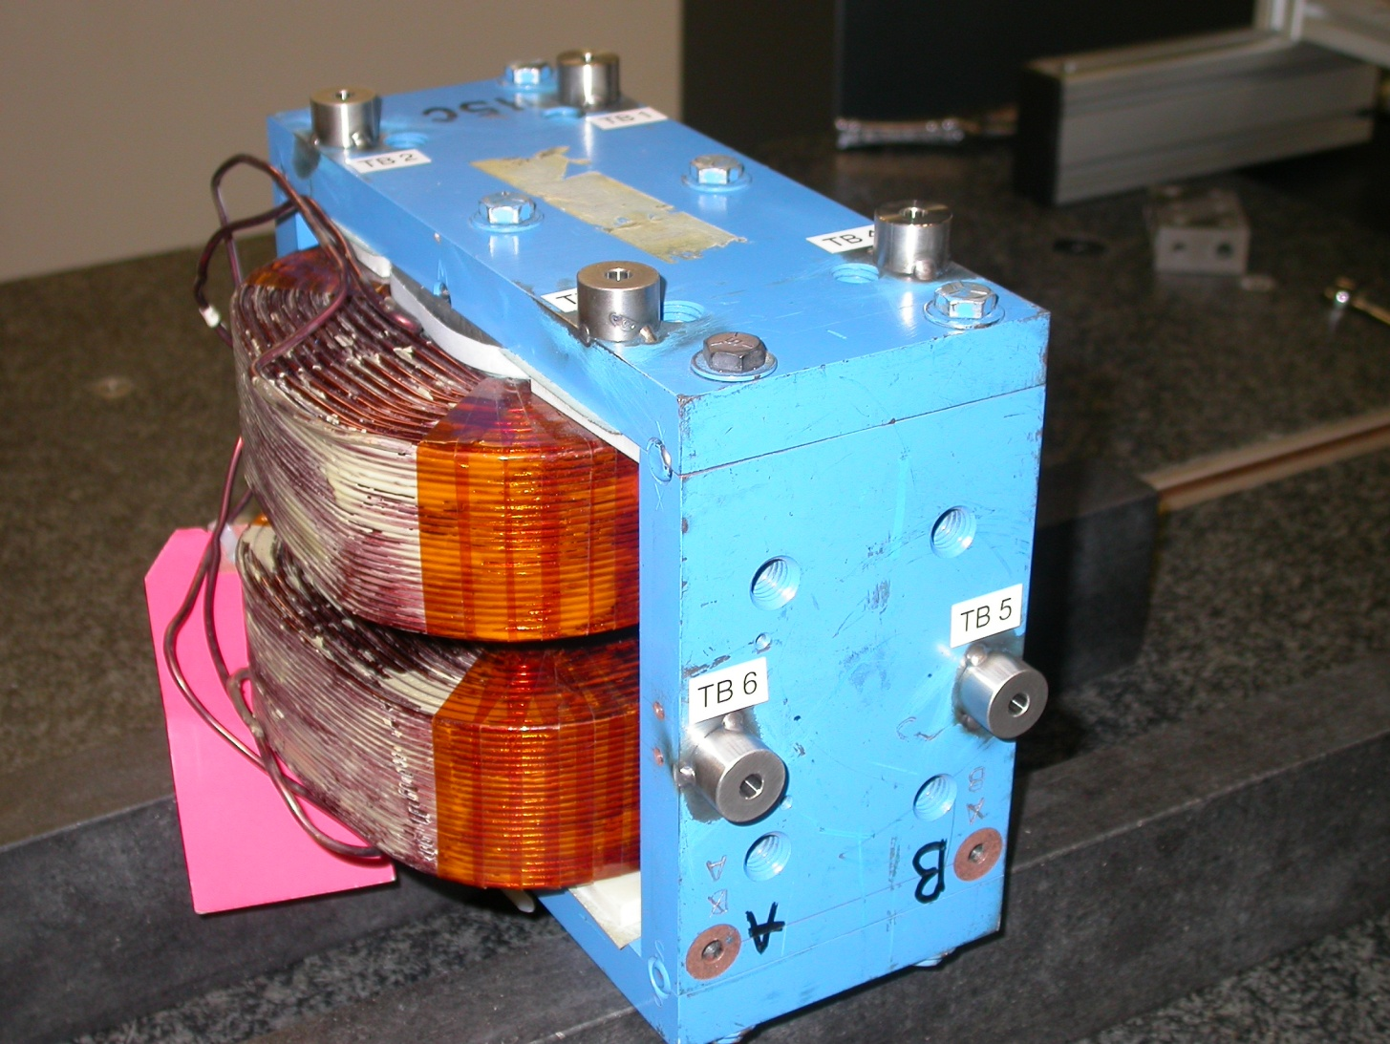
-X
+Y
-Z
Projected cylinder into 1” offset plane

Tooling Ball | Form | n | X | Y | Z | b
TB 1 | 0.00024 | 0.25046 | 3.49242 | 5.45759 | 1.63957 | 0.00047
TB 2 | 0.00012 | 0.25050 | 3.48810 | 5.45606 | -1.61569 | 0.00023
TB 3 | 0.00019 | 0.25046 | -3.49419 | 5.45834 | -1.61656 | 0.00031
TB 4 | 0.00025 | 0.25045 | -3.49551 | 5.45704 | 1.63662 | 0.00042
TB 5 | 0.00071 | 0.25024 | -6.24374 | 0.00747 | 1.62757 | 0.00042
TB 6 | 0.00015 | 0.25044 | -6.25000 | 0.00400 | -1.62405 | 0.00034

Pole Tip Distance/Gaps (at location X, Z)

Station | Gap Distance | X | Z
1 | 0.60065 | -1.125 | -1.375
2 | 0.60050 | 1.125 | -1.375
3 | 0.60026 | 0.000 | 0.000
4 | 0.59982 | -1.125 | 1.375
5 | 0.59945 | 1.125 | 1.375
Avg. Gap | 0.60020 | - | -

