BFW Traveler: Assembly and Alignment Procedure
Serial Number: BFW # / VC # / WC # / Base #

NOTE - This document:
- records the assembly and alignment steps for the LCLS Undulator Beam Finder Wire (BFW).
- collates assembly steps as provided by Argonne National Labs, along with tested alignment steps at SLAC. Any steps not mentioned in this document and noted in any future device must be for recorded on the traveler for the specific device, and relayed to LCLS Operations for revisions of this document.
- is valid for all procedures starting from delivery of the BFW device from Argonne to SLAC Quality Control (QC), till the delivery of the BFW from SLAC QC to SLAC’s LCLS Undulator Girder Assembly Group.
- pertains only to the BFW top assembly and vacuum chamber and internal components. Procedure/traveler sign-off for the BFW Support is documented separately.
- requires that the BFW Report specifying the repeatability and position (as last recorded) data for each device be reviewed as part of the procedure. All italicized-bold terms are explained in the BFW Report.
- explains dispositions, if any, on the reverse side of each page.

Responsible SLAC QC Personnel:

Responsible LCLS Engineer:

Part 1: BFW Bench Assembly

 |  | Acc. | Rej.
1-1 | Fabricate and assemble alignment bench as per fabrication drawing (SA-381-011-71). Install alignment pins. Ensure correct orientation of diamond pin (refer drawing)
1-2 | Install and lock down Bench Assembly on CMM
1-3 | Locate coordinate system on Bench Assembly (Bench$CSY).
1-4 | Coordinate axes are defined using Right Hand Coordinate System

Part 2: BFW Assembly for Calibration

 |  | Acc | Rej.
2-1 | Receive BFW container at SLAC QC Bldg 025, from SLAC Bldg 750. Box should contain BFW unit, spare Helicoflex Seal, measurement data for specific BFW device
2-2 | No Damage to BFW upon receipt at SLAC QC Bldg 025?
2-3 | Remove BFW from container. Ensure BFW is wrapped in plastic.
2-4 | Remove BFW Top Assembly from Chamber and place on alignment bench. (Take care not to damage sealing surfaces).
2-5 | Chamber: Look for aluminum coating on inside of chamber
2-6 | Chamber: Flange clamp is made of Dichronite (Dark Gray) chain link/standard clamp?
2-7 | Chamber: Alignment pins tightly secured in holes?

 |  | Acc. | Rej.
2-8 | Chamber: No loose hardware inside vacuum chamber?
2-9 | Chamber: No debris inside chamber?
2-10 | Secure BFW Top Assembly to Bench Assy with four mounting screws on the corners.
2-11 | Connect air supply to BFW, with regulator set at 90 psi, and appropriate shut off valve. Ensure no air leaks.
2-12 | Connect 24VDC with on-off switch to solenoid valve.
2-12 | Open shut off valve to air supply and activate the solenoid valve (i.e. power on the solenoid).
2-13 | Remove the four temporary screws at the top of the assembly.
2-14 | Check operation of the unit by turning the 24VDC supply on and off. Slide should move up and down. (i.e. beam in – beam out positions).
2-15 | Check 3 places (valve near air cylinder, plug on air control module, valve on air control module) for air fittings seal (RTV or Silicone/Teflon Tape)
2-16 | Check for air leaks during operation (audible air leaks)
2-17 | Upon receipt from Argonne, ensure speed of travel is ~ 1 second, in both directions.
2-18 | During actuation, ensure Limit Switches meet in Target In/Out Positions
2-19 | Ensure light illuminates (LED) on controls module when turning on power supply
2-20 | No thread damage on feedthru threaded rods
2-21 | Prior to installation, ensure BFW Card Wire Crosshairs are present on BFW Card
2-22 | BFW Card, BFW Top Assembly and BFW Chamber all have same serial number
2-23 | BFW Card has copper flex tabs installed
2-24 | Install BFW Card on BFW Card Holder
2-25 | Connect copper tabs from welded rod to BFW card
2-26 | Feedthru Welded Rods nuts tightly secured with four nuts per weld rod
2-27 | Continuity from Top Feedthru to BFW Card Connection Tabs
2-28 | Continuity on IN and OUT limit switches verified?
2-29 | Resistance measurement verified on potentiometer?

Part 3: BFW Non-Vacuum Measurements
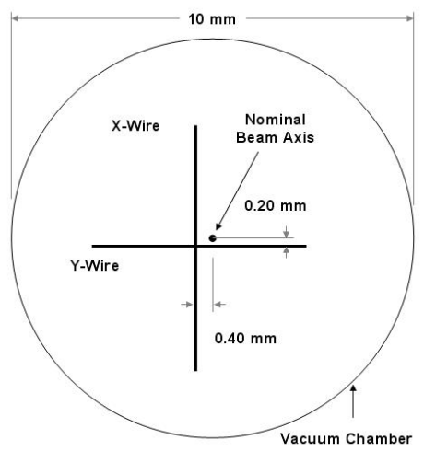

Figure 1: Schematic diagram of the positions of the X-, and Y-Wires with respect to the nominal beam axis when the system is full aligned. The electron beam direction of travel is out of the page.

The BFW card circle center should ideally be the same as the magnetic center for the BFW. The wires on the card are machined then, to be offset nominally by -0.4 mm (vertical wire) and -0.2 mm (horizontal wire) nominally.

 |  | Acc. | Rej.
3-1 | Retrieve Data from specific BFW Support Alignment
3-2 | Retrieve Data from specific BFW Card Optical Measurements
3-3 | Measure position of BFW Tooling Balls (TB) 5-8 in BTB$CSY and BFW card in Bench$CSY using CMM.
3-4 | Through multiple iterations, cycle the assembly and position card to within X-position +/-0.008” (~200 microns) of its nominal zero position. As far as possible, try and get the card as close to zero as possible.
3-5 | Calculate X-Wire and Y-Wire positions in Beamline$CSY
3-6 | Wire Crosshairs are aligned to ±0.100 to X = -0.400 mm and Y = -0.200 mm?
3-7 | (do only if above step is NOT RATIFIED) Adjust y-precision screws on top of BFW assembly. All screws are right handed. Precision screws behave like limits for the top kinematic plate held by three holding ¼-20 screws (screws 5,6,7 in diagram). Y-Precision screws have 100 threads per inch. 1 turn, in theory, gives 0.01” (has been shown to give 0.014”). Total available adjustment: +/- 0.075” (+/-1900 microns). Loosen locking collar on y-precision to turn. After vertical alignment, retighten the locking collars on screws 10, 11 and 12, and locking screws 5,6,7. These screws should be tightened to slightly more than finger tight. Over tightening these screws will significantly move the adjustment settings.
3-8 | X-precision screws have not been touched throughout process?
3-9 | Cycle 10 times, take measurement after every cycle, give 1-min relaxation between cycles
3-10 | Note down positions of TB5-8 and card in Bench$CSY.

 |  | Acc. | Rej.
3-11 | Non-vacuum data to be recorded for card – use retrieved data from BFW Support and BFW Card Optical Measurements: (1) X-position of Card Center (2) X-Intpt (3) Y-Intpt (4) X-wire w.r.t Base (nominal -0.400 mm) (5) Y-wire w.r.t Base (nominal 258.4736 mm)
3-12 | No abnormal trends in wire / TB values within 10-cycles?
3-13 | Calculate all X,Y,Z average, range and standard deviation values for TB5-8, card and wire
3-14 | Calculate Transformation Wire$CSY to BFWTB$CSY. Use final value of measurements, making sure that final value is not an outlier.
3-15 | Calculate Transformation Wire$CSY to Bench$CSY
3-16 | Hold BFW card in TARGET IN position using the four holding screws on the top of the device, and record the final value of the TB/wire in the Bench$CSY
3-17 | BFW Support aligned and signed off?

Part 4: BFW Vacuum Measurements

 |  | Acc. | Rej.
4-1 | Wire Crosshairs check prior to installation for vacuum
4-2 | BFW Vacuum Chamber is Pre Aligned (Girder Alignment) to X = 0.00 mm and Y = 258.67 mm to its Base
4-3 | Used new Helicoflex Gasket?
4-4 | Install BFW top assembly with the card locked in the TARGET IN position, on the BFW chamber seated on the BFW support
4-5 | Tighten all vacuum screws, 48 ft-lb (use 50 ft-lb for M6)
4-6 | Pump Down for Vacuum Test – Reach Low -6 or High -7 Scale.
4-7 | Vacuum Leak Test: NIL (no indicated leak)?
4-8 | Measure TB5-8 in Bench$CSY
4-9 | Use Transformation of Wire$CSY → BFWTB$CSY to get Wire$CSY in Bench$CSY
4-10 | Cycle 10 times, take measurement after every cycle, give 1-min relaxation between cycles
4-11 | Calculate X-Wire and Y-Wire positions in Beamline$CSY
4-12 | Calculate all range, standard deviation, average values for TB5-8, wires
4-13 | Wire position within RMS spec (X: 65 microns, Y: 30 microns)?
4-14 | Wire Crosshairs are aligned to ±0.100 to X = -0.400 mm and Y = -0.200 mm?
4-15 | Record the final value of CMM measurement as the location of the wires.

Part 5: BFW Assembly for Transportation to Bldg 750 (Girder Assembly)

 |  | Acc. | Rej.
5-1 | Assembly is held with the four temporary holding screws 1,2,3,4 and with foam sandwiched between top two sub-assemblies?
5-2 | Ground connector tab installed on feedthrus on top?
5-3 | Check Continuity of the ground connector about the ceramic area?
5-4 | RF shield (metal tube) installed on top of feedthrus?
5-5 | BFW wrapped in plastic for transportation?
5-6 | Transformation Values relayed to Ed Reese – Girder Alignment, Bldg 081?
5-7 | All data recorded and transferred electronically with no manual data entry?
5-8 | BFW Report prepared with CSY data, wire data, and highlighted data on wire repeatability, position in virtual beam line CSY, and Wire$CSY → BFWTB$CSY?
5-9 | BFW Report with Sign-off sheet signed off by Vacuum, Mechanical, Alignment, Physics?
5-10 | BFW Assembly RFI and ready to move from SLAC QC Bldg 025 to Bldg 750?

Side View

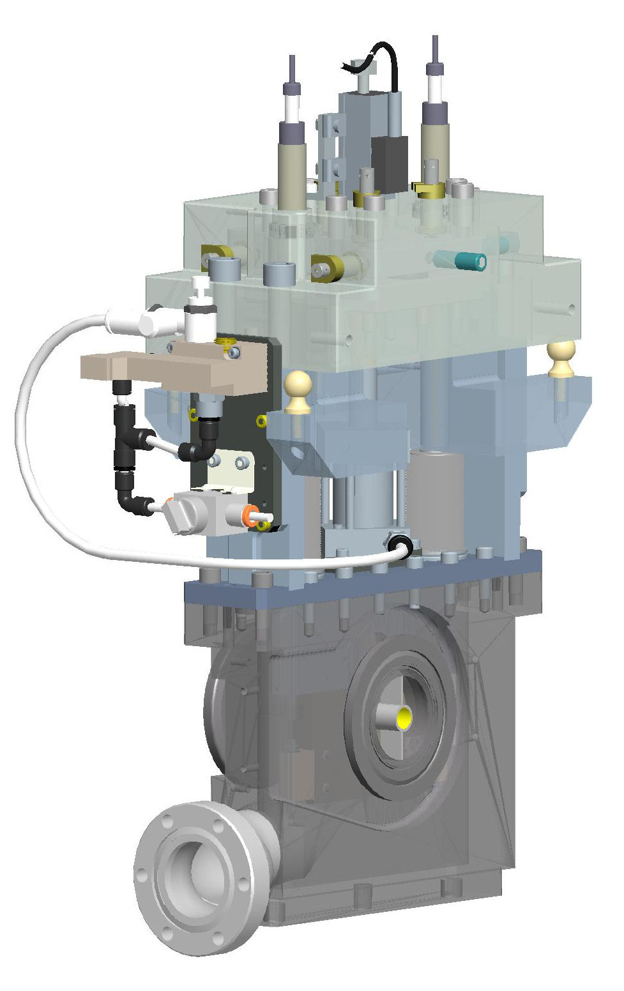

Fiducials
4 places

Air supply to shut off valve

Solenoid valve

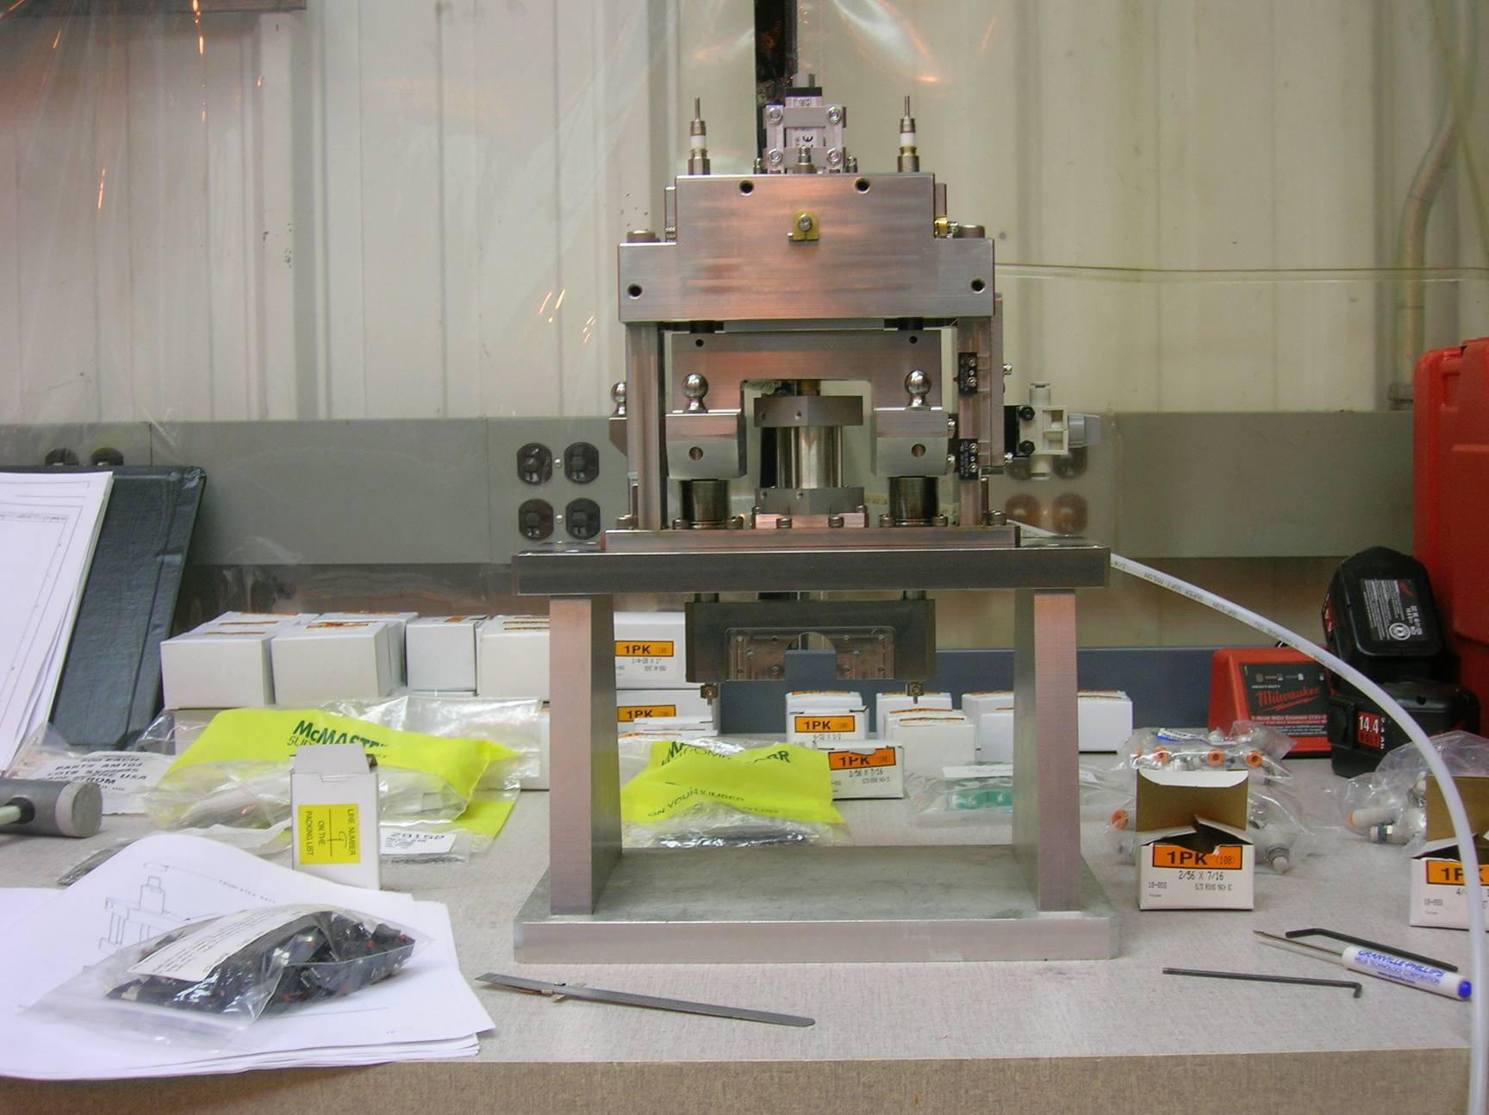
Signal Connection
Precision Screw
Pneumatic Cyl.
Frame and Mounting Flange
Control Air Assembly
Limit Switch
Bench
Card Holder
90 psig air supply
Potentiometer

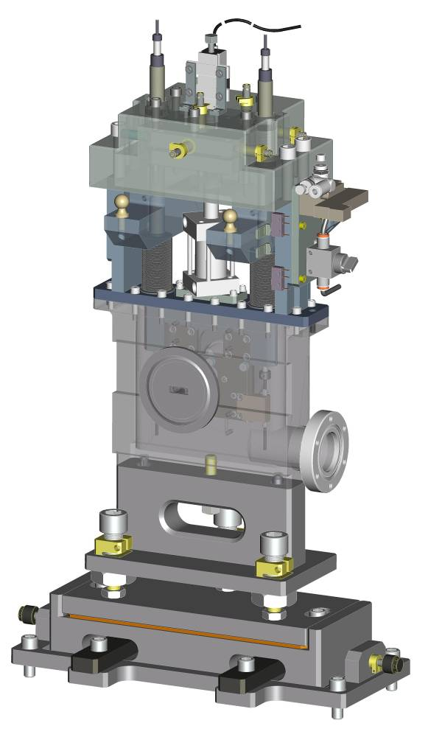
Adjustable Mounting Support
Vacuum Pump Connector (2.75” Conflat Flange)
Card Position Monitor (Limit switches)
Air Supply Shut Off Valve
Pneumatic Solenoid Valve
Precision Screw
Electrical Connectors for Wire Signals
Vacuum Chamber Connection Flange
(NW-50 CeFix w/Clamp)
Beam Port
Pneumatic Cylinder
Alignment Fiducials
Frame
Compression Spring Positioner
Potentiometer
Housing

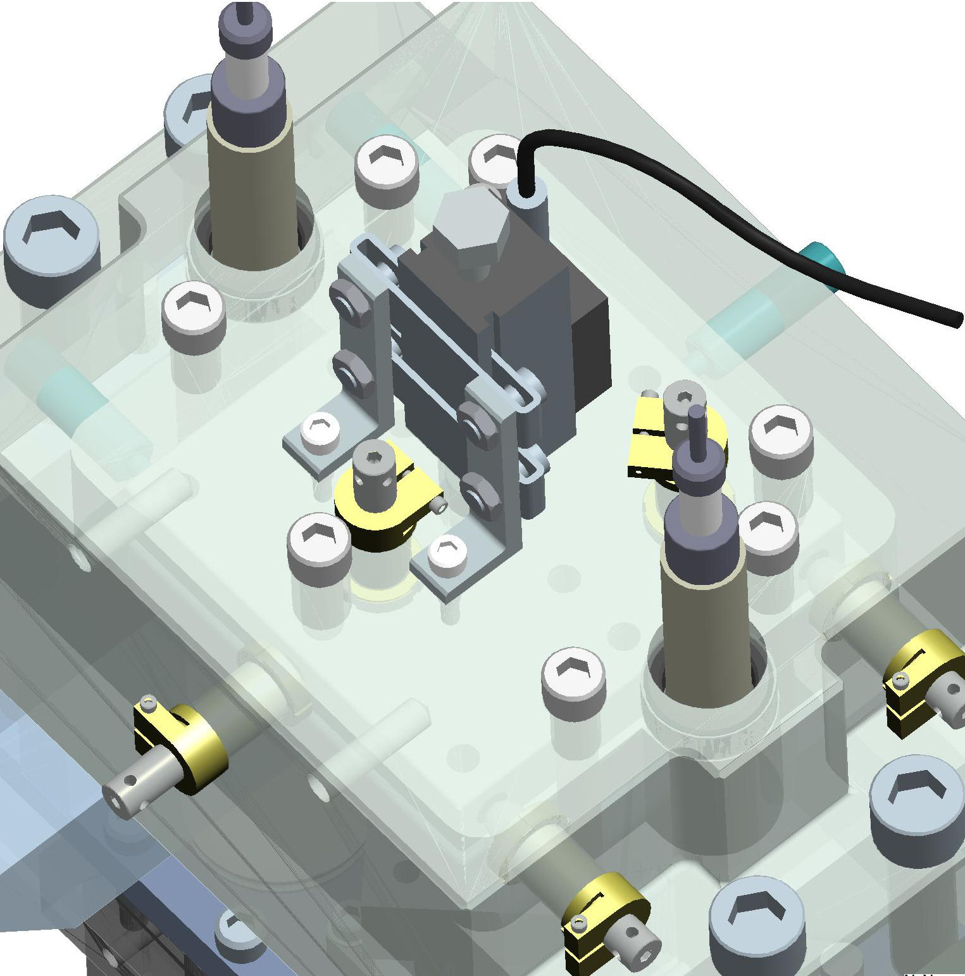
Top View
¼-20-UNC Screws 1 and 2
¼-20-UNC Screws 3 and 4

Y-Precision Screws 10, 11, and 12
¼-20-UNC Screws 5, 6 and 7 (Brass washers under heads are not shown)
This precision screw remains fixed
Socket head screw loosens and tightens collar on precision screws (Typ.)
Socket head for adjusting the precision screws (Typ.)

X-Precision Screws 8 and 9 – DO NOT TOUCH

