7.0 Alignment Proposal
This chapter will describe procedures and methods which, if carried out in a careful and rigorous manor, will yield the aligned position of all LCLS components within their position tolerances. Major geodetic principles governing survey and alignment measurement space are briefly revisited and their relationship to a lattice coordinate system are shown. The chapter then continues with a discussion of the activities involved in a step-by-step sequence from initial lay-out to final alignment.

7.1. LCLS Surveying Reference Frame
Horizontal position differences between the projection of points on the geoid or a best fitting local ellipsoid and those on a local tangential plane are not significant for a project of the size of the LCLS. Hence, it is not necessary to project original observations like angles and distances into the local planar system to arrive at planar rectangular coordinates.
However, in the vertical plane, the curvature of the earth needs to be considered (see fig. f71_a). Since leveling is done with respect to gravity, the reference surface is the geoid. Because of the relatively small area of the LCLS project, one can substitute the non-parametric geoid with a locally best-fitting sphere or spheroid. Table 1 shows the projection differences between a tangential plane, a sphere, and an ellipsoid as a function of the distance from the coordinate system’s origin. Notice that for distances as short as 20 m the deviation between plane and sphere is already 0.03 mm (see table t71_a).
Table t71_a Curvature Correction
Distance  r  [m] | Sphere  HS  [m] | Spheroid  HE  [m]
20 | 0.00003 | 0.00003
50 | 0.00020 | 0.00016
100 | 0.00078 | 0.00063
1000 | 0.07846 | 0.06257

7.1.1 Network Design Philosophy
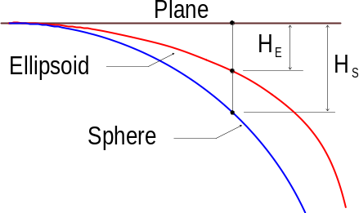
Fig. f71_a Effect of earth curvature
The global alignment tolerance, the relatively weak links between machine sections, and advances in surveying make it possible to forego the traditional design of a two tiered network hierarchy covering the whole machine. Instead, each machine section can be considered independent, only connected by tunnel networks. A two tiered approach will only become necessary if a remote experiment is added to the project and at that time needs to be connected to the undulator. Omitting a primary network not only removes many constraints for component placement, since fewer lines-of-sight need to be maintained, but also presents a significant reduction in alignment costs.
Traditionally, forced centered “2+1-D” triangulation and trilateration techniques were used to measure the tunnel networks.
However, a 3-D “free stationing” approach does not require forced-centered instrument set-ups, thus eliminating the need for set-up hardware and their systematic error contributions. Removable heavy duty metal tripods, translation stages, CERN sockets and optical plummets are not needed (see fig. f711_a). The network design still must consider other systematic error effects, especially lateral refraction. Another important consideration is the target reference system. Its design becomes much easier with free stationing since we are dealing only with targets and not with instruments as well. Accordingly, it is proposed to use a 3-D design, which is now widely used in high precision metrology. This approach is centered around a 1.5" sphere. Different targets can be incorporated into the sphere in such a way that the position of the target is invariant to any rotation of the sphere. At SLAC, designs have been developed to incorporate theodolite targets (see fig. f711_b), photogrammetric reflective targets as well as glass and air corner cubes (see fig. f711_c) into the sphere. Receptacles for the spheres, which are usually referred to as “nests” or “cups”, have been designed to accommodate different functions. CEBAF has a very suitable design for nests to be grouted into the floor, and designs are available at SLAC for cups tack-welded onto magnets, for mounting cups on wall brackets and for a “centered” removable mounting placed into tooling ball bushings (see fig. f711_d).
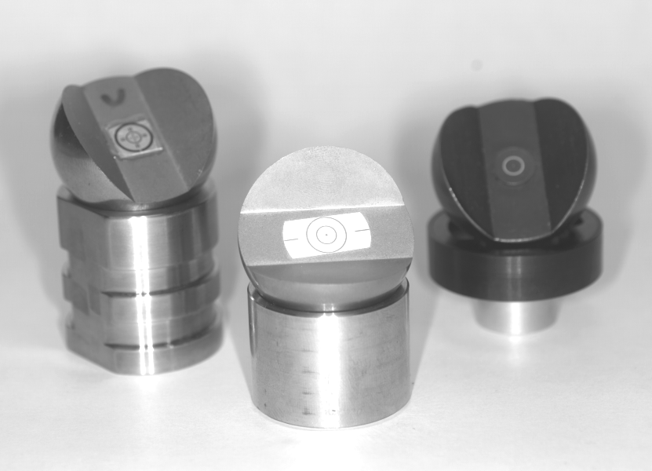
Fig. f711_b Sphere mounted theodolite target
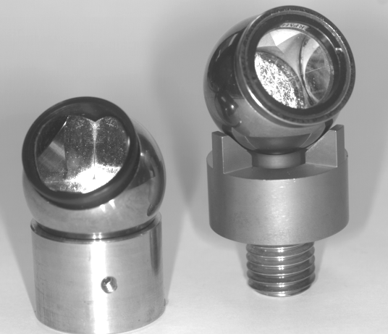
Fig. f711_c Sphere mounted glass and air reflectors
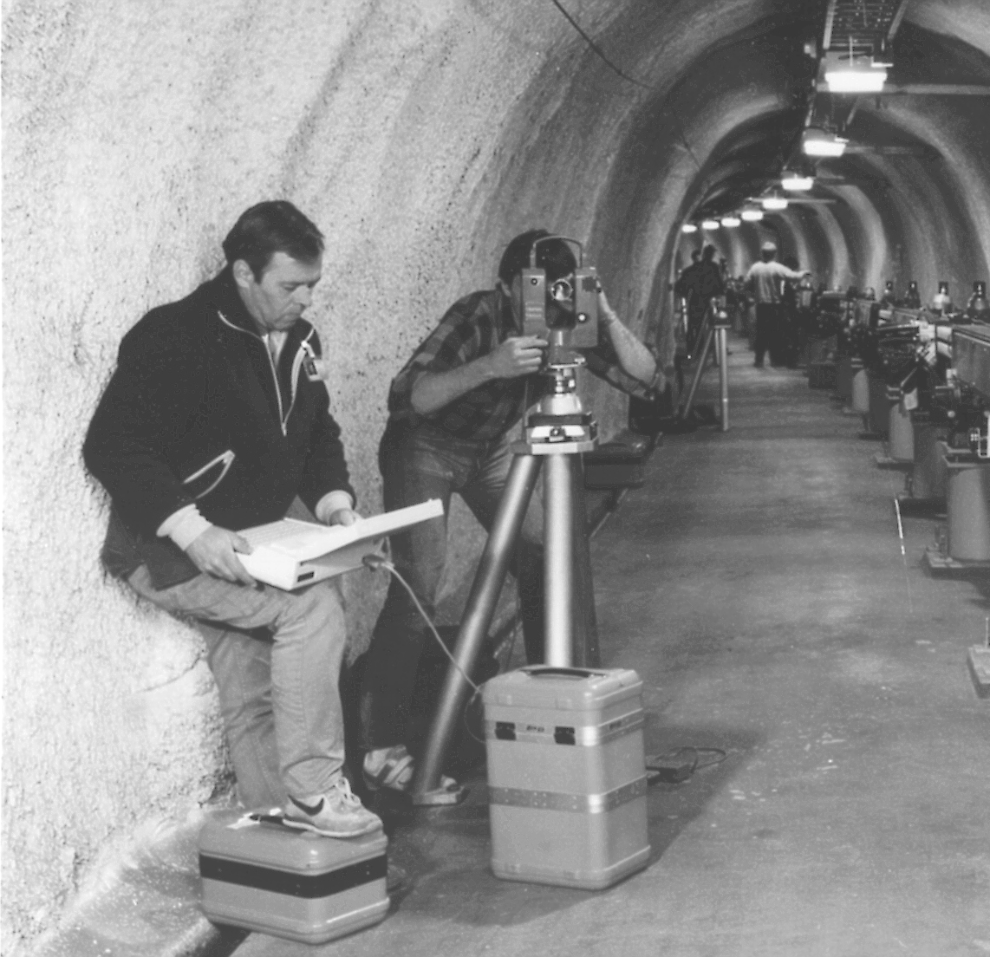
Fig. f711_a Forced Centered Set-up at SLAC
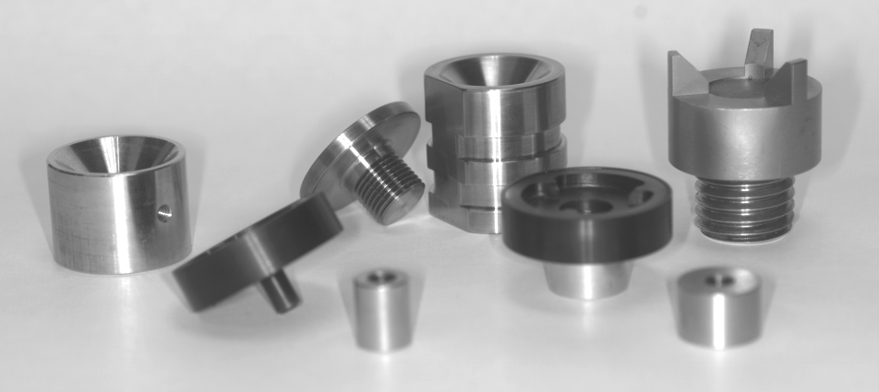
Fig. f711_d Sphere receptacles: floor, component, and wall bracket fixed mount versions, removable
centered version

7.1.2 Network Lay-Out
The LCLS network consists of three parts: the linac network, the undulator network and the transport line/experimental area network.
7.1.2.1 Linac Network The linac network serves a different purpose than the other networks. Since the linac already exists, it does not need to support construction survey and alignment, but rather will only provide local tie-points during the linac straightening (smoothing) procedure.
7.1.2.2 Undulator Network The undulator network’s overall geometry is dictated by the tunnel geometry, machine lay-out and the fact that the free stationing method requires a greater number of reference points. The geometry should also permit observing each target point from at least three different stations. The reference points can be of two different hierarchical classes. The second order points, or tie points, mainly serve to connect the orientation of free stationed instruments, while the first order points additionally provide the geometric reference during machine installation; they are the equivalent of traditional traverse points or monuments. The following sketch (fig. f7122_a) shows a typical section of the lay-out. A triplet of monuments is placed in the tunnel cross section containing a corrector magnet. One monument will be placed close to the corrector magnet on the floor, the second one mounted at instrument height to the aisle wall, and the third monument mounted to the back wall also at instrument height.

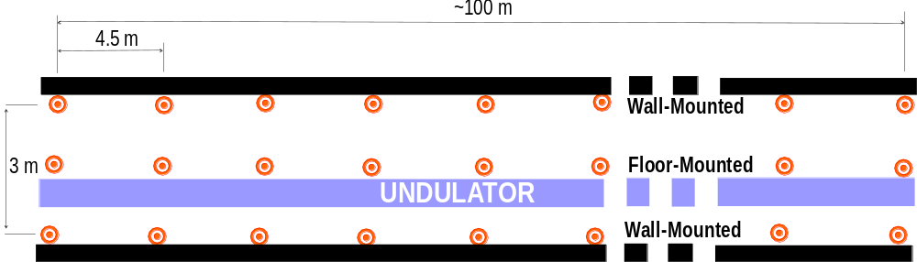

Fig. F7122_a Undulator network lay-out
7.1.2.3 Transport Line/Experimental Area Network Initially, the project will only include an experimental area directly down-stream of the undulator. This network will be constructed and established similar to the undulator network. The only difference being that each cross-section will have only two monuments. These monuments will be mounted to the walls at instrument height.

7.1.3 Alignment Coordinate System

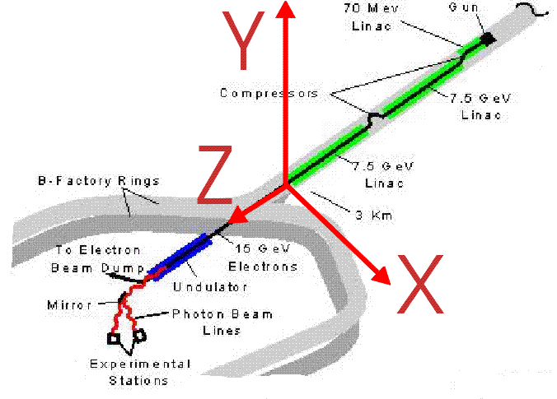

Fig. f713_a Coordinate system definition
The alignment coordinate system will be a Cartesian right-handed system. The origin is placed at the linac Station100 (in analogy to the SLC coordinate system). There will be no monument at the origin, it is purely a virtual point. The Y-axis assumes the direction of the gravity vector at the origin but with opposite sign. The Z-axis is in the direction of the linac, and the X-axis is perpendicular to both the Y and Z axes. The signs are defined by the right-handed rule (see fig. f713_a).

7.1.5 Network Survey
The most efficient instrumentation for the network observations will be a laser tracker / total station combination (fig. f715_a). We have available two state-of-the-art SMX4000/4500 laser trackers, and in addition a new Total Station optimized for industrial metrology, the Leica TDA5000 (fig. f715_b). While it is superior in angular accuracy to a laser tracker, it is significantly less accurate in distance measurements. Consequently, we will rely on the laser tracker for distance accuracy and on the Total Station for angle accuracy.

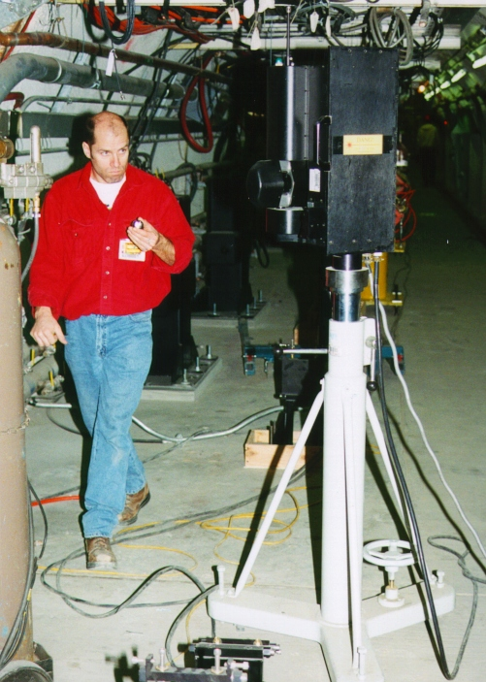

Fig. f715_a SMX Laser Tracker

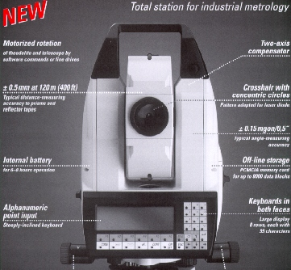

Fig. f715_b Leica TDA5000 Total Station
The laser tracker will be placed close to the intersection of the diagonals of each reference point quadrilateral (see fig. f715_c). From there, four points in a forward direction and four points in backward direction will be measured. The measurement procedure will include three sets of direction measurements to the same eight points in both front and reverse positions plus one set of distances in both positions. To strengthen the determination, the Total Station will be used to measure additional direction sets. It will be set up at two additional stations at the Z-position of the intersection of the quadrilateral diagonals and laterally shifted by about 0.5 m in both directions. From these stations direction sets to six points each downstream and upstream will be measured. To strengthen the overall straightness of the network, wire offset measurements between the wall monuments will be carried out. To minimize wire motion noise, a 30 m long wire in a 10 m overlap mode will be used. All reference points will also be observed with a standard high precision double-run level procedure. A Zeiss DiNi11 digital level in combination with 2 m invar rods is recommended. To further strengthen the elevation determination, all points will also be observed with the portable HL5 hydrostatic level. First simulations show absolute station standard deviations of less than 80 µm without wires and less than 40 µm with wire measurements.

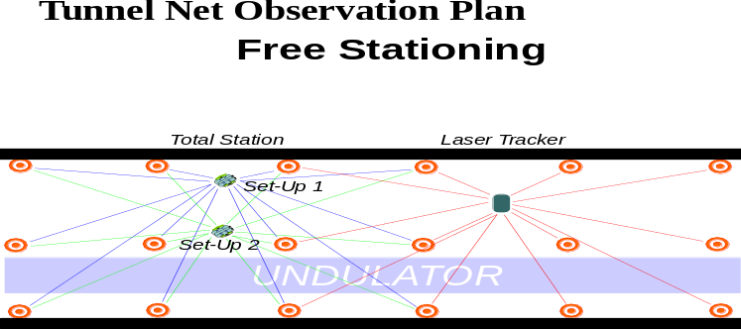

Fig. f715_c Observation plan

7.1.6 Data Analysis and Data-Flow
To reduce the data from the measurements as described above, special software is required. This type of analysis software is based on the photogrammetric bundle approach. Since a photogrammetric sensor is arbitrarily oriented in space, not only its translational parameters but also its rotational orientation parameters must be treated as unknowns and become part of the solution. With traditional trilateration/ triangulation based analysis software, however, pitch and roll are supposed to be oriented to gravity, and yaw is expressed as a function of translations. Additionally, the traditional software assumes that the instrument is centered on a point to which sufficient measurements have been taken. This analysis approach does not work well with free-stationing, and does not work at all with present generation laser trackers, since they cannot be oriented directly to gravity.
To reduce errors stemming from transcription of data, the data-flow should be automated. The suggested instruments support direct connection to field computers. The fully automated data-flow should extend from field computers through data analysis to data storage.
Measurements with any type of instrument will be guided by software based on rigid procedures running on field data logging computers. The data logging software will also pre-analyze the measurements, and will try to determine and flag possible outliers before the measurement set-up is broken down. This method combined with an automated data-flow will greatly reduce errors and improve measurement consistency and reliability.

7.2 Lay-out Description Reference Frame

7.2.1 Lattice Coordinate System
The LCLS lattice is designed in a right handed beam following coordinate system, where the positive y-axis is perpendicular to the design plane, the z-axis is pointing in the beam direction and perpendicular to the y-axis, and the x-axis is perpendicular to both the y and z-axes.

7.2.2 Tolerance Lists
The relative positioning tolerances σ_{x}, σ_{y}, σ_{z} of the undulator sections, dipoles, quadrupoles and sextupoles are listed in the following table:

Table t722_a LCLS positioning tolerances
 | σ_{x} [µm] | σ_{y} [µm] | σ_{r}  [mr] | σ_{x/z} [µm/m]
Straightness of undulator sections | 50 | 100 | 1 | n/a
Relative alignment between sections | 50 | 100 | 1 | n/a
Global straightness of undulator | 100 | 500 | 2 | 100/10
Linac straightness | n/a | n/a | n/a | 150/15
Quadrupole ab initio | 50 | 50 | n/a | n/a

7.2.3 Relationship between Coordinate Systems
The relationship between the surveying and lattice coordinate systems is given by the building design and machine lay-out parameters. The result is a transformation matrix (rotations and translations).

7.3 Fiducializing LCLS Magnets
The correct fiducialization of magnets is as important as their correct alignment since an error in either task will effect the particles’ trajectory and cannot be distinguished from each other. Fiducialization can be accomplished either through opto-mechanical and opto-electrical measurements or by using fixtures, which refer to a magnet’s reference features. Detailed descriptions can be found in the literature.
The most demanding task is the quadrupole positioning. With a total error budget of only 50 µm, the fiducialization must be done to better than 25 µm to accommodate a 40 µm alignment error. The quadrupoles will have tooling plates attached which reference fiducials to the magnets’ axes. It is suggested to use the vibrating wire method to find the magnetic axes. A Coordinate Measurement Machine (CMM) will be used to relate the wire position to the fiducials.
The undulator fiducialization will be carried out on a CMM from physical measurements and verified using Hall probes mounted to the CMM probe head.

7.4 LCLS Absolute Positioning
Common to all parts of the machine, free-stationed laser trackers, oriented to at least four neighboring points, are used for the absolute positioning measurements. The tracking capabilities of these instruments will significantly facilitate the control of any alignment operation (moving components into position).

7.4.1 Undulator Absolute Positioning
7.4.1.1 Undulator Anchor Hole Layout Survey. During the anchor layout survey, the anchor hole positions for the girder supports are marked on the piers. It is recommended to fabricate a standard template including all anchor holes at one girder end thus significantly reducing the number of individual lay-out pointings. A Total Station from one free-stationed position can locate and position the template with only two pointings. Before the holes are marked, the location of the template should be checked from a second station. In the sequences of work, the last station can then serve for the n+1 girder as its first station. Specialized software is required to improve the efficiency and reliability of this task.
7.4.1.2 Pre-alignment of Girder Supports and Magnet Movers The undulator girders will be supported by motorized adjustment systems sitting directly on top of concrete piers. The motorized adjustment systems are based on the Bowden cam shaft design. Two individually controlled cam shaft pairs and two single cam shafts provide five degrees of freedom per girder. The cam shaft design doesn’t compromise the rigidity of the supports and, consequently, doesn’t show a resonance in an undesirable frequency range. This mover system comes in two horizontal slices. The bottom piece consists of a mounting plate, which holds the shafts and stepping motors. The top part is integrated into the girder by mounting the kinematic cams to the girder. The girder is held onto the shafts by gravity, or if necessary loaded by springs.
To accommodate easy installation, the bottom parts of the movers, set to mid range, have to be aligned relative to each other. The required relative position tolerance of these, however, is fairly loose, since the two axes cams are only paired with a single axis cam. On the other hand, to retain as much magnet mover range as possible, the bottom part of the magnet movers should be within 0.5mm of their nominal positions.
To facilitate placing a pedestal such that its top is within 0.5 mm of its nominal position, a widely used method can be used. Here, the base plate of the bottom part of a mover is mounted to the pier by four standoff screws, which are grouted/epoxied into the concrete. The vertical/horizontal pre-alignment of the base plate is accomplished by the following sequence of steps: After the four bolts are epoxied into the concrete, a nut with a washer on top is screwed onto each bolt. These nuts are set to their nominal heights by a simple level operation. Next the base plate is set on the nuts, and a set of washers and nuts is then screwed on the bolts to fasten it down. However, the top nuts remain only hand tight at this point. Next, the elevation and tilts of the base plate are set by adjusting the position of the lower nuts, and subsequently checked with a level with respect to local benchmarks. Then a total station with a “free station Bundle” software package is used to determine the horizontal offset and to simultaneously double-check the vertical offset of the base plate from its nominal position. Finally, the base plate is moved into horizontal alignment using a clamp-on adjustment fixture (push - push screw arrangement), and the nuts are tightened to the prescribed torque. To vibrationally stiffen the set-up, the space between the pier and the base plate should be filled with non-shrinking grout after the alignment has been confirmed.
7.4.1.3 Quality Control Survey Once the above step is completed, the mover positions will be mapped. If the positional residuals exceed the tolerance, a second iteration can be “jump started” by using the quality control map to quantify the position corrections, which need to be applied. Should a second iteration be necessitated, a new quality control survey is required after completion of the alignment process.

7.4.2 Transport Line and Experimental Area Absolute Positioning
The absolute positioning of these components will follow the same procedures as described above.

7.5 Relative Alignment

7.5.1 Relative Undulator Alignment
7.5.1.1 Introduction The trajectory is determined by a string of quadrupoles; these quadrupoles are supported by magnet movers and are powered by individual power supplies to permit beam-based-alignment. For the beam-based-alignment algorithm to converge, a 50 µm ab-initio placement is required. Taking fiducialization errors into account, these magnets need to be aligned to 40 µm.
7.5.1.2 Quadrupole Positioning Using conventional optical methods, it is not possible to achieve the required horizontal positioning tolerance. It is therefore planned to support the optical methods in the horizontal plane with stretched wire measurements. Two wires, one on either side of the magnets, will provide a straight line reference. The horizontal distances between the wires and the magnets’ fiducials are measured with a Wire Position Monitors (WPM) attached to an arm which references to the fiducials. Using only one WPM/arm will eliminate systematic offsets. The WPMs are simply a U-shaped bracket with a light emitting diode on one side and a split silicon photo diode on the other side. The wire runs between the two diodes and casts a shadow on the silicon photo diode. If the WPM is off-axis relative to the wire, as shown on the left of Fig. f7512_a then there is a large differential output. When the diode is centered about the wire, the output of the two diodes is the same and a differential amplifier indicates a null. A small wire diameter promotes better resolution without hurting dynamic range because it is clear which side of the detector the shadow is on.
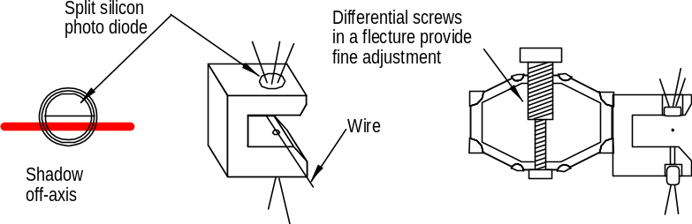
Fig. f7512_a Photo diode type of WPM with micrometer adjustment mechanism.
For vertical positioning, measurements using the portable hydrostatic level Pellissier H5 will give elevation differences to better than 10 µm.
7.5.1.3 Undulator Alignment After the quadrupoles are aligned as described above and their positions are refined with beam-based-alignment, they define the undulator’s trajectory. The undulator sections can now be accurately positioned using the same wire and hydrostatic leveling based method as were used for the quadrupole alignment.

7.5.2 Linac Smoothing
7.5.2.1 Purpose of linac smoothing To generate an optimal beam for injection into the undulator, the present local straightness of the linac is not sufficient. To achieve the desired beam parameters, the straightness quality needs to be mapped, and where necessary mechanically adjusted. In particular, the straightness of individual linac structures, the straightness alignment of structures on a girder, and of the relative alignment of the sections on either side of a quadrupole with respect to each other and with respect to the all need to be mapped.
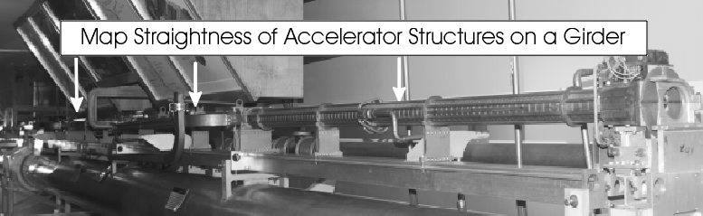
Fig. f7521_b Straightness of accelerator structures on a girder
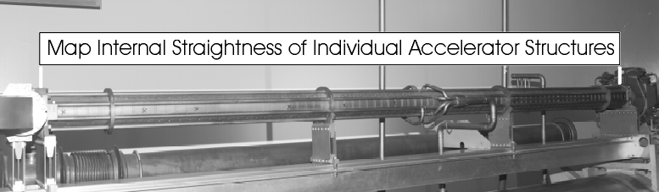
Fig. f7521_a Straightness of individual accelerator structures
7.5.2.2 Linac straightness measurement procedure Because of the required resolution, reliability and the large amount of work (about 1 km of beam line), the task is best performed with a system which does not require an operator to point, and adjust micrometers. It also should allow on-line data logging. It is therefore proposed to use a laser system developed by Hamar. The instrument generates two laser light planes by bouncing a laser beam off rotating mirrors. The two light planes are truly perpendicular to each other. The flatness or wobble-induced error of each light plane is specified as 5 µrad, which is well below the straightness specification at maximum distance. The light source would be set-up at about the middle between two quadrupoles offset horizontally and vertically such that the light planes clear all beam line components. This set-up vs. a set-up at an endpoint reduces the length of the line-of-sight to about 5 m thus greatly lessening the effects of potential refraction and air turbulence on the light beam. After bucking in the light planes both horizontally and vertically to two points on the measured object, intermediate offsets between e.g. the accelerator structure and the light planes are measured with a photo-sensitive-detector (PSD) attached to an offset arm. The detector is linked to an interface box by a cable, which can be as long as 15 m. The interface box provides a serial link to a data logger. To measure the offsets, the offset arm is held against the accelerator structure sequentially in both planes. To determine the perpendicular offset, the alignment technician will arc the arm. While the arm is being arced, the light position is continuously read-out and stored. Software will then determine the perpendicular offset by finding the smallest read-out value. Since the PSD measurement range is limited to about 8 mm, the arm will be adjustable in length. To avoid errors due to the adjustability, the adjustment length will be monitored by an electronic dial gauge, which also reports its reading to the data logging software. The total straightness measurement error budget is expected to be below 75 µm.
The relative alignment of a linac quadrupole in relation to its adjacent accelerator sections will be determined analogously. However, since these quadrupoles are not fiducialized and also don’t have any precision reference surfaces, the offset will be measured to their BPMs instead. Each BPM has a cylindrical body, which is inserted between the poles with a very close fit, and protrudes from the poles on either side of the magnet. The BPM is expected to reference the magnet’s axis to about 100 µm. The adjustment range of the offset arm will be sufficiently dimensioned to allow the same arm to measure both BPMs and accelerator structure offsets.
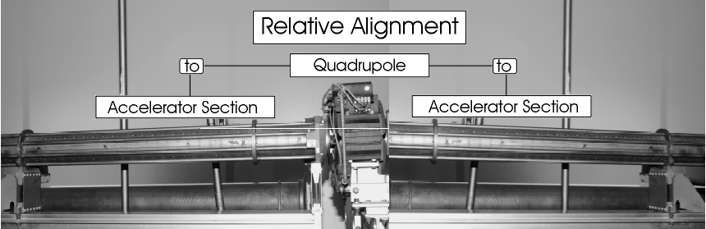

Fig. f7521_c Relative straightness alignment of accelerator structures and associated quadrupole

7.5.3 Relative Alignment of Transport Line and Experimental Area Components
The position tolerances of these components will be achieved during the absolute alignment step. A relative alignment is not required.

7.6 Undulator Monitoring System
In the vertical dimension a hydrostatic leveling system cloned after ESRF’s HLS will accurately monitor relative and global vertical position changes. Four sensors per girder are required. To eliminate temperature effects on the hydrostatic leveling results, any vertical deviations from a plane of the water runs must be avoided. This condition is guaranteed using the “half-filled” pipe approach. Assuming 4 sensors per girder, a total of about 88 sensors will be required.
Since there is no natural absolute reference in the horizontal plane, some kind of artificial local reference needs to be created as is done by stretched wires. Two wires, one on either side of the undulator sections/ magnets will provide the straight line reference. Inductive sensors will provide wire position information. The system is modeled after the Panofsky wire system used in the original installation of SLAC’s A beam. Test measurements have shown sub-micron resolution and better than 10 µm stability.

Notes and Bibliography ? The Geoid is the reference surface described by gravity; it is the equipotential surface at mean sea level that is everywhere normal to the gravity vector. Although it is a more regular figure than the earth’s surface, it is still irregular due to local mass anomalies that cause departures of up to 150m from the reference ellipsoid. As a result, the geoid is nonsymmetric and its mathematical description nonparametric, rendering it unsuitable as a reference surface for calculations. It is, however, the surface on which most survey measurements are made as the majority of survey instruments are set-up with respect to gravity. The reference ellipsoid is the regular figure that most closely approximates the shape of the earth, and is therefore widely used in astronomy and geodesy to model the earth. Being a regular mathematical figure, it is the surface on which calculations can be made.
For more information see also: Ruland, R.: Magnet Support and Alignment, in: H. Winick, Editor, Synchrotron Radiation Sources - A Primer, pp. 274 - 304
Forced centering refers to a specific instrument mount. This type of mounting system, whether vendor specific or independent, allows the exchange of instruments on a station without loosing the measurement point, i.e. all instruments are by mechanical “force” set up in exactly the same position. However, experience has shown that even the best of these forced centering systems has a σ of about 50-100 µm. Unfortunately, the forced centering system contributed error is not random. Since a whole set of measurements is usually completed from a slightly offset position, this error behaves mostly systematically. No efficient method is known to determine the offset vector. These errors, vertical refraction, and lateral refraction are the biggest contributors to the systematic error budget in surveying engineering.
2+1 -D refers to the fact that because of mechanical problems in the forced-centering hardware, three-dimensional networks were usually split into separate horizontal (2-D) and vertical (1-D) networks. Both networks were established, measured and analyzed separately.
Rather than setting up the instrument over a known point, the instrument’s position is flexible and chosen only following considerations of geometry, line of sight and convenience. To determine the instrument position, at least three points, whose coordinates are already known or are part of a network solution, need to be included in the measurements.
Lateral refraction is caused by horizontal stationary temperature gradients. In a tunnel environment, the tunnel wall is often warmer than the air. This creates vertical stable temperature layers with gradients of only a few hundredth of a degree Celsius per meter. If one runs a traverse close to a tunnel wall on one side only, the systematic accumulation of the effect can be significant. E.g. during the construction of the channel tunnel, a control measurement using gyro theodolites revealed that after about 4 km they had already veered about 0.5 m off the design trajectory.
The " character indicates inches; 1 in = 2.54 cm, hence the diameter of the 1.5" sphere is equivalent to 3.81 cm.
While a wire offset measurement arm with the desired resolution is not available off the shelf, wire systems with even higher resolutions have been built successfully in the past both at LLNL and SLAC
Ruland, R., Setting Reference Targets, in Proceedings of the CERN Accelerator School on “Magnetic Measurements and Alignment”, Capri, 1997, in print.
H. Imfeld et al.,The Pellissier H5 Hydrostatic Level, in: Proc. of the Fifth International Workshop on Accelerator Alignment, Chicago – Argonne National Laboratory, 1997, in print
Hamar Lasersystems, Model L-723 Triple Scan® Laser with Model A-517 Scan Target.

