Draft 3
Apple–II undulator study
Yurii Levashov
SLAC
August 11, 2011
Abstract
APPLE undulators could be used as polarization control devices for LCLS. SLAC magnetic Measurement Group did extensive measurements of APPLE-II device to characterize its magnetic and mechanical properties. Results of the tests are presented.

- Introduction
Successful operation of LCLS free electron laser sparked a number of proposals for its upgrade. One of the proposals is to install a few APPLE-ΙΙ type devices at the end of LCLS undulator line and use them as afterburners to control polarization of the light.
An Apple-II undulator was designed and manufactured by Advance Design Consulting USA Inc. (ADC) for SSRL. An initial customer acceptance test carried by SLAC showed that the undulator did not meet requirements for multipole components of magnetic fields and could not be used in a storage ring.
SLAC magnetic measurement group used this device to study possible measurement and tuning techniques and to get experience working with APPLE-ΙΙ devices. Since requirements for magnetic field quality are different for storage rings and for FELs, the goal was also to check if this device could be used on LCLS-Ι line as an afterburner. Additionally, the APPLE-ΙΙ undulator could be operated in a variable phase mode. We have studied this feature as an alternative way to change undulator K.
The undulator was moved into MMF and series of Hall probe/moving coil measurements were made to characterize the device. Undulator parameter K, magnetic field integral dependence on gap, polarization settings repeatability, and tuning options of the device were studied.

- Measurement devices

The undulator under test is equipped with precision glass scales and encoders to control motion of the undulator jaws. The scales are accurate to 0.5µm. Two additional devices were used to control the undulator gap: Mitutoyo linear gage and Keyence sensor LK-G82. Stability and accuracy of the latter devices were tested by direct comparison.
Senis 3-D Hall probe was used for the magnetic field measurements. The probe was not calibrated. For repeatability check there is no need in absolute value of the fields. We applied the same coefficient of 5V/T for X and Y probes. Z-probe was not used.
Field integrals were measured using a long coil. The coil has 320 turns of wire to enhance the signal to noise ratio. Metrolab PDI5025 was used to integrate the coil signal. The coil measurement system was calibrated using two reference c-shape magnets with known field integrals.

- Gap encoder stability check

The glass scales are mounted so that they are in the same vertical plane with jaw lead screws but they are 220 mm away from the undulator magnetic axis. Any bending in support structure will result in uncontrollable errors in gap. To check gap setting accuracy the Mitutoyo gage and the Keyence sensor were mounted next to each other close to magnetic axis on the downstream end of the undulator, as shown in picture 1. Polished gage blocks were used as reference surfaces for the sensors. Gap was set using the undulator encoders and double checked with the gage and the sensor readings.
Sensors stability was checked by comparison of the readings taken for four days. Results are shown in figure 1. Gap encoders and the linear gage readings are stable to 1µm and the Keyence sensor could drift up to 3 µm overnight.

Top jaw bracket
Mitutoyo linear gage
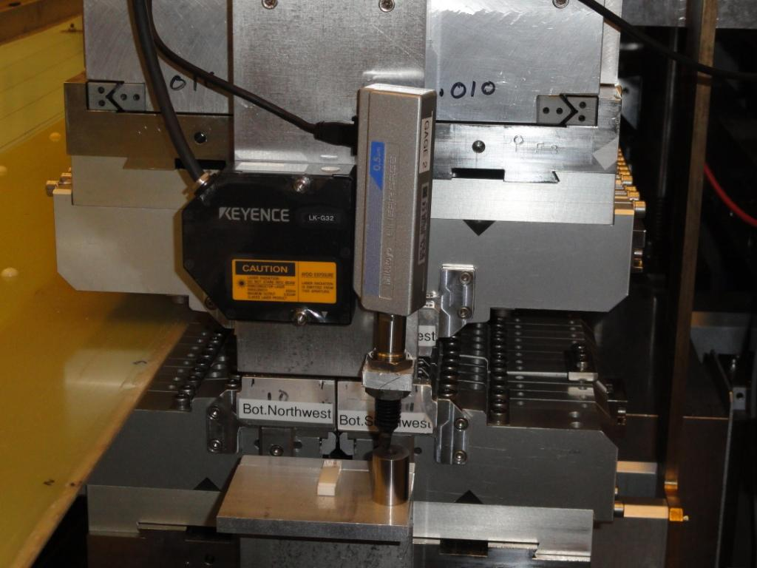
Low jaw bracket
Gage block
Ceramic gage block
Keyence sensor
Picture 1 Sensor mounting on the undulator frame.

Figure 1 Sensor stability in time
- Hall Probe measurements

4.1. Gap and K setting repeatability

For successful FEL operation, an undulator parameter K should be set with very high accuracy of 1.5⋅10⁻⁴. It corresponds to 1µm accuracy for the gap setting. For an afterburner the K tolerance is lower than for a regular undulator in FEL line, i.e. ΔK/K should be < 10⁻³. It means that afterburner gap should be repeatable set and kept the same to a few microns. Since magnetic forces vary a lot with changing the undulator gap, phase or polarization, setting undulator gap to a few micrometers is a challenge.
Initially, the undulator gap was set to 25.000mm, which corresponds to 1.5Å radiation wavelength for electron energy γ = 26686.34. First magnetic field measurements by Hall probe were not repeatable. To find a reason for that we started with Hall probe noise check. The probe was placed into a zero gauss chamber and its noise was measured for ~ 1 hour, as shown in figure 2.

Figure 2 Hall probe noise, 54 min

The probe zero offset drifts ±0.1G. An average magnetic field magnitude for 25mm gap is 0.44 T, which gives us ~5⋅10⁻⁵ error in K, which is negligible. Later, we checked screws, which hold magnet keepers, and have found that they were not torque to proper value. After all the screws were re-torque, we were able to get repeatable field measurements. Keeping the gap the same, we did 10 Hall probe scans along z-direction. Keyence sensor and undulator encoders were used to check the gap changes during the measurements. The linear gage was removed since it was on the Hall probe path.
The results are summarized in table 1.
Table 1.
Run # | Keyence (mm) | Encoder (mm) | K
127 | 0.0053 | 24.9990 | 2.378505
128 | 0.0053 | 24.9990 | 2.378493
129 | 0.0055 | 24.9990 | 2.378531
130 | 0.0055 | 24.9989 | 2.378493
131 | 0.0055 | 24.9988 | 2.378565
132 | 0.0053 | 24.9988 | 2.378684
133 | 0.0053 | 24.9988 | 2.378690
134 | 0.0053 | 24.9988 | 2.378578
136 | 0.0053 | 24.9988 | 2.378643
137 | 0.0053 | 24.9988 | 2.378657
Repeatability of K measurements (ΔK/K) is ~10⁻⁴, which is adequate for our tests. A drift in the encoder readings of 1.2µm corresponds to small measured K change. Keyence reading did not change at the same time.
To test K setting reproducibility we have chosen 4 gaps: 14mm is a minimum gap we could set, 25mm gives us K for 1.5Å, 35.6 mm gives us K correct for second harmonic of light 0.75Å, and 90mm is the maximum gap. The undulator encoders were used to set the gap. We started with the minimum gap of 14mm, then open it to 25mm and did Hall probe measurements 3 times. It constituted a data set. Next, the gap was opened to 35.6mm and another data set was measured. Then the gap was opened to the maximum gap. The procedure was repeated in back order from the maximum gap to the minimum gap and to the maximum gap again. Hall probe measurements were done for 25mm and 35.6mm gaps only. In total 9 data sets were measured for 25mm gap and 8 data sets measured for 35.6mm gap. An average K was calculated for all data sets. Relative value of K for each data set was used as a criteria of measurement repeatability. As shown in figure 3, the K setting is reproducible to 6⋅10⁻⁴ for 25mm gap and to 8⋅10⁻⁴ for 35mm gap. Both numbers are below of 10⁻³ requirement for ΔK/K.

Figure 3 Results of K measurements at 2 different undulator gaps

4.2. Changing undulator phase

The undulator K could be changed by varying phase between top and bottom sections of the undulator. When bottom sections don’t move and top sections slide along Z or vice versa, the vertical field of the undulator changes from its maximum value to 0 (z-shift equal to λ_{u}/2). It is equivalent to opening the gap. A variable phase undulator could be made smaller in size compared to a variable gap undulator, since the section motion is small. At the same time keeping the structural stability is a challenge, since vertical magnetic force has the same amplitude as for variable gap undulator but changes sign at z = ± λ_{u}/4.
In this test we kept the undulator gap the same, which was controlled using gap encoders and double checked by the linear gage. The phase was varied from -0.4 λ_{u} to +0.5 λ_{u} by moving two top rows of magnets. Hall probe scans were made to measure the fields. The gap change vs. phase measured by encoders and the linear gage is shown in figure 4 and K change vs. phase in figure 5. Difference in the linear gage readings at phase zero and at phase = +0.5 λ_{u} is ~15µm. The difference indicates significant deformations (pitch) in support structure.

Figure 4 Undulator gap change vs. phase

◊ - Measurement
- - Fit
Figure 5 Undulator K change vs. phase

Since the magnetic force changes sign at phase ±0.25 λ_{u}, there is concern about backlash between moving parts in support structure. To check for possible backlash, we did more detailed K measurements around phase λ_{u}/4. Four sets of measurements were made; 2 sets forward from 0.22 λ_{u} to 0.28 λ_{u} and two sets backwards. Each set of measurements was fit with parabola and relative differences in K were calculated. Repeatability of the measurements was 10⁻⁴. Results are shown in figure 6. There is significant change in K but no hysteresis, which means no detectable backlash. Smooth variations in K tell us about deformations in support structures due to change in magnetic forces. The magnitude of deformations could be estimated from magnitude of K variations. If 1µm in gap difference corresponds to ΔK/K = 10⁻⁴, the deformation of the support structure is ~ 10µm.

Figure 6 K change around phase λ_{u}/4

4.3. Polarization

The goal of the polarization test was to check how repeatable the undulator K could be set for different polarizations. Gap was set to 25mm, and polarization changed from planar horizontal to circular and next to planar vertical. K values and polarization rate coefficients were calculated from Hall probe measurements.
Results are summarized in table 2.
Table 2
Run # | P₁ | P₂ | P₃ | K | Comments
234 | 1.0 | +2.4⋅10⁻³ | +2.4⋅10⁻⁴ | 2.377599 | Lin. Hor.
236 | 1.0 | +4.4⋅10⁻⁴ | +8.0⋅10⁻⁴ | 2.377630 | Lin. Hor.
237 | 0.32 | -2.2⋅10⁻³ | 0.95 | 1.916268 | Cir. Right
238 | 0.32 | -1.8⋅10⁻³ | 0.95 | 1.916610 | Cir. Right
239 | 0.32 | -2.1⋅10⁻³ | 0.95 | 1.916416 | Cir. Right
240 | -0.99 | +1.5⋅10⁻³ | -0.126 | 1.388215 | Lin. Vert.
241 | -0.99 | +1.6⋅10⁻³ | -0.126 | 1.387960 | Lin. Vert.
242 | -0.99 | +1.4⋅10⁻³ | -0.126 | 1.387998 | Lin. Vert.
243 | 1.0 | +1.5⋅10⁻³ | 0.047 | 2.376603 | Lin. Hor.
244 | 1.0 | +1.9⋅10⁻³ | 0.047 | 2.377226 | Lin. Hor.
245 | 1.0 | +2.5⋅10⁻³ | 0.047 | 2.377078 | Lin. Hor.

Degree of polarization could be calculated using normalized Stokes vector coefficients P_{i} and should be ideally equal 1.
$$P=\sqrt{{P_{1}}^{2}+{P_{2}}^{2}+{P_{3}}^{2}}$$
The K setting was reproducible to 10⁻⁴.

- Field Integrals

SSRL field integral requirements for APPLE-II undulator are: ±40 (50) µTm for first horizontal (vertical) field integrals and ±100 (150) µTm² for the second horizontal (vertical) field integrals. For undulators used as afterburners, the tolerances could be less tight since the undulators will be placed at the end of the undulator line. Hall probe is not accurate enough to measure field integrals due to zero offset drift. Information about field integrals was obtained from measurements done by 4.76m long coil.
The coil, moved a short distance across the undulator gap, picks up flux change over the full length of undulator. Signal from the coil is proportional to magnetic field integrated over the whole coil length, which should be zero in an ideal case. Error fields cause non-zero signal from the coil. The field integrals are calculated from integrated signals, coil length and motion distance of the coil. Earth field integrals were measured in advance but corrections were not applied.

- Coil measurements

The coil used for LCLS-I undulator measurements was not long enough to be used for APPLE–II undulator measurements. Another coil made previously for the APPLE-II was too heavy to be carried by precision stages without special load reducing system, which could not be installed in MMF next to the Dover bench. A new, lighter version of long coil was designed and fabricated. Also a new design of the coil support system was tested during the measurements.
Long coil measurement accuracy, based on measurements of LCLS-I undulators, was ±5µTm and ±10µTm² respectively for the first and second field integrals. Repeatability of the measurements with the new coil was the same. Signals from the coil contained sinusoidal component, which indicated presence of significant coil vibrations. Support structure of the coil should be re-designed to address this issue.
Field integrals dependences vs. gap, phase and polarization were measured at x = ±6mm from magnetic axis of the undulator with 1mm steps. Results are shown in figure 7, 8, 9 and 10.
Measurements show significant change in field integrals vs. gap at gaps in between 15mm and 25mm. Y-field integrals show acceptable change vs. phase but X-field first and second integrals change a lot. Both X and Y field integrals change with polarization. Multipole components of fields are big and they change with polarization also. It could be explained by deformations of the support structure of the undulator.

Figure 7 Field integrals gap dependence measured by long coil.

Figure 8 Field integrals phase dependence measured by long coil.

Figure 9 Y-Field integrals dependence on polarization measured by long coil.

Figure 10 X-Field integrals dependence on polarization measured by long coil.

- Field optimization options

APPLE-II undulator is a Pure Permanent Magnet (PPM) device. Field optimization of PPM devices is done by moving individual magnet blocks (virtual shimming) or by adding extra magnetic material on top of the blocks or at the ends of the device (magic fingers). Iron shims are rarely used for correcting shift-dependant field components but no perfect compensation is expected. In our study we tried virtual shimming technique and magic fingers.

7.1. Virtual shimming

Four vertically magnetized blocks, one in a quadrant, were moved inside the gap by 0.3mm each. This is the maximum distance the block could be moved due to magnet keepers design. The motion was controlled by a set of capacitance sensors with 5µm resolution. The distances were measured at a single point on a block before and after the block motion. There was no control of block roll, yaw or pitch. Hall probe scans were made before and after the block motion. Difference in vertical field was determined, as shown in figure 11.

Figure 11 Effect of a vertically magnetized block motion by 0.3mm inside the gap at pole # 125

As it was predicted in calculations, block motion of 0.3mm has a very small effect on vertical field integral. Positive change in field at vertical block location z = 3.11m is almost fully compensated by negative field change at neighboring blocks with horizontal magnetization, z = 3.09m and z = 3.145m.
Since pole # 125 is almost at the end of the undulator, the motions should affect first field integrals the most. As shown in figure 12, first Y-field integral has changed by 60 µTm, and X-field integral change is small.
Noticeable is introduction of multipole components (quadrupole and octupole) both in Y and X field integrals. It means that the blocks were moved not parallel to each other or the motion distances were not equal. Better design of block adjustment mechanism, which will allow motion for bigger distances and better parallelism of block movements, is desirable.

Figure 12 Effect of vertical block motion on field integrals

Four different blocks were moved horizontally across the gap by 0.9mm to create change in x-field. Results are shown in figure 13. Horizontal motion of blocks also has small effect on field integrals. There are no negative effects but field change caused by 0.9mm block motion is less than 30 G. Such a small effect of block motion on field integrals makes it usable for final field optimization only. As it was recommended in ref.4, initial tuning should be done by sorting and swapping the magnets until field integrals are ≤ 100 µTm.

Figure 13 Effect of vertically magnetized block motion across the gap

7.2. Magic fingers

“Magic fingers” is an array of small magnets placed at the ends of an undulator to use for miltipole components correction of field integrals. Typically, two arrays of magnets placed in one holder are used; one is made of vertically magnetized magnets and another one made of horizontally magnetized magnets. By changing distance between individual magnets and center plane of the undulator one could increase/decrease field locally. Eight holders are required; one for each four segments at upstream and downstream ends.
In our case, magic fingers arrays were designed differently. Magnetic field strength is changed by adding/removing magnets to/from the stack of existing ones at each location. This is a wrong design solution, since adding magnets far away from the gap has almost zero effect on the field in the gap. To check strength of the magic fingers we have changed the sign of the correction field by flipping one of them. Second vertical field integrals measured before and after the flip are shown in figure 14.

Finger location
Figure 14 Effect of flipping of a magic finger on field integrals

The effect if obvious but this is an extreme and a discrete case. A better design of magic finger holders, which will provide mechanism for fine motion, is needed for precise field optimization.

- Summary

An APPLE-II type undulator was moved into MMF. A number of Hall probe and coil measurements were made to study changes in undulator parameters for different modes of operation. Repeatability of K measurements was 10⁻⁴. The undulator support structure is rigid enough to set the K to 10⁻³ for all operational modes; gap, polarization, and phase change. Gap encoders are accurate to ±0.5µm but located 220 mm away from the undulator magnetic axis. Local deformations of jaws are uncontrollable and could exceed 10µm. Field integrals were measured by long coil with accuracy ±10 µTm. The coil measurements conformed that the undulator was not tuned to the specifications. There is significant change in field integrals (up to 200 µTm for first field integrals and up to 300 µTm² for the second ones) for gaps less than 20mm. Changing both the undulator phase and polarization has big effect on field integrals. Multipole components of magnetic fields (quadrupole mostly) are introduced also.
Tuning options of the undulator are not adequate. Magnet blocks movements are not parallel to each other and motion ranges are not big enough to cover tuning requirements. Magic fingers design is not correct (it was changed w.r.t. original design, see ref.3) and does not let the fine adjustments of multipole components of the fields. The undulator could be tuned to specifications after block re-sorting, multiple swapping of the magnets, and magic fingers re-design. Iron shims might be required to tune shift dependent components.

Acknowledgment
Author would like to thank Heinz-Dieter Nuhn and Zach Wolf for useful discussions.

Work supported in part by the DOE Contract DE-AC02-76SF00515. This work was performed in support of LCLS project at SLAC
R.Carr, “Adjustable phase insertion devices as X-ray sources” Nucl. Instr. And Meth. A306 (1991) 391-396
SSRL Engineering Note M506, Revision 1
E.Hoyer, S.Marks, P.Pipersky, R.Schlueter, “Multiple trim magnets, or “magic fingers” for insertion device field integral correction” , Rev. Sci. Instrum. 66(2), February 1995
J.Bahrdt, W.Frentrup, A.Gaupp, M.Scheer, U.Englisch, “Magnetc field optimization of permanent magnet undulators for arbitrary polarization”, Nucl. Inst.and Meth. A 516 (2004) 575-585

