HXU-016 screw’s torque check.
There are 2 sets of screws checked; M6 screws on the side of the strongback and M8 screws on the top and bottom of magnet assemblies, see pictures below.
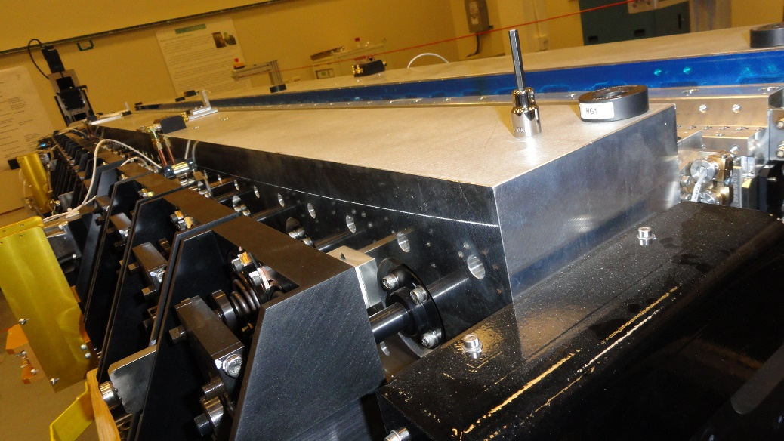
M6
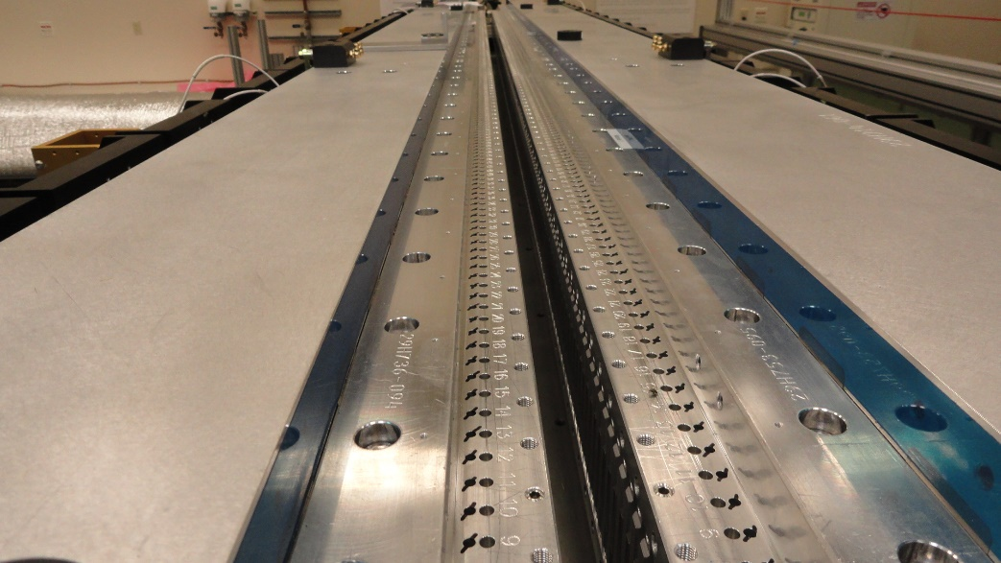
M8
For M6 screws the torque was set to 50 in-lbs (5.6 N-m), for M8 screws the torque was set to
9 ft-lbs (12.2 N-m) in accordance with specifications (see assembly instructions).
The results of the check is in the table below. If a screw was not torqued properly the amount of the torque wrench rotation in terms of a full turn was an input into the table. There were 38 lose M6 screws on the aisle side and only 3 screws lose on the wall side of the undulator, out of 192 total. There was a single M8 screw lose but it looks like it has never been torqued at all. The check was always started close to the pole #44 (center of the magnet section) and went in both directions to the ends of the section. For M6 screw’s check the gap was set to 30mm, for M8 screw’s check the gap was set to 110mm.

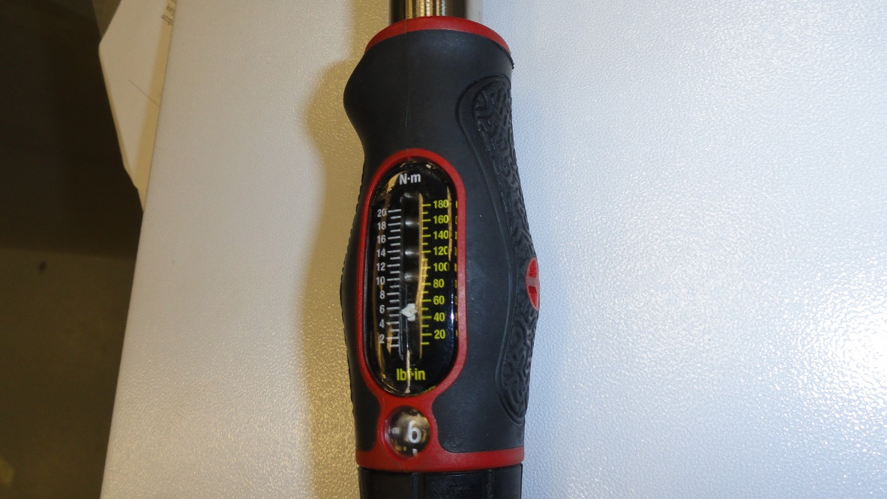
Torque setting for M6 screws (5.6 N-m)
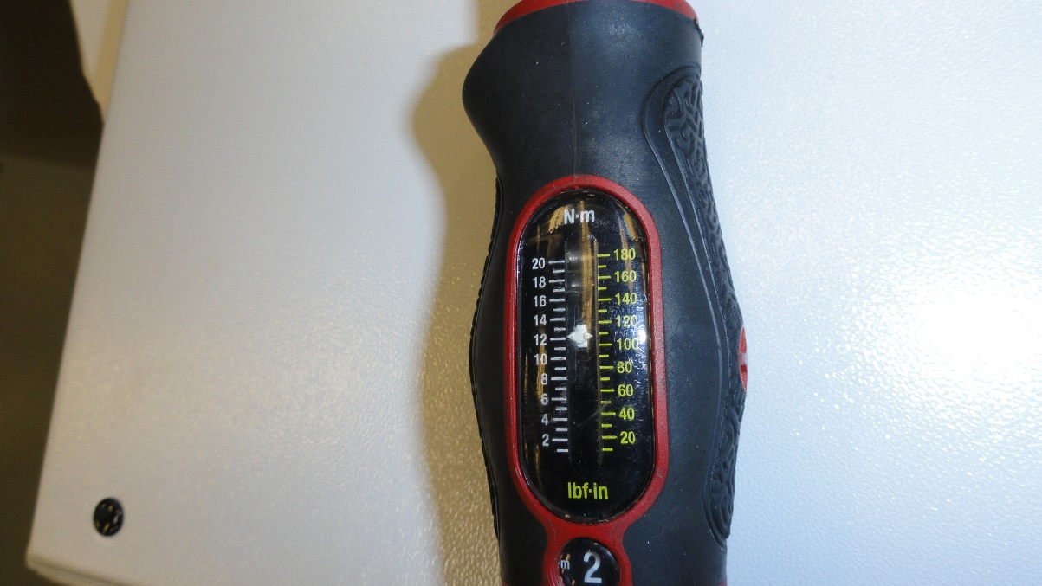
Torque setting for M8 screws (12.2 N-m)

Module # |  | Pole # | Side screw |  |  |  | Bottom screw  aisle
 |  |  | Aisle |  | wall
 |  |  | Top | Bottom | Top | Bottom
1 |  | 3 |  | 1/8
1 |  | 8 |  | 1/8
1 |  | 47 | 1/8
1 |  | 52 | 1/8
1 |  | 57 | 1/8
1 |  | 64 | 1/8 | 1/4
1 |  | 80 |  |  |  | 1/4
1 |  | 86 |  | 1/8
2 |  | 3 | 1/8
2 |  | 8 | 1/8 | 1/16 |  | 1/16
2 |  | 13 | 1/8 | 1/4
2 |  | 15 |  |  |  |  | 1 full turn
2 |  | 20 | 1/16 | 1/8
2 |  | 25 |  | 1/8
2 |  | 35 |  | 1/8
2 |  | 48 | 1/16 | 1/4
2 |  | 54 |  | 1/16 |  | 1/16
2 |  | 59 | 1/16
2 |  | 65 |  | 1/4
2 |  | 71 |  | 1/16
2 |  | 76 |  | 1/16
2 |  | 81 | 1/8 | 1/16
2 |  | 86 |  | 1/4
3 |  | 3 | 1/16 | 1/16
3 |  | 7 |  | 1/4
3 |  | 13 | 1/8
3 |  | 19 | 1/4
3 |  | 24 |  | 1/8
3 |  | 30 |  | 1/16
3 |  | 40 |  | 1/16
3 |  | 63 |  | 1/16
3 |  | 74 | 1/16
3 |  | 84 | 1/8
total |  |  | 16 | 22 | 0 | 3 | 1
After 240 full cycles
1 | 20 |  |  | 1/16
1 | 68 |  | 1/16 | 1/16
1 | 74 |  | 1/8 | 1/16
2 | 25 |  |  | 1/4
2 | 42 |  |  | 1/8
2 | 66 |  | 1/16
3 | 7 |  |  |  |  | 1/16
3 | 18 |  | 1/16
3 | 24 |  | 1/8
3 | 53 |  |  |  |  | 1/16
3 | 74 |  |  |  | 1/8

