SLAC Magnetic Measurement Plan and Traveler for 190A Unipolar
LCLS-II Quadrupoles of Type 2Q4W (SA-344-112-18)

This traveler is intended to cover mechanical fiducialization and magnetic measurements of the 2Q4W quadrupole magnets needed for S30XL line of LCLS-II. There are 10 magnets to be measured. The table below gives the MAD names, polarities, and installation directions of the 190 A unipolar 2Q4W quadrupoles.

MAD Name | Eng. Name | Drawing# | Barcode | Polarity | Bus bars
QDAS16 | 2Q4W | SA-344-112-18 | 4256 | P | Downstream
QDAS13 | 2Q4W | SA-344-112-18 | 4257 | N | Downstream
QDAS18A | 2Q4W | SA-344-112-18 | 4258 | P | Downstream
QDAS15 | 2Q4W | SA-344-112-18 | 4259 | N | Downstream
QDAS12 | 2Q4W | SA-344-112-18 | 4260 | P | Downstream
QDAS17 | 2Q4W | SA-344-112-18 | 4261 | N | Downstream
QDAS14 | 2Q4W | SA-344-112-18 | 4262 | P | Downstream
QDAS18B | 2Q4W | SA-344-112-18 | 4263 | P | Downstream
QDAS19 | 2Q4W | SA-344-112-18 | 4264 | N | Downstream
SPARE | 2Q4W | SA-344-112-18 | 4265 | N | Downstream

Receiving:
The following information is to be noted upon receipt of the magnets by the SLAC MM group:
Received by (MMG initials): | SDA
Date received (mm/dd/yyyy): | 9/13/2022
SLAC barcode number: | 4261
Vendor serial number on the magnet: | 9160

Preparation:
A beam direction arrow, with text “Beam Direction”, is to be applied to the top and/or connector side of the magnet with a sticker supplied by LCLS-II. The terminals shall be oriented down beam. Mark the MAD names.
Beam-direction arrow in place (initials): | SDA
MAD name marked on Magnet : | QDAS17

Fiducialization:
Fiducialization may be done before or after magnetic measurements. The magnet is to be fiducialized by the CMM group. This will require the installation of removable tooling balls, location of the geometric axis of the poles of the magnet, and location of tooling balls with respect to the center of this geometric axis when the poles are aligned precisely horizontal.
CMM technician (initials): | KC

URL of on-line CMM fiducialization data (please modify or correct if necessary):
http://www-group.slac.stanford.edu/met/MagMeas/MAGDATA/LCLS-II/Fiducial%20Reports/QDAS17_Fiducial_Report.pdf

Magnetic Measurements:
Enter URL of on-line magnetic measurements data (please modify or correct if necessary):
http://www-group.slac.stanford.edu/met/MagMeas/MAGDATA/LCLS-II/Quad/4261

- Measure the inductance and resistance of the magnet:
Inductance of coil (mH): | 4.10 mH
Resistance of coil (Ohms): | 0.0670 Ohm
Magnet temperature in degrees C | 25.4 ºC
- Perform Safety Checks
Safety Check | Initials
Disconnect Thermal Switch Chain and Verify Trip Power Supply Interlocks | SDA
Verify that no Water Flow trips the Flow Switch Power Supply Interlocks | SDA

- Determine the connection polarity (with main supply outputting positive current) which produces a “positive” field polarity and “negative” field polarity as shown below:

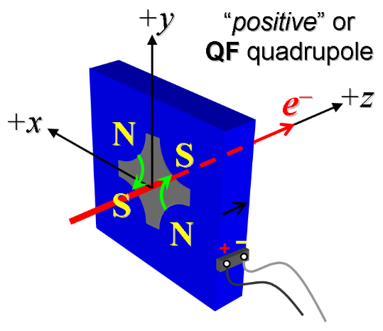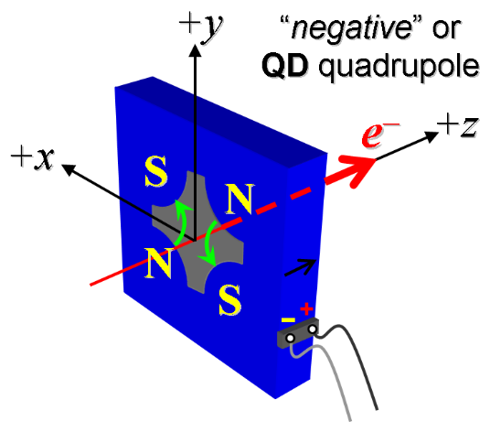
Figure 1. Polarity convention for magnets having “positive” (left) and “negative” (right) polarities.

- Mark the polarity near the magnet leads with clear “+” and “-” labels as shown above.
Magnet polarity chosen from Fig. 1 is (P or N): | N

- Connect the magnet to the LCW supply. The total magnet flow should be 0.8 gpm. Record the ΔP and flow below.

Record total flow rate and pressure. | 1.04 gpm @ 116 psi
- Connect the magnet terminals in the correct polarity as established above, to a unipolar power supply with maximum current I ≥ 190 A.

- Run the magnet up to 190 A for ~30 minutes to warm it up (record temperature).
LCW delta T (°C) | 7.4 °C
Ambient temperature (°C): | 23.8 °C
Final magnet steel temperature (°C): | 29.3 °C
Mean of 4 Coil Temperatures (°C): | 33.3 +/- 2.2 °C

- Standardize the magnet, starting from zero to 190 A and back to zero, through three full cycles, finally ending at zero, with a flat-top pause time (at both 0 and 190 A) of 10 seconds. Use a cosine ramp rate of 20 A/sec, and record the ramp rate used.
Standardization complete (initials): | SDA
Ramp rate used (A/sec): | 20 A/sec

- If the power supply can be run as low as 2 A with <10-mA (0.5%) rms current regulation, then measure ∫Gdl from 0 to 190 A following the current range step sizes given in the table below.

Current Range | Step Size Up | Step Size Down
0 to 20 A | 5-A | 5-A
20 to 170 A | 10-A | 20-A
170 to 190 A | 5-A | 20-A

Filename & run number of ∫Gdl up & down data: | Strdat.ru1, strplt.ru1

- For all magnets, with rotating coil, measure the magnet harmonics at 20, 100, 190 A current setting. Multipole values should be given as a percentage of the quadrupole moment evaluated at the probe radius.
Filename & run number of harmonic data: | Hardat.ru1, harplt.ru1
Probe radius used for harmonics (cm): | 1.41349
Rotating Coil Designation (Name) | 1.124DQB22

- Confirm the pole-tip field using a Hall probe at an excitation current of 190 A.
Hall probe pole-tip field at 190 A (mean of 4 poles): | 0.577 +/- 0.01 T @ 190.072 A

- Upon completion of tests, email URL of on-line data to Mark Woodley. Mark Woodley will determine if the magnet is accepted. Upon acceptance of magnet, analysis data will be placed in on-line data folder.
Magnet accepted and Analysis file(s) put into on-line data folder (initials): | SDA
Assigned beamline location (MAD-deck name): | QDAS17

