SLAC Magnetic Measurement Plan and Traveler for 30 A Unipolar
LCLS-II Quadrupoles of Type 2Q4 (SA-344-112-01)

This traveler is intended to cover mechanical fiducialization and magnetic measurements of the 2Q4 quadrupole magnets needed for LCLS-II bypass dogleg line. There are a total of 3 of these magnets needed in that area. The configuration for these magnets are, SA-344-112-01. The table below gives the MAD names, polarities, and installation directions of the 30 A unipolar 2Q4 quadrupoles (the order in the beam line is QBP10 through QBP12).

MAD Name | Eng. Name | Drawing# | Barcode | Polarity | Bus bars
QBP10 | 2Q4 | SA-344-112-01 | 4228 | QD | Upstream
QBP11 | 2Q4 | SA-344-112-01 | 4229 | QF | Upstream
QBP12 | 2Q4 | SA-344-112-01 |  | QD | Upstream

Receiving:
The following information is to be noted upon receipt of the magnets by the SLAC MM group:
Received by (MMG initials): | SDA
Date received (dd-mm-yyyy): | 5/7/2019
SLAC barcode number: | 4229
Vendor serial number on the magnet: | 35

Preparation:
A beam direction arrow, with text “beam direction”, is to be applied to the top and/or connector side of the magnet with a sticker supplied by LCLS-II (F.-J. Decker will determine the direction).
Beam-direction arrow in place (initials): | SDA

Fiducialization:
Fiducialization may be done before or after magnetic measurements. The magnet is to be fiducialized by the CMM group. This will require the installation of removable tooling balls, location of the geometric axis of the poles of the magnet, and location of tooling balls with respect to the center of this geometric axis when the poles are aligned precisely horizontal.
CMM technician (initials): | KC

URL of on-line CMM fiducialization data (please modify or correct if necessary):
http://www-group.slac.stanford.edu/met/MagMeas/MAGDATA/LCLS-II/Fiducial%20Reports/4229_Fiducial_Report.pdf

Magnetic Measurements:
Enter URL of on-line magnetic measurements data (please modify or correct if necessary):
http://www-group.slac.stanford.edu/met/MagMeas/MAGDATA/LCLS-II/Quad/4229

- Determine the connection polarity (with main supply outputting positive current) which produces a “positive” field polarity and “negative” field polarity as shown below:

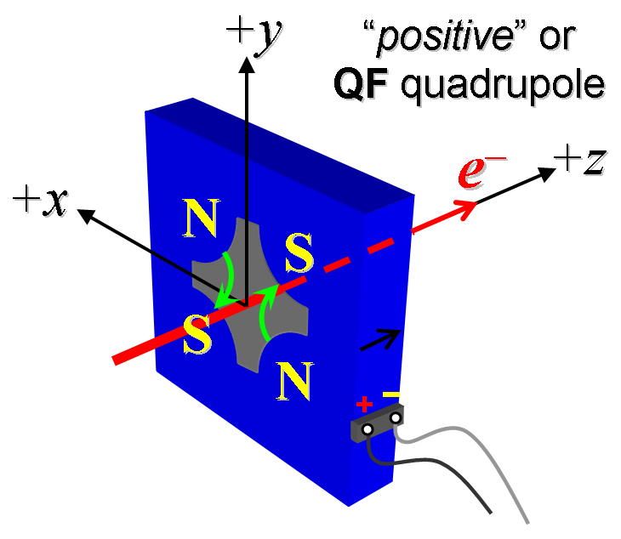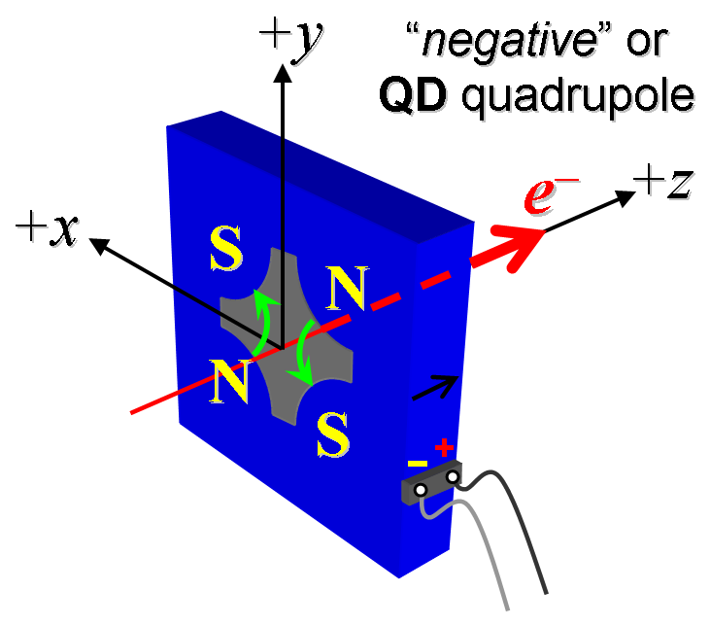
Figure 1. Polarity convention for magnets having “positive” (left) and “negative” (right) polarities.

- Mark the polarity near the magnet leads with clear “+” and “−” labels as shown above.
Magnet polarity chosen from Fig. 1 is (P or N): | P

- Connect the magnet terminals in the correct polarity as established above, to a unipolar power supply with maximum current I ≥ 30 A.

- Run the magnet up to 30 A for ~30 minutes to warm it up (record temperature).
Ambient temperature (°C): | 19.8 °C
Final coil temperature (°C): | 26.5 °C
Final magnet steel temperature (°C): | 21.8 °C

- Standardize the magnet, starting from zero to 30 A and back to zero, through three full cycles, finally ending at zero, with a flat-top pause time (at both 0 and 30 A) of 10 seconds. Use a three liner ramp rate of 5 A/sec, if possible, and record the ramp rate used.
Standardization complete (initials): | SDA
Ramp rate used (A/sec): | 5 A/sec

- Measure the length-integrated field gradient, ∫Gdl, from 0 to 30 A in 3-A steps (11 ‘up’ measurements), and then back down from 30 A to 0 in 3-A steps (10 ‘down’ measurements).
Filename & run number of ∫Gdl up & down data: | Strdat.ru1, strplt.ru1

- For all magnets, with rotating coil, measure the magnet harmonics at 12, 21, 30 A current setting. Multipole values should be given as a percentage of the quadrupole moment evaluated at the probe radius.
Filename & run number of harmonic data: | Hardat.ru1, harplt.ru1
Probe radius used for harmonics (cm): | 1.95965
Rotating Coil Designation (Name) | 48BC1.6

- Confirm the pole-tip field using a Hall probe at an excitation current of 30 A.
Hall probe pole-tip field at 10 A (mean of 4 poles): | 0.0905 +/- 0.01 T @ 30.0181 A

- For one magnet only, perform a final thermal test. Run the current up to 30 A. Measure the magnet temperature for 4 hours. Record the temperature below.
Ambient temperature (°C): | Measurements made on 4228
Final coil temperature (°C): | Measurements made on 4228
Final magnet steel temperature (°C): | Measurements made on 4228

- Measure the inductance and resistance of the magnet and resistance of each coil:
Inductance of coil (mH): | 2.369 mH
Resistance of magnet (Ohms): | 0.0540 Ohm
Resistance of each coil TL, TR, BL, BR (e.g. top left) | 0.0134 | 0.0144 | 0.0130 | 0.0124
Magnet temperature in degrees C | 18.6 ºC

- Upon completion of tests, email URL of on-line data to Mark Woodley. Mark Woodley will determine if the magnet is accepted. Upon acceptance of magnet, analysis data will be placed in on-line data folder.
Magnet accepted and Analysis file(s) put into on-line data folder (initials): | SDA
Assigned beamline location (MAD-deck name): | QBP11

