SLAC Measurement Plan and Traveler for the LCLS ‘0.91Q17.72’ type BSY Quadrupole Magnet
Revision 0 Initial Release March 31, 2016

This traveler covers mechanical fiducialization and magnetic measurements of the LCLS “0.91Q17.72” BSY quadrupole magnets needed for the 2017 LCLS run. There are 4 of these magnets needed for the LCLS BSY Copper linac to HXR beamline. These quadrupole magnets are each ~46 cm long and were originally located in the FFTB beamline.

Receiving:
The following information is to be noted upon receipt of the magnets by the SLAC MM group:
Received by (initials): | SDA
Date placed on test stand (dd-mmm-yyyy): | 12/12/2016
SLAC barcode number: | 4014
Magnet Name: | Q5
SLAC approved electrical safety covers? (Y or N): | N
SLAC approved lifting eyes? (Y or N): | N
Shipping Damage? (Y or N): | N
Vendor tests passed on magnet label? (Y or N): | N
SLAC drawing number (enter number): | SA-380-301-00

Preparation:
A beam direction arrow, with text “beam direction”, is to be applied to the top and/or connector side of the magnet with a sticker supplied by LCLS. Power leads at down beam end as shown in Figure 1.
Beam-direction arrow in place (initials): | SDA

Figure 1.
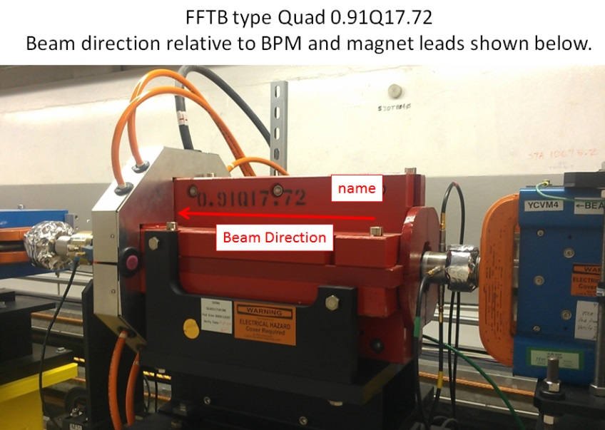
Fiducialization:
Fiducialization may be done before or after magnetic measurements. The magnet is to be fiducialized by the CMM group. This will require the installation of removable tooling balls, location of the geometric axis of the poles of the magnet, and location of tooling balls with respect to the center of this geometric axis when the poles are aligned precisely horizontal.

CMM technician (initials): | KC

URL of on-line CMM fiducialization data (please modify or correct if necessary):
http://www-group.slac.stanford.edu/met/MagMeas/MAGDATA/LCLS-II/quad/
Magnetic Measurements:
- Verify that the magnets are complete and undamaged, including wiring connections.
Incoming inspection OK (initials): | SDA
Date of arrival to mag. meas.(mm-dd-yyyy): | 12/12/2016

Enter URL of on-line magnetic measurements data (please modify or correct if necessary):
http://www-group.slac.stanford.edu/met/MagMeas/MAGDATA/LCLS-II/quad/4014

- Magnet assignments:
Q4 (QD) Use Q5 from the LCLS-1 beam line (Serial # Q321).
Q5 (QF) Use spare orange magnet labeled Q5(Serial # 1052).
Q6 (QD) Use Q6 from the LCSL-1 beam line (Serial # -verify in the tunnel).
QA0 (QF) Use QA0 from the LCLS-1 beam line (Serial #Q322).

- Mark Q5 and QA0 magnets as a “QF” (positive polarity) and Q4 and Q6 as a “QD” (negative polarity).
Magnet marked as (please enter “QF” or “QD”): | QF

- Determine the connection polarity (with supply outputting positive current) which produces the correct field polarity for the “QF” or “QD” magnet as shown below (depending on its QF or QD assignment):

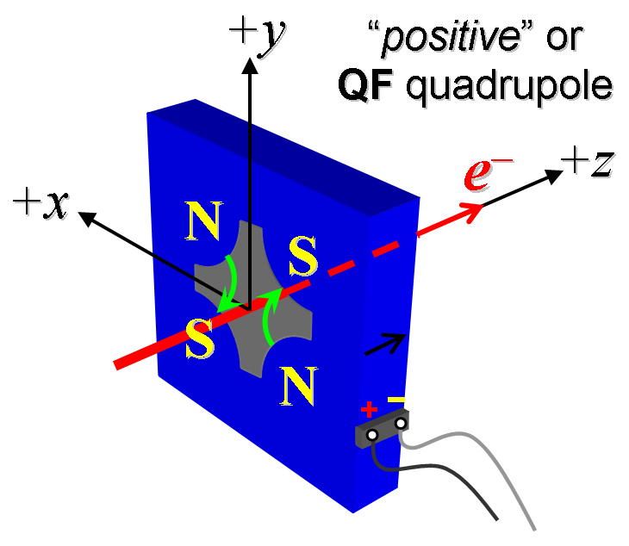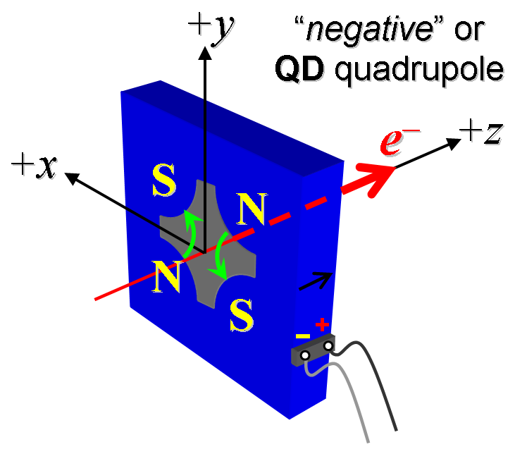
Figure 2. The QF quadrupoles: Q5 & QA0 have “positive” polarity (left), while the QD quadrupoles: Q4 & Q6 have “negative” polarity (right).

- Mark the polarity near the magnet leads with clear “+” and “−” labels as shown above.
Polarity has been labeled (technician initials): | SDA

- Connect the magnet terminals in the correct polarity as established above, to a unipolar power supply with maximum current I ≥ 50 A.

- Connect magnet to LCW supply. Adjust supply pressure to a delta P of ~110 psi to achieve a flow rate of 1.2 gpm. Run the magnet up to 50 A for ~1 hour to warm it up (record, delta P, flow rate, and magnet coil and steel temperature).
LCW delta P (psi) | 110 psi
LCW flow rate (gpm) | 1.22 gpm
LCW delta T (°C) | 2.8 °C
Ambient temperature (°C): | 18.4 °C
Final magnet steel temperature (°C): | 21.7 °C

- Additional training for QA0: Standardize into saturation, >200amps and repeat 8x. Then proceed with 50 A training process.
- Training with 50 A: Standardize Q4, Q5, Q6 & QA0 magnet, starting from zero to 50 A and back to zero, through ≥ 30 full cycles, finally ending at zero, with a flat-top pause time (at both 0 and 50 A) of 10 seconds. Use a ramp rate of 5 A/sec, and ramp style three-linear, and record the ramp rate and ramp style used.
- Standardize the magnet, starting from zero to 50 A and back to zero, through three full cycles, finally ending at zero, with a flat-top pause time (at both 0 and 50 A) of 10 seconds. Use a ramp rate of 5 A/sec, if possible, and record the ramp rate used.
Standardization complete (technician initials): | SDA
Ramp rate used (A/sec): | 5 A/sec

- Measure the length-integrated field gradient, ∫Gdl, from 0 to 50 A in 4-A steps (13 ‘up’ measurements), and then back down from 50 A to 0 in 4-A steps (13 ‘down’ measurements).
Filename & run number of ∫Gdl up & down data: | Strdat.ru2, strplt.ru2

- Confirm the pole-tip field using a Hall probe at an excitation current of 24 A.
Hall probe pole-tip field at 24 A (mean of 4 poles): | 0.099 +/- 0.005 T

- Measure the field harmonics at a 24 A current setting using a 0.75-inch diameter probe.
Rotating coil designation (coil name): | 0.75DQB26
Rotating coil radius (m): | 0.0093472 m
Harmonics data file name: | Hardat.ru2, harplt.ru2

- Measure the inductance and resistance of the magnet:
Inductance of coil (mH): | 1.03 mH
Resistance of coil (Ohms): | 0.111 Ohm

- Upon completion of tests, send data link to Mark Woodley who will produce a data analysis file. Place data analysis file in magnetic measurements data directory
Magnet data accepted and data analysis file produced | SDA via email. 1/27/2017

Enter URL of on-line magnetic measurements analysis data :
http://www-group.slac.stanford.edu/met/MagMeas/MAGDATA/LCLS-II/quad/4014/0.91Q17.72_4104.pptx

