SLAC Traveler for LCLS-II 2.362Q3.5 BC1B, BC2B Tweaker Quadrupole Magnets

This traveler is intended to cover reception, preparation, mechanical fiducialization, and magnetic measurements of the BC1B, BC2B tweaker quadrupole magnets.

Receiving:
The following information is to be noted upon receipt of the magnets by the SLAC MFD group:

Received by (initials): | G.T
Date received (mmm-dd-yyyy): | 5/19/2016
SLAC barcode number: | 4100
Vendor serial number from magnet label: | 7
SLAC approved electrical safety covers? (Y or N): | Y
SLAC approved lifting eyes? (Y or N): | Y
Shipping Damage? (Y or N): | N
Vendor tests passed on magnet label? (Y or N): | Y
SLAC drawing number: | SA-380-702-28

Place Duplicate Bar-Code Sticker Here:

All documentation that accompanies the magnets should be sent to John Amann, MS 52.
Paperwork sent (initials):

Preparation:
A beam direction arrow, with text “beam direction”, is to be affixed to the magnet, by sticker supplied by SLAC QC group.

Fiducialization:
The magnet is to be fiducialized by the CMM group. This will require the installation of removable tooling balls, location of the geometric axis of the pole tips of the magnet, and location of tooling balls with respect to the center of this geometric axis when the poles are aligned precisely at ±45 degrees to horizontal and vertical axes.

CMM technician (initials): | KC 6/6/2016

URL of on-line CMM fiducialization data:
http://www-group.slac.stanford.edu/met/MagMeas/MAGDATA/LCLS-II/Quad/4100/4100_Fiducial_Report.pdf

Magnetic Measurements:
- Verify that the magnets are complete and undamaged, including wiring connections.
The wiring scheme is shown below in Figure 1.
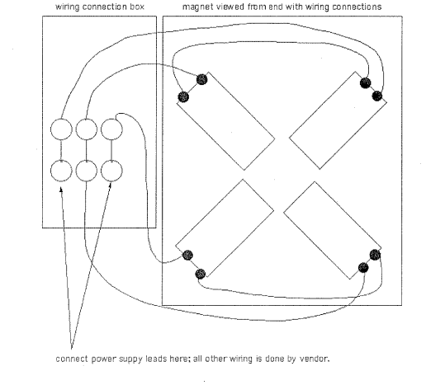
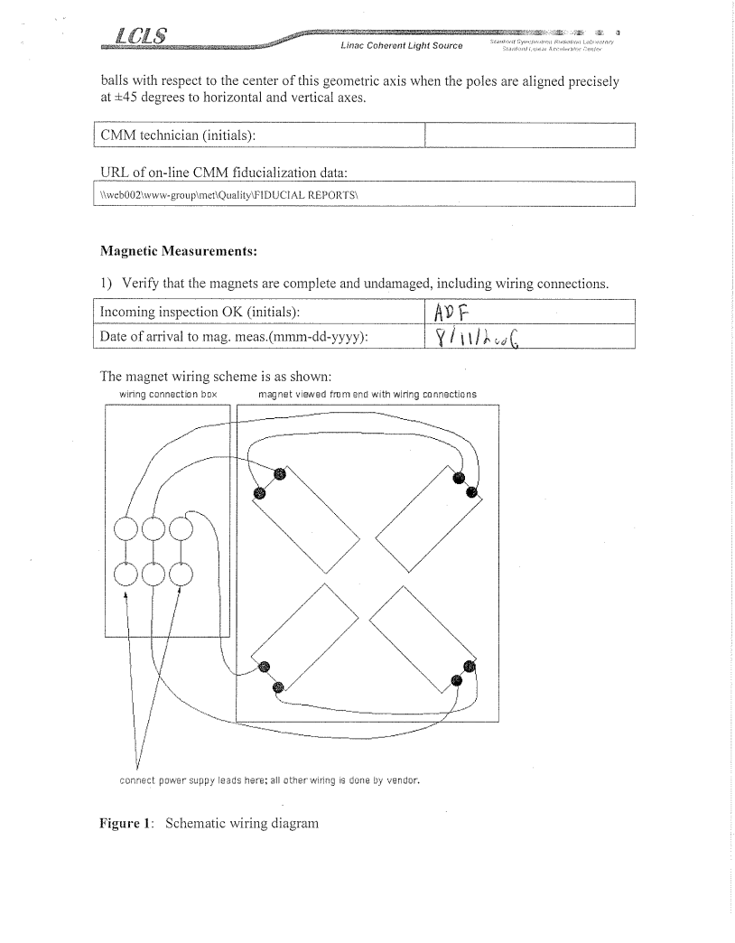

Figure 1. Wiring Scheme
Incoming inspection OK (initials): | SDA
Date of arrival to mag. meas.(mmm-dd-yyyy): | 8/16/2016

- Verify there is a large, clear electron beam direction arrow placed on at least one side of the magnet.
Beam-direction arrow in place (initials): | SDA

- Determine the coil connection polarity (with supply outputting positive current) which produces a “positive” field polarity as shown below (all tweaker quads have the same polarity):
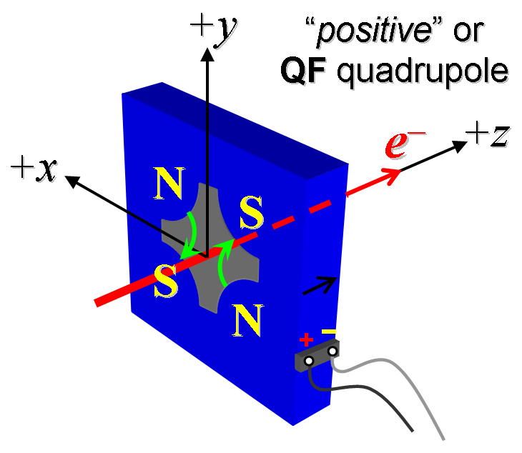
Figure 2. All tweaker quads have “positive” polarity, as shown above, when power supply is outputting positive current.

- Mark the polarity near the magnet leads with clear “+” and “−” labels as shown above.
Polarity has been labeled at terminals (initials): | SDA

- Connect the magnet to a bipolar 12-A power supply, preferably an MCOR12. Run the magnet up to 8 A for ~30 minutes to warm it up (record magnet and ambient temperature).
Power supply type (text, e.g. MCOR12): | MCOR12
Magnet connected and warmed up (initials): | SDA
Ambient temperature (degrees C): | 26.1 °C
Magnet coil temperature achieved (degrees C): | 27.3 °C

- Standardize the magnet, starting from 0 to +12 A, then through 3 full cycles from +12 A to −12 A and back up to +12 A, finally ending at −12 A (the MCOR12 ramp rate is not controllable, but a flat-top pause time of 3 seconds is desired at each maximum and minimum current).
Magnet standardized (initials): | SDA
Ramp rate used (Amps/sec): | 1 Amps/sec, 3 linear ramp

- Maintaining the history cycle, measure the length integrated gradient, ∫Gdl, from −12 A to +12 A in 1-A steps, including zero (25 ‘up’ measurements). Then, still maintaining the history cycle, measure ∫Gdl back down from +12 A to −12 A in 1-A steps, including zero (25 more ‘down’ measurements). Please record (below) the current necessary to achieve an integrated gradient of 2.1 kG and call P. Emma at 2458 if it is significantly different than 12 A (e.g., 20%).
Excitation current needed to attain ∫Gdl = 2.1 kG: | 10.806 Amps

Enter URL of on-line magnetic measurements data (please modify or correct if necessary):
http://www-group.slac.stanford.edu/met/MagMeas/MAGDATA/LCLS-II/Quad/4100/

Rotating coil designation (coil name): | 1_124DQB22_4_Layer
Rotating coil radius (m): | 0.0140208 m
Data file name of ∫Gdl vs. current (file-name & run #): | strdat.ru1

- Measure field harmonics at −12, −6, +1, +6, and +12 A settings using a 1-inch diameter probe.
Rotating coil designation (coil name): | 1_124DQB22_4_Layer
Data file name of harmonics (file-name & run #): | hardat.ru1

- Measure the inductance and resistance of the full magnet:
Inductance of full magnet (mH): | 0.782 mH
Resistance of full magnet (Ohms): | 0.0793 Ohm

- Hall Probe measurement of the poletip field at -12A
  - After a standardization procedure with the current at -12A, measure the field at the tip of each of the 4 poles, as best you can, with a Hall Probe. Record the mean field value and its standard deviation.
Standarization completed on: | 8/16/2016, SDA
Actual current when measurements taken (nominal -12A) | -12.00860 A
Corrected poletip field mean value | 0.0472 T
Experimental error in measuring a poletip field on this quad | +/- 0.005 T

- Upon completion of tests, inform Paul Emma and John Amann.
Magnet accepted (signed):
Assigned beamline location (MAD-deck name):

