NON-COMPLIANCE REPORT # M-24901
PART NAME: | X-BAND HYBRID FLANGE FEMALE | DATE: | 8/4/15
PF/SA NO.: | SK-NW-150331-1 | INSPECTOR: | K. CABAN
WORK ORDER NO.: | M-24901 | ENGINEER: | N. WHYNOTT | EXT.:
VENDOR | EDM DEPT INC. | ROUTE TO: | CUSTOMER
Reason for Non-Compliance: | Disposition (UAI, Rework, Scrap, Other):

- Dim #6, 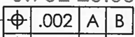 of 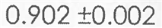is out of position ranging from 0.0022 to 0.0027 on SN 101 & 102.
- Dim #20, 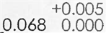 measures 0.0678 on SN 101.
- Dim #46 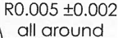 measures 0.0078 on SN 102.
- Dim #61, 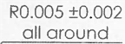 measures 0.0008 on SN 101.
- Dim #66, 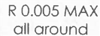 measures 0.0058 to 0.0065 on SN 101 & 102.

** A. HAASE TOOK SN 103 PRIOR TO MEASUREMENT ON 07/16/15

