NON-COMPLIANCE REPORT # 32291-10
PART NAME: | STEM | DATE: | 9/3/15
PF/SA NO.: | PF-391-738-82 RED | INSPECTOR: | K. CABAN
WORK ORDER NO.: | 32291-1110 | ENGINEER: | B. ARNOLD | EXT.: | 8534
VENDOR | ACCEL MFG. | PLANNER: | DIANNA
Reason for Non-Compliance: | Disposition (UAI, Rework, Scrap, Other):

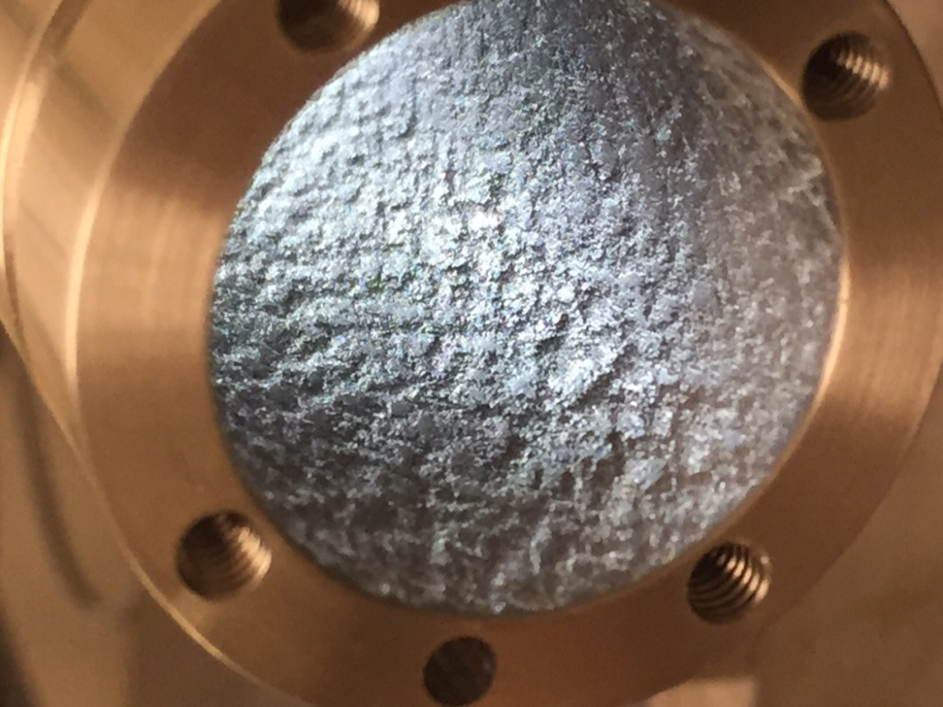
- R .005 MAX measures 0.0099 (+0.0049” out of tolerance).

- Inside Diameter 1.00 ± .020 measures 1.0525.
  - All Surface finish 63 has the finish of stock tube which is greater than 63. (See Photo).

